Subject:
EET 110

Prof.:
Marjaneh Issapour

Date:
2/16/2009

Piter Garcia
Farmingdale University of New York

Manual Lab Experiment # 13
Made by Piter Garcia

Farmingdale State College
State University of New York

Experiment No.
#4

Title:
The Half Wave Rectifier:
Oscilloscope & TRMS Measurements

Date of Experiment: 02/23/09
Date handed in: 03/01/09
Date due:

Grade:
U

Lab Partners:
Khiry Marshall
Electrical Engineering Technology
Debugging Problems: Compiler Errors

Indentify the compiler errors in Problems 21 to 24 and state what is wrong with the code.

Corrected Code

int a = 7, b = 9, c = 2;
if (a < b)
{
c = = b;
}

21.
int a = 7, b = 9, c = 2;
If (a << b)
{
c = = b;
}

Answer:
There are two errors in this code. First, if statement must be written in small case. Otherwise, the compiler will not analyze it as a statement but a variable. Second, the << will not give any result through the compiler reading and might not obtain the desire result. In fact, only one error does not allow the code to be analyzed by the compiler, which is the fist.

Corrected Code

int three_for_me = 3, quick_four;
switch (three_for_me)
{
case 7: cout << "\n hello"; break;
case 8: cout << "goodbye"; break;
}

22.
int 3_for_me = 3, quick_4
switch (3_for_me)
{
Case 7: cout << “hello”; break;
case 8: cout << “goodbye”; break;
}
Answer:
There are four errors in this code. All of them cannot be analyzed by the compiler in this case. First, the data types (3_for_me and quick_4) have numbers included. In the same way, the statement “Case” is spelt wrong with the “c” in capitalizes. Therefore, the compiler does not understand the statement.

23.
Corrected Code

float inventory, Case;
inventory = 8;
if (inventory = 3)
{
Case = inventory;
inventory = 0;
}
float inventory, case;
inventory = 8;
if (inventory = 3)
{
case = inventory
inventory = 0;
}

Answer:

This code has two errors. The same error is made twice. The compiler cannot process the code because the data_type is written with the statement “case.” Therefore, the compiler confuses it as a statement and does not give it the value as a dara_type., provoking an error in the code reading process.

Corrected Code

int Hurry = 17, m, n, o;
if (m < n)
{
o = Hurry;
n = o;
}
else
m = Hurry;
24.
int Hurry = 17, m, n, o;
if (m < n)
o = Hurry;
n = o;
else
m = Hurry;

Answer:
This code has one error. if statement cannot be understood by the compiler because it is not be used correctly. In other words, curl brake ({,}) are not being used and the compiler does not understand it as statement.
Debugging Problems: Run-Time Errors

Each of the programs in problems 25 to 27 compiles but does not do what the specification states.

What is the incorrect action and why does it occur?

25. Specification: Write out Hello World twenty-five times. Each hello begins a new line.
Corrected Code

#include <iostream>
using namespace std;
int main ()
{
int i = 1;
while (i < 25)
{
cout << "\n Hellow World\n";
++i;
}
return 0;
}
#include <iostream>
using namespace std;
int main ()
{
int i = 1;
while (i < 25)

cout << "\nHellow World";
++i;
return 0;
}

Answer:

The if statement cannot be understood by the compiler because it is not being correctly used. This occurs because the curl brakes ({,}) are not being used and the debugger does not understand the statement, repeating Hello World more than 25 times.

26. Specification: Check to see if the user’s input is a 0 or a 1. If it is a 0 or a 1, write out Hello World.
Corrected Code

#include <iostream>
using namespace std;
int main ()
{int user_input;
cout << "\nEnter an integer.\n";
cin >> user_input;
if (user_input = 1 || user_input==0)
{cout <<"\nHellow World\n";
}return 0;}

#include <iostream>
using namespace std;
int main ()
{
int user_input;
cout << “\nEnter an Integer.”;
cin >> user_input;
if (user_input == 0 ǀ ǀ 1) cout << “\nHello Wolrd”;
return 0;
}
Answer:
The incorrect action is not to have assigned a data_type to the number 0. Therefore, the debugger does not understand the function of “0” and give u Hallo World for any pressed number. On the other hand, another reason why it does not give the desire result is because the curl brakes have been omitted by the user in this code.
27. Specification: Check to see if the user’s input is 1, 2, or 3. Write out the numeric word (such as ONE) if it is within range; otherwise OUT OF RANGE.

#include <iostream>
Corrected Code

#include <iostream>
using namespace std;
int main ()
{
int user_input;
cout << "\nEnter an Integer.";
cin >> user_input;
switch (user input)
{
default: cout << "OUT OF RANGE";
case 1;
case << “\nONE”;
case 2:
cout << “\nTWO”;
case 3:
cout << “\nTHREE”;
}
return 0;

}
using namespace std;
int main ()
{
int user_input;
cout << “\nEnter an Integer.”;
cin >> user_input;
switch (user input)
{
case 1;
case << “\nONE”;
case 2:
cout << “\nTWO”;
case 3:
cout << “\nTHREE”;
default: cout << “OUT OF RANGE”;

}
return 0;
}

Answer:
The incorrect action here is simple. The default must be placed ahead or before what is asking to the debugger to do. So it recognizes the numbers below as the range assigned.
Reading the Code
In problem 28-31, what will be the output from the source code?
28. C++ Code | Input (C++ Code)
int x = 10, y = 6, ctr = 0;  cout << "Hi There!” << end1 << end1;  while (ctr < 3)  {  cout << x << y;  ++ctr;  y--;  }  do {  cout << "\nI Love C++!";  } while(ctr < 3); | #include "stdafx.h"  #include <iostream>  using namespace std;  int main ()  {  int x = 10, y = 6, ctr = 0;  cout << "\nHi There! << end1 << end1\n";  while (ctr < 3)  {  cout << x << y;  ++ctr;  y--;  cout<<"\n\n";  }  do  cout << "\nI Love C++!\n";  while(ctr < 3);  }

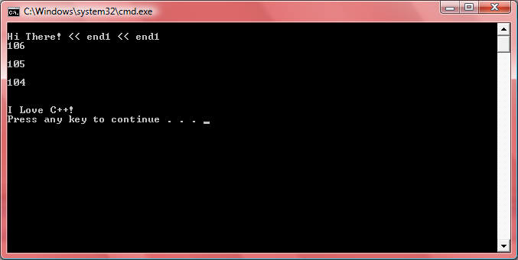
Output

Obtain Numbers
Ob

Power= (V*V)/R
Power in milli Watts
cout<<Power
Current in milli Amps
Resistor in Killo Ohms

Voltage

Obtain Numbers
Ob

F= (9/5)*C+32
cout<<Fahrenheit

CF in degrees
CI in degrees

Centigrade

Fahrenheit in degrees
(F)

