In this assignment we are following the steps applying in the “Data Mining: A Preprocessing Engine” research paper to normalize our dataset suing three methods of normalization such as z-score, min-max, and decimal point normalization. Also, we are using three different type of methodology to test the data training set. The first one is the decision tree, however you replace ID3 for the J48 option in WEKA. The second is the K-Nearest Neighbor (KNN). Lastly, we used an artificial neural network transfer function to model for dataset, which was coded in R.

Different Approaches Results:
Approach | Min-Max |  | Z-Score |  | Decimal Scaling
Dataset | P1 | P2 | P1 | P2 | P1 | P2
Accuracy | 84.01 | 78.40 | 81.29 | 82.31 | 74.41 | 68.10
Tree Growing time/sec | 0.03 | 0.06 | 0.04 | 0.01 | 0.03 | 0.06
No. of Leaf Nodes | 2 | 6 | 2 | 156 | 2 | 6

In the table above we normalized the dataset with the Min-Max, Z-Score and Decimal scaling methods. As we can observe, from the results we obtained the method with the most efficient tree was the Min-Max normalization method. However, this was only for the first partition of the dataset because, as you can see in the table above, the Z-Score normalization method was most efficient for the second partition of the dataset, which it is in fact of more importance for analysis purpose.

The Accuracy of the data mining techniques:
Technique | Min-Max Accuracy | Z-Score Accuracy | Decimal Point Accuracy
Rules generation | 99.31 | 100 | 83.19
KNN Training Set | 100 | 100 | 93.91
KNN Cross-validating 10 | 80.61 | 67.0 | 63
TF | 61 | 61 | 61

In the same way we proceeded to test each one of the normalization method with three data analysis techniques referenced from the research paper assigned. These techniques are Rules generation, KNN (Training Set and Cross-Validating 10,) and TF(transfer function) an artificial neural network simulation. As we can observe in the table above, the analysis results of the Min-Max and Z-Score normalization methods are very closed. It was not clear to me why the Z-Score method had such poor accuracy when cross validating the Kenneth Near Neighbor technique ten times. We were not able to study this case any further due to the time variant. Nevertheless, I would still recommend the Z-Score method, at this point, for mining purpose.

Analyzing normalized datasets with neural network model

Dataset Partition:
$trainset
We proceeded to further analyze the data to see which normalization method performs better during an artificial neural network model simulation. Because of the paper limitation, and the fact that Decimal Scaling results were not even close to those from Min-Max and Z-Score, we have applied this model analysis only to the datasets normalized with the Min_Max and Z-Score method.
[1] 147

$testset
[1] 147
Z-score model Analysis
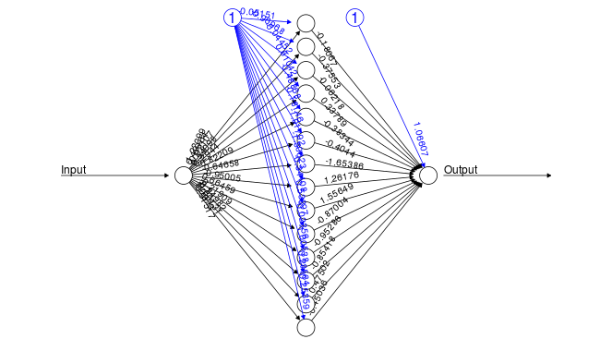
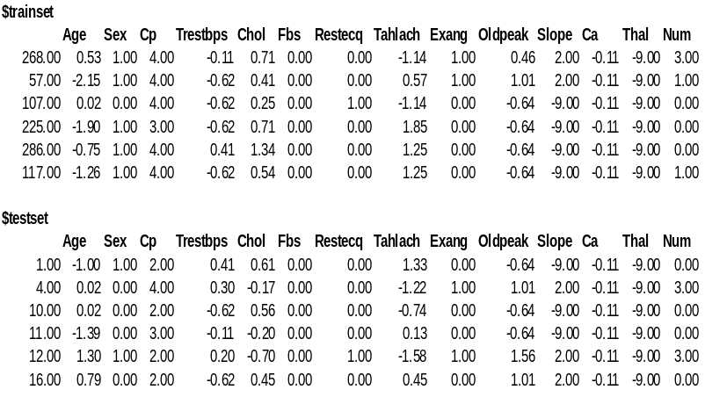

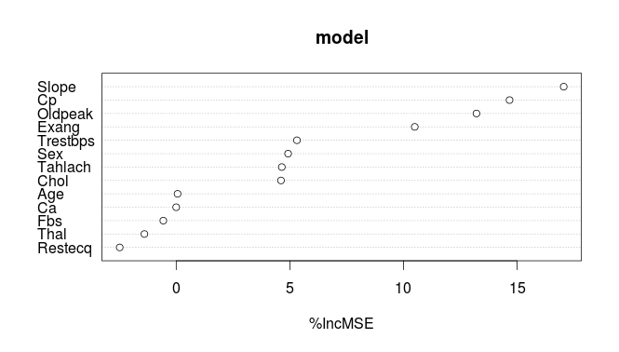
In order to further analyze the normalized datasets we used R to simulate an artificial neural network to analyze and compare both the Max_Min and Z-Score normalized datasets. In order to create the neural network we split the normalized dataset into two sets, the training set and the testing set. We are not describing these sets in deep due to the space limitation. However, you can find further information in the attachment that was submitted along with this document.

The first model is the original dataset. Notice how the Z-Score normalized dataset is slightly more distributed than that in the original dataset. The difference is not that big, and the reason to this is because the dataset we are using did not have that many outliers.

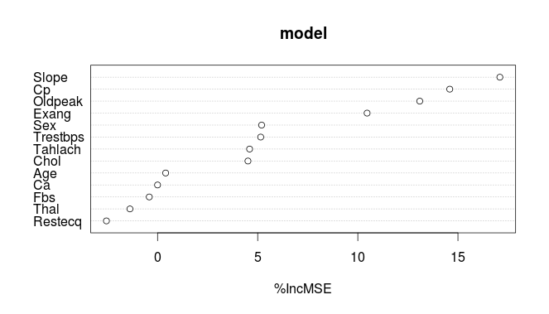

Max-Min Model Analysis
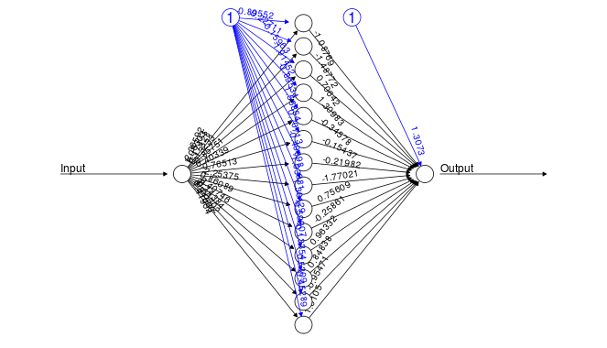
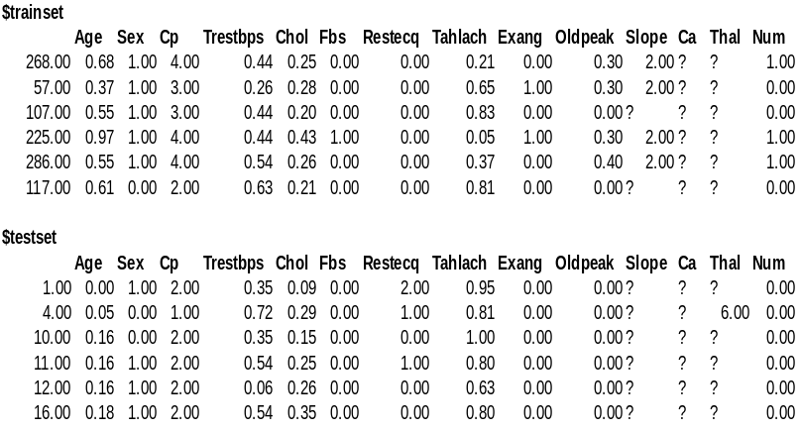

The output of the Max-Min normalization method in the neural network model was pretty similar. Using a similar approach to that used for the Z-Score normalized dataset, we trained the dataset and obtained a result similar to that obtained from the Z-Score neural network model. This made sense to use, because we were able to observe since the beginning of the our testing that Max_Min and Z-Score normalization methods results are very similar as shown in the tables above.

On the other hand, we believe that the reason why they are very similar now is because of the fact that we are only using on dataset to test this techniques and normalization methods. However, if we were to test multiple datasets we are certainly sure that the result would be different to that we have obtained during our testing. We can explain this in the following manner.

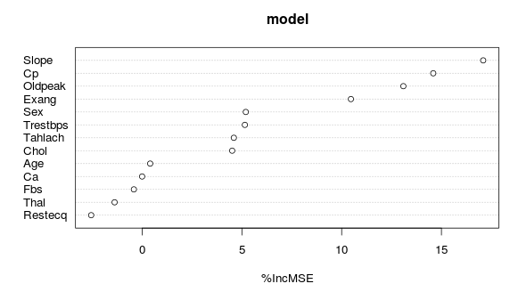
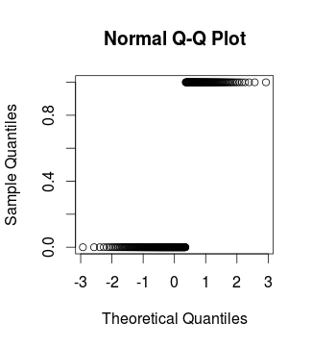
The images to the right are the prediction output from both the Z-Score and Max_Min normalized datasets. Although, they both had the same result or similar in most of our testing their output is not the same. However, they are proportionally about the same. What I mean with proportionally, I mean that the average of the number of people that were predicted to have heart disease are about the same. If we were to test multiple datasets then the output would be much greater and more than likely very different. In fact, we assume that the Z-Score normalization process would give the best response in this case. The reason why is because the Z-Score normalization seems to distribute the prediction output in a more efficient manner than in the Max_Min normalization process.

Further study of the dataset was done with the Z-Score normalized dataset. All information and test applied to all normalized and not-normalized datasets have been attached along with this documents, including the neural network models used for testing.
Z-Score Prediction
Min_Max Prediction
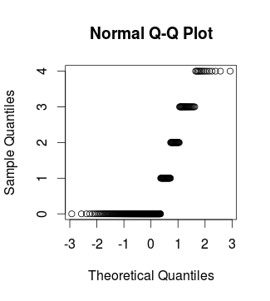Illustration 1: Z-Score Prediction

