CSSS 508: Intro to R
3/10/06
Homework 9 Solutions

Load the MASS library into R. We’re going to look at Pima.te, a data set looking at diabetes in Pima Indian women. The women are at least 21 years old, of Pima Indian heritage, and living near Phoenix, Arizona. They were tested for diabetes according to World Health Organization criteria.

library(MASS)
help(Pima.te)
attach(Pima.te)

The type variable is an indicator (Yes/No) for diabetic status.

table(type)
There are 109 diabetics and 223 non-diabetics.

The other variables are measurements taken by the US National Institute of Diabetes and Digestive and Kidney Diseases: npreg, glu, bp, skin, bmi, ped, and age.

1) Use graphs to illustrate differences between the diabetic group and the non-diabetic group. Discuss what you see.

We’re just comparing the measurements for two groups; boxplots and histograms are easy, simple methods to show the differences in group distributions.
When we use histograms, we keep the same overall x-limits and y-limits so we can compare the groups visually.

gr.label<-c(“Diabetic”,”Non-Diabetic”)
m<-matrix(c(1,4,5,2,3,6,7,8,9),3,3)
layout(m)
boxplot(age[type=="Yes"],age[type=="No"],names=gr.label,main=”Age”)
hist(npreg[type=="Yes"],breaks=seq(-0.5,max(npreg)+0.5),ylim=c(0,60),xlab="No. of Pregnancies",main="Diabetic")
hist(npreg[type=="No"],breaks=seq(-0.5,max(npreg)+0.5),ylim=c(0,60),xlab="No. of Pregnancies",main="Non-Diabetic")
boxplot(glu[type==”Yes”],glu[type==”No”],names=gr.label,main=”Glucose Concentration”)
boxplot(bp[type=="Yes"],bp[type=="No"],names=gr.label,main="Diastolic BP")
boxplot(skin[type=="Yes"],skin[type=="No"],names=gr.label,main="Skin Fold Thickness")
hist(bmi[type=="Yes"],breaks=seq(min(bmi),max(bmi),length=20),ylim=c(0,35),xlab="Body Mass Index",main="Diabetic")
hist(bmi[type=="No"],breaks=seq(min(bmi),max(bmi),length=20),ylim=c(0,35),xlab="Body Mass Index",main="Non-Diabetic")
boxplot(ped[type=="Yes"],ped[type=="No"],names=gr.label,main="Pedigree Function")

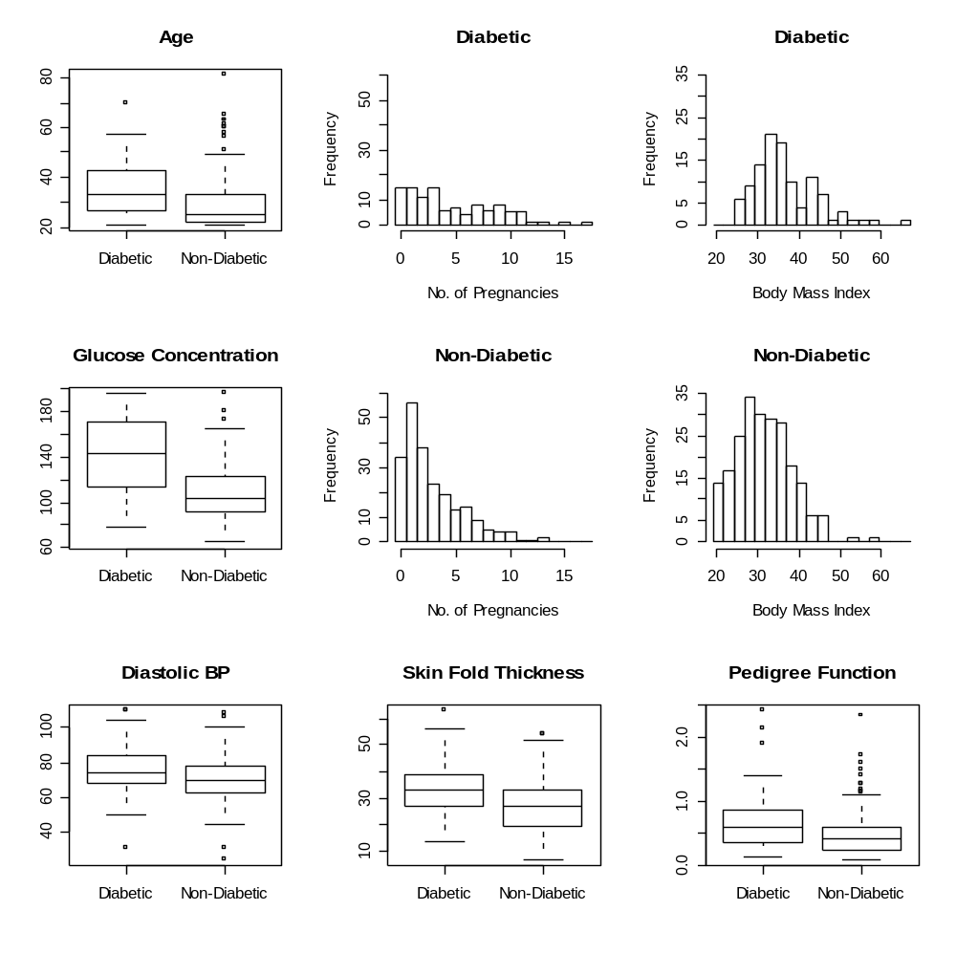

The diabetic women are older on average. They appear to have higher glucose concentrations (as expected). Although the average diastolic blood pressure measurements for the two groups are similar, the distribution of the diabetic group is slightly higher than that of the non-diabetic group. (The low outlier in the diabetic group pulls their average down.) The diabetic group has fewer pregnancies (again as expected). Also, their distribution is more evenly spread; the non-diabetic group is right-skewed.
The diabetic group appears to have slightly higher tricep skin fold thickness and a slightly higher average BMI. The pedigree function distribution of the diabetic group is higher than that of the non-diabetic group, but both groups have outliers with high pedigree function. These outliers might mask any information pedigree function might have in predicting diabetic status.

We would expect variables showing marked group differences to be useful in any logistic regression models predicting diabetic status. However, many of these variables are correlated so only a few of them may be significant predictors.

2) Fit a full logistic regression model using all variables to predict type. Find and interpret (in words) the odds ratios. Find 95% confidence intervals for the odds ratios. Which variables are significant?

full.fit<-glm(type~npreg+glu+bp+skin+bmi+ped+age,family=binomial)
> full.fit

Call: glm(formula = type ~ npreg + glu + bp + skin + bmi + ped + age, family = binomial)

Coefficients:
(Intercept) npreg glu bp skin
-9.514019 0.140944 0.037481 -0.008675 0.013167
bmi ped age
0.078951 1.110131 0.018055

Degrees of Freedom: 331 Total (i.e. Null); 324 Residual
Null Deviance: 420.3
Residual Deviance: 285.8 AIC: 301.8

Finding the odds ratios:
or<-round(exp(full.fit$coef),4)
> or
(Intercept) npreg glu bp skin bmi
0.0001 1.1514 1.0382 0.9914 1.0133 1.0822
ped age
3.0348 1.0182

Each pregnancy is associated with an odds increase of 15%. Each unit increase of plasma glucose concentration is associated with an odds increase of 3.8%. Each increase of one mm in diastolic blood pressure decreases the odds of being diabetic by 0.86%. A one mm increase in triceps skin fold thickness increases the odds of being diabetic by 1.3%. Increasing your BMI by one unit increases the odds of being diabetic 8.2%. A one unit increases in the diabetes pedigree function increases the odds of being diabetic by 203%. Each year increase in age increases the odds of being diabetic by 1.8%.

Finding the 95% confidence intervals:
full.sum<-summary(full.fit)$coef
> full.sum
Estimate Std. Error z value Pr(>|z|)
(Intercept) -9.514018726 1.229278052 -7.7395173 9.979497e-15
npreg 0.140943820 0.059651528 2.3627864 1.813812e-02
glu 0.037480843 0.005558286 6.7432373 1.548959e-11
bp -0.008674979 0.012588977 -0.6890932 4.907646e-01
skin 0.013167190 0.020025448 0.6575229 5.108448e-01
bmi 0.078951021 0.028432214 2.7768158 5.489428e-03
ped 1.110131445 0.446921212 2.4839534 1.299328e-02
age 0.018055352 0.018358630 0.9834804 3.253711e-01
upper.ci<-round(exp(full.sum[,1]+1.96*full.sum[,2]),4)
lower.ci<-round(exp(full.sum[,1]-1.96*full.sum[,2]),4)
ci<-cbind(or,upper.ci,lower.ci)
colnames(ci)<-c("or","upper.ci","lower.ci")
ci
or upper.ci lower.ci
(Intercept) 0.0001 0.0008 0.0000
npreg 1.1514 1.2942 1.0243
glu 1.0382 1.0496 1.0269
bp 0.9914 1.0161 0.9672
skin 1.0133 1.0538 0.9743
bmi 1.0822 1.1442 1.0235
ped 3.0348 7.2870 1.2639
age 1.0182 1.0555 0.9822

Number of pregnancies, plasma glucose concentration, body mass index, and diabetic pedigree function are also significant predictors of diabetic status.

3) Choose and fit a simpler, reduced logistic regression model. What variables do you think are important to keep in the model? How were the variables chosen?

One choice would be to use all the significant variables in the full fit.
red.fit<-glm(type~npreg+glu+bmi+ped,family=binomial)
> red.fit

Call: glm(formula = type ~ npreg + glu + bmi + ped, family = binomial)

Coefficients:
(Intercept) npreg glu bmi ped
-9.55218 0.17807 0.03797 0.08411 1.16566

Degrees of Freedom: 331 Total (i.e. Null); 327 Residual
Null Deviance: 420.3
Residual Deviance: 287.4 AIC: 297.4

This model does have a lower AIC than the full fit model and so is a better fit (if you choose by an information criterion). However, I think it is probably a good idea to adjust for age.

red.fit2<-glm(type~npreg+glu+bmi+ped+age,family=binomial)
> red.fit2

Call: glm(formula = type ~ npreg + glu + bmi + ped + age, family = binomial)

Coefficients:
(Intercept) npreg glu bmi ped
-9.82468 0.14533 0.03721 0.08479 1.12721
age
0.01482

Degrees of Freedom: 331 Total (i.e. Null); 326 Residual
Null Deviance: 420.3
Residual Deviance: 286.7 AIC: 298.7
Even though the AIC is slightly higher (and age is not significant in the model), adjusting for age is a worthwhile addition to the model.
summary(red.fit2)

Call:
glm(formula = type ~ npreg + glu + bmi + ped + age, family = binomial)

Deviance Residuals:
Min 1Q Median 3Q Max
-2.9314 -0.6352 -0.3694 0.6158 2.5430

Coefficients:
Estimate Std. Error z value Pr(>|z|)
(Intercept) -9.824679 1.150706 -8.538 < 2e-16 ***
npreg 0.145332 0.059183 2.456 0.014063 *
glu 0.037208 0.005501 6.764 1.34e-11 ***
bmi 0.084786 0.021952 3.862 0.000112 ***
ped 1.127209 0.445553 2.530 0.011409 *
age 0.014817 0.017501 0.847 0.397204
---
Signif. codes: 0 `***' 0.001 `**' 0.01 `*' 0.05 `.' 0.1 ` ' 1

(Dispersion parameter for binomial family taken to be 1)

Null deviance: 420.30 on 331 degrees of freedom
Residual deviance: 286.73 on 326 degrees of freedom
AIC: 298.73

Number of Fisher Scoring iterations: 5

red.sum<-summary(red.fit)$coef
or<-round(exp(red.sum[,1]),4)
upper.ci<-round(exp(red.sum[,1]+1.96*red.sum[,2]),4)
lower.ci<-round(exp(red.sum[,1]-1.96*red.sum[,2]),4)
red.res<-cbind(or,upper.ci,lower.ci)
colnames(red.res)<-c("or","upper.ci","lower.ci")

> red.res
or upper.ci lower.ci
(Intercept) 0.0001 0.0006 0.0000
npreg 1.1949 1.3060 1.0933
glu 1.0387 1.0498 1.0277
bmi 1.0877 1.1356 1.0419
ped 3.2080 7.6599 1.3435

We could also let the step function choose the model:
step(full.fit)
Start: AIC= 301.79
type ~ npreg + glu + bp + skin + bmi + ped + age

Df Deviance AIC
- skin 1 286.22 300.22
- bp 1 286.26 300.26
- age 1 286.76 300.76
<none> 285.79 301.79
- npreg 1 291.60 305.60
- ped 1 292.15 306.15
- bmi 1 293.83 307.83
- glu 1 343.68 357.68

Step: AIC= 300.22
type ~ npreg + glu + bp + bmi + ped + age

Df Deviance AIC
- bp 1 286.73 298.73
- age 1 287.23 299.23
<none> 286.22 300.22
- npreg 1 292.35 304.35
- ped 1 292.70 304.70
- bmi 1 302.55 314.55
- glu 1 344.60 356.60

Step: AIC= 298.73
type ~ npreg + glu + bmi + ped + age

Df Deviance AIC
- age 1 287.44 297.44
<none> 286.73 298.73
- npreg 1 293.00 303.00
- ped 1 293.35 303.35
- bmi 1 303.27 313.27
- glu 1 344.67 354.67

Step: AIC= 297.44
type ~ npreg + glu + bmi + ped

Df Deviance AIC
<none> 287.44 297.44
- ped 1 294.54 302.54
- bmi 1 303.72 311.72
- npreg 1 304.01 312.01
- glu 1 349.80 357.80

Call: glm(formula = type ~ npreg + glu + bmi + ped, family = binomial)

Coefficients:
(Intercept) npreg glu bmi ped
-9.55218 0.17807 0.03797 0.08411 1.16566

Degrees of Freedom: 331 Total (i.e. Null); 327 Residual
Null Deviance: 420.3
Residual Deviance: 287.4 AIC: 297.4

Step chooses a model with number of pregnancies, plasma glucose concentration, body mass index, and the diabetic pedigree function.

