ABSTRACT
The aim of this project is to implement some cleaning and mining techniques that we have learnt in a project chosen by our team. The name of our project is "What Should I Wear", and we will be using weather data sets of the United States to analyze, compare, and approximate the weather trends including the precipitation of a particular area requested by the user in a designated input time range. In fact, we will be able to suggest users whether they should wear a coat or short through an interface that we have designed to allow users to consult what to wear according to the weather of the city, including its precipitation, for short-term vacationing purpose.

OVERVIEW
The logical structure of our project is composed of three main phases that better describe the milestones achieved throughout our project development. These phases are classified as Design, Architecture and Implementation. Each phase explains in detail the main steps taken to model and structure a database with our interface to meet the project specifications. In order to better organize our documentation we have divided these phases into two main sections, which contain a summary of the work process done in our project. These two sections are Database and Interface, and their development can be described as follows:

The datasets of our database consist of maximum and minimum temperature, precipitation, wind speed, longitude and latitude (position about 1/8 degrees apart) of some locations. These datasets have been collecting weather information for the past forty four years. This amount of data not just help us analyze the trends of some areas over the past years but makes our results more reliable. The main goal was to design a database, from which we can easily generate tables for the cities, cities' s weather information, and user' s cities selections.

The design of our interface works as a platform to shape and implement our project according to our expectations. The way we have designed our interface is according to the database design. Therefore, we have created a set of features that users will be able to use in a website through our database implantation. The appearance of our website is highly influenced by the architecture of our project, and even though our first interface design appearance may not correlate with the implementation, the features are the same. We used certain tools in order to provide our interface with the structure needed to meet our project specifications. For this project, PostgreSQL is the database engine underlined by our management system to create, read, update and delete data from the database. Moreover, we have included other database and web development software that have helped us to model and process our database faster and easier. The application programming interface that we are using, to allow users to interact with our underlying engine without going through our system, is DJango. We are also making use of tools such as Python and HTML.

In particular, we will explain some tools and techniques used to achieve our goals in each one of the sub-sections explained in the Database and Interface sections. These subsections are explained separately in each sub-structure as the process taken in each one varied. Our main goal is to make querying for the weather information easy and reliable. This can be accomplished through our database and interface application by taking the input of users and providing them with a graphical output that can be easily interpreted.

DESIGN

The operational process of our design meets the objective of a high quality development which responds to real life scenarios in big data. The focus of this step is the development of an acceptable functional solution to the requirements of our project with an exterior design solution that is compatible with our database, interface, and our goal as a whole. A successful design development is needed in order to coordinate the activities of users and project architecture to meet our goal.

Database

We are using a data set provided by the University of Washington’s Surface Water Modeling Group. The data set contains daily and monthly records of daily total precipitation, maximum temperature, minimum temperature, and average 10-meter wind speed. The data is available both per-month and per-day for fifteen regions in North America. Data is available for all regions for dates ranging from 1949 to 1999, as well as earlier and later for some regions. This project will be focusing on the data that is available for all regions (from 1949 to 1999).
Figure 1: Tables Design.

- Preparation
The main goal was to make querying for the weather information easy and reliable. Therefore, to make a better use of the database, we have formatted each dataset to remove redundant, noisy, and unnecessary data, which helped our system to run more efficiently.

The main purpose of the preparation process was to make our database look as the images below. In this way, we are able to read the formatted data files according to the requirements of our project. This process allows us to easily relate each one of the input dates to the corresponding city and its temperature, within the given range, to approximate the city' s weather condition within the given dates.

In order to create the desired appearance described above, we needed to make our database go through some steps to make this structure possible.

- First, the datasets were compressed and therefore we needed to extract them by using the little Edian format, which was a very difficult process to include in our code.

- Second, we sorted the cities and separated them from those we did not plan to include in our database. Also, the datasets were huge and unnecessary for our implementation. Therefore, we modifieded the datasets to contain only weather information from 1980 to 2000.This, according to obtained data, includes enough data for the purpose of our project.

- Lastly, each dataset was formatted to relate to the weather, user, and longitude-and-latitude tables to its corresponding city by means of an id, which enabled us to match a city weather records' dates to the user given dates.

The datasets we obtained were huge and very difficult to handle. The preparing process was a very important step in our project to improve and speed up every process. At first, it was very difficult for us to test our features because the system was slow and overloaded with data. This is why we proceeded to exclude a large amount of cities and only work with some cities to make testing more efficiency and reliable.

- Cleaning
We designed the appearance and structure of our database to perform according to the results of our cleaning process. The purpose was to allow the tables in our database to relate to the input dates, corresponding city and its temperature. Thus, we would be able to approximate the city' s weather condition within the given range of the input dates in an easier and faster manner. Our main model was based on the Temperature, City Tables, and their structure was studied by tools that are explained in the architecture phase of this project. An example of the design of these tables' structure can be seen in the figures 4 and 5. User's table was built, but it was supposed to have a different structure to the others since this table is populated as users register. The structure design of this table can be seen in the figure 7.

After the user access our system, the content of this will access to the other tables such as the city and weather tables. Once it has gathered the necessary data it will proceed to do some data processing techniques, explained in the implementation phase, to approximate the weather condition of a city selected by the user within the input dates. This performance is explained in details in the architecture phase of this project.

Figure 2: Table to Insert Cities.

Figure 3: Table to Insert Data(weather).

The main tables used to create our database are the Data and City tables. These tables were created, after uncompressing the data, with an algorithm we coded in Java. This process is explained in detail in the architecture phase; we will briefly explain how the design of this process took place.

Figure 4: City Table.

In order to load our tables into our system it was necessary for us to have the two tables, mentioned
above, formatted.
Figure 5: Data(Weather) Table.

The structure of each table should be as follows. First, the City table, this is composed by latitude, longitude, and the cityName. Lastly, the Data table, which is composed by the date, precipitation, temperature, and wind of each city. This is the structure we used to design our database as shown in the figures 4 and 5. The Data tables are used by our interface to implement the features of our system. This includes weather approximation as well as to suggest cities that the user may like according to the user' s behavior, which has not been implemented yet.

Interface
We have designed a website that works as a platform to shape and implement our project according to our expectations and database design. We have created a set of features that users are able to use in our website through our database and code implantation.

Figure 6: Search Interface Design

An example of the appearance of our interface frame design is in figure 8. Our website is highly influenced by the architecture of our project, and therefore its design may not look exactly, or even similar, to the original result.
Figure 7: Search-Place Structure Design

We used certain tools in order to provide our interface with the structure needed to meet our project specifications. For this project, PostgreSQL is the database engine underlined by our management system to create, read, update and delete data from the database. Moreover, we included other database and web development software that helped us model and process our database faster and easier. The application programming interface that we are using, to allow users to interact with our underlying engine without going through the user interface of our system, is DJango. We are also making use of tools such as Python and HTML. These tools are described in detail in the architecture section of our project, and examples of these are given to show the reader how the structure design of our interface took place.

The platform that we are using to manage our database is DJango. The installation and upgrading process is very easy since we have the ability to automatically install database adapters and other dependencies. Using DJango in our management systems has allowed us to extract valued content from our datasets and build a high performing web applications system in an elegant and efficient way. The following factors have been improved with the use of DJango.

- First, we can define our data models much easier with Python which provides us with a dynamic database access APIA that has been formatted with SQL.

- Second, it provided us with an automatic admin interface that adds and updates users and user's content automatically.

- Third, it supports Multi-language applications. This is essential for our implementation since it is used mostly for vacation purposes.

- Finally, we can always use cache frameworks to increase future performance.

All features of our project were designed to help users to decide what they should wear when traveling and, or, going on vacation. In order to achieve this, we need to provide users with features that allow them to search for a place, monitor the approximate weather information, and have a list of suggested cities that users may want to visit accordingly. The design of these features can be described as follows:

Figure 8: Sign-In Interface Design

The idea is to have a system in which we assign each user with a unique id and password. An example of this feature can be seen in the figure 8, but this is not fully implemented in our system yet because of the time we are only proving with clothing suggestions. We have an application for users to access our system through a website, facilitating users to utilize it in a more efficient manner, and improves our system as follows.

- First, it helps us to increase user registrations quickly.
- Second, it provides us with an app id and app secret-id; thi has not been implemented yet.
- Overall, this feature could potentially help us integrate more features and allow for future improvements.

Figure 8: Sign-Place Table Design

Figure 9: Search-Place

We did not implement this feature, however, this feature would have allowed users to personally search and find cities of their interest. This feature would automatically add the searches done by the user; the list of searches or table would provide suggestions to the user with a list of cities that he or she may like. More detail of the structure of this feature is covered in the architecture phase of our project. The image in figure is an example of this feature's design.

Graph
In the graph feature, there is a function that we use to approximate the weather information of a city. Once the weather data was approximated, this data is accessed and analyzed for the system to provide the user with a clothing suggestion. The process in which we make use of the weather data to make the approximation is better explained in the architecture phase of our project.

Suggestion List
This feature was not implemented, but it would have shown a graphical representation of the approximated weather and precipitation of the designated city that the user searched for. We would have used the table that stores all the searches done by the user, and use the data in this table such as user's information and the weather information of the cities. After all this information was gathered, we would have created another table to contain the suggested cities that the user may want to visit. The structure design of this feature is explained in the architecture phase of our project.

ARCHITECTURE

It was critical to model the right architecture in order to succeed in our system and implementation design. The architecture process is an essential part of our project, which specifies the overall structure of our system. In this process with provide you with the description and analysis of high level properties of our system originated from our database and interface. The database contains the assignment of functionality for our designed features, data corporal distribution, composition of designed features, scaling and performance, and data design modifications. In contrast, the interface section includes the body of work for our module interconnection features, templates and frameworks for our system that serve the needs of our database domain, and formal models of component integration mechanisms.

Database

- Preparation
In the formatting process of our project we used some algorithm techniques to model our data to meet the project requirements. The appearance of the database was obtained through algorithms such as the little EDIAN. Also, we used our own Java code implementation to reduce the datasets to only 20 years of weather information, and to reduce the number of cities.

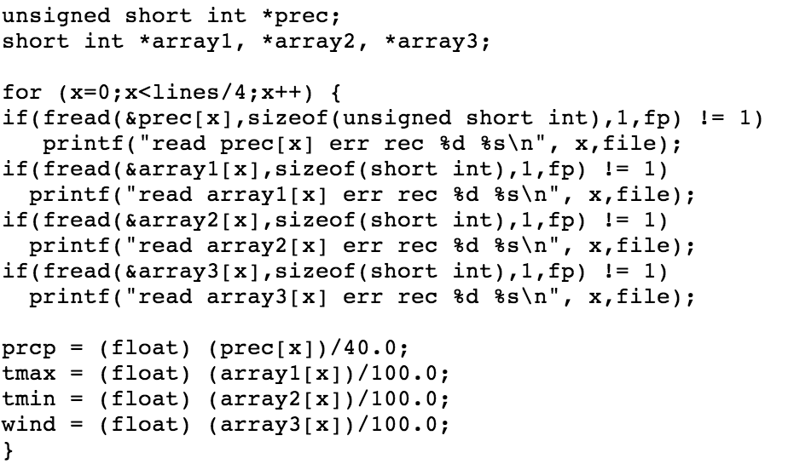
Figure 10: Little EDIAN Algorithm

Little EDIAN is a compression format algorithm that we used to uncompress the datasets mentioned in the design section of our project. We had access to the algorithm through Washington University Website referenced below, and a demonstration of the algorithm is shown in figure10.

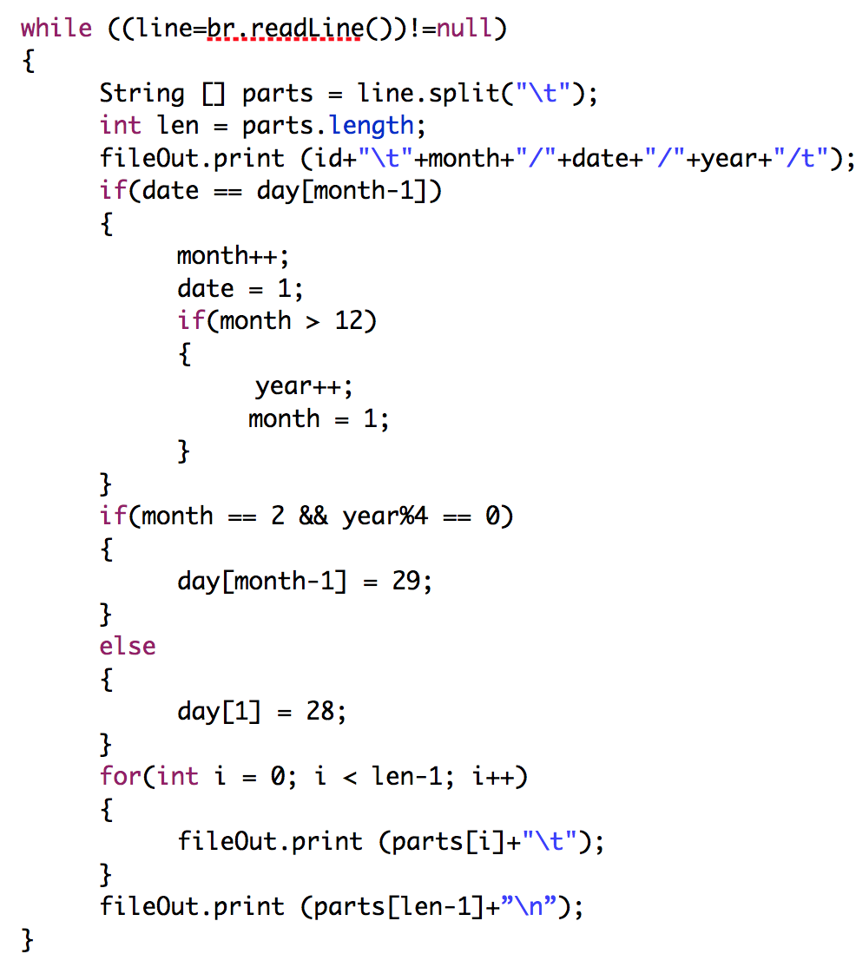
We implemented in JAVA the code shown in Figure 11. This code reduces the data to 20 years of weather information, and it only loads the datasets from the west cost cities.

In order to use our database, we had to model each dataset to load and query easily. To do this, we have used our own code implementation that creates the city and data table explained in the designed section. These tables are created by the algorithm shown in the figure 11. This algorithm Figure 11: Java Source Code - Data(Weather) Reduction consist of two parts; the first is creating the city table and the second is creating the data table. An image of these two is shown in the figures 4 and 5.

The reduction and formatting of the datasets made easier the querying process. The algorithm mentioned in the structure of this division was necessary in order to perform our testing procedures. The reason for this is because the datasets were huge, and we did not need more than 20 years of weather data to approximate the weather of a city.

- Cleaning
The structure of our database was modeled through the pgAdminIII work platform. This work platform helped us to generate the tables that we needed to make possible the functionalities of each features. Through this application we were able to generate the city and data tables, which are very essential for our implementation. A demonstration of the work platform is shown in the figure 12.

The structure of the pgAdmingIII platform devises a query plan for each query that is given to generate the tables. The generation of these tables will decrees the querying time, and gives us a close approximation in a quick step.
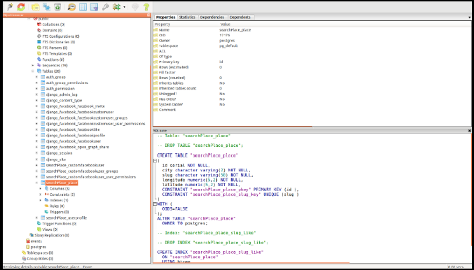
Figure 12: Work Platform to Create Tables Data

The data table consist of weather information of the cities, these are temperature maximum and minimum, precipitation and wind speed. These weather information corresponds to each city id, and the data is from 1980 to 2000. The schema of this table is shown in the image above. City, the data table for the city, contains only the id, the longitude, and latitude of each city. The id is used as a reference to the Data table. The schema of this is shown in the figure 14.

Search
In the search place table, we have assigned to each area, which we named city in our query, a unique id through which we can distinguish it from the other areas.

User
We are not currently implementing this table in our interface because we ran out of time. However, this table can be used in the pgAdminIII work platform to query accordingly in future.

City data
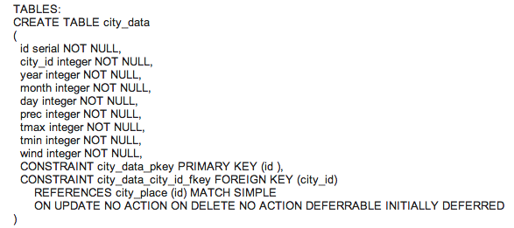
Figure 13: Table of City and Data
Contains the data of temperature, wind, precipitation that matches with the cities.

City Searchplace
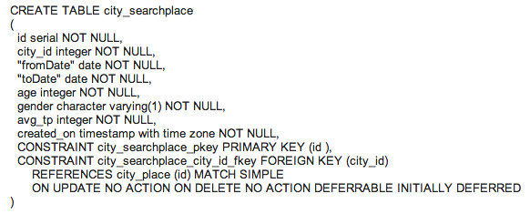
Figure 15: Table of the Cities to Search
Contains the data of temperature, wind, precipitation that matches with the cities.

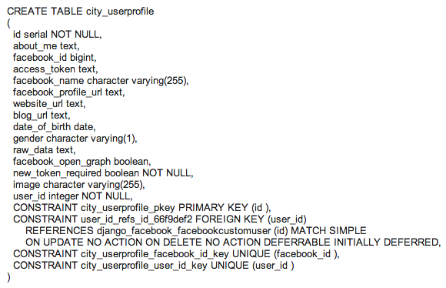
Figure 16: Table of the User Cities Searched

Interface
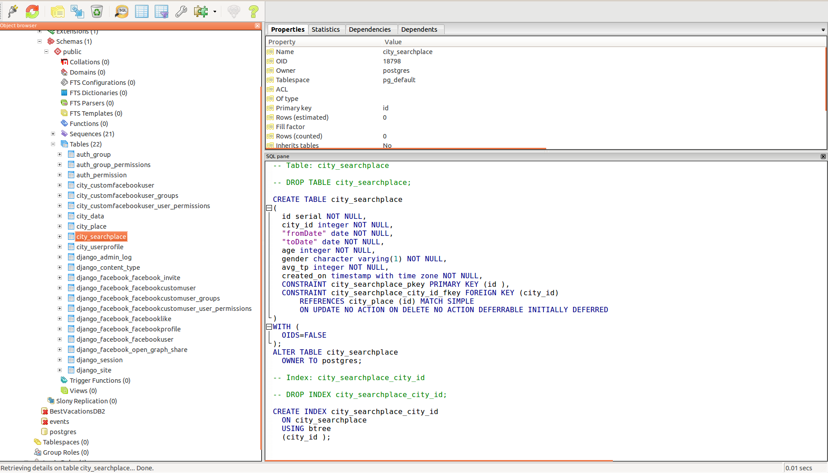
Figure 17: Schema of the Interface.

An example of our interface development is shown in the image 18. The features that we display
are search, graph, and clothing suggestions. The design structure of each of these is covered below.

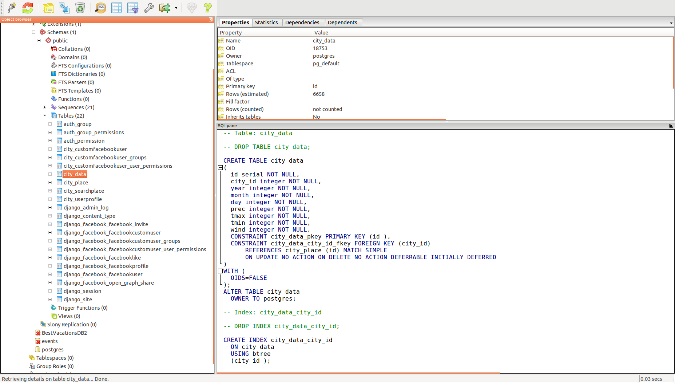
Figure 18: Schema of the Interface

The structure of our interface is modeled by Django through its queries techniques. We used these techniques to populate the user table, to query the other tables in our database, and to perform some data mining techniques. DJango provides for an intuitive way of representing the database in python. It uses a model class for database tables where an instance of a class represents a record of each table, as shown in the image below.

- Creating Objects
To create an object, we would need to instantiate this class using keywords to model class, and then save the changes. The class needs to be imported using the python path to the class. Assuming models live in a le mysite = blog = models.py, The code in figure 17 adds a record to Blog().

- Updating Objects
This is an intuitive task where we perform the updating in the class. Next, we ask the database to save the changes. The example in figure 18 changes the name of the instance of the class b5.

- Retrieving Objects
This is done using the Queryset on the manager. Queryset in Django is equivalent to a select statement. In the example below, the object represents the default manager and Blog() represents the query set with a few filters that filter out the results. Next, a number of filters can be used on the resultant query. Keywords like filter and exclude are used for that. The keyword “all” is used if all the results are required. In case we require only a single output the keyword get is used. We could also limit the results such that we get a range of results from the table.

- Person Objects
The table Person has not been implemented in our interface yet, but is very necessary when implementing the algorithm to obtain a list of suggested cities that users may like. All the data gathered is saved in a table named Person, and the reason why is important is because this table would allows us to identify users and predict users' behavior according to their search history.

Overall, the architecture of our system can be improved by understanding the complexity of our system. We still are recognizing common paradigms that allow high level relationships among systems to be understood., and we will be able to build a new system as variations on our current systems.

IMPLEMENTATION
The Implementation section describes how system applications will be installed, deployed and transitioned into our operational system for the purpose of our project. In this section we will provide you with an overview of the system, describe major tasks involved in the implementation process, and the overall resources needed to support the implementation effort such as hardware, software, facilities, techniques, among others. Furthermore, we will present users with the documentation and tools necessary to make an informed decision on how to deploy our system for short-term traveling cloth wearing suggestions. In addition, multiple features have been added and we will explain how to utilize them in our system during its implementation process. We will demonstrate how these applications, based on our interface and database sections, can be installed and configured in any environment by deploying the enabled operations of our system that have been completely developed and tested for our project.

Database
- Preparation
--Database Reduction
We have reduced the amount of data we have, obtained from the online source cited below, due to our current design. We did not believe that more than 20 years of data was necessary to achieve the goal of this project. And since the cleaning and preparation process of the data was taking too long because of the data sets being too big, our computer processors to were having trouble to handle our database. The two images is a comparison between our database before and after shrinking the data sets to 20 years of data.

Database before reduction
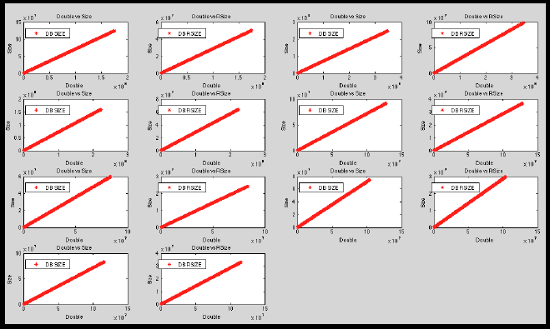

Database after reduction
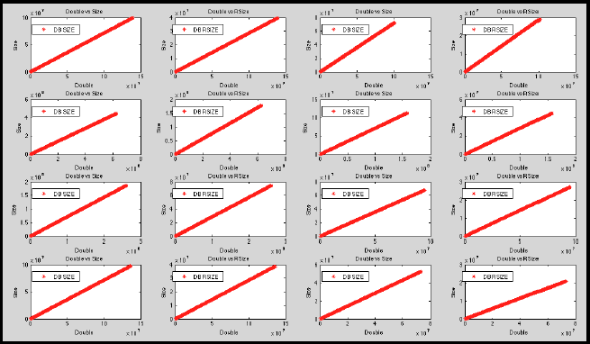
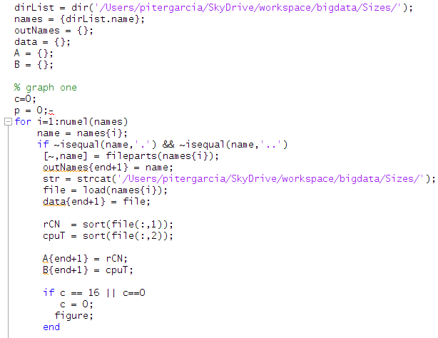
In order to do this, we used the following MATLAB program that we coded specifically for our database, which has been attached to the report.
This part of the code loads all files from the location in dirList into names. Names contains a list of directories, and each one of this contain a list of data sets. In the for loop, each data set is being counted and weighted for comparison purpose. This code is run twice; the first time was ran on the normal database and its result is shown in the first image. The second time, it was ran on the modified database and its result is the second image. As you can observe, the first image has missing directories and datasets; that is how big it was, the software was not able to process it all. The second image has all directories and all datasets of each one, this is because the data is a lot smaller and it has shrink more than 30% of the normal data. The database has now been reduced to a 20 years old data.

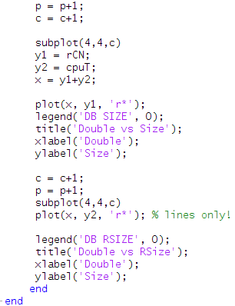
This part of the code plots the size and the dataset number of each directory for comparison purpose. A quick hint to help to understand the image is by carefully looking at each one of the small graphs. If you notice, the small graphs in the first figure have a higher range of those in the second figure.

--Adding Meaningful Attributes
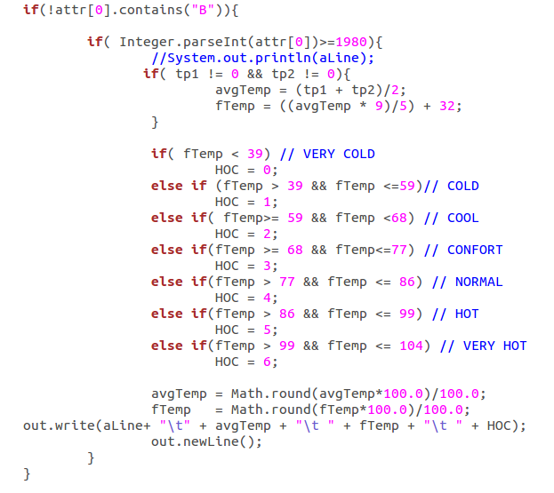
We have also coded a Java program to modify the datasets according to our design. For our design it was necessary to have the average temperature as well as a class that specifies a level of approximation as how cold or hot a place is. This would make it easier for us when applying normalization techniques to make datasets comparison much easier.

This is a snip of the code and it contains the heart of the program. The first part of the program calculates the average temperature of a place. The maximum temperature is tp1 and the minimum temperature is tp2, then the average temperature is avgTemp is calculated by adding the two temperature and dividing it by 2. A very simple arithmetic function. The next step was to convert the actual temperature, as we all know the measurement in which we read the temperature in the USA is Fahrenheit. Therefore, we converted the actual temperature from Celsius to Fahrenheit to be able to make decisions easily without having to convert the value every time we access it. After calculating the average temperature, and converting it from Celsius to Fahrenheit, we proceeded to create a ranking of how cold or hot a place is by analyzing its average temperature. The idea is to predict the weather trends of a place in a given future date, and therefore, the data must be prepared for classification. To facilitate temperature range predictions, we have created a derived attribute from the numeric minimum and maximum temperature attributes. The attribute HOC is derived as follows, by binning records based on which range their maximum and minimum temperatures fall into:

xx to 38 → xx is considered as anything that is below 38F, and it is ranked as Very Cold or HOC = 0.
39 to 58 → Anything between 39 F and 58 F is considered, in our table, as Cold or HOC = 1.
59 to 68 → Anything between 59 F and 68 F is considered, in our table, as Cool or HOC = 2.
69 to 77 → Anything between 69 F and 77 F is considered, in our table, as Comfort or HOC = 3.
78 to 86 → Anything between 78 F and 86 F is considered, in our table, as Normal or HOC = 4.
87 to 99 → Anything between 87 F and 99 F is considered, in our table, as Hot or HOC = 5.
100 to 104 → Anything between 100F and 104F is considered, in our table, as Very Hot or HOC = 6.

This ranking will be very helpful when mining the data because we will not have to be looking at all temperatures and precipitation of the place. Instead, we will only have to check the ranking of this place to be able to give the user an advice in whether they should wear a coat or not.

-Data Cleaning
--Creating an Mean Database
We used R to load all datasets from all directories, which are exactly fifteen. We have extracted the mean value of each dataset for the temperatures obtained from 1980 to 2000. The results are very clear and self-explanatory, which can massively improve the mining algorithms implementation. The program that we have coded to create a mean database is shown below, and it is also attached to this project. Also, we have created a confusion matrix for each one of the cities(directories) datasets to explain how this data representation can highly help during the mining and prediction process of this project.
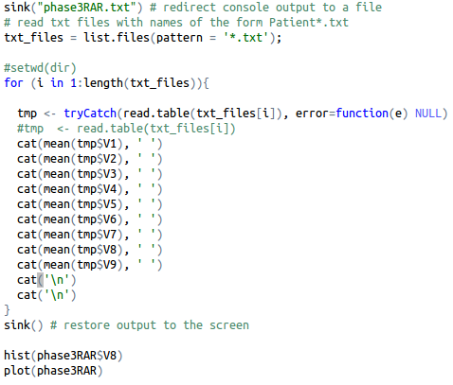
This is the code used to extra the mean values from each dataset in each directory. The variable “txt_files” contains all fifteen directories, the this is used to load the file into tables that R can read and extract the mean values from each one of its columns. There are some values that are not important, such as year and month. We are ignoring those in this case, our focus is in V8 and V9 the mean values of the average temperature and the weather ranking.

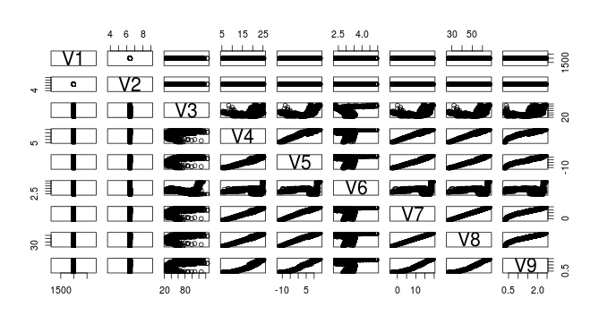
This is the resulting confusion matrix from Alkansas_Red, one of the directories in our database, and the cities corresponding to this. As you can see, most of the weather temperature falls below 60 degrees F. This may not be as clear to you read it because of the way the matrix is sorted. However, we have extracted important values from this matrix and explained below.

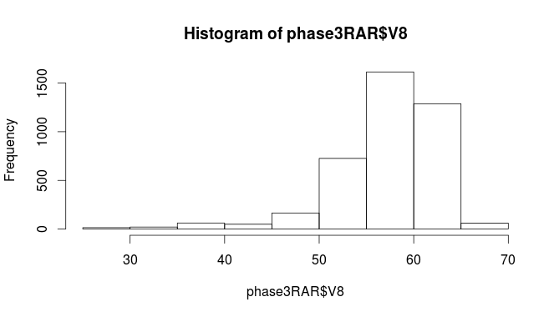
We extracted two important variable from the dataset to analyze directly. These variables are V8 and V9, which are the average temperature and the ranking of the weather of the cities pertaining to the Alkansas_Red directory. Here it is more clear to observe what is going on in Alkansas_Red during the years 1980 to 2000. You can see from 20 years of data, the most frequent temperature in this place is 60. The hardly got 70degrees F! Therefore, do not be surprise if our interface suggest you to wear a coat when planning to travel to this area.
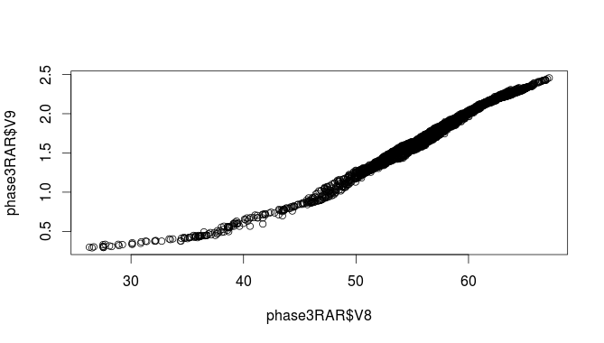
This image explains even better the weather situation in this place. As we observe, Alknsas_Red territory is not actually a bad place to travel to. For the most part is 60degrees F. In winter the lowest it gets is 30, for the most part, and in summer the hottest it gets is 70. However, this is not a place to go to a beach! The weather here, according to our ranking, is for the most part comfortable. Therefore, cloths such as shorts and ten-tops are not recommended for the most part.

We could have done the same analysis on the 15 territories, or directories, that we have in our database. However, we do not think this is necessary since it would take too much space out of our report. The analysis, based on the mean database, is very straight-forward. It avoid unnecessary analysis on our database, we can easily check in our database what probability does this territory has to be cold or hot before applying a more extensive analysis. Below are the images of the 15 territories, or directories, that provide a comparison of their average and ranking temperature.

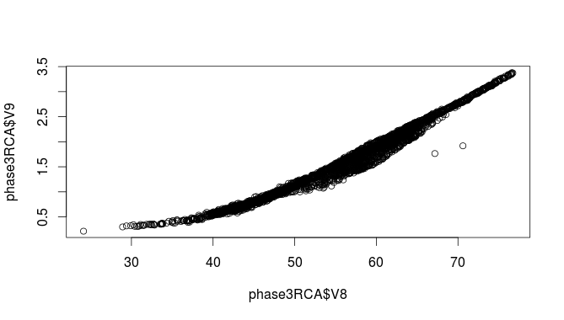
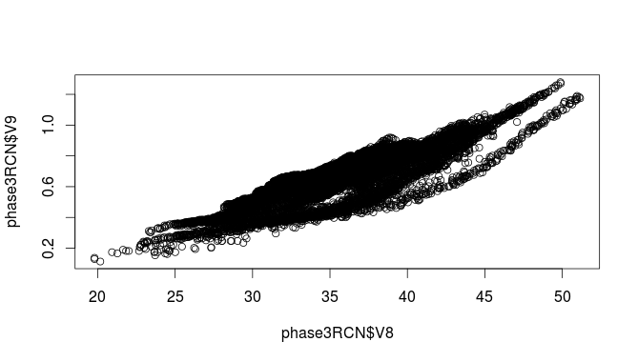
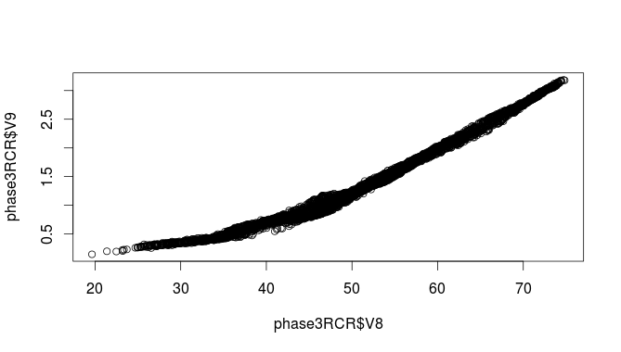
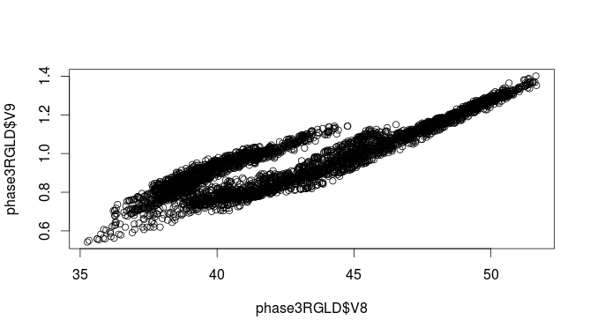
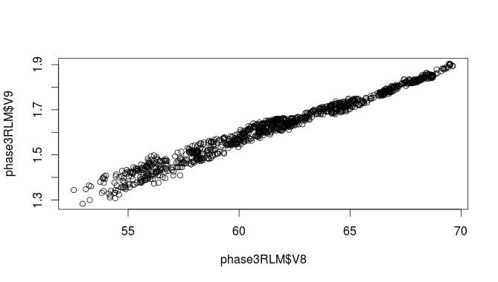
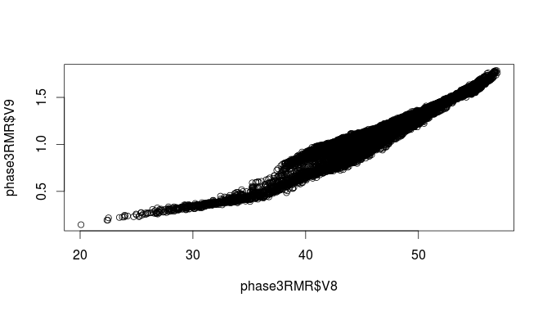
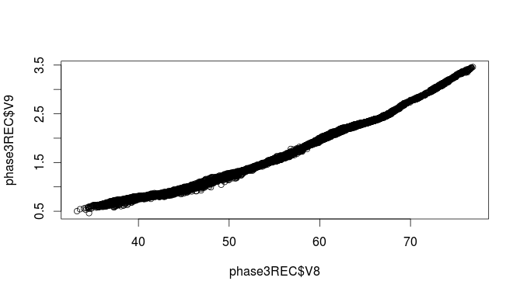

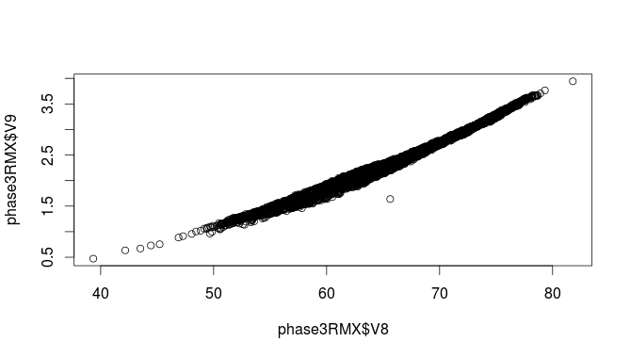
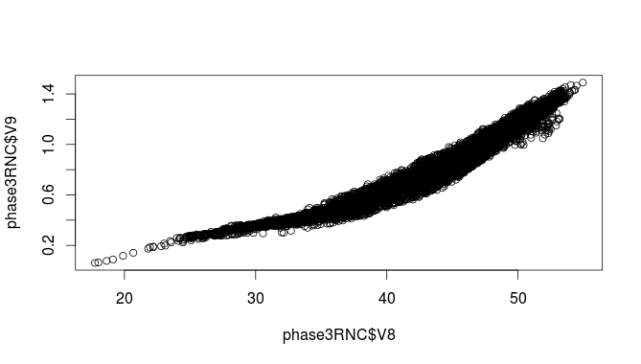
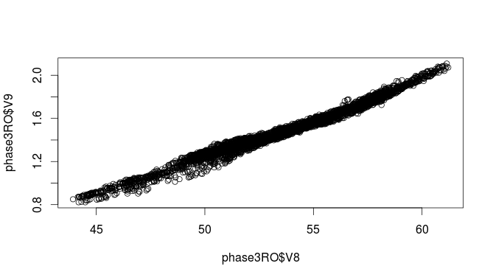

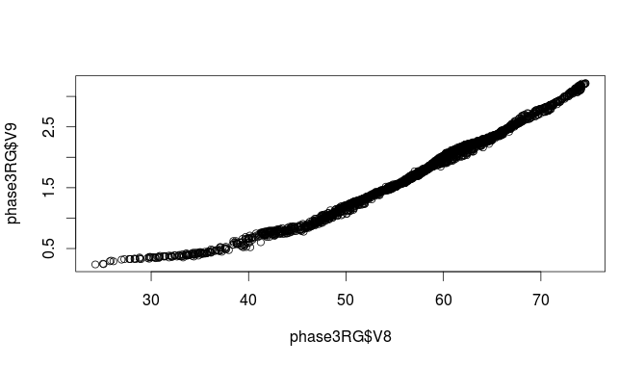
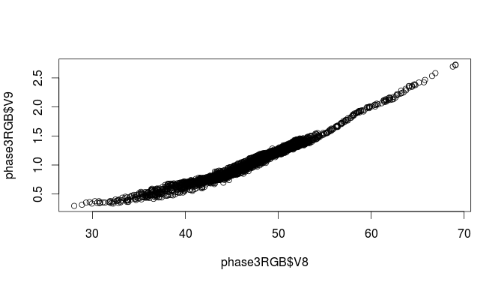

These are the graphs obtained from R that compares the average and ranking temperature of each territory or directory. Each graph represents a territory, or directory, and the weather dataset contains temperature only from 1980 to 2000.

--Creating a Zero-Database

The data was filtered through our Java code to reduce our database to only 20 years worth of weather data in all datasets of each city in our database. We have applied the Z-score technique to our database, but before this, we reduced the amount of data by removing some columns that are not important during the Z-score application process. For this created another database in Matlab with important values from our normal database to apply the Z-score technique. As a result, we created another database based on the results obtained from the important values database after applying the Z-score technique . Finally, we compared results from the normal database, important values database, and Z-score database by comparing the first set of the last territory of each database to make testing easier and more efficient. Below is the program, divided in parts, that we have coded in Matlab, and a detailed description of each part of this code.

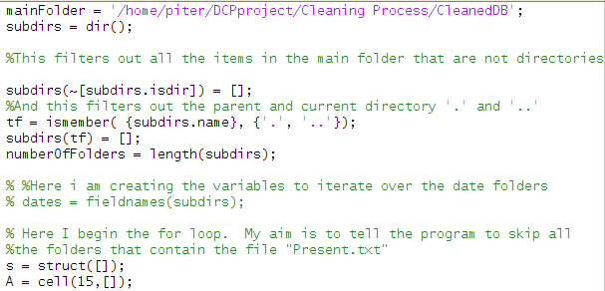
In this part of the code, we are accessing all the sub-directories, or territories, and saving them in the variable “tf.” Then, we count the number of sub-directories and save this in the variable “numberOfFolders” to use in further analysis of this code. This part of the code only focuses in accessing and counting all of the territories in our database.
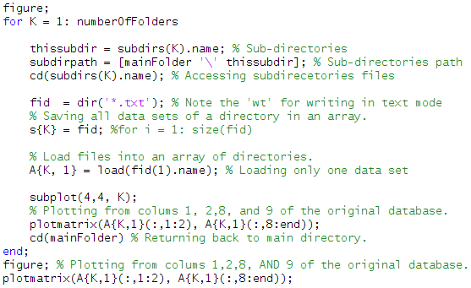
The first loop in this code is to analyze the current data. Remember that the current data in our database is not as dirty as it was before. We have already removed unnecessary data and added important attributes that make our datasets more meaningful in our database to make data analysis and mining easier and faster. In this part of the code we are accessing all sub-directories and, once in the subdirectory, we are accessing all datasets or text files and saving them into the variable “fid.” For our data analysis we only loaded one file, the first dataset, to make the analysis and comparison of the data easier. However, to create the Zero database this code was modified by only adding a loop inside this part of the code. In this way, we load all text files, or datasets, into the variable s and then add this to our list of subdirectories “A.” Inside the loop we plot the first dataset of each sub-directory , for best results and comparison purpose we used the confusion matrix plot from Matlab. Outside the loop we plot the last subdirectory, folder 15, just to better explain users what is exactly happening with the data. Since we put all 15 plots together in one figure, it may be difficult for users to relate to the data, and therefore, we decided to plot one of the sub-directory dataset and explain it in details.

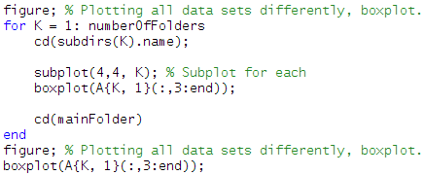
After using the confusion matrix from Matlab, to better analyze the data and to explain its behavior in relation to our interface, we decided to use another plotting type from Matlab. The plot type that we used was the boxplot, and gives a complete different view of the weather data contained in the data sets of multiple territories or directories.
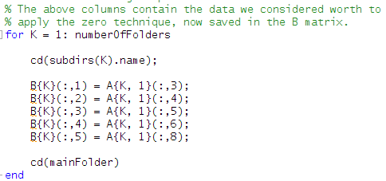
The analysis performed above was only about our normal database, which contains years, month, max and min temperature, precipitation, wind speed, average temperature in Celsius, average temperature in Fahrenheit, and ranking temperature. We came to the conclusion that in order to make a better analysis of this database we need to clean it even more, which means creating another database that contains only the important or meaningful attributes for a deeper analysis of the data. For example, if a user is looking for cloth wearing suggestions to travel to certain place in certain date. If we happen to be in winter, and according to our database deeper analysis this place is cold 95% of the time, there is no point in search and analyzing 20 years worth data. This is why we thought of this and the R database to make suggestions and weather trends prediction faster and easier. The system can easily access this database, to avoid a longer and slower analysis, and have a fast respond on weather this person needs a coat or not. We decided that minimum and maximum temperature, precipitation, wind speed, and average temperature in Fahrenheit were the most important an more meaningful attributes for this database. The way we created this database was through Matlab, by extracting the important attributes from our current database into a new database. This is exactly what this code is doing, is moving columns 3, 4, 5, 6, and 8 from A(our current database) to columns 1, 2, 3, 4, and 5 from B(our new database.)

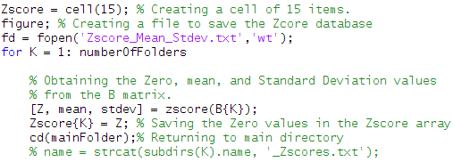
In order to make better use of the weather data provided by our database, it was necessary for us to make some modifications to lead us to a better interpretation of the data. As we explained before, our weather data is based on the year, month, precipitation, max and min temperature, and we have added the average temperature, and temperature scale parameters. These attributes allow us to mine the data faster and more efficient, especially the temperature scale parameters which actually approximates the comfort level of the temperature. Also, we have created two databases, the normal database and the new database, to help improving the data analysis and mining of our system. The next step is to create a Z-score database, Matlab made it easy for us to do this step. Since we had already extracted the most important attributes from our database, it was easy for us to just apply the Z-score method on the new database and save the results on to a third database that contains all the Z-score values of the weather data of all territories or directories of our database. Furthermore, we decided to record the mean and standard deviation values of each dataset along with their Z-score values of the attributes previously mentioned when creating the new database.
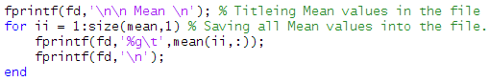
This is the code that we use to record the mean value of each column, or attributes previously mentioned when creating the new database, on each data set contained in each directory or territory.

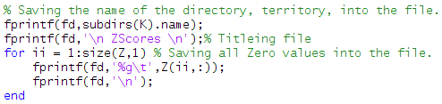
This is the code that we use to record the Z-score value of each row, of all attributes previously mentioned when creating the new database, on each data set contained in each directory or territory.

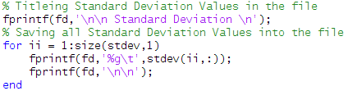
This is the code that we use to record the standard deviation value of each column, or attributes previously mentioned when creating the new database, on each data set contained in each directory or territory.

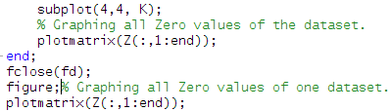
Finally, we proceeded to plot one database of each directory or territory to analysis and comparison purpose. As you can see, just like in the other loops, we have individually plot territory 15 from our Z-score database to help users to relate to the data. We used the confusion matrix plot from Matlab.

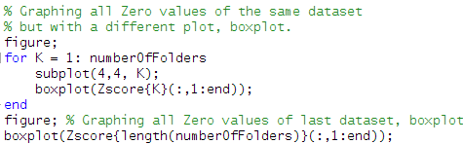
This part of the code was used to graph the data just as in the above code, the only difference is that we are using box plotting instead. This helps us to better understand the analysis from a different point of view.

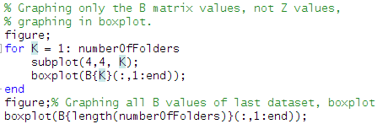
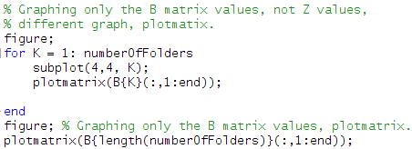
Since we already graphed the normal and Z-score database, we have decided to graph the new database as well. The code you see to the left is the code to graph the first data set of all directories in a box plot from Matlab. In a similar way, the code next to this is to graph the first data set of all directories in the new database. Graphing is very important in this case to make users understand the difference between each database and their importance in our system. Also to help users understand the effect of each technique on each database and our system. We proceeded to compare and analysis each one of these figures in the following manner.

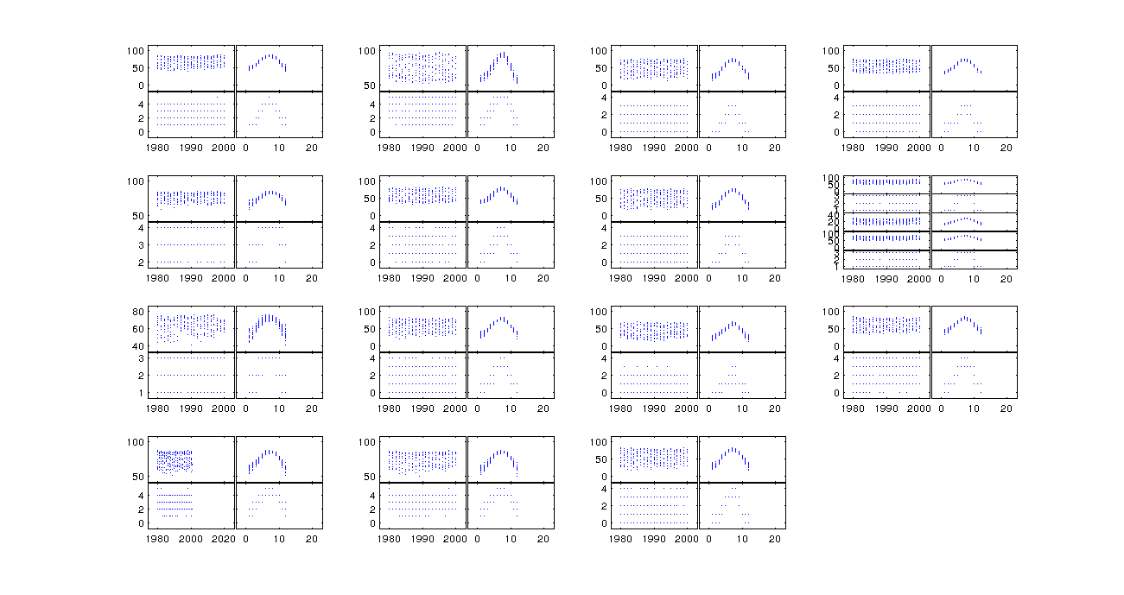
Normal Database Data Analysis

These graphs are a result from some of the code explained above. We are analyzing and comparing each one of the graphs so this way users can have a better understanding of the data, and can relate to each technique and result. We first plotted the first data set from each one of the territory in our normal database, which are 15 directories and as you can see in the image there are 15 plots. The normal database is composed of the year, month, minimum and maximum temperature, precipitation, wind speed, average temperature in Celsius, average temperature in Fahrenheit, and ranking temperature. Nevertheless, we only plotted the year, month, average temperature in Fahrenheit, and the ranking temperature. Since the image in the image above is not to clear we will proceed to explain one of the dataset from the directory 15, which also included in figure above.
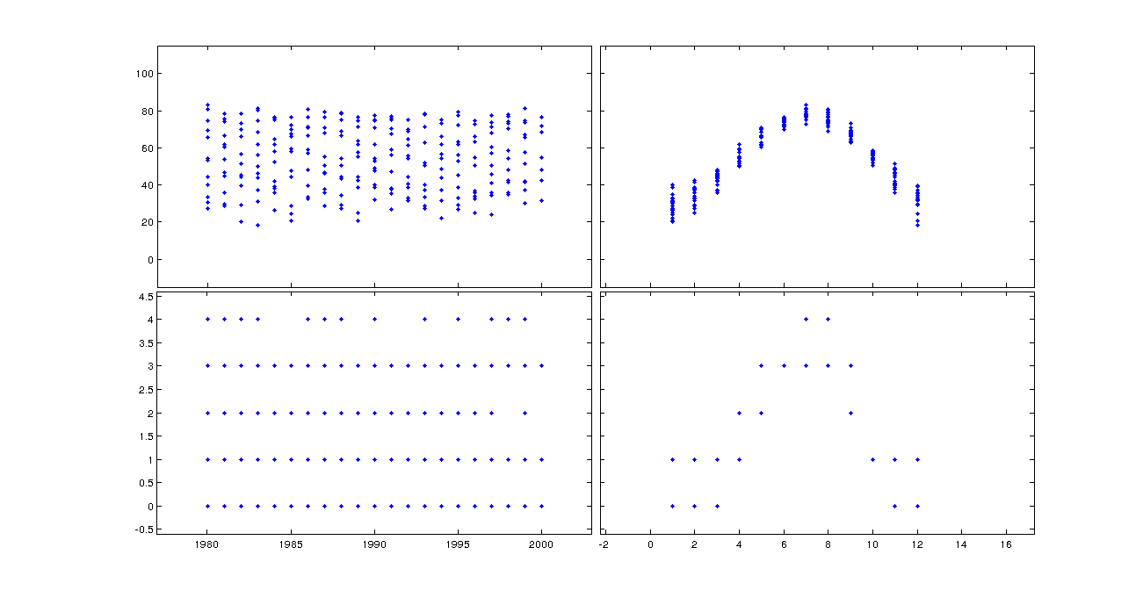

This figure explains better the behavior of the data. During the years of 1980, 1985, 1990, and 2000 the temperature average was of about 80 degrees Fahrenheit. The highest ranking for the years 1984-5, 1989, 1991-2, 1994, 1996 and 2000 was of 3 and for the rest of the years it was 4. This means that out of 20 years this place has reached the level 4th 13 times, which means that this place has on average a normal temperature ranging from 78 and 86 degrees Fahrenheit. The lower block to the right shows the months that have been the hottest. We easily see how from May to August the temperature reaches its hottest, and in this case the hottest is below 86 within the normal temperature. From April to November temperatures reaches a comfortable level the, 3rd level for the most part, ranging from 68 to 77 with the possibility of reaching level 4th . This is all the information we were able to obtain from the normal database, which was easy to predict due to the ranking temperature variable. However, we are hoping that the other implementations, or databases, reduce the data amount and analysis time when mining.
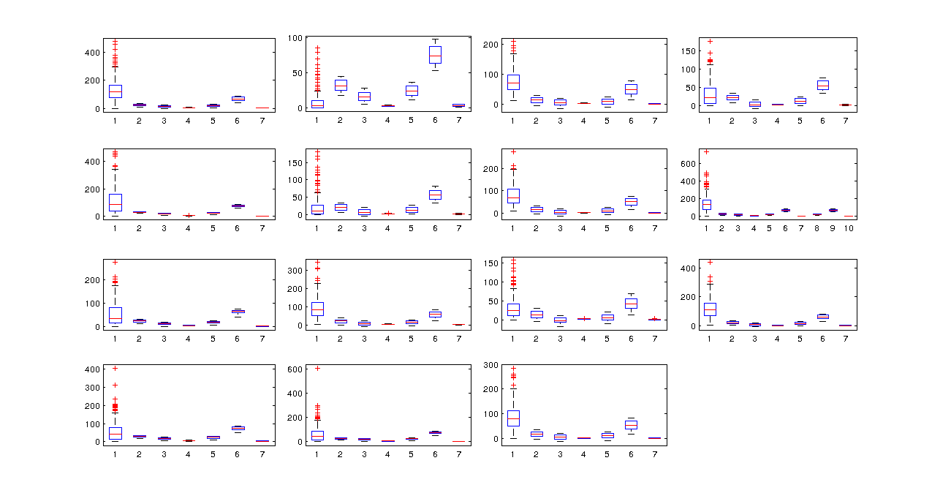
This figure is a different plot, or boxplot, obtained from Matlab. We decided to graph it in this format with the hope of understanding better the data and maybe getting better results. As in the image above, this image contain 15 plots that contains the data weather from the 15 directories or territories in our normal database. A better explanation of the boxplot and weather data is given in the image below, by analyzing one of the plot shown in the current figure.
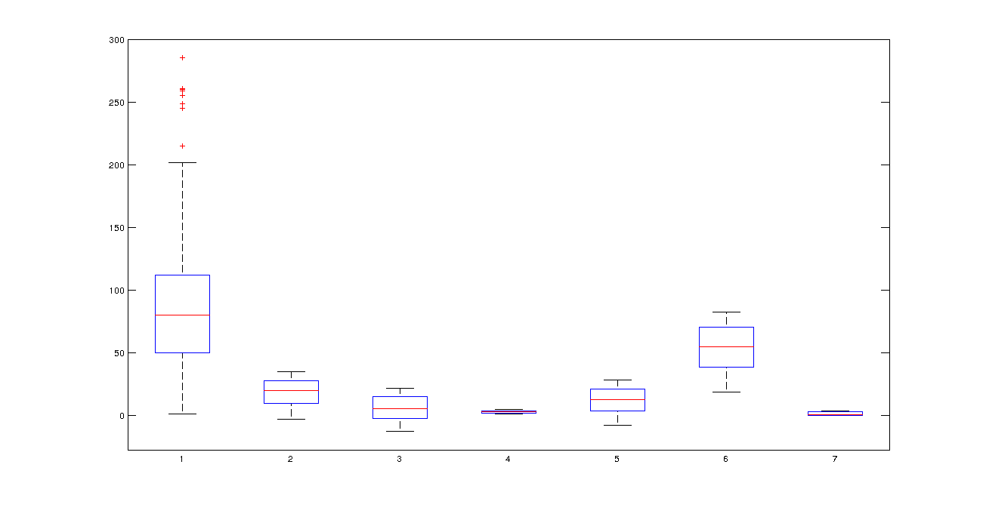

In this plot we are analyzing more data than in the matrixplot. We are analyzing columns 3, 4, 5, 6, 7, 8, and 9, which are minimum and maximum temperature, wind speed, average temperature Celsius and Fahrenheit, and ranking temperature. This is the same dataset as in the matrixplot, first data set from the directory or territory 15. Honestly, I did not like the output from boxplot. However, the answer is understandable since fed the box with too much data. Even though the output is not as informative as in the previous one, we still are able to make some smart assumptions based on the data. The first bucket, which is the one to the left, contains the temperature that this place often phased. The temperature of this place is in normal level, 4th level since it ranges from more than 50 to less than 90 degrees Fahrenheit.

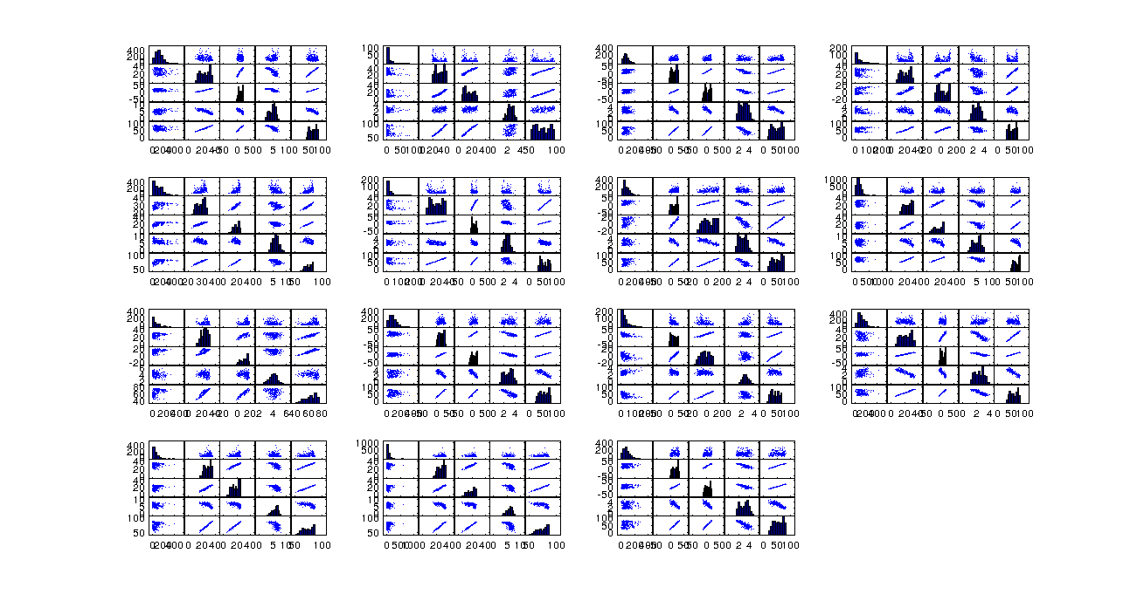
Unique Values Database Data Analysis

The same procedure that was taken to graph a plot of each one of directory in the normal database was taken to graph the plots of the first data set of each territory in the new database. The new database is composed by unique values that are important to our system and could make data analysis and mining easier and faster. These values are minimum and maximum temperature, average, precipitation, wind speed, and average temperature in Fahrenheit. In the same way as the in the previous database analysis, we will explain in detail the analysis of this database by analyzing on of the data set from one of the plots in this figure.
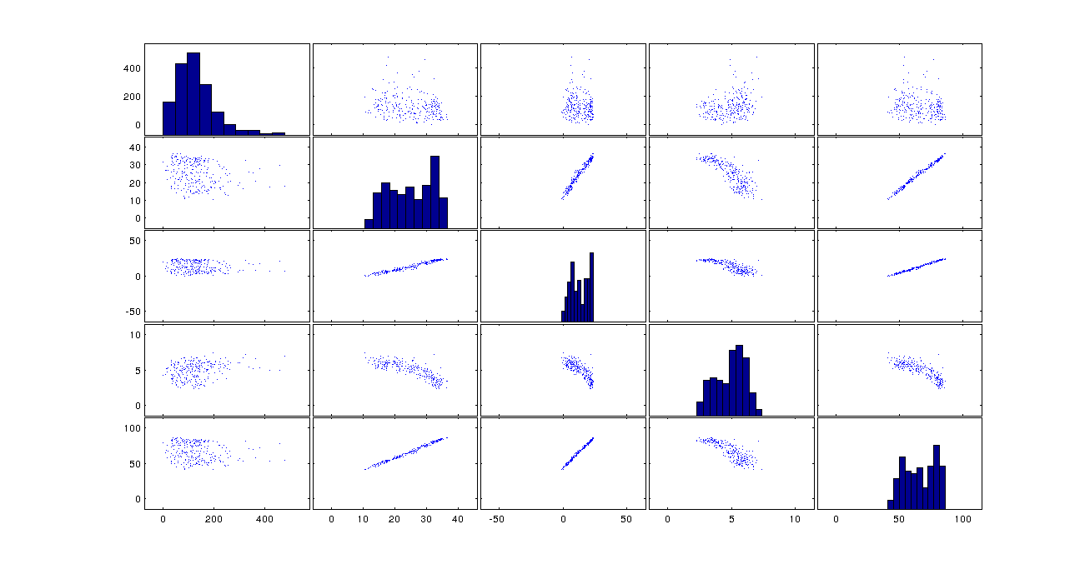
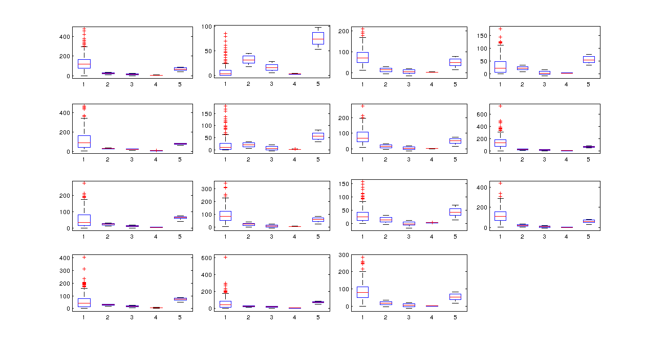
This graph is plotting all of the attributes of the new database, which were mentioned above. Even though this database only contains important attributes of our system, it is not very useful all on its own. From this figure all you can get is that temperatures during those 20 years ranged between about 45 and 85 degrees, everything else is irrelevant and does not add any meaning to the data. The good thing about this database is that makes it easy for to create a Z-score database. Also, this database is of great use when combining with the results obtained in the R-database.
We decided to graph it in this format with the hope of understanding better the data and maybe getting better results. As in the image above, this image contain 15 plots that contains the data weather from the 15 directories or territories in our normal database. A better explanation of the boxplot and weather data is given in the image below, by analyzing one of the plot shown in the current figure.
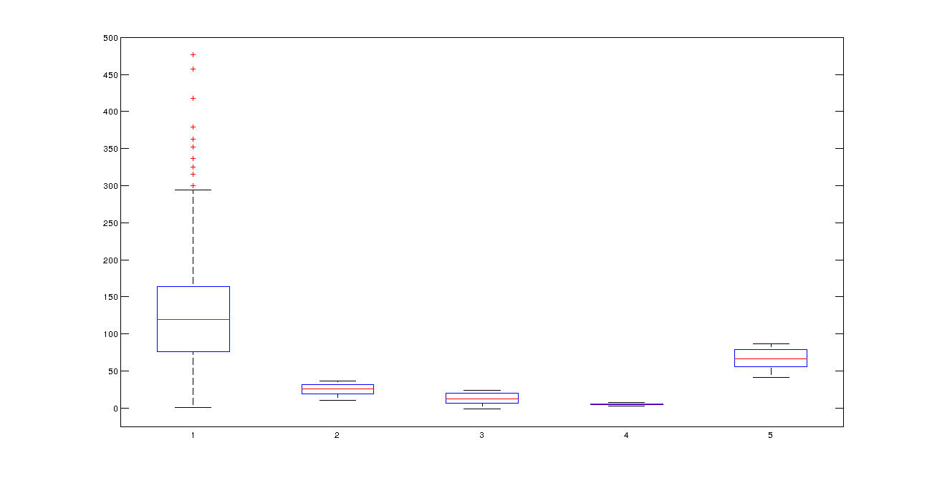
This plot is just as useless as the plot above. We do not get much information from it but the fact that most of the temperature during those 20 years of weather data ranges from 77 to 86, falling within the normal level of temperature in the USA temperature system.

Z-score Database
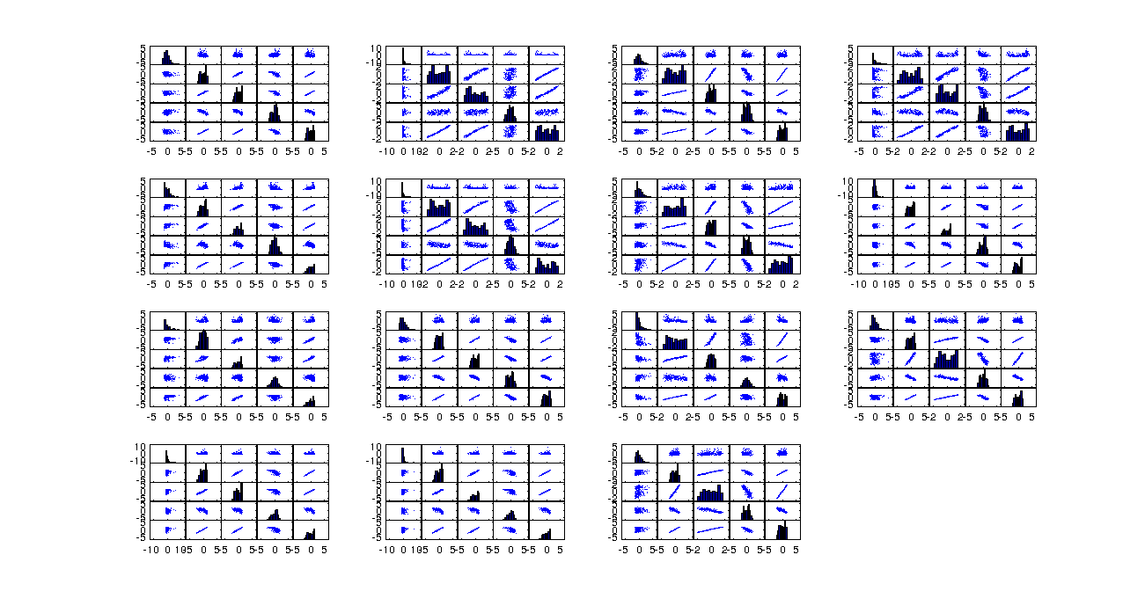
This is the last database that we created, and hoping to get better results than in the new database. The attributes of this database are the same as those mentioned in the new database, or unique values database. The only difference is that we have applied the Z-score method to each one of the attributes, hoping for a better result during data analysis to facilitate data mining. As we mentioned in the other database analysis, a better explanation of the matrix plot is given by choosing one of the data set of from one of the 15 directory plotted in this image.
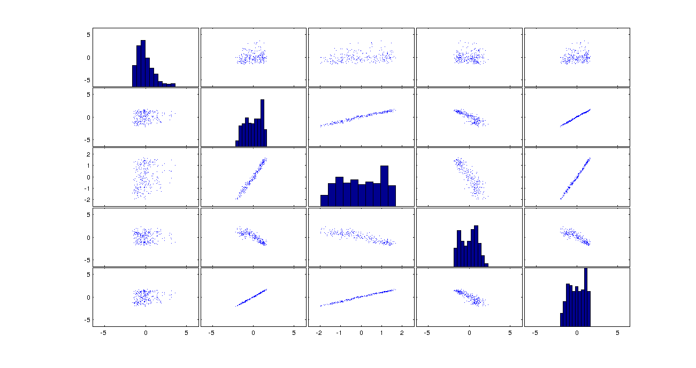

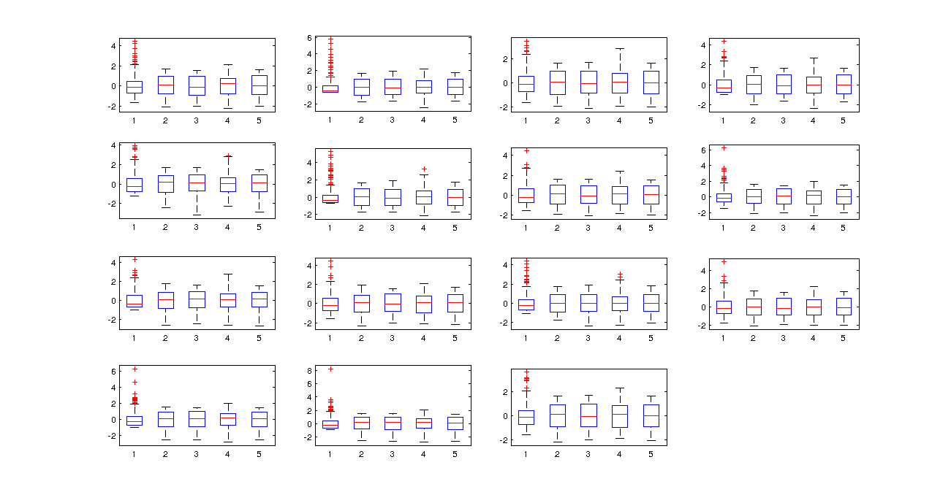
As we can observe in the image the plot has improve a lot. We have reduced the data to its maximum and it is less confusing. It is easier to make assumptions from this plot and use it for analysis purpose. The average temperature can be used as the ranking number that we used, if see the average temperature is below 5, just as we predicted. The max, min, precipitation, and win speed is also centered, which means that this place is with the normal level of the temperature. Z-score can easily explain the behavior of the data set, if in this place it was cold for the most it would show the data distribution on the left side of the scale and opposite if it was hot for the most part. However, since most of the temperature were within the normal level the data distribution of this is centered. This means, if a person were planning to travel in summer to this place I would suggest to wear normal clothing as well as short since 68F – 77F it is a good temperature to wear shorts at least in the afternoon.

We decided to graph it in this format with the hope of understanding better the data and maybe getting better results than that obtain durin the new database analysis. As in the image above, this image contain 15 plots that contains the data weather from the 15 directories or territories in our normal database. A better explanation of the boxplot and weather data is given in the image below, by analyzing one of the plot shown in the current figure.
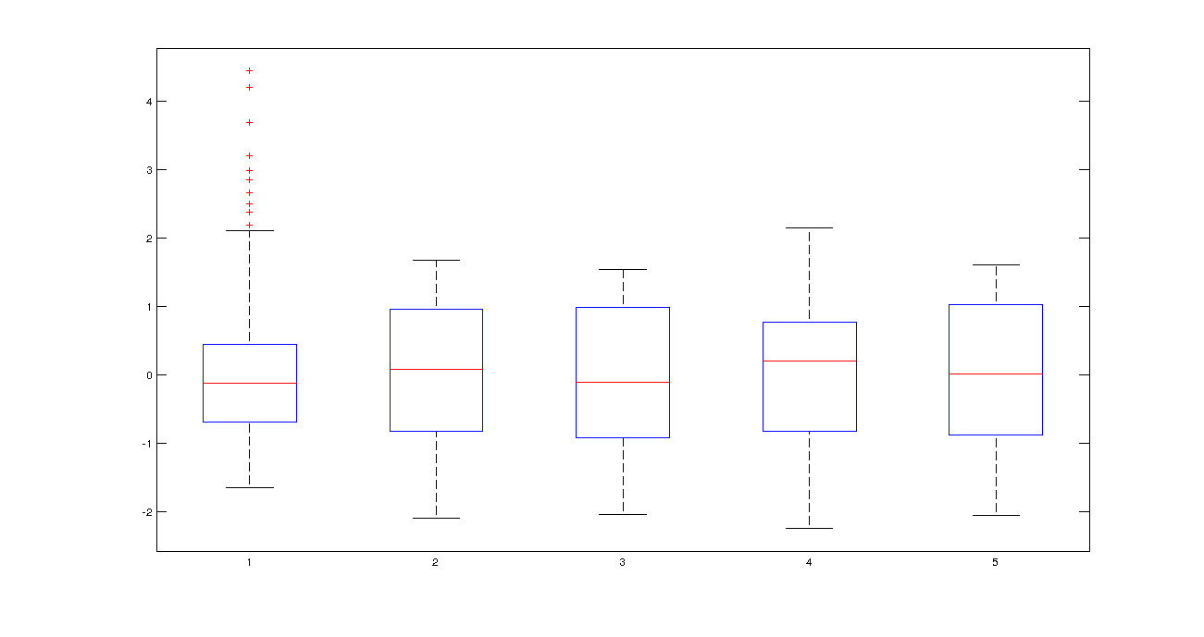

This figure is a lot better that the one obtained in the new database analysis. Here we better observe the behavior of the data. It is easy to see how centered the data is, make assumptions from it. As we can see, most of the temperatures are within the 3rd. This is actually the first analysis in which the boxplot shows better results than the matrixplot, and this is because of the Z-score results. This figure shows how most temperature reaches the 3rd level, but some temperature get to the 4th level or even above but below 5. It also shows how all temperatures are within a normal range, the lines in read, for the most part the weather is within normal temperatures of 68F-77F(comfortable temperature) but it can reach temperatures of 77F-86F(normal temperature) during summer.

As a result, we have created three databases to improve data analysis and mining. It was very clear that our normal database, obtained by cleaning the real database, is of great use the way it is. However, to improve the efficiency of our system we decided to play a bit more with the database and create more databases that could of great use during mining. The new database results are not very helpful by itself, it needs other factors such as the R-database, which contain the mean values of all datasets. On the other hand, the creation the new database made it easy for us to create the Z-score database. The Z-score database can be used along with the new database to avoid further and extensive analysis of the data when suggesting the user what to wear when traveling. Z-score method reduce a lot of the data and summarize in a way that is much easier for a persona and our system to understand when making a decision or prediction.

Interface

The data will be used to predict the weather for future dates by analyzing weather in the past. One way to do this which has been reported in literature is through the use of the k-nearest-neighbor algorithm. The authors used this knowledge discovery technique to predict precipitation levels in the Himalayas[1]. In this paper, the authors compared similar weather situations to predict what the percentage of precipitation would be, given certain conditions. We plan to adapt this approach to predict the range for minimum and maximum temperatures. By comparing historical weather records with current conditions for the predicted record, we hope to be able to determine an accurate range for high and low temperatures.

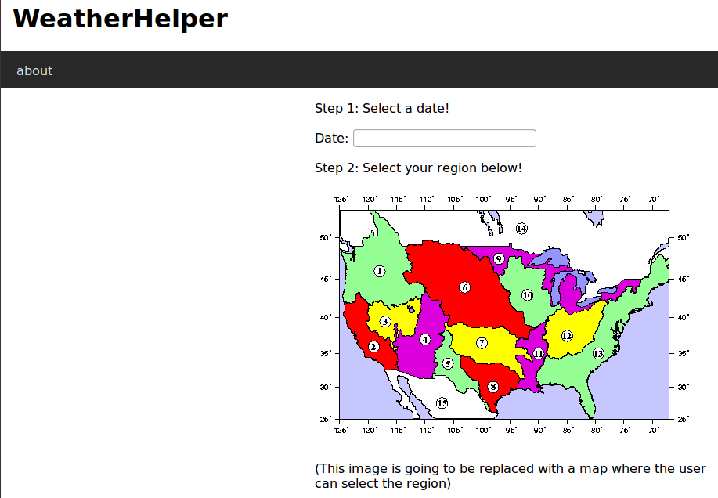
Data Access
Figure 19: Data Access - Interface Development.

In order for users to perform any kind of task, users need to access our system through our website. Once in, we get access to the necessary information, input by the user, to proceed with the search and provide users with a cloth wearing suggestion. DJango easily connects python to our domain in order to process the necessary information for any given query.

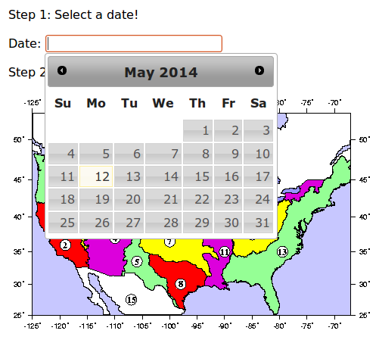
Search
Figure 20: City Search- Interface Development

In this feature we are searching into our database through DJango for a particular city. This is done by entering the city name in DJango, which queries into the database class.

Graph
Figure 21: Weather Graphical Approximation - Interface Development.

The graph is generated through the function that we have built into DJango. This takes take the regression
of the data of each day within a given range. Then, we use the graph with the resulting data using python, and resulting data is an approximation of the weather that the user has selected for traveling purpose, an example of this function is in figure 23.

Suggested List
This has not been implemented in our interface yet. However, our system is design so every time the user searches for a city, this search is being saved by DJango in a separate table. Also, it stores the average temperature of the queried destination. We query into our database using the average temperature to suggest the user with a list of appropriate destinations.

Figure 22: Weather Approximation Function

These components were planned, analyzed, and designed into our system through documentation such as data flow diagrams and others that will guide users to use our system if any issue arises. We have tested our system several times to make sure that our system works and performs the duties it is intended to perform. It was critical to make sure that each application was implemented in accordance with our design and architecture plan to ensure that our system is ready for implementation. In this way, we were able to determine issues, occurred during the implementation process, which affected our system. Overall, we have established an overall development with the best practices to achieve the goal of our system implementation.

LESSONS LEARNED
We learned numerous cleaning and mining techniques while working on this project. We learned a number of ways of preparing our data so that we can easily use it in our application. For example, the data downloaded from the website was raw and faulty, we added average temperature, fahrenheit temperature, and ranking temperature to each data set to make it more meaningful. We also learned how to convert text less into mysql database so as to be able to use in our project.

We learned how to clean a database to make query easy on a huge database. As a result of querying for the weather conditions of a place, we get a number of results by using regression techniques on our database. This provides a single ranking value for each corresponding date that the user is going to be on vacation.

We also learned a few data mining techniques that we were not able to include in our interface because we ran out of time. We are currently able to suggest a few vacation destinations for our users, but in order to provide users with such information we need to make our application more interactive. The suggestions are based on the age, gender and the last search made by the user. Using these variables it is easy to perform data mining, as mentioned above, to search in our database for more destinations that the user may like.

CURRENT STATUS
The current status of our project is being explained through the three main sections that gave place to our project development.

First, we gathered the weather data of a few cities of U.S.A. This data consists of temperature, precipitation and wind speed corresponding to each city from 1980 to 2000. Each city is related to an id, latitude, and longitude.

Second, we developed an interface to provide the user with a GUI to query efficiently on the database. The interface allow the users to search for destinations to vacation in a given range of dates. There is no log on, which allows the user to avoid the whole process of signing in. The users can choose a place from this list, or search for their city of preference to vacation, and the vacation time duration. Then, the application searches for the corresponding weather data of the place and approximate temperature, precipitation, and wind speed of the place to suggest an adequate cloth to wear.

Lastly, the suggested cities, which is not incorporated on interface yet, before and after the user search is done we use a data mining technique known as association rule discovery. In this way, we can provide users with list of suggested cities and make our interface more interactive.

FUTURE WORK

Big Data
More research is needed to improve the ability to blend different datasets, and data sources into integrated systems. As new types, data could be assimilated into different models. Also, it will be important to understand the error characteristics of our current data and our model to come up with modifications that may improve our system. Data assimilation for climate purposes is still in an early stage of development and requires continued research support. As these developments occur, reprocessing of data to take advantage of the new knowledge will be vital if we want to sustain long-term records in the future.

Data Mining
If our weather observations were well-documented, and it contained good metadata about the systems and networks used to make them, it would become more valuable with time. The creation of weather-quality data records is a fundamental objective for our observing system for weather. International standards and procedures for the storage and exchange of metadata need to be developed and implemented for many weather observing system components, including those of the operational satellite community. For this, it will be essential that all such data be properly archived and managed with the full expectation that they will be reused many times over in the future, often as a part of reprocessing or reanalysis activities. Future modifications may require that data be migrated to new media as technology changes, be accessible to users, and be made available with minimal incremental costs. For this, we will need systems for quality control and feedback, proper data archival and access, sustained data preservation, rescue and digitization, and climate data management systems.

CONCLUSION
This project, "What Should I Wear," was prepared in response to avoid traveling unprepared when an unexpected bad weather hits during a vacation trip. The full implementation of the project, over the coming years, will ensure users to have the observational information needed to understand, predict, and manage their response to weather and weather change, over the 21st century and beyond, for vacationing purposes. It will address the commitments of the users to certain places, and support their needs for weather observations in fulfillment of the objectives of their vacation. The database sustains observations of the essential climate variables that are used to make significant progress in the generation of weather analysis and derived information for our project. These observations give an enhanced support to our research, modeling, and analysis for users' s cloth wearing in any event. In fact, these observational records improve weather predictions for short-term traveling, especially vacations. These observations must be sustained into the future to evaluate how the weather is changing so that informed decisions can be made by any user on prevention, mitigation, and strategies when traveling. It is crucial for users to support the further research needed to refine understanding of the approximated weather and its changes. This will allows us to initialize predictions on time scales out to decades ahead, and to develop the models used to make these predictions as well as short-term scenario-based projections.

We made use of Matlab to make analysis of the our databases after reducing it and applying the Z-score method. We use the matrix confusion plot and the box plot to analyze the weather data of each city. The images are only displaying one dataset of each city because the database is too big and a more complex algorithm must be applied to reduce it into a figure, similar to those displayed above. The first couple images are displaying the weather data related only to the average temperature, year and level of comfortability; this is before the Z-score was applied to our database. The second couple of images are displaying only the weather data information such as precipitation, max and min temperature, and average temperature. The last couple of images are displaying the same weather data values as the ones mentioned previously, except that we are applying Z-score in this one. As you can observe, these images say a lot about the these cities in terms of the weather temperature. The original data was hiding important information, as we observe, that can actually help us for the mining and prediction process development.

