Develop a data dictionary for this dataset. For each attribute:
- Determine the data type
- Determine the number of unique values
- Determine the range of numeric values
- Enumerate categorical or ordinal values
e) Note any inconsistencies you see in the dataset
a)
Data Type |  |  |  | The data types found in this dataset are Nominal, Ordinal, Interval and Ratio, as shown in the table to the left.
Not Numeric |  | Numeric
Nominal | Ordinal | Interval | Ratio
Make | Fuel | NormalizedLoss | RiskRating
 | Aspiration | Weelbase | EngSize
 | Doors | Length | Bore
 | Body | Width | Comp.ratio
 | Drive | Hight | HP
 | EngineLoc | Weight | PeakRPM
 | Engine Type | Stroke
 | Cylinder | CityMpg
 | FuelSys | HwyMpg
 |  | Price
b)
Unique Value – Not Numeric |  |  |  | These are the unique values (not numeric). Each value occurs only once in its attribute section, and this is what makes it unique.
Make | Engine Type | Cylinder | FuelSys
mercury | dohcv | three | mfi
 |  | twelve | spfi
Unique Value - Numeric |  |  |  |  |  | These are the unique values. Each value occurs only once in its attribute section, and this is what makes it unique.
NormalizedLoss | Weelbase | HP | Width | Stroke | CityMpg
234.778 | 120.9 | 288 | 60.3 | 2.452 | 45
256 |  | 264

Range - Numeric
NormalizedLoss | Weelbase | Length | Width | Hight | Weight | Stroke | CityMpg
65 to 256 | 86.6 to 120.9 | 141.1 to 208.1 | 60.3 to 72.3 | 47.8 to 59.8 | 1488 to 4066 | 2.07 to 4.17 | 13 to 49
Range - Numeric
RiskRating | EngSize | Bore | Comp.ratio | HP | PeakRPM | HwyMpg | Price
-2 to 3 | 61 to 326 | 2.54 to 3.94 | 7 to 23 | 48 to 288 | 4150 to 6600 | 16 to 54 | 5118 to 45400
c)
d)
Categorical/Nominal – Enumerating all values for Make
MAKE === Confusion Matrix ===
a b c d e f g h i j k l m n o p q r s t u v <-- classified as
0 0 0 0 0 0 0 0 0 0 0 0 0 0 0 0 0 0 0 3 0 0 | a = alfa-romero
0 0 0 0 0 0 0 0 0 0 0 0 0 0 0 0 0 0 0 7 0 0 | b = audi
0 0 0 0 0 0 0 0 0 0 0 0 0 0 0 0 0 0 0 8 0 0 | c = bmw
0 0 0 0 0 0 0 0 0 0 0 0 0 0 0 0 0 0 0 3 0 0 | d = chevrolet
0 0 0 0 0 0 0 0 0 0 0 0 0 0 0 0 0 0 0 9 0 0 | e = dodge
0 0 0 0 0 0 0 0 0 0 0 0 0 0 0 0 0 0 0 13 0 0 | f = honda
0 0 0 0 0 0 0 0 0 0 0 0 0 0 0 0 0 0 0 4 0 0 | g = isuzu
0 0 0 0 0 0 0 0 0 0 0 0 0 0 0 0 0 0 0 3 0 0 | h = jaguar
0 0 0 0 0 0 0 0 0 0 0 0 0 0 0 0 0 0 0 17 0 0 | i = mazda
0 0 0 0 0 0 0 0 0 0 0 0 0 0 0 0 0 0 0 8 0 0 | j = mercedes-benz
0 0 0 0 0 0 0 0 0 0 0 0 0 0 0 0 0 0 0 1 0 0 | k = mercury
0 0 0 0 0 0 0 0 0 0 0 0 0 0 0 0 0 0 0 13 0 0 | l = mitsubishi
0 0 0 0 0 0 0 0 0 0 0 0 0 0 0 0 0 0 0 18 0 0 | m = nissan
0 0 0 0 0 0 0 0 0 0 0 0 0 0 0 0 0 0 0 11 0 0 | n = peugot
0 0 0 0 0 0 0 0 0 0 0 0 0 0 0 0 0 0 0 7 0 0 | o = plymouth
0 0 0 0 0 0 0 0 0 0 0 0 0 0 0 0 0 0 0 5 0 0 | p = porsche
0 0 0 0 0 0 0 0 0 0 0 0 0 0 0 0 0 0 0 2 0 0 | q = renault
0 0 0 0 0 0 0 0 0 0 0 0 0 0 0 0 0 0 0 6 0 0 | r = saab
0 0 0 0 0 0 0 0 0 0 0 0 0 0 0 0 0 0 0 12 0 0 | s = subaru
0 0 0 0 0 0 0 0 0 0 0 0 0 0 0 0 0 0 0 32 0 0 | t = toyota
0 0 0 0 0 0 0 0 0 0 0 0 0 0 0 0 0 0 0 12 0 0 | u = volkswagen
0 0 0 0 0 0 0 0 0 0 0 0 0 0 0 0 0 0 0 11 0 0 | v = volvo

Ordinal – Enumerating all values for all cardinal attributes
ENGINELOC
=== Confusion Matrix
a b <-- classified as
202 0 | a = front
3 0 | b = rear

DOOR
=== Confusion Matrix
a b <-- classified as
0 89 | a = two
0 114 | b = four

FUEL
=== Confusion Matrix
a b <-- classified as
185 0 | a = gas
20 0 | b = diesel
ASPIRATIONS
=== Confusion Matrix
a b <-- classified as
168 0 | a = std
37 0 | b = turbo

DRIVE
=== Confusion Matrix =
a b c <-- classified as
0 76 0 | a = rwd
0 120 0 | b = fwd
0 9 0 | c = 4wd

BODY
=== Confusion Matrix ===
a b c d e <-- classified as
0 0 6 0 0 | a = convertible
0 0 70 0 0 | b = hatchback
0 0 96 0 0 | c = sedan
0 0 25 0 0 | d = wagon
0 0 8 0 0 | e = hardtop

CYLINDER
=== Confusion Matrix ===
a b c d e f g <-- classified as
159 0 0 0 0 0 0 | a = four
24 0 0 0 0 0 0 | b = six
11 0 0 0 0 0 0 | c = five
1 0 0 0 0 0 0 | d = three
1 0 0 0 0 0 0 | e = twelve
4 0 0 0 0 0 0 | f = two
5 0 0 0 0 0 0 | g = eight

ENGINETYPE
=== Confusion Matrix ===
a b c d e f g <-- classified as
0 0 12 0 0 0 0 | a = dohc
0 0 13 0 0 0 0 | b = ohcv
0 0 148 0 0 0 0 | c = ohc
0 0 12 0 0 0 0 | d = l
0 0 4 0 0 0 0 | e = rotor
0 0 15 0 0 0 0 | f = ohcf
0 0 1 0 0 0 0 | g = dohcv

FUELSYS
=== Confusion Matrix ===
a b c d e f g h <-- classified as
94 0 0 0 0 0 0 0 | a = mpfi
66 0 0 0 0 0 0 0 | b = 2bbl
1 0 0 0 0 0 0 0 | c = mfi
11 0 0 0 0 0 0 0 | d = 1bbl
1 0 0 0 0 0 0 0 | e = spfi
3 0 0 0 0 0 0 0 | f = 4bbl
20 0 0 0 0 0 0 0 | g = idi
9 0 0 0 0 0 0 0 | h = spdi

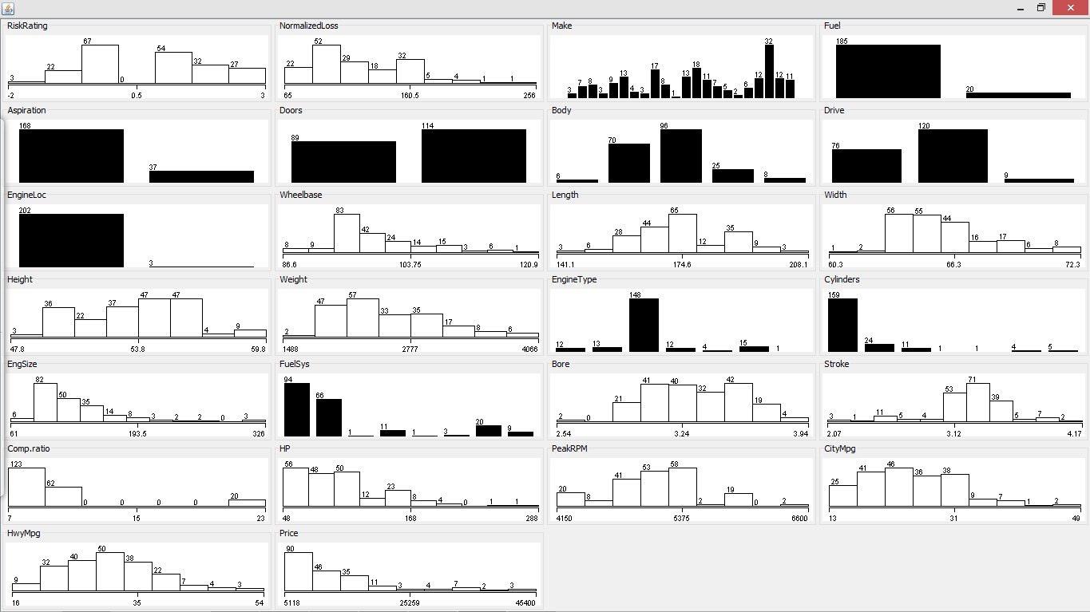
e)
Inconsistencies
 | RiskRating | Bore | Stroke | HP | PeakRPM | Price
Unknown Value (?) | 41 | 4 | 4 | 2 | 2 | 4
Ignored Class | 41 | 4 | 4 | 2 | 2 | 4

The inconsistencies that I found in the dataset was the fact that some attributes, such as those shown above, have values that are unknown, such as “?.” This symbol cannot be identified as any of the data type found in the dataset, and therefore it causes issues when processing the data. The table above shows the attributes that contain this symbol, and the number of time that is being repeated in that column. If you observe the output generated below, this values were ignored because they do not add any information to the dataset.

RISKRATING
=== Evaluation on training set ===
=== Summary ===

Correlation coefficient 0
Mean absolute error 29.122
Root mean squared error 35.3339
Relative absolute error 100 %
Root relative squared error 100 %
Total Number of Instances 64
Ignored Class Unknown Instances 41

BORE
Correlation coefficient 0
Mean absolute error 0.2358
Root mean squared error 0.2729
Relative absolute error 100%
Root relative squared error 100 %
Total Number of Instances 201
Ignored Class Unknown Instances 4

STROKE
Correlation coefficient 0
Mean absolute error 0.2318
Root mean squared error 0.3159
Relative absolute error 100 %
Root relative squared error 100 %
Total Number of Instances 201
Ignored Class Unknown Instances 4

HP
=== Evaluation on training set ===
=== Summary ===

Correlation coefficient 0
Mean absolute error 30.5049
Root mean squared error 39.6164
Relative absolute error 100 %
Root relative squared error 100 %
Total Number of Instances 203
Ignored Class Unknown Instances 2

PEAKRPM
Correlation coefficient 0
Mean absolute error 385.8283
Root mean squared error 478.1525
Relative absolute error 100 %
Root relative squared error 100 %
Total Number of Instances 203
Ignored Class Unknown Instances 2

PRICE
Correlation coefficient 0
Mean absolute error 5841.1883
Root mean squared error 7927.2729
Relative absolute error 100 %
Root relative squared error 100 %
Total Number of Instances 201
Ignored Class Unknown Instances 4

