1. Using the following data, construct a histogram of sandwich size in grams
Size in grams
100
279
147
263
269
459
164
273
114
214
209
246
294
147
189
244
165
206
226
249
352
149
190
284
169
220
229
118
376
121
250
190
198
143
260
125
434
133
311
122
Bin | Frequency | Cumulative % | Bin | Frequency | Cumulative %
100 | 1 | 2.50% | 279.5 | 12 | 30.00%
159.8333333 | 10 | 27.50% | 159.8333333 | 10 | 55.00%
219.6666667 | 10 | 52.50% | 219.6666667 | 10 | 80.00%
279.5 | 12 | 82.50% | 339.3333333 | 3 | 87.50%
339.3333333 | 3 | 90.00% | 399.1666667 | 2 | 92.50%
399.1666667 | 2 | 95.00% | More | 2 | 97.50%
More | 2 | 100.00% | 100 | 1 | 100.00%

2. Average heights in a kindergarten class were 40” with a standard deviation of 2”. All students with heights from 38” to 46” are considered to be within the national average.
a. If the heights are approximately normally distributed and 14 students are within the national average range, how many students in the class are shorter or taller than the national average?
None of the students are taller than the national average, as the average is 40.
(1/2)(14) = 7 students
b. What is the probability that a student is taller than 44”?
The probability that a student is taller than 44 is (44 – 40)/2 = 2 -> probability is 95.4%
95.4%
c. What is the probability that a student is shorter than 37”?
The probability that a student is shorter than 37 is (37-40)/2 = -1.5 -> probability is less than 90%
Less than 90%

Mean 40
Std Dev 2
National Average 38-46
Hights are approximately normally distributed
14 students are within the 38-46 national average range
3. The following are the average sulfur dioxide emissions from two different power plants in the Finger Lakes NY area (in average tons per day) for 14 months. For example, Plant 1 in month 1 averaged 10.6 tons per day.
Analyze the data and generate an appropriate graphical representation.
Plant 1 | Plant 2
10.6 | 23.3
12.2 | 25.3
23.6 | 25.6
12.6 | 29.7
16.9 | 24
22.8 | 15.9
13.7 | 19.5
14.3 | 26.7
14.3 | 14.8
17.7 | 25.5
10.9 | 32.1
13.5 | 30.9
14.7 | 25
17.1 | 14.7
Column1
Mean | 15.35
Standard Error | 1.056572834
Median | 14.3
Mode | 14.3
Standard Deviation | 3.95333355
Sample Variance | 15.62884615
Kurtosis | 0.586668838
Skewness | 1.069484148
Range | 13
Minimum | 10.6
Maximum | 23.6
Sum | 214.9
Count | 14
Largest(1) | 23.6
Smallest(1) | 10.6
Confidence Level(95.0%) | 2.282586834

Bin | Frequency | Cumulative % | Bin | Frequency | Cumulative %
14.7 | 1 | 7.69% | 26.3 | 5 | 38.46%
20.5 | 3 | 30.77% | More | 4 | 69.23%
26.3 | 5 | 69.23% | 20.5 | 3 | 92.31%
More | 4 | 100.00% | 14.7 | 1 | 100.00%

Bin | Frequency | Cumulative % | Bin | Frequency | Cumulative %
0.9 | 1 | 7.69% | 15.13333 | 7 | 53.85%
15.13333 | 7 | 61.54% | 19.36667 | 3 | 76.92%
19.36667 | 3 | 84.62% | More | 2 | 92.31%
More | 2 | 100.00% | 10.9 | 1 | 100.00%
 |  | 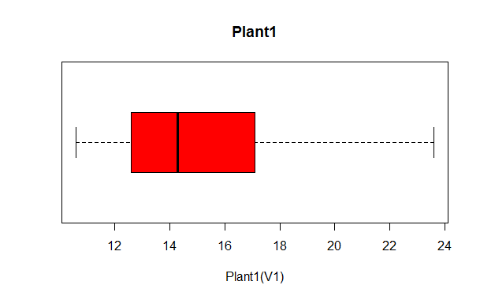
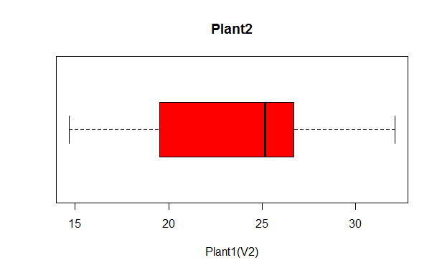
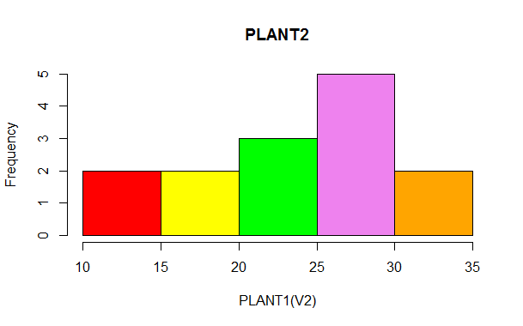
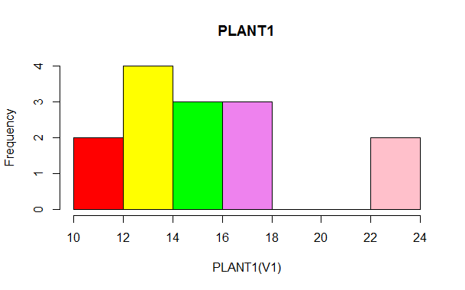
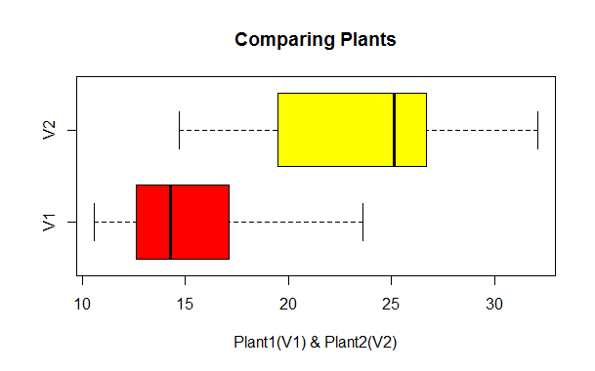

Column1
Mean | 23.78571429
Standard Error | 1.514285714
Median | 25.15
Mode | #N/A
Standard Deviation | 5.665938329
Sample Variance | 32.10285714
Kurtosis | -0.72966105
Skewness | -0.42531661
Range | 17.4
Minimum | 14.7
Maximum | 32.1
Sum | 333
Count | 14
Largest(1) | 32.1
Smallest(1) | 14.7
Confidence Level(95.0%) | 3.271415394

4. This data represents an actuarial study of age at retirement vs. length of life. The study was based on the number of pension checks sent to retirees of Boeing Aerospace.
Graph this data and put in a trendline. What do you notice about the graph?
Based on the graph below I am able to observe that the younger you retire the longer you live, that is according to the graph/data. You can see that the trend of those that retired between 55 to 60 years old and those that retired after 60 is about 20 years of different. That is the amount of years that those who retired late lost.
Age at Retirement | Average age at Death | Trend
55.1 | 83.2 | 28.1
56.4 | 82.5 | 26.1
57.2 | 81.4 | 24.2
`58.3 | 80 | 21.7
59.2 | 78.5 | 19.3
60.1 | 76.8 | 16.7
61 | 74.5 | 13.5
62.1 | 71.8 | 9.7
63.1 | 69.3 | 6.2
64.1 | 67.9 | 3.8
65.2 | 66.8 | 1.6

5. Given this dataset, analyze snowfall for these cities. Which one gets more snow?

Albany
mean 54.0513 84.951 60.8661
std. dev. 16.8072 13.7691 13.7992

Binghamton
mean 76.672 115.4078 79.4789
std. dev. 12.5609 9.0776 10.0523

Buffalo
mean 78.1535 118.2002 106.4025
std. dev. 20.2374 19.5054 26.6908

Rochester
mean 72.557 131.3117 108.5862
std. dev. 13.6591 15.2297 14.7562

Syracuse
mean 99.4286 156.815 130.21
std. dev. 18.086 20.5699 17.5711

Clustered Instances
0 38 ( 55%)
1 14 ( 20%)
2 17 ( 25%)

As we can observe in the graphs and analysis, the city the gets snow the most is Syracuse.

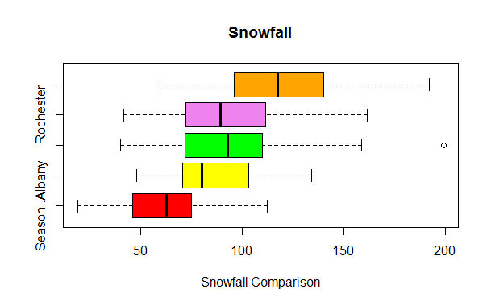
6. An instructor misplaced his exams after correcting them. There were 8 total exams. The low grade was 50. The high was 100. The mode grade was 78 (for three students). The median for the grades was 83. He remembers that two students had grades in the 90's. What is the missing grade? Explain how you arrived at your answer.
Syracuse
Column1
Mean | 81.5
Standard Error | 5.274602
Median | 83
Mode | 78
Standard Deviation | 14.91883
Sample Variance | 222.5714
Kurtosis | 2.812656
Skewness | -1.35091
Range | 50
Minimum | 50
Maximum | 100
Sum | 652
Count | 8
Largest(1) | 100
Smallest(1) | 50
Confidence Level (95.0%) | 12.47245
Answer
78
78
78
88
90
90
100
The grade missing is 88, I was able to obtain this value by using the formula in excel so the value of the median is the same as the one provided (83). The value that gave me the exact result was 88.

7. My home in Buffalo is approximately 72 miles away from RIT. The table below shows travel times for 20 trips back and forth.
a. What is the mean travel time?
b. What is the standard deviation?
c. Find the 95% confidence interval for the mean

Bin | Frequency | Cumulative % | Bin | Frequency | Cumulative %
58 | 1 | 5.26% | 89 | 6 | 31.58%
73.5 | 5 | 31.58% | 104.5 | 6 | 63.16%
89 | 6 | 63.16% | 73.5 | 5 | 89.47%
104.5 | 6 | 94.74% | 58 | 1 | 94.74%
More | 1 | 100.00% | More | 1 | 100.00%
d. I think my daughter has pinkeye. The only appointment slot open at the doctor's office is for 3 p.m. I leave my office at 1:45. What is the probability that I can make it by 3 p.m.? (Consider the travel time between my house and the doctor’s office to be negligible)
Column1
Mean | 83.1
Standard Error | 3.475402
Median | 83
Mode | 82
Standard Deviation | 15.54247
Sample Variance | 241.5684
Kurtosis | 0.117622
Skewness | 0.343987
Range | 62
Minimum | 58
Maximum | 120
Sum | 1662
Count | 20
Largest(1) | 120
Smallest(1) | 58
Confidence Level(95.0%) | 7.274101

In order to make you need to get there in <= 75mins
Based on the graph provided, the probability for you to make it in 73.5 is of 36.58%
This means that you have more than 37% to make it in 75mins.
8. Suppose the actual amount of instant coffee that a filling machine puts into 6-ounce jars is a normally distributed random variable with a standard deviation of 0.06 ounces. If we want no more than 3% of jars to contain more than six ounces, what should be the mean fill of the jars?

The purpose is to have 3%, or less, of jars to contain no more than six ounces.
The coffee is normally distributed.
Therefore, 3% of the jars should contain 3% of the original mean.
- Mean = [1/(3%jars)](Total)
- 3%Mean = (1/Jars)(Total)
3% of the mean.

9. This table contains data on the effectiveness of three spam detection algorithms.
Analyze the data to see which algorithm seems to work best

FPR Graph – Analysis
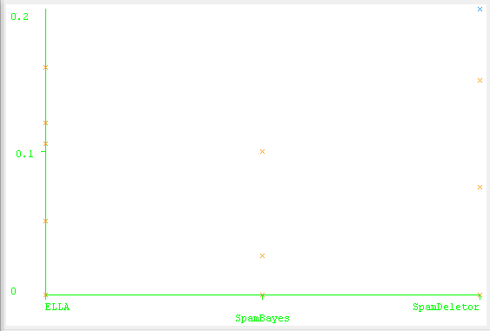
FNR Graph – Analysis
As we can observe in the graphs, SpamBayes is more effective based on the results. It has less false positive response than the others, more false “negative” response, more “TRUE” POSITIVE response, and less true negative response.
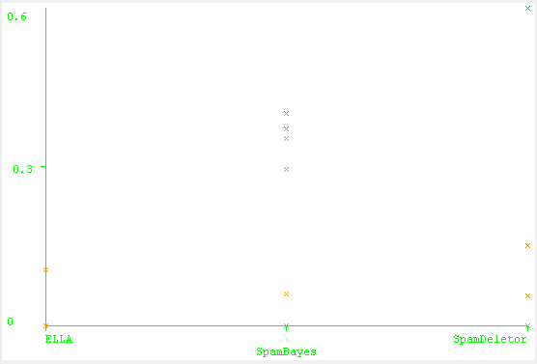
TPR Graph – Analysis
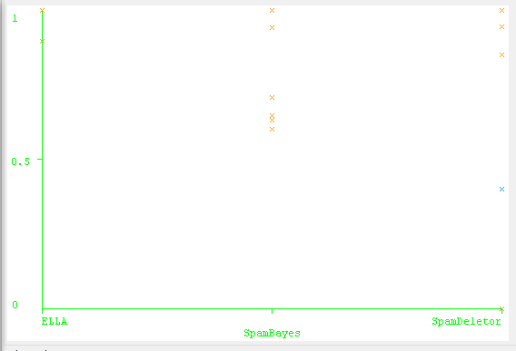
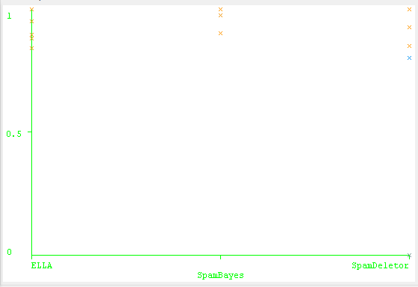
TNR Graph - Analysis

