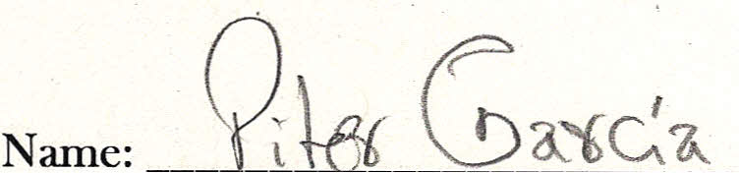
ID#: _

Job Title:
Job #: _________________________

Address |  | Instr. | Data |  | Bytes | Label | Mnemonic |  | Comment

This acknowledges that the complaint of
Piter Garcia
has been submitted to the:

New York Office
U.S. Department of Education
32 Old Slip, 26th Floor
New York, NY 10005-2500
Phone: | 646-428-3900 | Fax: | 646-428-3843
TDD: | 877-521-2172 | Email: | OCR.NewYork@ed.gov

