How to run Microsoft’s Common Language Runtime (CLR) protocol

- Create a new project from the File menu.
- Choose to create a CLR project and then select the Windows Form Application as shown below:
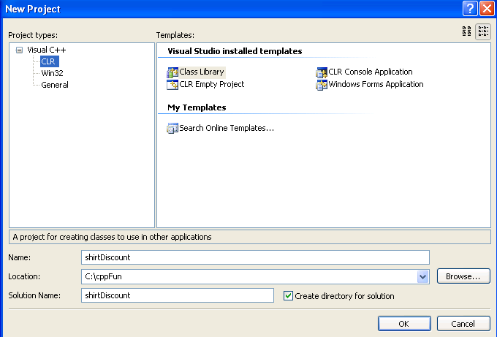
- Be sure to save your project to a location that you know. Click OK.
- Your screen should look similar to the following:
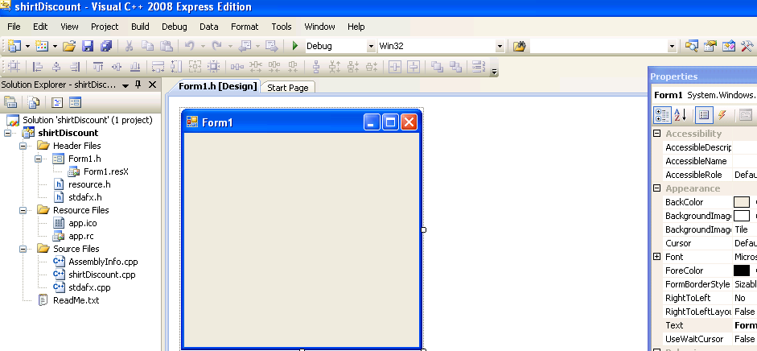
- You will want to have the Toolbox and the Properties Window appear on your screen. If they do not appear, go to the View menu and click on Toolbox. To display the Properties window you may have to click on Other Windows and then click Properties Window.
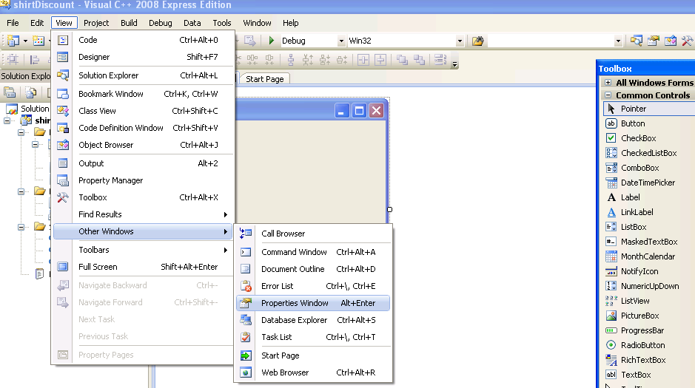
- You are now ready to add Common Controls from the Toolbox to your form. For this exercise you will need to use Labels, TextBoxes and Buttons. Double click on the label tool and it will appear on the form.
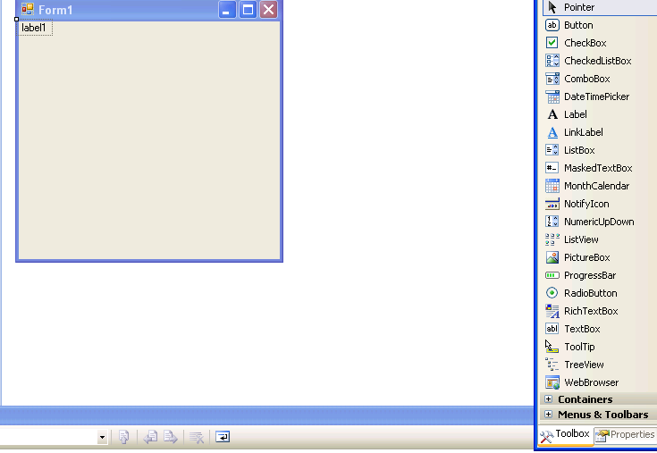
- You should drag label1 to the location you want it to be placed on the screen.
- With the label1 figure selected, switch to the properties window so that you can change the properties for label1. Find the text property and change it to read: Number of Shirts.
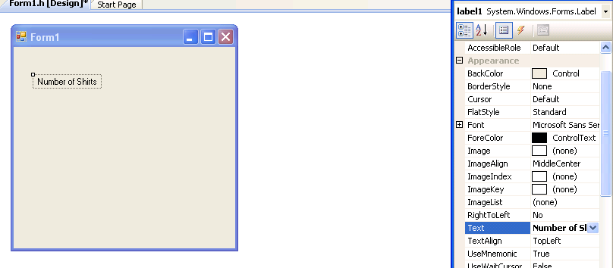
- You can now double click on the TextBox tool and drag it down under the label. The default name for this box is TextBox1.
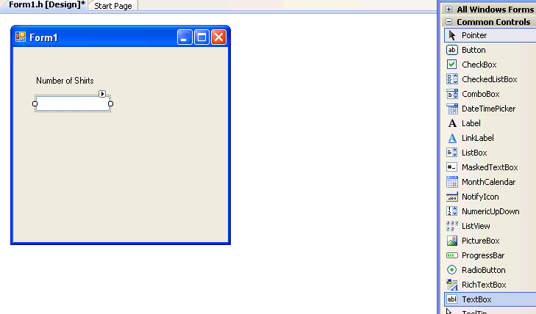
- You will be able to enter the number of shirts you have bought. Here is the problem that needs to be solved:
The local t-shirt shop sells shirts that retail for $12. Quantity discounts are given as follows:
Number of Shirts Discount
5 – 10 10%
11- 20 15%
21- 30 20%
31 or more 25%
Your program will display the discount to be applied, the cost per shirt and the total cost. Here is how the interface should look:
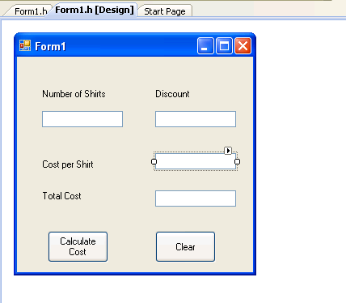
- The Calculate Cost is a button where I have replaced the text with the words Calculate Cost. The default name is button1. You will double click on this button and you will be able to enter the code to determine the cost. I will provide you with most of the code and you will have to code the if statement and the assignment statements.
Here is where the code will go:
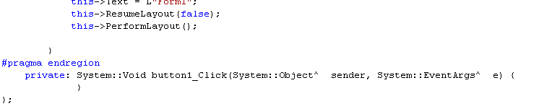
Hit an Enter and put in the following code:
private: System::Void button1_Click(System::Object^ sender, System::EventArgs^ e)
{
int num_shirts;
double discount;
double cost_of_shirt = 12;
double discounted_cost_of_shirt;
double total_cost;
Int32::TryParse(textBox1->Text, num_shirts);
// Here is where your if statement must go. It
// will determine the discount percentage
discounted_cost_of_shirt = //Fill in the formula
total_cost = //Fill in the formula
textBox2->Text = discount.ToString() + "%";
textBox3->Text = discounted_cost_of_shirt.ToString(“C”);
textBox4->Text = total_cost.ToString(“C”);

Here is the code for the Clear button (button2):
private: System::Void button2_Click(System::Object^ sender, System::EventArgs^ e) {
textBox1->Text = " ";
textBox2->Text = " ";
textBox3->Text = " ";
textBox4->Text = " ";
- Here is what the output looks like:
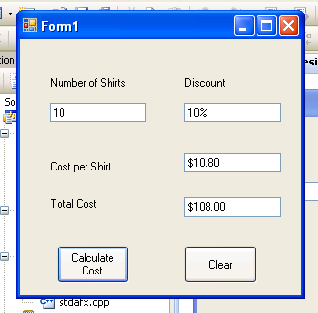
- You can right justify the numbers by setting the TextAlign property to right.
- In order to submit the solution, right click the project folder and use winzip to zip the project. Attach the zipped file to your angel assignment.
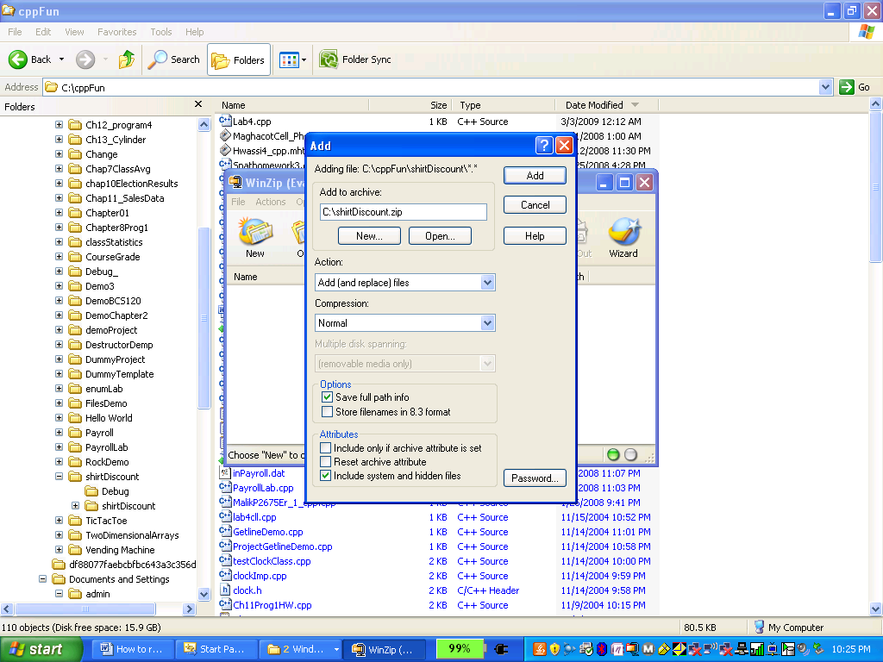

private: System::Void label4_Click(System::Object^ sender, System::EventArgs^ e) {
}

private: System::Void button1_Click(System::Object^ sender, System::EventArgs^ e)
{
int num_shirts;
double discount;
double cost_of_shirt = 12;
double discounted_cost_of_shirt;
double total_cost;
Int32::TryParse(textBox1->Text, num_shirts);
// Here is where your if statement must go. It
// will determine the discount percentage
if (num_shirts<5)
discount=0;
else if( num_shirts>=5)
discount= 10.;
else if( num_shirts>10)
discount= 15.;
else if( num_shirts>20)
discount= 20.;
else
discount= 25.;

discounted_cost_of_shirt = cost_of_shirt*(num_shirts/discount); //Fill in the formula
total_cost = cost_of_shirt-discounted_cost_of_shirt; //Fill in the formula
textBox2->Text = discount.ToString() + "%";
textBox3->Text = discounted_cost_of_shirt.ToString(“C”);
textBox4->Text = total_cost.ToString(“C”);

private: System::Void button2_Click(System::Object^ sender, System::EventArgs^ e) {
textBox1->Text = " ";
textBox2->Text = " ";
textBox3->Text = " ";
textBox4->Text = " ";

}

