To experimentally observe and analyze the performance of a zener regulated linear power supply in terms of its regulation, ripple and ripple rejection characteristics. The operation will be examined with and without an operational amplifier in the controlling feedback loop and the performance variations will be noted.

1.
Oscilloscope
2.
Half, Full Center Tap, and Full Wave Rectifier Board
3.
Ohmmeter (Fluke – 45)
4.
Powerstat-Variable Transformer 3 Amp
5.
2 Capacitors – 100 $μ$fd and
6.
Resistor - Pot
7.
Various lengths of hook-up wire and instrument leads as required

- Low line no load measurements (Variac Voltage = 105):
- V out-dc= 4.427V
- I Load= 0
- V-out-pp-ripple = 5.61mV
- V zener = 4.996V
- V zener-pp-ripple = 5mV
- V cf = 16.239V
- V cf-pp-ripple = 2.35V

- High line no load measurements (Variac Voltage = 120):
- V out-dc= 4.433V
- I Load= 0
- V-out-pp-ripple = 5.94mV
- V zener = 5.005V
- V zener-pp-ripple = 6.6mV
- V cf = 19.04V
- V cf-pp-ripple = 2.71V

- Low line full load measurements (Variac Voltage = 105 / R-load = 100 ohms):
- V out-dc= 3.953V
- I Load= 39.53mA
- V-out-pp-ripple = 5.9mV
- V zener = 4.984V
- V zener-pp-ripple = 26mV
- V cf = 13.978V
- V cf-pp-ripple = 7.85V

- High line full load measurements (Variac Voltage = 120 / R-load n= 100):
- V out-dc= 3.948V
- I Load= 39.48mA
- V-out-pp-ripple = 5.6mV
- V zener = 4.992V
- V zener-pp-ripple = 23.2mV
- V cf = 16.3V
- V cf-pp-ripple = 8.30V

Performance parameters for the power supply obtained from part (a) through (d) with the above calculations.
- The output % line regulation at no load:
For Vcf
$$\left(\frac{16.3v- 13.978v}{16.3v}\right)*100=14.25$$
For Vcf
$$\left(\frac{16.239v-13.978v}{16.239v}\right)*100=13.92$$

For Vcf
$$\left(\frac{19.04v-16.3v}{19.04v}\right)*100=14.37$$

$$For Vout$$
$\left(\frac{4.433v-4.427v}{4.433v}\right)*100=$.14

$$For Vcf$$
$$\left(\frac{19.04v-16.239v}{19.04v}\right)*100=14.69$$

- The output % line regulation at full load:
For Vout
$$\left(\frac{3.953v-3.948v}{3.953v}\right)*100= .13$$

- The output % load regulation at low line:
For Vout
$$\left(\frac{4.958v-4.427v}{4.958v}\right)*100=11.18$$

- The output % load regulation at high line:
For Vout
$$\left(\frac{4.433v-3.948v}{4.433v}\right)*100=10.94$$

- The ripple rejection in db from input to the zener:
For LL-NL 20$log({\frac{105\sqrt{2}}{5m} })$= 90db

For HL-NL 20$log({\frac{120\sqrt{2}}{6.6m} })$= 88db

- The ripple rejection in db from the zener to the output
For LL-NL 20$log({\frac{5m}{5.61m} })$= -1db

For HL-NL 20$log({\frac{6.6m}{5.94m} })$= 1db

- The ripple rejection in db from input to output:
For HL-NL 20$log({\frac{120\sqrt{2}}{5.94m} })$= 88db

For LL-NL 20$log({\frac{105\sqrt{2}}{5.61m} })$= 90db

Output % Line and Load Regulation
Load | Line Regulation |  | Load Regulation | Ripple Voltage | Ripple Rejection in db
 |  |  |  |  | LL | HL
None | 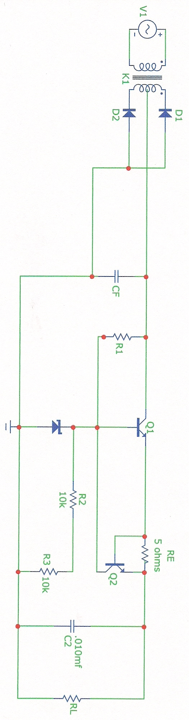  .14 | LL | $$11.18$$ | $$V cfpp$$ | 90db | 88db
Full | $$.13$$ | HL | $$10.94$$ | $$V zenerpp$$ | 1db | 1db
 |  |  |  | $$Voutpp$$ | 90db | 88db

- Low line no load measurements (Variac Voltage = 105):
- V out-dc= 6.084V VR6= 6.26v R6= 3k
- I Load= 0
- V-out-pp-ripple = 2.568V
- V zener= 4.998V
- V zener-pp-ripple = 230$μ$V
- V cf = 16.7V
- V cf-pp-ripple = 2.56V

- High line no load measurements (Variac Voltage = 120):
- V out-dc= 6.473V
- I Load= 0
- V-out-pp-ripple = 2.94V
- V zener = 5V
- V zener-pp-ripple = .210mV
- V cf = 18.255V
- V cf-pp-ripple = 1.01V

- Low line full load measurements (Variac Voltage = 105 / R-load = 100 ohms):
- V out-dc= 8.519V
- I Load= 85.1mA
- V-out-pp-ripple = 9.99V
- V zener= 4.968V
- V zener-pp-ripple = 62.9mV
- V cf = 10.840V
- V cf-pp-ripple = 11.14V

- High line full load measurements (Variac Voltage = 120 / R-load n= 100):
- V out-dc= 10.085V
- I Load= 100.85mA
- V-out-pp-ripple = 11.83V
- V zener = 4.977V
- V zener-pp-ripple = 53mV
- V cf = 12.546V
- V cf-pp-ripple = 13.18V

Performance parameters for the power supply obtained from part (a) through (d) with the above calculations.
- The output % line regulation at no load:
$$For Vout$$
$$\left(\frac{6.473v-6.084v}{6.473v}\right)*100=6.01$$

$$For Vcf$$
$$\left(\frac{18.255v-16.7v}{18.255v}\right)*100=8.52$$
$$100=6.01$$

- The output % line regulation at full load:
For Vout
$$\left(\frac{10.085v-8.519v}{10.085v}\right)*100=15.53$$

For Vcf
$$\left(\frac{12.54v- 10.84v}{12.54v}\right)*100=13.56$$

- The output % load regulation at low line:
For Vcf
$$\left(\frac{16.7v-10.84v}{16.7v}\right)*100= 35.9$$

For Vout
$$\left(\frac{8.519v-6.084v}{8.519v}\right)*100=28.58$$

- The output % load regulation at high line:
For Vout
$$\left(\frac{10.085v-6.473v}{10.085v}\right)*100=35.82$$

For Vcf
$$\left(\frac{18.255v-12.54v}{18.255v}\right)*100=31.31$$

- The ripple rejection in db from input to the zener:
For HL-NL 20$log({\frac{120\sqrt{2}}{.210m} })$= 118db

For LL-NL 20$log({\frac{.230m}{2.5681m} })$= -81db
For LL-NL 20$log({\frac{105\sqrt{2}}{.230m} })$= 96db

For HL-NL 20$log({\frac{120\sqrt{2}}{2.94} })$= 35db

For LL-NL 20$log({\frac{105\sqrt{2}}{2.568} })$= 35db

For HL-NL 20$log({\frac{.210m}{2.94} })$= 83db

- The ripple rejection in db from the zener to the output

- The ripple rejection in db from input to output:

Output % Line and Load Regulation
Load | Line Regulation |  | Load Regulation | Ripple Voltage | Ripple Rejection in db
 |  |  |  |  | LL | HL
None | $$6.01$$ | LL | $$28.58$$ | $$V cfpp$$ | 96db | 35db
Full | 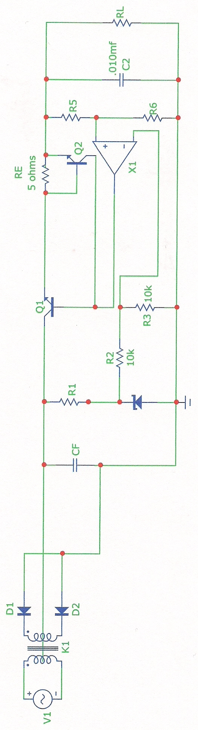  $15.53$ | HL | $$35.82$$ | $$V zenerpp$$ | -81db | 83db
 |  |  |  | $$Voutpp$$ | 35db | 118db

Tabulated Calculations (1):

Output % Line and Load Regulation
Load | Line Regulation | Load Regulation | Ripple Voltage | Ripple Rejection in db
None | .14 | $$11.18$$ |  | LL | HL
Full | $$.13$$ | $$10.94$$ | $$V cfpp$$ | 90db | 88db
 |  |  | $$V zenerpp$$ | 1db | 1db
 |  |  | $$Voutpp$$ | 90db | 88db
Tabulated Calculations (2):

Output % Line and Load Regulation
Load | Line Regulation | Load Regulation | Ripple Voltage | Ripple Rejection in db
None | $$6.01$$ | $$35.82$$ |  | LL | HL
Full | $$15.53$$ | $$28.58$$ | $$V cfpp$$ | 96db | 35db
 |  |  | $$V zenerpp$$ | -81db | 83db
 |  |  | $$Voutpp$$ | 35db | 118db

