The objective of this experiment is to investigate the summing circuits of six op-amps along with its experimental result to compare with the theoretical result to make assuming an ideal op-amp.

1.
Voltmeter
2.
3 M4741 Operational Amplifiers
3.
A 5k ohm resistor
4.
Two 50 ohm resistors
5.
A 1M ohm resistors
6.
A 10k ohm resistor
7.
Various lengths of hook-up wire and instrument leads as required

- Measurement of input offset voltage: Vio

A= $\left(1 + \frac{Rf}{Ri} \right)$ = $\left(1+\frac{5k}{50} \right)$ = 101
Vo = 104.5
Vo = AVi → Vi = $\frac{Vo}{A}$
Vi = $\frac{104.5}{101}$ = 1.0347m

Vo= 73.12mV
Vo= Vio + Rf IB
73.12mV = 1.0347m- 1M IB

IB = $\frac{73.12mV - 1.0347m}{1M}$ = 72.08588nA
IB = 72.08588nA

Vo= -67.88mV
Vo= Vio – IB R1
-67.88mV = 1.0347mV - IB 1M
IB = $\frac{67.88mV + 1.0347mV}{1M}$ = 68.915nA
IB = 68.915nA

Vo= 01.02mV, Vi= 1.0347m → Vo ≈ Vi
Vio= 1.02mV
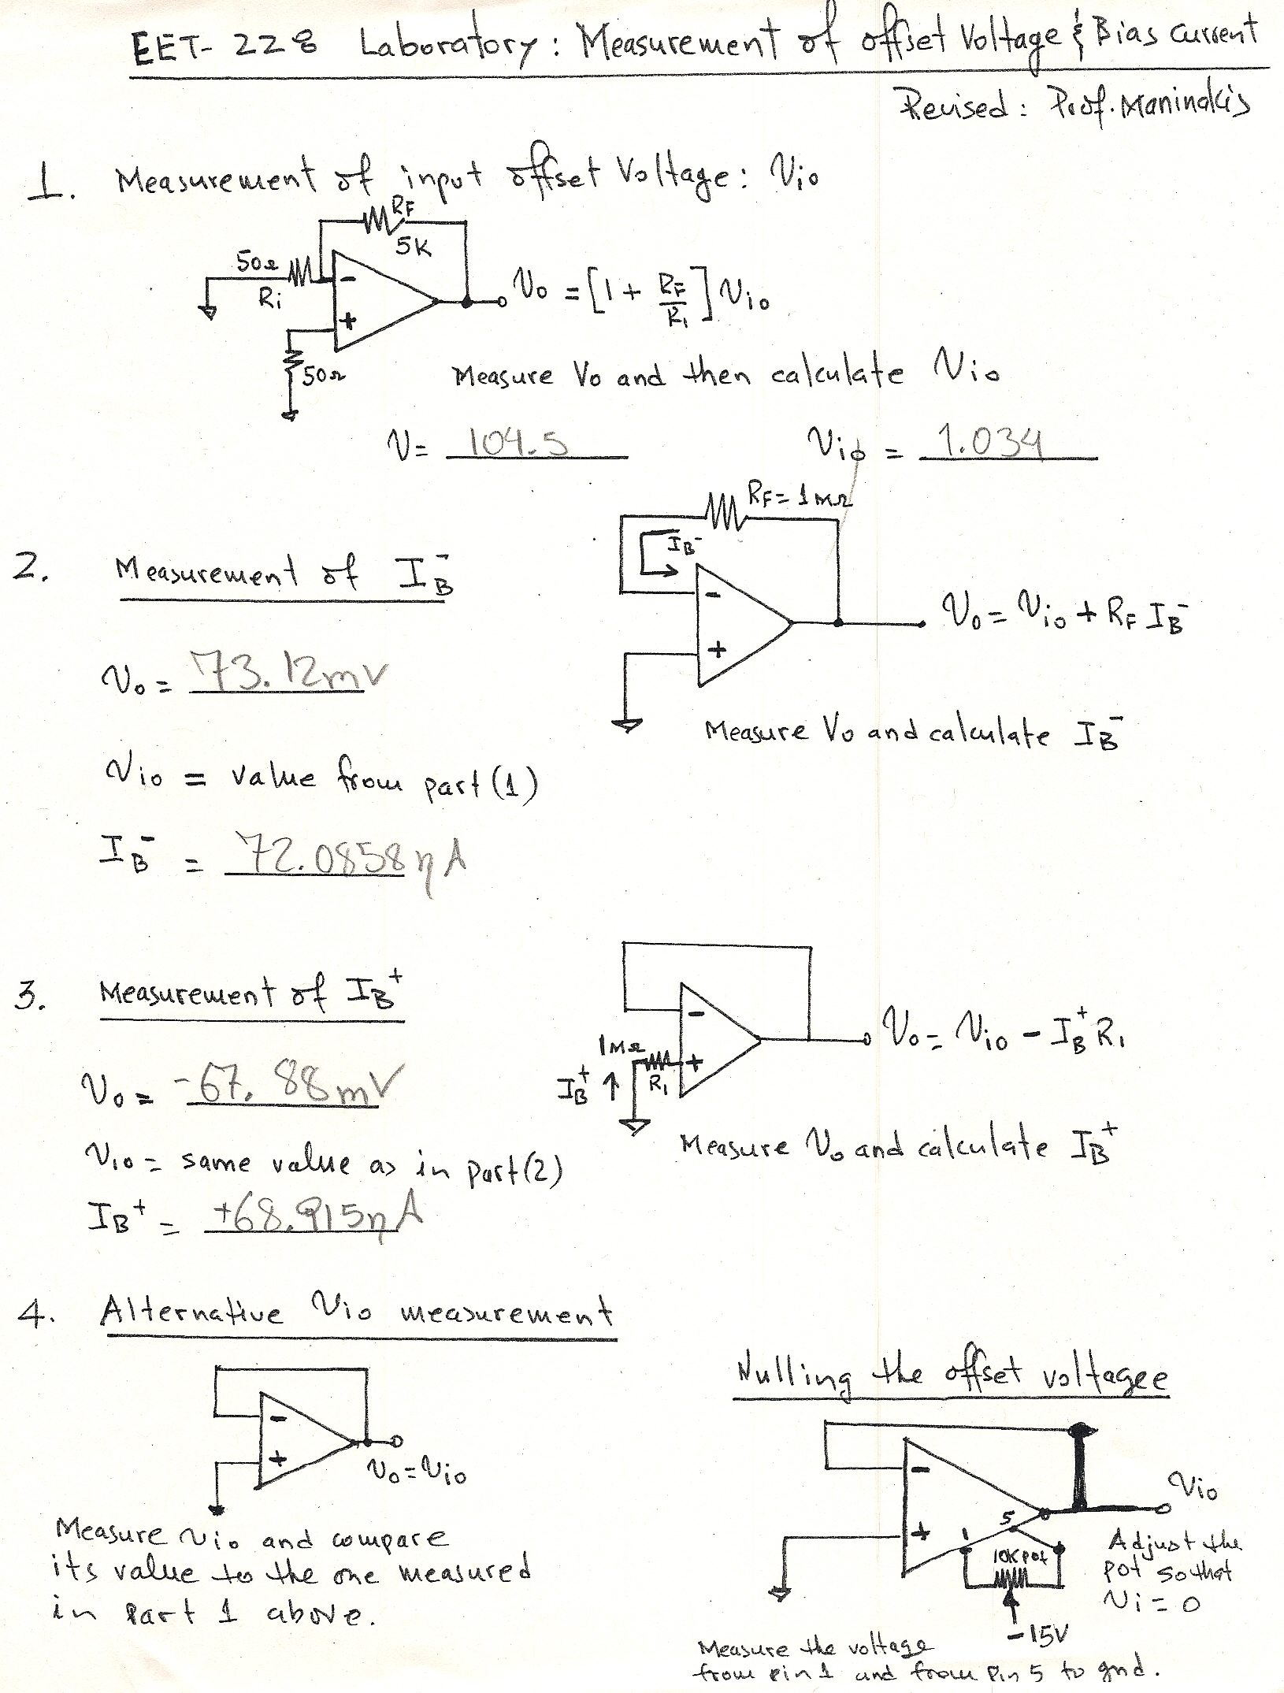

In the experiment above, the offset voltage was obtained from the transistor's current-voltage characteristics calculated using a two-dimensional numerical simulation with a current boundary condition at the base contact. The results show that the offset voltage strongly depends on the position of the emitter-base p-n junction and on the width of the emitter mesa.

