- Give a transition diagram for an NFA with four states accepting the following language, and then convert it into an equivalent DFA. The set of strings over {0,1)* that contain at least one "1" and have a "0" in the next-to-last position.
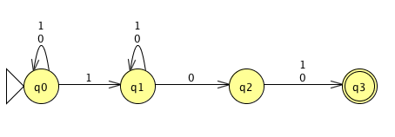

NFA

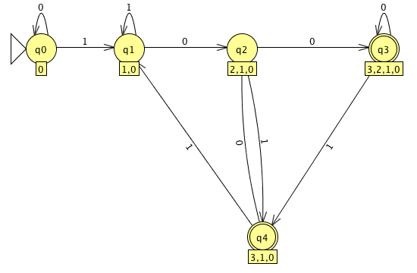

DFA

- Show that regular languages are closed under the complement operation. That is, given a DFA for a language L describe how to construct a DFA for the complement of L.

For any regular language we can construct a DFA D that generates all strings in L®. Having this DFA D, we can construct another DFA D’ which generates strings in L®’ but not in L®, that is $∑$* - L®. Given D = (Q, $\sum{,}$ $δ$, q0, F) for L®, we can construct D’ for L®’ = $\sum_{.}^{*}{- L(R)}$ by creating a new DFA D’ = (Q’, $\sum_{,}^{'}{δ'}$, q0, F’), where Q’, F’, and $δ'$ can be found as follows;

Q’ = {q0, …, qn}
$∑$ = $∑$
q0 = q0
F’ = Q – F
$δ'$ = $\sum{x}Q^{'}→Q'$

Notice that this construction is equivalent to changing the set of accepting states from F to Q-F by exchanging final and non-final states. The language L®’ = $\sum_{.}^{*}{- L(R)}$ is regular because is recognized by the DFA “D’,” which is the complement of L®. This proves that regular languages are closed under complement.

- Show that regular languages are closed under the reverse operation. That is, given a DFA for a language L, describe how to construct a DFA or NFA for L^{R}. You do not have to describe the construction formally.

Given a DFA D = (Q, $∑$, $δ$’, q0, F) for all strings in L, we construct a NFA N = (Q $∪$ {q’}, $∑$, $δ$, q’, {q0}) where Q’, F’, and $δ'$ can be found as follows;

Q’ = Q $∪$ {q’}
$\sum_{.}^{'}{=}$ $\sum{.}$
q0 = q’
F’ = {q0}
$δ'$(qj, a) = {qi: $δ$(qi, a) = qj}
$δ'$(q’, $ϵ$) = F
$δ'$(q’, a) = $∅$, if a $≠ ϵ$

We take the DFA that decides L and reverse the direction of every arc so a string will be accepted if, when we stand from a final state we can reach the initial state. To do this, we added a new state q’ to Q so the only accepting state is the previously initial state and q’ is the new initial state. We let $δ'$(q’, $ϵ$) = F and for all qi, qj$∈$Q, x$∈∑$ such that $δ$(qi, x) = qj we set that qi$∈δ$’(qj, x).

  - Show by an example that for some regular language L, any DFA (FA) accepting L must have more than one accept state.
Let L = {w| where |w| is even and does not contain the string 00}
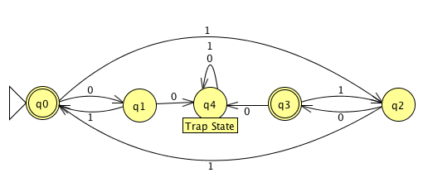
  - Explain why more than one accepting state is necessary.
Since 0 is even, the state q0 must be accepting empty strings, because of this, every even length string that starts with 1 cannot be accepted the start state q0 because it would allow the DFA to accept the strings such as 1001 which is clearly not in the language since it contains a pair of 0’s.

  - Prove that any NFA can be converted into one with a single accept state.
Let L={w | where |w| is even or w does not contain the string 00}
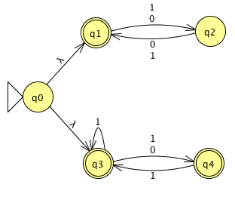

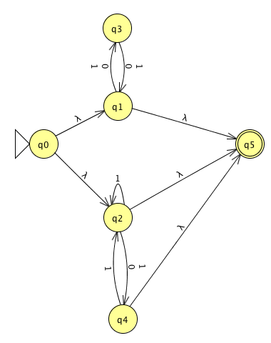
The NFA above is equivalent to the NFA below

The NFA to the left was easily turned from an NFA with three accepting states to an NFA with a single accepting state. This was done creating a new accepting states and drawing an epsilon transition from the all accepting states of the previous NFA to the new accepting states, afterwards, all previous accepting states must be turned into non-accepting states.

