- Let A,B,C be languages over some alphabet Sigma. In each part below, two languages are given. Say what the relationship is between them.
Whenever you say that one is NOT always a subset of the other, include a counterexample.

A(B intersection C), AB intersection AC
Are they always equal?
No
If not, is one always a subset of the other?

A*$∩$ B*, (A $∩$ B)*
Are they always equal?
No
If not, is one always a subset of the other?
A* intersection B* is always a subset of (A intersection B)*

A*B*, (AB)*
Are they always equal?
No
If not, is one always a subset of the other?
No
Counter Example: For A = {a}, B = {b}
aa is in A*B* but not in (AB)*
abab is in (AB)* but not in A*B*

A*(BA*)*,(A*B)*A*
Are they always equal?
Yes

Prove using induction that given a language L, if L² is a subset of L, then L⁺ is a subset of L.
Claim L, if $L^{2}⊂$ L, then $L^{+}⊂$ L
Proof: Assume that $L^{2}⊂$ L
$L^{(n + 1) }⊂$ L
$L^{+}⊂$ L, since $L^{+}$ = $\coprod_{n ∈N}{L^{(n + 1)}}$
Basis: $L^{(0 + 1) }$ = $L^{1}$ = L, -> $L^{(0 + 1) }⊂$ L
Induction:
IH: $L^{(n + 1)}⊂$ L
NTS: $L^{((n + 1)+1) }⊂$ L
$L^{(n + 2)}$ = $L^{(n + 1)}$L -> DEF L^(n + 2)
$L^{(n + 2)}$)$⊂$ LL -> (IH, Lemma)
$L^{(n + 2)} ⊂$ $L^{2}$ -> DEF L^2
$L^{(n + 2)}⊂$ L -> ASSUMPTION
- I will prove that all horses are the same color. Proceed by induction on the size of sets of horses. Basis step: All the horses in a set containing a single horse are obviously the same color. Inductive hypothesis: Assume that in all sets of k horses, all the horses are the same color. Take some set of k+1 horses. Remove one horse from the set. Now we have a set of k horses, which are all the same color by the IH. Replace that horse and remove a different one. All these horses must also be the same color. Since all horses in these two subsets of k elements are the same color, and since they overlap, all k+1 horses are the same color. Therefore all the horses a set of any size are all the same color, so all horses are the same color.
What is wrong with this proof?
The assumption that the two sets of horses have a common element for any set of any size k is wrong because the proof does not hold when k = 2.
The proof above makes an implicit assumption by saying that the two subsets of horses have a common element, set = set1 U set2. This assumption cannot be true for the case in which the original set contains two horses. The reason why is because when k = 2 set1 and set2 will consist of exactly one of the two horses. And, because each of these two sets contains only one-color horse, the original set also contained only one-color horse. This proves that there are no common elements in the two sets, because there is no mean to conclude that they both have the same color, therefore it is unknown whether the two horses share the same color and the last assumption is wrong.
- Draw FA (deterministic) for the following languages over {0,1}:
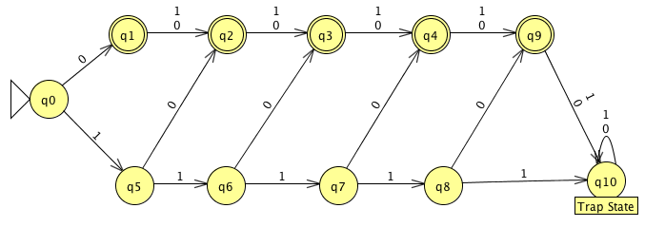
  - All strings of length at most 5 that contain at least one 0,
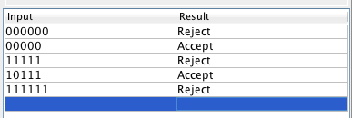
Example Inputs:

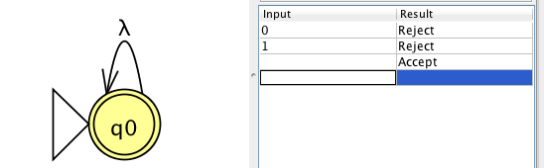
  - Language containing only the empty string (epsilon), and

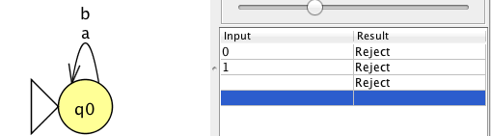
  - The empty language.

- Let k be a positive integer. Let L_{k} be the language defined as follows:
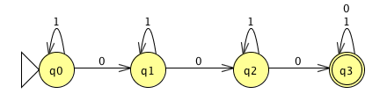
L_{k} = {x | x is in {0,1}*, x contains at least k 0's}
  - Draw the transition diagram of a DFA for L₃
  - Formally specify (5-tuple and all parts) a DFA M_{k} such that L(M_{k}) = L_{k}
Q = { q0, … qn}
$\sum{=}$ {0,1}
q0= q0
F = {qn}

$δ$ = (qi, 0) = qi+1, and $δ$ = (qi, 1) = qi,
$δ$ = (qn, 0) = qi, and $δ$ = (qn, 1) = qi,
$δ$ = (q(n-1), 0) = qn$ϵ$F , and $δ$ = $δ$ = (q(n-1), 1) = q(n-1)

