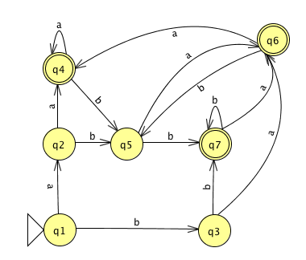
- Minimize the following finite automaton: ({q1, q2, … q7}, {a, b}, $δ$, q1, {q4, q6, q7}), where $δ$ is as follows:
 | a | b
q1 | q2 | q3
q2 | q4 | q5
q3 | q6 | q7
q4 | q4 | q5
q5 | q6 | q7
q6 | q4 | q5
q7 | q6 | q7
Minimizing DFA by Combining States:
Original DFA
q2 | X
q3 | X | X
q4 | X | X | X
q5 | X | X | O | X
q6 | X | X | X | O | X
q7 | x | X | X | X | X | X
 | q1 | q2 | q3 | q4 | q5 | q6
We found that q5=q3 and q6=q4, removing q3 and q6 from the original DFA and matching transitions to each one of the removed equivalence state.

Removing q3, transition on “b” from q2 to q3 is now from q2 to q5.
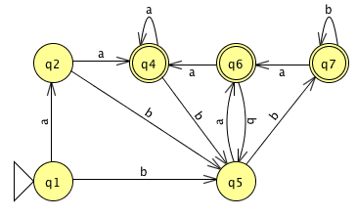
Next, removing q6, transition on “a” from q7 to q6 is now from q7 to q4.

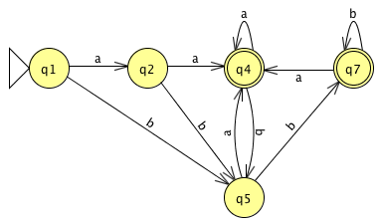
Resulting Minimized DFA:

- Problem 1.53: Let $Σ$ = {0,1,+,=} and let ADD = {x=y+z | x and y and z are binary integers and x = y+z}.
Prove that ADD is not regular using the pumping lemma.
Assume, for a contradiction, that ADD is regular. Then, ADD has a length m > p where p is the pumping length. Now, let’s choose s to be a string that is in the language and that will meet the pumping lemma requirements where:

- |y| > 0
- |xy|<=p
- xy^iz $∈$ ADD for all i>=0

Let s= 1^p, since x = y + z we can say that s= 1^p = 1^p + 0.
Now from a and b we have that y = 1^k for some k > 0 and k<=p. According to the pumping lemma we can choose any i, and the string s will still be in the language. Let’s choose i = 2, then xy^2z = 1^p+k. This says that 1^p+k = 1^p + 0 which $∉$ ADD since it does not satisfy binary addition, this is a contradiction.

- Give a context-free grammar for the following language:
{ 0^{n}1^{m} | n != m }

S -> 0A | B1
A -> 0A1 | 0A | $ε$
B -> 0B1 | B1 | $ε$
- Give a PDA for the same language as in the last problem.
