Introduction To Computer Science Theory 2123
pp. 54-56, Nos. 2, 12, 13, p. 62, Nos. 1, 3, pp. 68-69, Nos. 1,
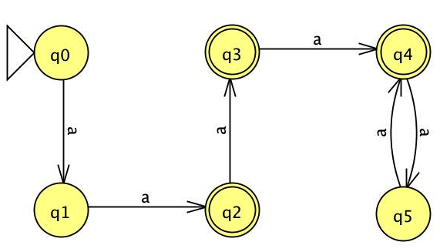
For question (1) use the Pair Table method.

2) Find a DFA that accepts the language defined by the NFA in fig 2.8

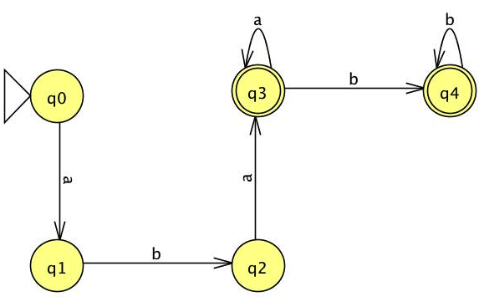

3) Design a NFA with no more than five states for the set { abab^n : n >= 0 } u { aba^n : n >= 0 }

Input | Output
00 | Reject
010001 | Accept
10010 | Reject
000 | Accept
0000 | Reject
12) Which of the following strings 00, 010001, 10010, 000, 0000 are accepted by the following NFA.
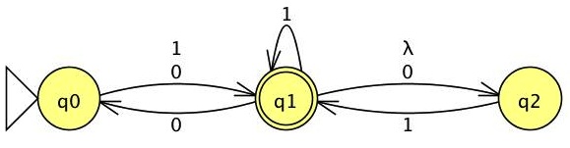
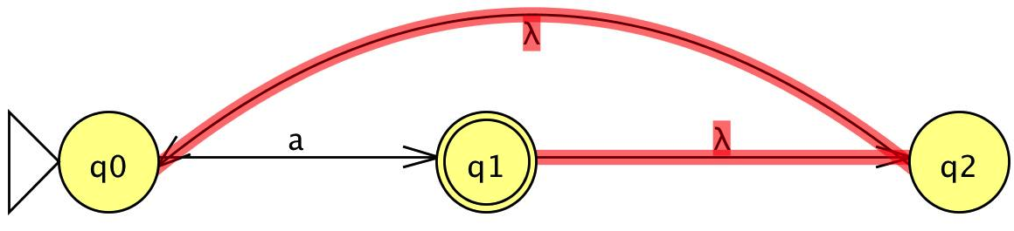
13) What is the complement of the language accepted by the NFA in fig 2.10?
L =

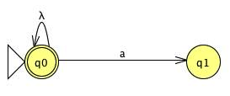
$\overline{L}$ = Where aεL and a$∉\overline{L}$


- Use the construction from the theorem 2.2 to convert the NFA in fig 2.10 to a DFA.
NFA Transition Table
Q | a | λ
q0 | q1 | -
q1 | - | q2
q2 | - | q0
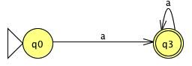

q0 Ξ q1 Ξ q2, which means that q0,q1, and q2 are not distinguishable one another. Therefore, they are equivalent and we only have to choose one transition; which in this case is q0, as shown above.
Transition Table without λ
Q | a
q0 | q1q2q0
q1 | q1q2q0
q2 | q1q2q0
q1q2q0 | q1q2q0
Can you see a simpler answer more directly?
Yes, it is quite obvious that the NFA is just looping on a. Therefore an optimum solution, from first sight, would be:

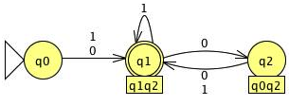

3) Convert the following nfa into AN equivalent DFA.

NFA $λ$ transition table
Q | 0 | 1 | $$λ$$
q0 | q1 | q1 | -
q1 | q0, q2 | q1 | q2
q2 | - | q1 | -

NFA without $λ$ transition table
Q | 0 | 1
q0 | q1q2 | q1q2
q1 | q0q2 | q1q2
q2 | - | q1q2

