Introduction To Computer Science Theory 2123
pp. 54-56, Nos. 2, 12, 13, p. 62, Nos. 1, 3, pp. 68-69, Nos. 1,
For question (1) use the Pair Table method.

2) Find a DFA that accepts the language defined by the NFA in fig 2.8
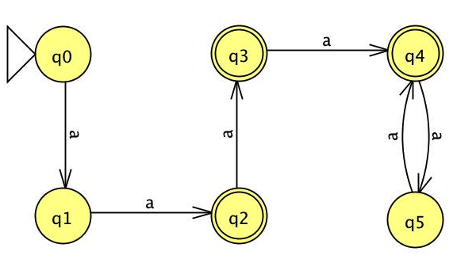

3) Design a NFA with no more than five states for the set { abab^n : n >= 0 } u { aba^n : n >= 0 }
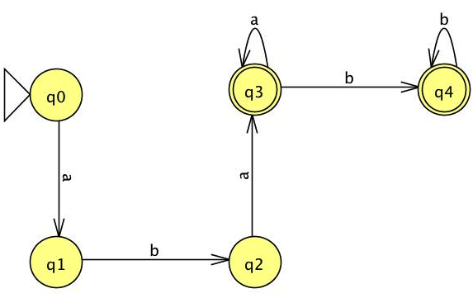

12) Which of the following strings 00, 010001, 10010, 000, 0000 are accepted by the following NFA.
Input | Output
00 | Reject
010001 | Accept
10010 | Reject
000 | Accept
0000 | Reject
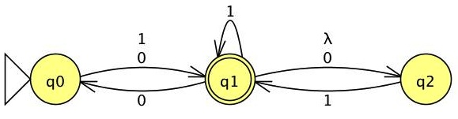

13) What is the complement of the language accepted by the NFA in fig 2.10?
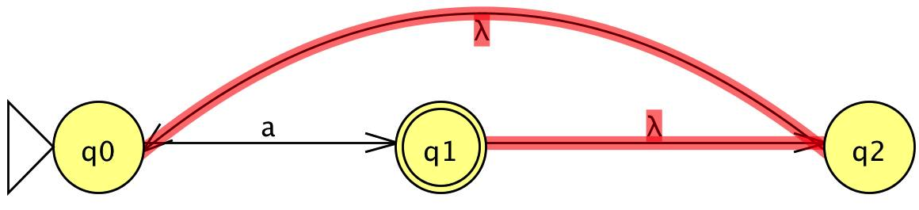
L =

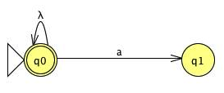
$\overline{L}$ =

Where aεL and a$∉\overline{L}$

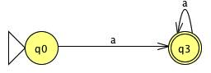

- Use the construction from the theorem 2.2 to convert the NFA in fig 2.10 to a DFA.

q0 Ξ q1 Ξ q2, which means that q0,q1, and q2 are indistinguishable one another. Therefore, they are equivalent and we only have to choose one transition; which in this case is q0, as shown above.
NFA Transition Table
Q | a | λ
q0 | q1 | -
q1 | - | q2
q2 | - | q0

Can you see a simpler answer more directly?
Transition Table without λ
Q | a
q0 | q1q2q0
q1 | q1q2q0
q2 | q1q2q0
q1q2q0 | q1q2q0
Yes, it is quite obvious that the NFA is just looping on a. Therefore an optimum solution, from first sight, would be:

3) Convert the following nfa into AN equivalent DFA.

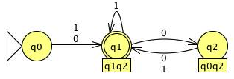
NFA

DFA

