1) Find the strings in L = ( ( a + b )*b ( a + b )* ) of length less than four:
L = ( ( a $∪$ b )*b ( a $∪$ b )* ), where |L| < 4.
The strings generated by |L| < 4 can be split as follows:
|L| = 0 -> There most be at least one b.
|L| = 1 -> b
|L| = 2 -> ab, bb, ba -> all strings must be followed by a b so we cannot generate aa.
|L| = 3 -> aba, abb, bba, bbb, aab, baa
Thus, all strings |L| < 4 are L = {b, ab, aab, aba, baa, bb, bbb, bba, ba, bab}

5) Find a regular expression for the set {$a^{n}b^{m}$: (n+m) is even}
(a(${(a∪a)}^{2}$)* $∪$ b(${(b∪b)}^{2}$)*) $∪$ ((${(a ∪ a )}^{2}$ )* $∪$ (${(b ∪ b)}^{2}$)*) ,
Also, (a(${(a)}^{2}$)* $∪$ b(${(b)}^{2}$)*) $∪$ ( ($a^{2}$)* $∪$ ($b^{2}$)* )

L = ( (a ($a^{2}$)* $∪$ b($b^{2}$)* ) $∪$ ( ($a^{2}$)* $∪$ ($b^{2}$)* ) )

7) What languages do the expressions ($∅$*)* and a$∅$ denote?
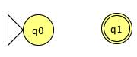
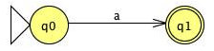
The NFA for L (a): The NFA for L (∅):

Constructing L (a∅) by concatenation:
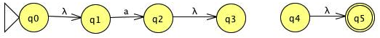
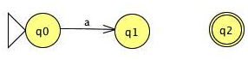
As we can see, the resulted NFA has no path to the final state q2, and therefore, the resulting language is L (∅). The concatenation of any language with ∅ results in ∅, and by this definition, the resulting NFA is consistent with the definition of the language.

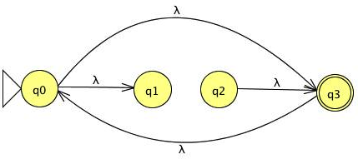
Constructing L (${∅^{*})}^{*}$:
This NFA has no path to the final state q5 on λ, but it is still accepting λ so the resulting language is L (λ). The star of any regular expression will result in a language which has at least has one element as λ and by this definition L (${∅^{*})}^{*}$ is L (λ), therefore the resulting NFA is consistent with the definition of the language.

11) Find a regular Expression for L = { a$b^{n}$w: n>=3, ${w∈\{a,b\}}^{+}$}
abbbb*${( a ∪ b )}^{+}$

7) Find the minimal DFA that accepts L(a*bb) $∪$ L(ab*ba)
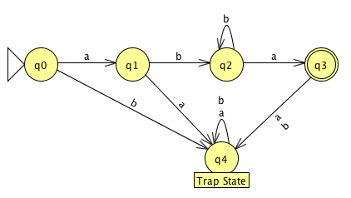
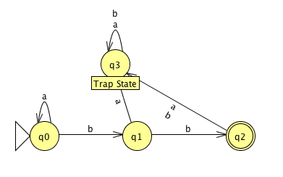
L1 = (a*bb) - DFA L2 = (ab*ba) - DFA
L = L1 $∪$ L2
L –DFA =

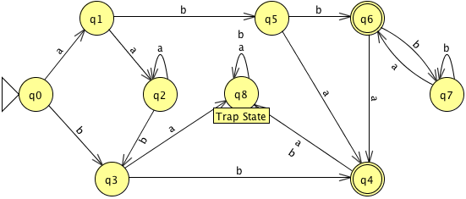
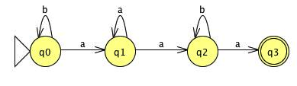
10) Find a regular expression for the languages accepted by the following automat.

a) = (b*aa*ab*a)

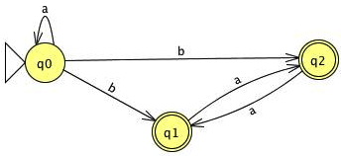

c) = (a*b $∪$ a*ba*)

- Construct a DFA that accepts the language generated by the grammar.

S -> abA,
A -> baB,
B -> aA| bb
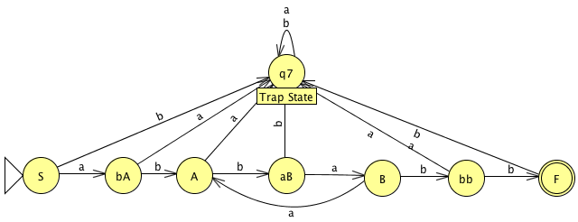
abba(aba)*bb

15) Show that any regular grammar G for which L (G) $≠$ $ϕ$ must have at least one production of the form
A –> x
Where A $∈$ V and X $∈$T

Assume, for a contradiction, that G = (V, T, S, P) is regular with L (G) $≠$ ∅ and it has no production of the form A->x, which means all productions in p are of the form->xB.

Now, for some A, B∈V and x$∈$T* and since L (G) $≠$ $∅$ there must exist some w$∈$T* such that w$∈$L (G). This means that there is some derivations S$⟹$*w that ultimately terminates after producing w, which means there is some step in the derivation that does not produce a variable. This is a contradiction, our assumption that all productions are not of the form A$⟶$xB is wrong. Thus, we conclude that at least one production in P is of the form A$⟶$x.

