Find the strings in L = ( ( a + b )*b ( a + b )* ) of length less than four:

L = ( ( a $∪$ b )*b ( a $∪$ b )* ) and |L| < 4.
Then, L = ( ( a $∪$ b )^2)b $∪$ (b( a $∪$ b )^2 ) $∪$ (b( a $∪$ b ) ) $∪$ (( a $∪$ b )b) $∪$ b
The strings are:

L = {b, ab, aab, aba, baa, bb, bbb, bba, ba, bab}

5) Find a regular expression for the set {a^nb^m: (n+m) is even}

a( (a $∪$ a )^2 )* $∪$ b( ( b $∪$ b )^2 )*
a( (a)^2 )* $∪$ b( (b)^2 )*

L = ( a( (a $∪$ a )^2 )* $∪$ b( ( b $∪$ b )^2 )* )

7) What languages do the expressions ($∅$*)* and a$∅$

By Theorem 3.1, the nfa for L(a) can be represented schematically as shown below:
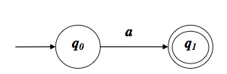
The nfa for L(∅) can represented as given below:
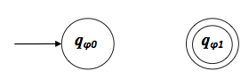
By Theorem 3.1, we can construct L(a∅) using concatenation of the above two nfa’s as shown below:
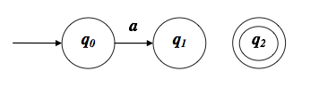

The concatenated nfa can be further simplified as shown above. Since this nfa has no path to the final state q2, the resulting language is L(∅). Also, we know that by definition, the concatenation of any language with ∅ results in ∅. So the resulting nfa is consistent with the definition of the language.
We already showed the construction of L(∅). By Theorem 3.1, we can construct L(∅∗) as shown below:
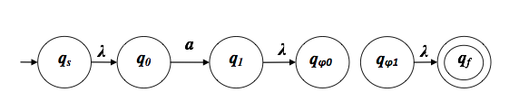
Since this nfa has a path to the final state qf on λ, the resulting language is L(λ). Also, we know that by definition, the star of any regular expression will result in a language which has at least one element as λ and by definition, L(∅∗) is L(λ). So the resulting nfa is consistent with the definition of the language.
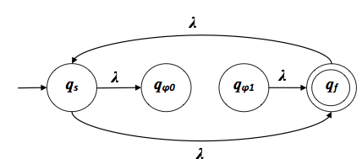

11) Find a regular Expression for L = { ab^nw: n>=3, w$∈${a,b}+}
a( ( b $∪$ b )^2 )^+ b( ( a $∪$ b )^+

7) Find the minimal DFA that accepts L(a*bb) $∪$ L(ab*ba)

L1 = (a*bb) L2 = (ab*ba)
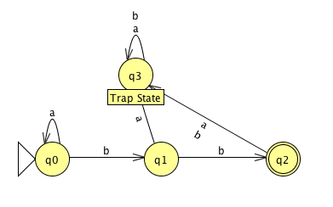
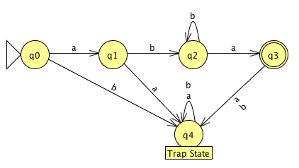
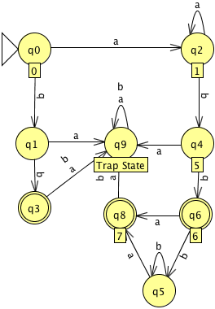

L = L1 $∪$ L2
L =
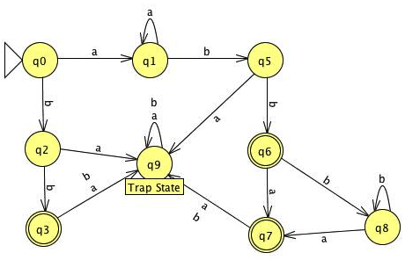

10) Find a regular expression for the languages accepted by the following automat.

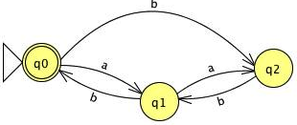

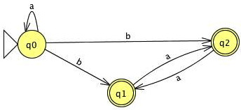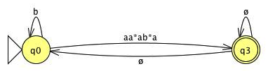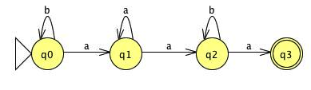
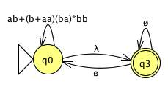

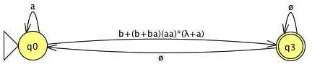
- Construct a DFA that accepts the language generated by the grammar.

S -> abA,
A -> baB,
B -> aA| bb

Abba(ab)*bb $∪$ abbabb

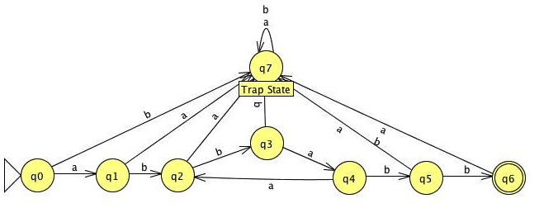

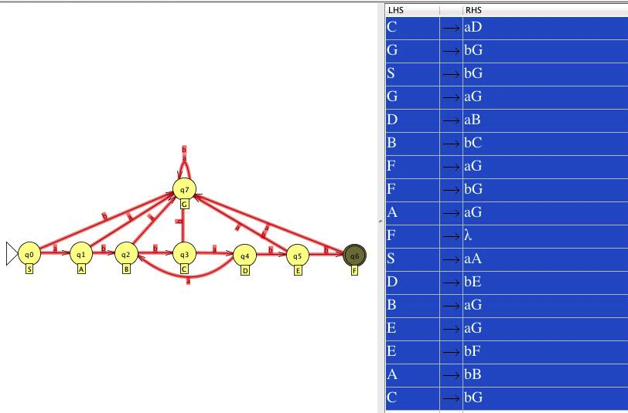

15) Show that any regular grammar G for which L(G) $≠$ $ϕ$ must have at least one production of the form

A –> x
Where A $∈$ V and X $∈$T

For a contradiction, assume that G = (V,T,S,P) is regular with L(G) ̸= ∅, but with no productions of the form
A→x. 7
That means all productions in P are of the form A → xB
forsomeA,B∈V andx∈T∗. SinceL(G)̸=∅,theremustexistsomew∈T∗ suchthatw∈L(G). That means there is some derivation S ⇒∗ w that ultimately terminates after producing w, which means there is some step in the derivation which does not produce a variable. However, this contradicts our assumption that all productions are of the form
A → xB. Thus, we conclude that at least one production in P is of the form
A→x.

