
Rochester Institute of Technology
Department of Computer Science
Advanced Computer Vision
Natural Scene Classiﬁcation
Final Report
Authors:
Karina Damico
Pauline Martial
Supervisor:
Dr. Roger Gaborski
February 14, 2013
1
Contents
I
Introduction
1
2
.
.
.
.
.
.
.
2
2
2
2
3
3
3
3
4
4
4
4
5
5
5
6
6
6
7
7
7
II Overview of the Approach
III Gabor-Gist Descriptor
III.1 Gabor Bank Formation . . . . . . . . . .
III.2 Gabor Histogram Approach . . . . . . . .
III.3 Gabor ”Manual-Bin” Histogram Approach
III.4 Gabor-Gist Visual Descriptor . . . . . . .
1Image Preprocessing . . . . . . . .
2Gist Feature Extraction . . . . . .
3Classiﬁcation Results . . . . . . . .
Abstract—Scene categorization is a fundamental prob-
lem in image understanding. It is a challenging task in
computer vision and widely applied in many ﬁelds, such
as image retrieval, video surveillance, travel navigation
or medical browser. Large image collections such as the
Internet require eﬃcient organization which is why a lot of
attempts were performed to design automated systems to
solve scene classiﬁcation task in recent years.
The study presented in this paper aims to obtain high ac-
curacy of scene classiﬁcation through creating an advanced
feature vector based on multiple feature sets extracted
using Gabor ﬁlters, CENTRIST and color histograms. The
goal is to produce feature vectors that describe the scene
as accurately as possible. Each feature extraction method
is ﬁrst examined alone, then is combined with features
obtained with other methods and tested on accuracy
improvement. This paper shows the high performance
obtained when combining these techniques.
IV Centrist Descriptor
IV.1 Computation of CT Value . . . . . . . . . .
IV.2 Parameters . . . . . . . . . . . . . . . . . .
IV.3 Results with a Neural Network . . . . . . .
V Color Histogram
VI Hybrid Descriptors
VI.1 Method 1: Voting Algorithm . . . . . . . .
VI.2 Method 2: Neural Network . . . . . . . . .
1Gabor + Centrist Hybrid Results
2Gabor + Color Histogram Hybrid
Results . . . . . . . . . . . . . . . .
3Centrist + Color Histogram Hy-
brid Results . . . . . . . . . . . . . .
4Gabor + Centrist + Color His-
togram Hybrid Results . . . . . . . .
VIIConclusion
I. Introduction
S
CENE classiﬁcation is diﬀerent from conventional
object detection. The scene is a unique composition
of several objects related and organized in often unpre-
dictable layout. The relationships between objects and
their organization mostly deﬁne the scene class. It makes
classiﬁcation task even more diﬃcult, as a computer is
unable to ”understand” such relationships. Object-based
judgement is able to provide more or less satisfactory
results for man-made scenes as the object functional
representation may itself supply suﬃcient information for
labelling a scene. The situation is much more complicated
for classifying natural scenes, where separate object
detection does not provide enough information to relate
the image to a particular category. High level features
stay beyond any existing technique: semantic descriptors
are not recognizable by computers. Thus, images have to
be described by low level descriptors that aim to mimic
semantic content of the image and make it understandable
for computers.
In the study presented in this paper, each feature is
investigated independently before being combined with
other features. Features are evaluated using statistical
methods as well as individual classiﬁcation results. Sta-
tistical evidence is gathered primarily from the training
set as inclusive or exclusive validation runs. This further
provides insight into how representative is the feature for
images of the same category. Classiﬁcation results are
generated from an exclusive subset of the training set as
well as the test set.
The following of the paper is organized as follows. In sec-
tion II, our global approach chosen to solve scene recogni-
tion problem is explained. Sections III, IV and V respec-
tively detail how Gabor, Centrist and color histogram
feature descriptors are deﬁned and used to describe the im-
age. Obtained feature vectors are combined in section VI
and their performance is evaluated. Section VII concludes
this paper and summarizes the best results obtained.
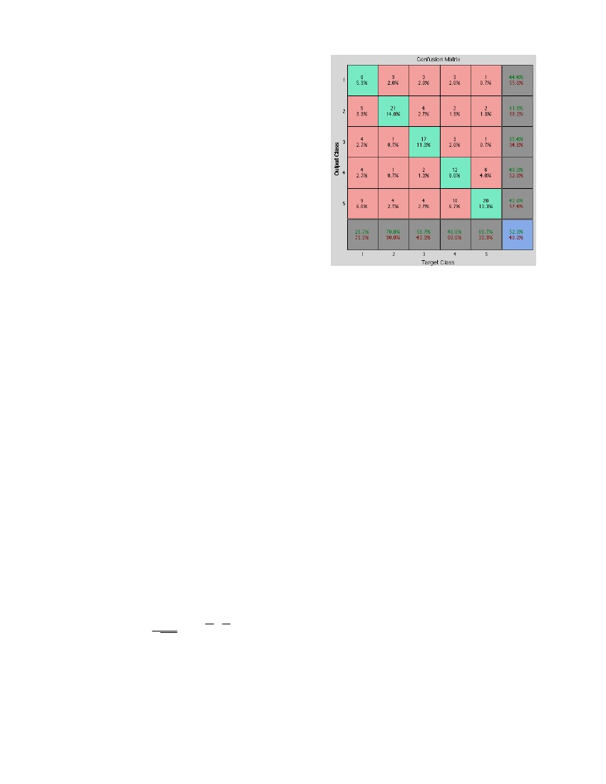
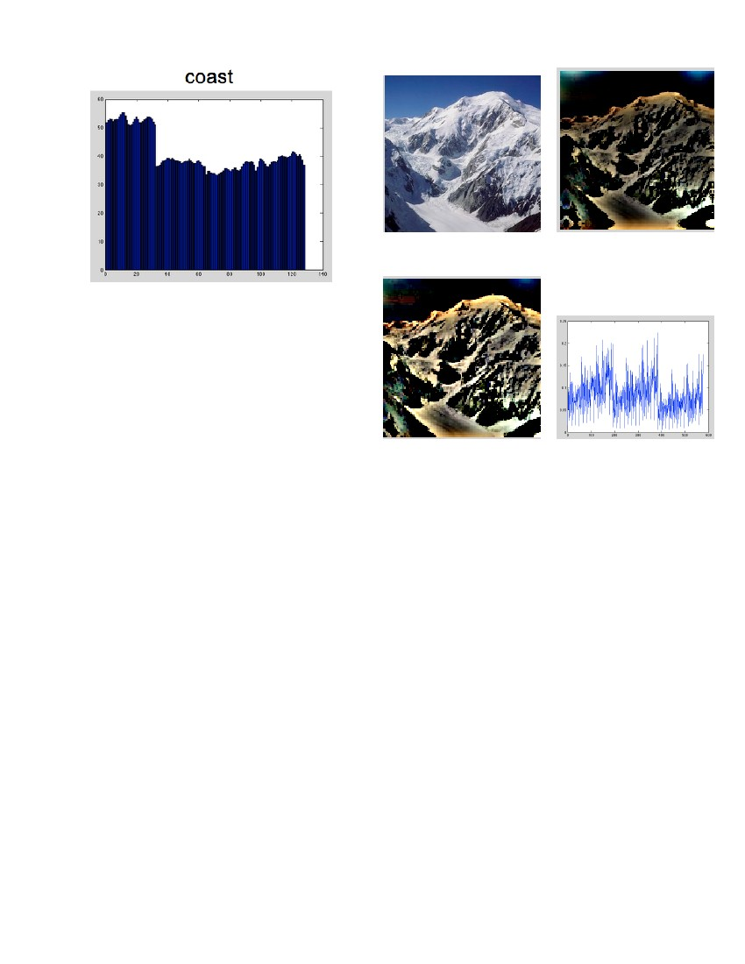
2
II. Overview of the Approach
In order to have a scene classiﬁcation as accurate as pos-
sible, several methods are used and combined. This choice
was made with the assumption that because methods have
their best eﬃciency for diﬀerent classes, combining them
should improve the overall accuracy. Results presented in
section VI further revealed that this assumption was true.
The chosen methods for scene classiﬁcation are Gabor de-
scriptors (described in section III), Centrist feature vec-
tors (described in section IV) and color histogram feature
vectors (described in section V). Those three descriptors
are very diﬀerent and use complementary information of
the images. This is the key that enable an eﬃcient combi-
nation of the feature vectors.
III. Gabor-Gist Descriptor
Gabor descriptors proved their eﬃciency as robust tex-
ture descriptors. Similarity between low level processing
in biological vision and Gabor lter banks was found and
proved by Daugman [1]. Thus, Gabor descriptor is the
way to make computer ”understand” images in the way
human brain does it.
The Gabor feature extraction consists of designing a set
of Gabor ﬁlters in the spatio-frequency domain, and form-
ing a bank of ﬁlters to be applied to the images in order
to transform information from the pixel space into the fea-
ture space. In the spatial domain, a 2D Gabor ﬁlter is a
Gaussian kernel function modulated by a sinusoidal plane
wave. The Gabor ﬁlters are self-similar: all ﬁlters can be
generated from one mother wavelet by dilation and rota-
tion [2].
In this study, all the experiments were conducted with
single 12 ﬁlter Gabor bank, but diﬀerent techniques to pre-
process data and reduce dimensionality were used.
III.1. Gabor Bank Formation
Gabor descriptor for an image is computed by passing
the image through the Gabor lter bank. Gabor lter is a
linear band-pass lter whose impulse response is deﬁned as
a Gaussian function modulated with a complex sinusoid.
Mathematically, a Gabor ﬁlter of a particular orientation
and frequency is a sinusoid modulated by a Gaussian:
h(x, y) = s(x, y)g(x, y)
where s(x, y) is a sinusoidal plane and g(x, y) is a 2-D
Gaussian. The Gaussian is represented by:
−1/2( x2 + y 2 )1
σxσy√eg(x, y) =
2πσ
2
2
Fig. 1. Confusion matrix for Gabor Histogram method 1-Coast;
2-Forest; 3-Highway; 4-Mountain; 5-Tall Building
A Gabor ﬁlter in 2 dimensions can be used to approx-
imate the frequency and spatial response of the diﬀerent
scene categories. Gabor ﬁlters can be viewed as speciﬁc
edge detectors, which are able to percept edges of a cer-
tain orientation and strength. A ﬁlter bank consisting of
ﬁlters with 3 diﬀerent scales (4, 8 and 16) and 4 orienta-
tions (0, 45, 90 and 135 degrees) was considered for feature
extraction, giving a total of 12 Gabor ﬁlters bank.
III.2. Gabor Histogram Approach
The idea of this method is to calculate intensity his-
togram for Gabor ﬁltered images. A color image converted
into grayscale was split into four horizontal pieces in order
to preserve some spatial information and potentially in-
crease the classiﬁcation accuracy. Each quarter of an im-
age in the training and testing sets was convolved with the
ﬁlter bank. Intensity histogram was calculated from each
piece of the image (32 bin histograms showed similar accu-
racy to 64 bins). Thus, the feature vector dimensionality
is 1x128. Testing was performed in two ways:
• Calculating average histogram for each class from
training images, and then comparing it with his-
tograms of testing images using Euclidian distance,
• Using Multilayer Perceptron neural network.
Both classiﬁcation methods performed similarly with 52%
overall accuracy (see ﬁgure 1). Note that error rates diﬀer
from a category to another category. Because Gabor his-
togram approach performed very poorly, it was decided to
continue experimenting with other approaches.
III.3. Gabor ”Manual-Bin” Histogram Approach
As mentioned above, the histogram approach leads to
the loss of the spatial information: it only indicates the
strength of responses in certain directions and scales. The
idea of ”manual-bin” histogram approach is to calculate
and s(x, y) as:
s(x, y) = e−j2π(u0 x+v0 y)
The ﬁlter has a real and an imaginary component repre-
senting orthogonal directions. The two components may
be formed into a complex number or used individually [3].
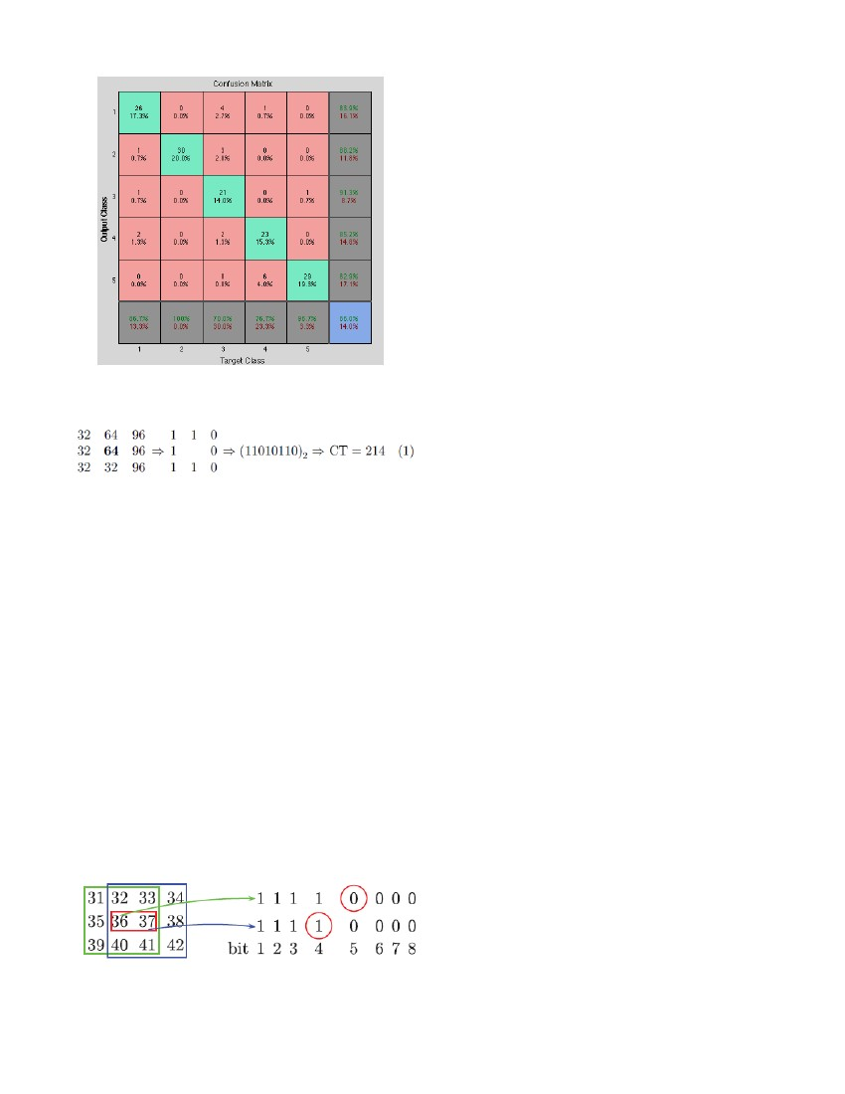
3
Fig. 3. a) Original Image and b) Whitened Image
Fig. 2. Avaraged histogram for Coast category with Gabor ”manual-
bin” histogram approach
the value for each bin separately and thus save the response
spatial information and intensity.
The method was tested using MLP on 150 testing im-
ages and performed even worse than previous approach
- misclassiﬁcation rate of 51%. Overall histogram dimen-
sionality reduction approaches on grayscale images showed
unsatisfactory classiﬁcation accuracy, hence it was decided
to leave histogram idea and move to Gabor-Gist descrip-
tor.
III.4. Gabor-Gist Visual Descriptor
4.1 Image Preprocessing
Gabor-Gist feature extraction was performed on color
image in contrast to previous approaches. Gabor ﬁlter
bank (12 ﬁlters) was applied to each color plane of RGB
images. For better results, color images were ﬁrst pre-
processed before being ﬁltered: images were whitened and
contrast was adjusted.
The purpose of whitening is removing pairwise, linear
correlations, and thus remove noise and ”simplify” an im-
age. Whitening can be done through designing a ﬁlter in
the frequency domain that will ﬂatten the spectrum of a
natural image. Amplitude spectrum of such ﬁlter has to
rise linearly with frequency, to compensate for the am-
plitude spectrum of natural images. This can be done
through deﬁning a grid of frequency coordinates. Because
convolution in the space domain is equivalent to multiplica-
tion in the frequency domain, whitening can be performed
through multiplying the spectrum of the image with the
spectrum of the ﬁlter and taking the inverse Fast Fourier
Transform of the ﬁltered image (see ﬁgure 3.b). Contrast
normalization is the standard operation to be done after
whitening. For this project, normalization was done by
dividing the output of the whitening step by the local lu-
minance variance [3] [4].
4.2 Gist Feature Extraction
In the scope of this project, Gist dimensionality was
reduced using an averaging over non-overlapping square
Fig. 4. a) Contrust Normalized Image and b) Gabor GIST visual-
ization
image blocks (for this project, ﬁxed 4x4 grid of sub-regions
over the map was considered) [5]. Thus, the size of feature
vector is 1x576: 4x4 grid (16 windows where average values
is computed) x 12 (ﬁlters in the Gabor bank) x 3 (number
of color planes for RGB image).
4.3 Classiﬁcation Results
Similarly to previous approaches, MLP neural network
with single hidden layer was considered as a classiﬁer. All
images form the training set were converted into 1x576x69
feature matrixes for each category (1x576 feature vector, 69
images in each category in the training set). Then train-
ing matrices were converted into input matrix 576x345.
The corresponding target matrix has 5x345 for the train-
ing set and 5x150 for the testing set. Testing matrix size
is 576x150 (testing set contains 150 images). Training set
was divided into three categories: training (70% of train-
ing images), validation (15%) and testing (15%).
The number of input neurons is equal to the number of
features in the feature vector: 576. The number of hidden
nodes was found experimentally and the value of 300 was
the optimal number of hidden nodes. The number of out-
puts is the number of categories: 5 classes of scenes in the
dataset.
Overall classiﬁcation accuracy with Gabor-Gist features
on 150 training set reached 86%. Error rate diﬀers from
category to category, for example Forest images were classi-
ﬁed correctly in 100% of cases, when Highway had the low-
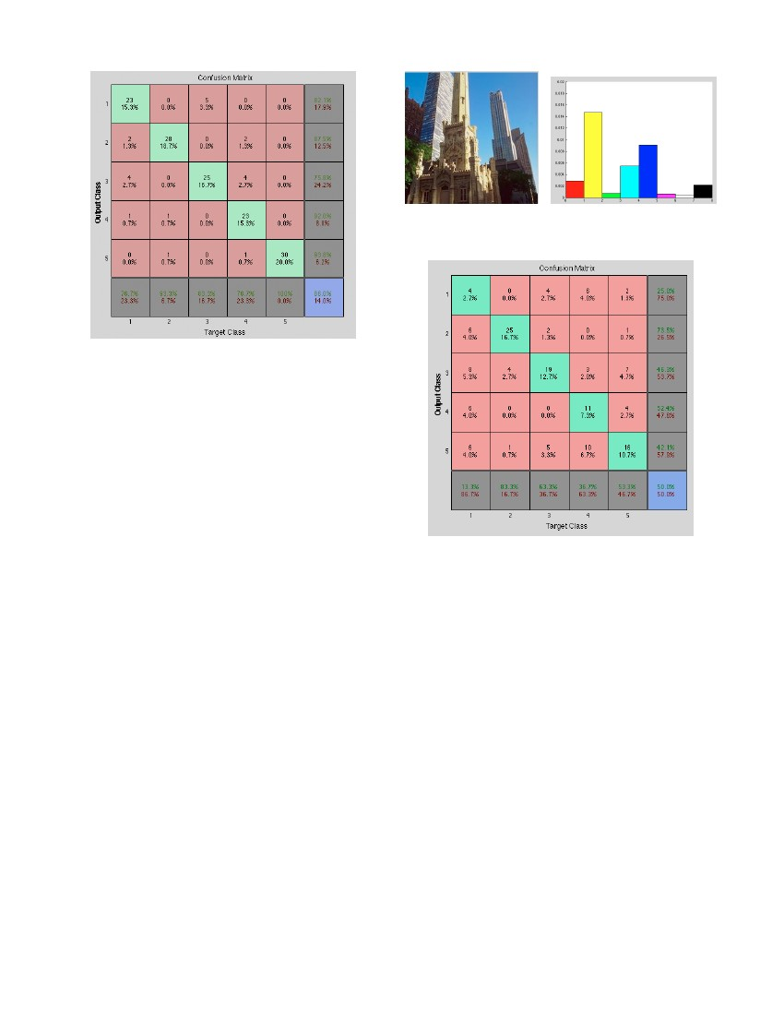
4
for each pixel of the image.
2. Once the CT values of all pixels of the image have
been calculated, the histogram of the CT values is
computed using function CENTRIST4lines.m. This
histogram is the Centrist feature vector.
The CT value is calculated as follows: for each pixel, the
8 neighbours are compared to the center pixel value and
are assigned value 0 if they are greater than the pixel
value, 1 is they are smaller (see ﬁgure 6). Concatenating
all 8 bits give a binary number with value between 0 and
255. This is the CT value. Figure 7 shows the obtained
CT values for two adjacent pixels. It reveals dependencies
between CT values: the right neighbour of a pixel for a
given 3x3 pixels square will be the left neighbour for the
adjacent 3x3 square. Thus if the right neighbour pixel
value is greater (for example in ﬁgure 7, 37 > 36), then
the left neighbour will be smaller for the next CT value
computation (36 < 37).
Fig. 5. Confusion matrix for Gabor-Gist. 1-Coast; 2-Forest; 3-
Highway; 4-Mountain; 5-Tall Building
IV.2. Parameters
The Matlab function CTfeatureVector.m creates the
feature vector Centrist for all training and testing images
and saves data in a .mat ﬁle. In order to obtain the best
performance, diﬀerent parameters have to be tested. The
following parameters have been used for the rest of the
project since they produced the smallest misclassiﬁcation
rate:
• Downsizing the image to a ratio of 0.125. This reduces
the computation time and keeps the relevant informa-
tion of the image.
• Dividing the image into 4 lines seemed to be the most
eﬃcient: instead of considering the image as a whole
entity, it is divided into 4 lines. The Centrist vector
is computed for each line and the 4 Centrist vec-
tors are concatenated to obtain the Centrist vector
of the image. This enable to keep some of the spa-
tial information in the image that can help classifying
scenes.
• Histogram Intersection Method. In order to compare
the Centrist feature vector of a tested image to the
mean of the Centrist vectors of images belonging
to a given class, the measure of diﬀerence must be
calculated. This can be done using the Euclidian dis-
tance or the Histogram Intersection Method. The His-
togram Intersection Method generated much better
classiﬁcation than when using the Euclidian distance.
• 40 bins are used for the histograms. This is the best
compromise between the classiﬁcation rate, the com-
putation time and the size of the generated Centrist
feature vector.
IV.3. Results with a Neural Network
Fig. 7. CT value calculation for 2 adjacent pixels. Red circles reveal
dependencies between CT values: because 36 < 37 when calculating
CT value of green box center pixel, the relation will be 37 > 36 when
calculating CT value of blue box center pixel
Fig. 6. CT value calculation
est accuracy - only 70% of correctly classiﬁed images. See
confusion matrix in ﬁgure 5 for more details. Comparably
to Gabor histogram approaches, Gabor-Gist over color
image performed signiﬁcantly better. Hence, Gabor-Gist
features will be used for the hybrid feature vector creation.
IV. Centrist Descriptor
IV.1. Computation of CT Value
CENsus TRansform hISTogram (Centrist), is a visual
descriptor used to identify scene categories [6]. The Cen-
trist feature vector is perfectly suitable for scene classiﬁ-
cation because this descriptor encodes the structural prop-
erties of a given image without keeping the detailed textu-
ral information that would not be helpful for this problem.
The Centrist feature vector of a given image is calcu-
lated in 2 distinct steps:
1. First, the CT value for each pixel is computed. This
is performed by a call to Matlab function compare.m
When fed into a neural network, the Centrist method
gives a misclassiﬁcation rate of 14% (see ﬁgure 8) which is
a correct value for a single classiﬁcation method. Note that
even if the overall misclassiﬁcation rates for Gabor-Gist
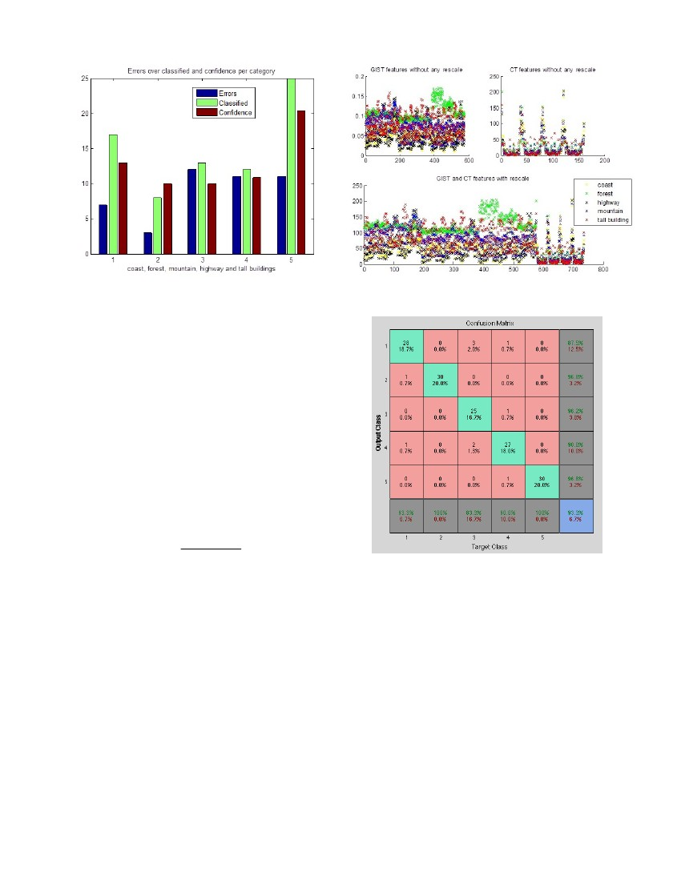
5
Fig. 9. a) Tall Building Image and b) Color Histogram Image Rep-
resentation
Fig. 8. Confusion matrix for CENTRIST features. 1-Coast; 2-Forest;
3-Highway; 4-Mountain; 5-Tall Building
(ﬁgure 5) and for Centrist (ﬁgure 8) are both 14%, the
misclassiﬁcation rates vary for each category. This means
that the method used will aﬀect each categorie’s misclassi-
ﬁcation rate. For example the Tall Building category has a
misclassiﬁcation rate of 0% with the Centrist descriptor
and 3.3% with Gabor-Gist. At the opposite, the Coast
category is much better classiﬁed if Gabor-Gist is used
(13.3% instead of 23.3% with Centrist).
V. Color Histogram
In scope of scene classiﬁcation problem, color descriptors
cannot be considered reliable for the reason that colors are
the matter of constant change. The same scene appears
in diﬀerent colors depending on the time of the day or the
season for example.
A lot of papers still oﬀer color descriptors in the combi-
nation of texture descriptors and overall experiments show
that such combinations improve the performance of classi-
ﬁcation.
For this project, a simple color histogram descriptor was
implemented. The histogram is computed by counting the
number of pixels corresponding to the following colors: red,
yellow, green, cyan, blue, magenta, white and black. It is
performed ﬁrst through converting the image to HSV color
space and evaluating each plane in order to determine the
number of pixels belonging to each of the selected color
categories. The number of black and white pixels are esti-
mated through Saturation and Value planes, and the rest
of color categories are determined through Hue plane. Ev-
ery pixel color category is then normalized by dividing the
count of the pixels by the number of pixel in the image. A
8-bin color histogram formats 1x8 feature vector (see ﬁgure
9.b).
Classiﬁcation accuracy for color histogram features was
evaluated using MLP Neural Network (8 input, 8 hidden, 5
output neurons) using 150 testing images from ﬁve diﬀer-
Fig. 10. Confusion matrix for Color Histogram features. 1-Coast;
2-Forest; 3-Highway; 4-Mountain; 5-Tall Building
ent categories of scenes. Classiﬁcation error for color his-
togram descriptor is 50%, i.e. half of images were misclassi-
ﬁed (see ﬁgure 10). Color histogram features performed the
worst for Coast category images (only 13% accuracy), the
best performance is seen for Forest images (83% accuracy).
Experiments proved that color cannot be used as a reliable
feature for scene categorization problem, but as mentioned
before, our study is concerned with improving classiﬁca-
tion accuracy by adding color features to Gabor-Gist and
Centrist features and forming the hybrid feature vector
that is expected to provide the minimum misclassiﬁcation
rate.
VI. Hybrid Descriptors
VI.1. Method 1: Voting Algorithm
In order to combine the diﬀerent feature vectors, a vot-
ing algorithm has been coded in the Matlab function
votingAlgo. The ﬁle testVotingAlgoFunction.m can
be used to test the function using Gabor feature vector,
Gabor-Gist descriptor and Centrist feature vector, and
display the output. It can also run the tests several times
and give an average performance. For the voting algo-
rithm, training images are split randomly into a training
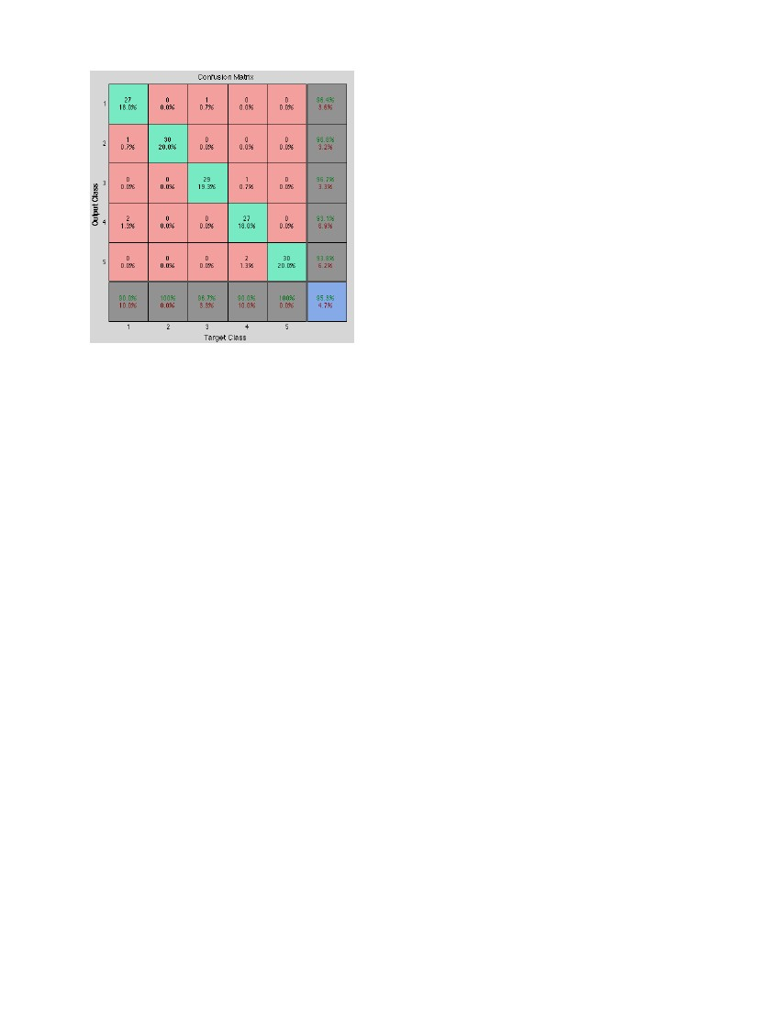
6
Fig. 11. Performance for the voting algorithm: results obtained for
classiﬁcation of 15 images of 5 diﬀerent classes
Fig. 12. a) Gabor-Gist and Centrist without rescale and b) Gabor-
Gist and Centrist after rescale
and a testing set with a chosen percentage. The results
for the voting algorithm were not as good as expected. In-
deed, ﬁgure 11 shows that a lot of images are misclassiﬁed,
knowing that there should be 15 images classiﬁed in each
category.
The following of the paper details the classical classiﬁer,
the neural network, that has been trained with the feature
vectors in order to solve the scene classiﬁcation problem.
VI.2. Method 2: Neural Network
The ﬁrst step that needs to be done in order to create the
hybrid feature vector is data scaling. Features extracted
with each approach have to be equally weighted. Scaling
values of vector b = [bmin , bmax ] in the range of vector a =
[amin , amax ] values is performed using equation (1).
y = (x − bmin )
amax − amin
+ amin
bmax − bmin
(1)
Fig. 13. Confusion matrix for Gabor + CENTRIST hybrid features.
1-Coast; 2-Forest; 3-Highway; 4-Mountain; 5-Tall Building
where x is the initial value of vector b and y the rescaled
value of b in the range of a.
Figure 12 shows the eﬀect of applying equation (1) to
Gabor-Gist and Centrist feature vectors. This will
later enable the neural network to take them both into
account with same weight.
In previous stages, input matrices for each descrip-
tor were built and targets stayed the same for the same
dataset. In order to create the hybrid vector of features, all
that needs to be done is appending one matrix to another
([features1; features2]) and train the MLP network on the
new combined input matrix. The same procedure applies
for testing input matrix. In the following sub-sections,
diﬀerent combinations of features are analysed and classi-
ﬁcation accuracy is evaluated.
2.1 Gabor + Centrist Hybrid Results
The confusion matrix produced by testing the images
based on Gabor-Gist and Centrist descriptors is shown
in ﬁgure 13. It indicates potential improvement from com-
bining the features together (if mutual classiﬁcation com-
pensation occurs). On practice, signiﬁcant classiﬁcation
error disease occurred, and overall accuracy raised from
86% (ﬁgure 5) to 93.3%(ﬁgure 13). Features compensated
each other deﬁciencies and didn’t create any noticeable
confusion.
2.2 Gabor + Color Histogram Hybrid Results
Our team was pretty sceptical about combining color
histograms with features extracted with other methods,
as color histograms performed poorly. The guess was that
color histogram features would add more confusion than do
any good. However, experiments demonstrated slight per-
formance improvement from 86% accuracy (Gabor-Gist
only) to 89.3% (Gabor-Gist and color histogram). Gabor-
Gist and color histogram hybrid improved the correct
7
the complementarity of the methods used: because Gabor-
Gist, Centrist and color histogram have their maximum
eﬃciency for diﬀerent categories, the overall accuracy is in-
creased when they are combined.
Finally, we can say that this combination of three descrip-
tors is very interesting and competitive when compared to
other existing methods that can be found in scene classiﬁ-
cation papers.
References
[1] J. Daugman, “Complete discrete 2-d gabor transforms by neural
networks for image analysis and compression,” Acoustics, Speech
and Signal Processing, IEEE Transactions on, vol. 36, no. 7, pp.
1169–1179, 1988.
[2] D. Dunn, W.E. Higgins, J. Wakeley, “Texture segmentation using
2-d gabor elementary functions,” IEEE Transactions on Pattern
Analysis and Machine Intelligence, vol. 16, no. 2, 1994.
[3] P. Kruizinga, N. Petkov, S.E. Grigorescu, “Comparison of texture
based features based on gabor ﬁlters,” IEEE Conf. on Image
Analysis and Processing, 1999.
[4] A.K. Jain, F. Farrokhnia, “Unsupervised texture segmentation
using gabor ﬁlters,” Pattern Recognition, vol. 24, 1991.
[5] C. Siagian, L. Itti, “Rapid biologically-inspired scene classiﬁca-
tion using features shared with visual attention,” IEEE Trans-
actions on Pattern Analysis and Machine Intelligence, vol. 29,
no. 2, Feb 2007.
[6] Jianxin Wu, James M. Rehg, “Centrist: A visual descriptor for
scene categorization,” IEEE Transactions on Pattern Analysis
and Machine Intelligence, vol. 33, no. 8, August 2011.
Fig. 14. Confusion Matrix for Gabor-Gist + Centrist + Color his-
togram hybrid features. 1-Coast; 2-Forest; 3-Highway; 4-Mountain;
5-Tall Building
classiﬁcation rate for Coast, Highway and Mountain cat-
egories. However, performance decreased for Forest and
Tall Building scene classes.
2.3 Centrist + Color Histogram Hybrid Results
Adding the color histogram descriptor to Centrist also
improved the classiﬁcation accuracy. Improvement oc-
curred for Coast, Forest and Mountain categories but a
performance decrease was observed for Highway and Tall
Building scene classes. Not that for both Gabor-Gist and
Centrist, adding color histogram feature vector improves
Coast and Mountain correct classiﬁcation and reduces Tall
building classiﬁcation. However, the behaviour diﬀers for
Highway and Forest images.
2.4 Gabor + Centrist + Color Histogram Hybrid Re-
sults
Finally, all the features extracted with the three meth-
ods studied in this work (Gabor-Gist, Centrist and color
histogram) were combined. As expected, this is the combi-
nation that performed the best. Compared to Gabor-Gist
+ Centrist hybrid, the classiﬁcation accuracy increased
from 93.3% (ﬁgure 13) to 95.3% (ﬁgure 14). Signiﬁcant
improvement occurred for Highway category (83.3% cate-
gory accuracy to 96.6%), and slight accuracy decrease was
demonstrated in Coast category (93.3% to 90% class accu-
racy).
VII. Conclusion
This paper shows that combining Gabor-Gist descrip-
tor with Centrist and color histogram feature vectors is
particularly eﬃcient for scene classiﬁcation. Indeed, the
accuracy obtained using a Neural Network as a classiﬁer is
above 95% for the provided dataset of images. This very
high rate of correctly classiﬁed images is made possible by

