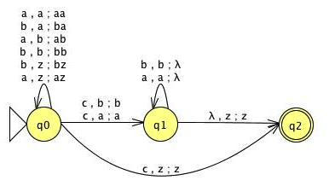
4) Construct nPDA’s that accept the following languages on $∑$ = {a, b, c}.
b)
L = { wcw: w$∈${a, b}*}

c) L = {$a^{n}b^{m}c^{n+m}$: n$≥$0, m$≥$0}
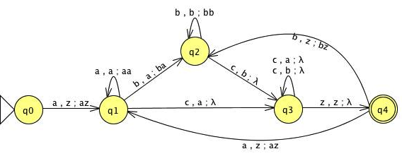

5) Construct an nPDA corresponding to the grammar
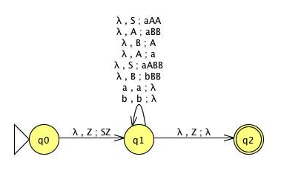
S -> aABB|aAA,
A-> aBB|a,
B -> bBB|A

7) Show that the following languages on $∑$ = {a, b, c} are not context-free
c) L = {$a^{n}b^{j}c^{k}$: k = jn}
Assume, for a contradiction, that L is regular so that there is a pumping length m>0.
Choose w = $a^{m}b^{m}c^{2m}$ so that w$∈$L and |w|$≥$ m.
Let w = uvxyz be the decomposition of w given by the pumping lemma.
- |vxy| $≤$ m.
- |vy| $≥$ 1.
- u$v^{i}$x$y^{i}$z∈L for all i≥0.
Choose i = 0 so that $w_{i}$ = u$v^{0}$x$y^{0}$z.

First case, $w_{i}$ = $a^{m-|vy|}b^{m}c^{m^{2}}$ and $w_{i}∉$L. Second case, $w_{i}$ = $a^{m-|v|}b^{m-|y|}c^{m^{2}}$ and $w_{i}∉$L. Third case, $w_{i}$ = $a^{m}b^{m-|vy|}c^{m^{2}}$ and $w_{i}∉$L. Forth case, $w_{i}$ = $a^{m}b^{m-|v|}c^{m^{2}-|y|}$ and $w_{i}∉$L. Fifth case, $w_{i}$ = $a^{m}b^{m}c^{m^{2}-|vy|}$ and $w_{i}∉$L.
Choose any i>0, cases where v or y contain a sequence of ab’s or bc’s where $w_{i}$ would be $a^{+}{ab}^{+}ba^{+} b^{+}$ or $a^{+}{ab}^{+}bc^{+} {cb}^{+}c^{+}$.
All cases contradict our assumption and hence, L is not context free grammar.
8) Determine whether or not the following languages are context-free.
a) L = {$a^{n}$w$w^{R}a^{n}$: n$≥$0, w$∈${a,b}*}
Assume, for a contradiction, that L is regular so that there is a pumping length m>0.
Choose W= $a^{m}a^{m}b^{m}b^{m}a^{m}a^{m}$ where w=$a^{m}b$ and $w^{R}$ = $ba^{m}$ and so that W$∈$L and |W|$≥$ m.
Let W= $a^{m}a^{m}b^{m}b^{m}a^{m}a^{m}$ -> W= $a^{2m}b^{2m}a^{2m}$ = $a^{p}b^{p}a^{p}$where p = 2m.
Let W = uvxyz be the decomposition of W given by the pumping lemma.
- |vxy| $≤$ m.
- |vy| $≥$ 1.
- u$v^{i}$x$y^{i}$z∈L for all i≥0.
Based on the above characteristics we can have the following cases:

First, v or y contain at least an “a” in the first block of a’s. If we pump up or down, it will result in a mismatch with the second block of a’s because we cannot have any a’s from the second block in v or y.

Second, v or y contain at least an “a” in the last block of a’s. As in the first case v or y cannot reach all a’s in the beginning of the string.

Third, v and y contain b’s; If we pump up, it would violate the n≥ m constraint since the number of b’s will exceed the number of a’s in each part because |vy|>0.
Finally, all cases contradict our assumption and hence L is not context free grammar.

