- List the operating characteristics for the following display technologies: raster refresh system, vector refresh systems, plasma panels, and LCDs.

- Raster Refresh system: in which an electron beam is swept across the screen, one row at time, from top to bottom. Each row is referred to as a scan line. As the electron beam moves across a scan line, the beam intensity turns on and off to create a pattern of illuminated spots. This electronic beam makes the screen a number of lines, drawing each one through the scan lines and refreshing the picture every interval of time from the refresh buffer " frame buffer".
The Raster Refresh system characteristics can be shown as follows:
- The pixels in the screen are not related.
- Fast in loading image.
- The quality of the screen decreases when magnifying.

- Vector Refresh system: The system cycles through the set of commands in the display file, drawing each component line in turn. After all line drawing commands have been processed, the system cycles go back to the first command in the list.
The Vector Refresh system characteristics can be shown as follows:
- The pixels in the screen are related by function ex: function of lines.
- Slow in loading because it needs some processing in its function.
- The quality of the image is increased when magnifying.

- Plasma panels: Constructed by filling the region between two glass panels with a mixture of gases that usually includes neon, a series of vertical conducting ribbons is placed on one gas panel and a set of horizontal conducting ribbons is built into the other glass panel.
The Plasma panels’ characteristics can be shown as follow.
    - New technology (10/1/2005).
    - The screen is divided into little small cells.
    - Have high resolution although the screen size may be small.
LCDs: Operating that produces a picture by passing polarized light from the surroundings or from an internal light source through a liquid-crystal material that can be aligned to either block or transmit the light. These are similar in construction to a plasma panel. The only difference is that the enfilement of the region between the glass plates is with a phosphor, such as zinc sulphide doped with manganese, instead of a gas.
LCD is made up of 6 layers
- Vertical polarizer plane layer of thin grid
- Wires layer of LCDs
- Layer of horizontal grid wires
- Horizontal polarizer and finally a reflector

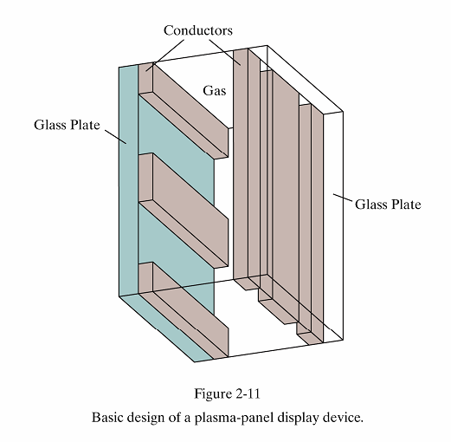
Plasma Panels
 Constructed by filling the region between two glass plates with a mixture of gases that usually includes neon.
 A series of vertical conducting ribbons is placed on one glass panel, and a set of horizontal conducting ribbons is built into the other glass panel.
 Firing voltages applied to an intersecting pair of horizontal and vertical conductors cause the gas at the intersection of the two conductors to break down into a glowing plasma of electrons and io ns.
 Picture definition is stored in a refresh buffer, and the firing voltages are applied
to refresh the pixel positions per second.
Thin-film electroluminescent display
(at the intersection of the conductors) 60 times

Random-scan Systems
The organization of a simple random-scan system (sometimes called vector scan system). An application program is input and stored in the system memory along with a graphics package. Graphics commands in the application program are translated by the graphics package into a display file stored in the system memory. This display file is then accessed by the display processor to refresh the screen. The display processor cycles.
Calligraphic or Random Scan display system
 Also called Vector, Stroke, Line drawing displays.
 Characters are also made of sequences of strokes (or short lines).
 Vectored – electron beam is deflected fro m end-point to end-point.
 Random scan - Order of deflection is dictated by the arbitrary order of the display commands.
 Phosphor has short persistence – decays in 10-100 ms.
 The display must be refreshed at regular intervals – minimum of 30 Hz (fps) for flicker-free display.
 Refresh Buffer – memory space allocated to store the display list or display program for the display processor to draw the picture.
 The display processor interprets
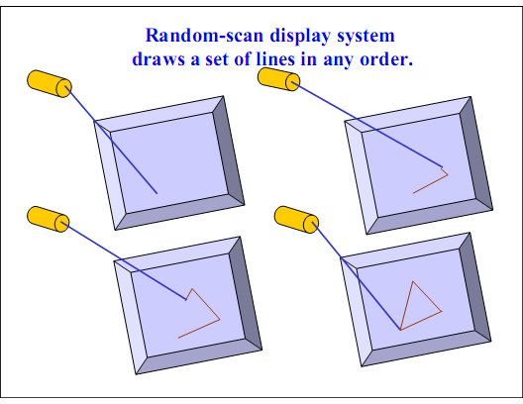
the commands in the refresh buffer for plotting.
-  The display processor must cycle through the display list to refresh the phosphor.
-  The display programhas commands for point- , line–, and character plotting.
-  The display processor sends digital and point coordinate values to a vector generator.
-  The vector generator converts the digital coordinate values to analog voltages for the beam- deflection Circuits.
o The beam-deflection circuits displace the electron beam for writing on the CRT’s
phosphor coating.
o Recommended refresh rate is 40 – 50 Hz.
 Scope of animation with segmentation – mixture of static and dynamic parts of a picture.
Raster Refresh Graphics Displays
In Storage tube and calligraphic line drawing refresh display, a straight line can be drawn directly fromany addressable point to another address.
Raster graphics device is a matrix of discrete cells, each of which can be made bright.
In Raster device, a straight line cannot be drawn straight. It can only be approximated by a series of dots close to the path of the line.
Only in the special cases of completely horizontal, vertical or for square pixels 45o, a straight line of dots result. All other lines appear as a series of stair steps; this is called ―aliasing‖ or ―jaggies‖.
Frame Buffers
-  It is a large contiguous piece of computer memory. At a minimum there is one memory bit for each pixel (picture element / pels) in the raster. This amount of memeory is called a bit plane.
-  1024 x 1024 element square raster requires 210x210=220 bitsinasinglebitplane(Black&White).
-  Framebufferisadigitaldevice.
-  Raster CRT is an analog device.
-  Conversion from digital representation to an anolog signal takes place when information is read fromtheframebufferanddisplayedontherasterCRT. ThisprocessisdonebyDAC(Digitalto Analog Converter).
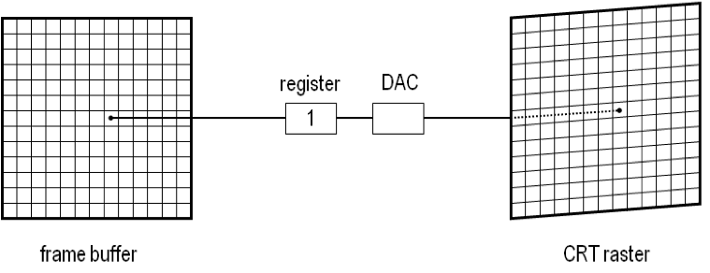
❖
Fig. Single Bit Plane Black and White Frame Buffer
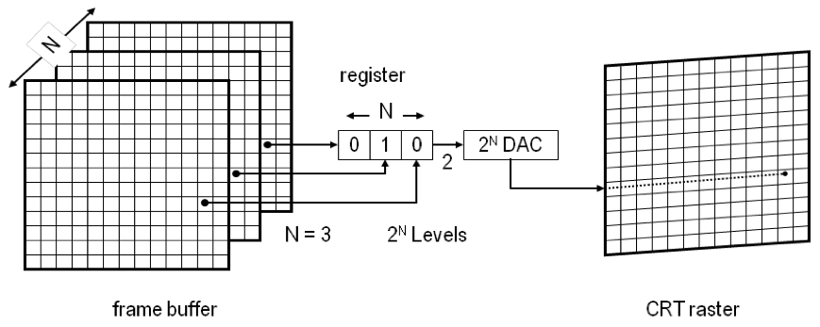
Fig. Frame buffer for N-bit nanochrome display
Color Or Gray Levels
-  The intensity of each pixel is controlled by a corresponding pixel location in each of the N bit planes.
-  The binary value (0/1) from each of the N bit planes is loaded into corresponding positions in a register.
-  The resulting binary number is interpreted as in intensity level between 0 (dark) and 2N -1 (full intensity).
-  This is converted to an analog voltage between 0 and maximum voltage if the electron gun by
the DAC. (e.g) 3 bit plane frame buffer for a 1024 x 1024 raster requires 3 x 1024 x 1024 memory bits.
Increasing the intensity levels (Lookup Table)
-  Upon reading the bit planes in the frame buffer, the resulting number is used as index into the lookup table. The lookup table must contain 2N entities.
-  Each entry in the lookup table is W bits wide. W can be greater than N. but only 2N entries (intensities) available.
2N intensity(totally)available.
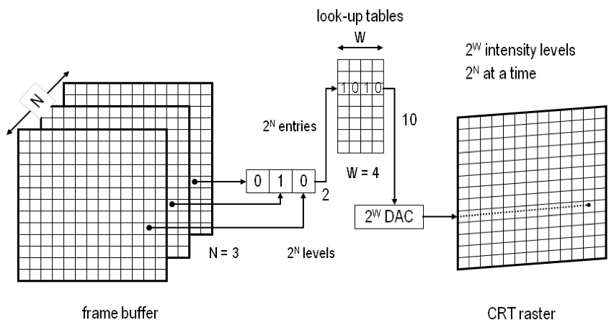
Color CRT
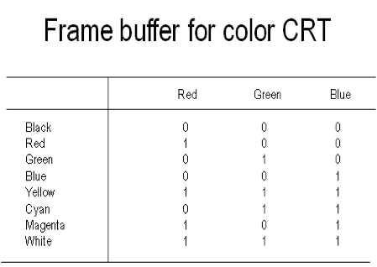
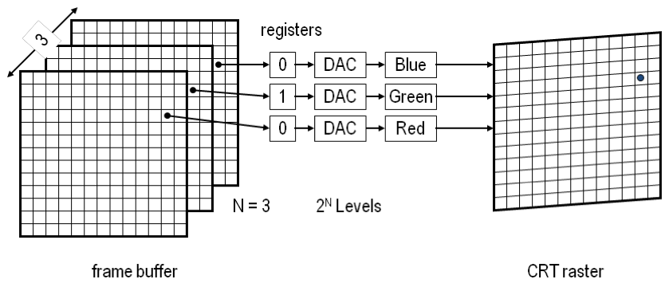
CATHODERAYTUBE BASICS
The CRT used in video monitors is shown. (link : http://www.tpub.com/neets/book6/21e.htm for more details).

Deflected electron beam
Electron focusing lens Horizontal deflection amplifier
Cathode Vertical deflection amplifier
A cathode is heated until e lectrons ―boil‖ off in a d iverging cloud (e lectrons repel each other because they have the same charge).
Electron beam
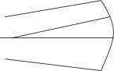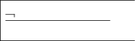
Anode (Phosphor Coating)
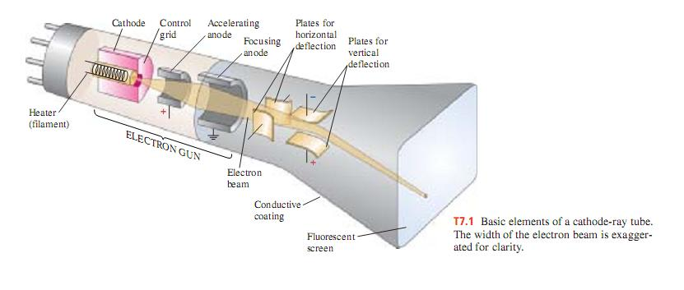

Components ofCRT

Electron Gun Control Electrode Focusing Electrode Deflection Yoke (Electrostatic deflection plate / Magnetic deflection coil) Phosphor coated screen.
Electron Gun: Electron gun contains two basic parts: a heater and a cathode. Electrons are generated by a cathode heated by an electric filament, surrounding the cathode is a control grid, with a hole at one end to allow electrons to escape. The control grid is kept at a lower potential than cathode. These electrons (negatively charged) are accelerated towards the CRT screen by a high positive voltage applied near the screen or by an accelerating anode.
Control Electrode: it is used to regulate the flow of electrons. The control electrode is connected to an amplifier which, in turn, is connectd to the output circuitry of the computer, thus allowing the computers to control the electron beam in turned off and on. We can modify the rate of flow of electrons, or beam current and control brightness of image.
Focusing Electron: this system helps to converge the cloud of electrons to a small spot as it touches the CRT screen. It is used to create a clear picture by focusing the electrons into a narrow beam, in other words, it focuses the electron beam to converge into a small spit as it strikes the phosphors. Otherwise the electrons would repel each other, and beam would spread out as it approaches the screen. Focusing is accomplished wih either electric or magnetic fields. The effect of the focusing electrode on the on the electron beam resembles that of a flass lens on the light waves.
Electrostatic focusing is commonly used in television and co mputer graphics monitors. With electrostatic focusing, the electron beam passes through a positiviely charged metal cylinder that forms an electrostatic lens. The action of the electrostatic lens focuses the electron beam at the center of the screen, in exactly the same way that an optical lens focuses a beamof light at a particular focaldistance.
Deflection Yoke:
Itisusedtocontrolthedirectionoftheelectronbeam. Thedeflectionyokecreatesanelectricor magnetic field which willbend the electron beamas it passes through the field.
When electrostatic deflection is used, two pairs of parallel plates are mounted inside the CRT envelope. One pair of plates is horizontal deflection to control the vertical deflection and other pair is mounted vertical to control horizontal deflection. In an alternative way for deflection system CRT are constructed with magnetic deflection coils, these coils are mounted on the outside of the CRT envelope. Two pairs of coils are used. One pair is mounted on the top and bottom of the neck and other pair is mounted on opposite side to the neck. Horizontal deflection is accomplished with one pair of coils and vertical deflection by the other pair. In a conventional CRT the yoke is connected to a sweep or scan generator. The scan generator sends out an oscillatory sawtooth current that, in turn causes the deflection yoke to apply a varying magnetic field to the electron beam’s path. The oscillatory voltage potential causes the electron beamto move across the CRT’s screen in a regular pattern.
Phosphorous-coatedscreen:
Inner surface of CRT is coated with special crystals called phosphors, which have a unique property that allows the entire system to work. Phosphors glow when they are attacked by a high -energy electron beam. They continue to glow for a distinct period of time after being exposed to electron beam. The glow given off by the phosphor during exposure to the electron is known as flouorescenec, the continuing glow given off after the beam is removed is known as phosphorescence and the duration of phosphorescence is known as the phosphors persistence.
Lower persistence phosphors require higher refresh rate to maintain a picture on the screen without flicker. Higher persistence phosphors require lower refresh rate to maintain a picture on screen without flicker. A phosphor with low persistence is useful for animation. A phosphor with high persistence is useful for display highly complex.

Working of CRT: A CRT is an evacuated glass tube, with a heating element on one end and a phosphor coated screen on the other end. When a current flows through this heating element, called a filament, the electrons actually boil off the filament. These free electrons are attracted to a strong positive charge from the outer surface of the focusing anode cylinder (sometimes called an electrostatic lens). However, the iside of the cylinder has a weaker negative charge. Thus, when the electrons head towards the anode they are forced into a beam and accelerated by the repulsion of the inner cylinder walls in just the way that waterspeedsupwhenitflowsthroughasmallerdiameterpipe. Bythetimetheelectronsgetouttheyare going so fast that they fly past the cathode they were heading for.
The next thing that the electrons run into are two sets of weakly charged deflection plates. These plates have opposite charges, one positive and the other negative. While their charge is not strong enough to capturethefastmovingelectronstheydoinfluencethepathofthebeam. Thefirstsetdisplacesthebeam up and down, and the second displaces the beam left and right. The electrons are sent flying out of the neck of the bottle, until they smash into the phosphor coating on the other end of the bottle. The i mpact of this collision o the outvalence bands of the phosphor compounds knowcks some of the electrons to jump into another band. This causes a few photons to be generated, and results in our seeing a spot on the CRT’s face.
Phosphor differinfollowing.
➢ Color : Different phosphors have different colors. ➢ How long they continue to emit light (the excited electrons returning to the ground
state) after the CRT beam is removed Persistence -- It is defined as the time it takes the emitted light fromthe screen to decay to one-tenth of its original intensity.
Interlacing :
On some raster scan systems each frame is displayed in two passes using an interlaced refresh procedure. Inthefirstpass,thebeamsweeps(oddscanlines)acrosseveryotherscanlinefromtoptobottom. Then after the vertical re-trace, the beamsweeps out the remaining (even scan lines). Interlacing of the scan lines in this way allows us to see the entire screen displayed in one-half the time it would have taken to sweep across allthe scan lines at once fromtop to bottom. Interlacing is primarily used with slower refreshing rates.

- Determine the resolution (pixels/cm) in the x and y directions for the video monitor in use on your system.

The Aspect ration is: 800 / number of lines.

- Determine the aspect ratio, and explain how relative proportions of objects can be maintained when resizing objects.

Some answers of qustions in P.82,P.83

- 2-1) List the operating characteristics for the following display technologies: raster refresh systems, vector refresh systems, plasma panels, and LCDs.

- 1)Raster Refresh system: in which the electronic beam makes the screen a number of lines, and draw each one and this is called (scan lines) and the picture is refreshed every interval of time from the refresh buffer " frame buffer".
- It's characteristics.
- a)The pixels in the screen aren't related. b)Fast in loading image. c)when magnifying, the quality of the screen decreases.
- 2)Vector Refresh system: a)The pixels in the screen are related by function ex: function of lines. b)slow in loading because t need some processing in its function. c)when magnifying the quality of the image is increase.
- 3)Plasma panels: a)new technology (10/1/2005). b)the screen is divided into little small cells. c)have high resolution although the screen size may be small.

- 2-2) List some applications appropriate for each of the display technologies in Exercise 2-1.

- 2-3) determine the resolution (pixels per centimeter) in the x and y directions for the video monitor in use on your system. Determine the aspect ratio, and explain how relative proportions of objects can be maintained on your system.

- The Aspect ration is: 800 / number of lines.

- 2-4) Consider three different raster systems with resolutions of 640 by 480 ,1280 by 1024, and 2560 by 2048. what size frame buffer (in bytes ) is needed for each of these systems to store 12 bits per pixel? How much storage is required for each system if 24 bits per pixel are to be stored?

- The answer: a) (640*480*12) / 8 b)(1280*1024*12) / 8 c)(2560*2048*12) / 8 we can replace 12 with 24.

- 2-5) suppose an RGB raster system is to be designed using an 8 inch by 10 inch screen with a resolution of 100 pixels per inch in each direction. If we want to store 6 bits per pixel in the frame buffer, how much storage (in bytes) do we need for the frame buffer?

- (800*10000*6) / 8 byte

- 2-6)how long would it take to load a 640 by 480 frame buffer with 12 bits per pixel, if 10^5 bits can be transferred per second? How long would it take to load a 24- bit per pixel frame buffer with a resolution of 1280 by 1024 using this same transfer rate?

- 640*480*12=100000x. after solution x= 3686400 / 100000=36.864 seconds.

- 2-7) suppose we have a computer with 32 bits per word and a transfer rate of 1 mip (one million instructions per second). How long would it take to fill the frame buffer of a 300 dpi(dot per inch) laser printer with a page size of 8 ½ inches by 11 inches?

- 2-8) Consider two raster systems with resolution of 640 by 480 and 1280 by 1024.how many pixels could be accessed per second in each of these systems by a display controller that refreshes the screen at a rate of 60 frames per second? What is the access time per pixel in each system?

- 60*640*480=18432000 pixels. 60*1024*1280=78643200 pixels.

- 2-9) suppose we have a video monitor with a display area that measures 12 inches across and 9.6 inches high. If the resolution is 1280 by 1024 and the aspect ration is 1, what is the diameter of each screen point?

- 2-10) How much time is spent scanning across each row of pixels during screen refresh on a raster system with a resolution of 1280 by 1024 and a refresh rate of 60k frames per second?

- 2-11) Consider a no interlaced raster monitor with a resolution of n by m(m scan lines and n pixels per scan line), a refresh rate of r frames per second ,a horizontal retrace time of t(horiz), and a vertical retrace time of t(vert) .what is the fraction of the total refresh time per frame spent in retrace of the electron beam?

- 2-12) what is the fraction of the total refresh time per frame spent in retrace of the electron beam for a no interlaced raster system with a resolution of 1280 by 1024, a refresh rate of 60 hz, a horizontal retrace time of 5 microseconds, and a vertical retrace time of 500 microseconds?

- 2-13) Assuming that a certain full-color (24-bit-per-pixel)RCB raster system has a 512 by 512 frame buffer, how many distinct color choices (intensity levels) would we have available? How many different colors could we display at any one time?

- 2-14) Compare the advantages and disadvantages of a three-dimension monitor using a varifocal mirror to those of a stereoscopic system.

- 2-15) List the different input and output components that are typically used with virtual reality systems. Also ,explain how users interact with a virtual scene displayed with different output devices , such as two dimensional and stereoscopic monitors.

- 2-16) Explain how virtual reality systems can be used in design applications. What are some other applications for virtual reality systems?

- 2-17) List some applications for large-screen displays.

- 2-18) Explain the differences between a general graphics system designed for a programmer and one designed for a specific application, such as architectural design.

- General graphics system: This is the system that provides a library functions that help programmer in designing his displaying using some programming language as C++ and Java. One of these General graphics systems is OpenGL (graphics library).
Special graphics system: This system help user who hasn't experience in programming to create shapes and views by simple interface consist of buttons and menu (For example : Photo Shop )

- 2-19) Explain the differences between the OpenGL core library, the OpenGL utility , and the OpenGL utility Toolkit.

- OpenGL core :This library function provide programmer functions that help him in constructing primitives shapes, geometric transformation and attributes
OpenGL Utility :This library function provide programmer functions that help him in constructing complex shapes and quadric shapes. It provides other advanced operations such as processing
OpenGL Utility Toolkit :This library function provides functions that Implement the interacting with screen window.

- 2-20) What command could we use to set the color of an OpenGL display window to light gray? What command would we use to set the color of the display window to black ?

- glClearColor (0.4, 0.4, 0.4, 0.0); // set the displayed
glClearColor (0.0, 0.0, 0.0, 0.0); // set the displayed window color black

- 2-21) List the statements needed to set up an OpenGL display window whose lower-right corner is at pixel position (200,200), with a window width of 100 pixels and a height of 75 pixels.

- glutCreatWindow ("My Window");
glutInitWindowPosition();
glutInitWindowSize(100,75);

- 2-22) Explain what is meant by the term" OpenGL display callback function"

- . Its answer in the last paragraph in section 2.9. But I can not understand it.

- 1-List the operating characteristics for the following display technologies: Raster refresh systems, vector refresh systems, plasma panels and LCDs .
Raster Refresh systems:
Electron beam is swept across the screen, one row at time, from top to bottom. Each row is referred to as a scan line. As the electron beam moves across a scan line, the beam intensity turns on and off to create a pattern of illuminated spots.
Vector Refresh Systems:
The system cycles through the set of commands in the display file, drawing each component line in turn. After all line drawing commands have been processed, the system cycles back to the first command in the list.
Plasma Panels:
Constructed by filling the region between two glass panels with a mixture of gases that usually includes neon, a series of vertical conducting ribbons is placed on one gas panel and a set of horizontal conducting ribbons is built into the other glass panel.
LCDs:
Operating by producing a picture by passing polarized light from the surroundings or from an internal light source through a liquid-crystal material that can be aligned to either block or transmit the light.
3-Determine the resolution (pixels per centimeter) in the x and y directions for the video monitor in use on your system. Determine the aspect ratio, and explain how relative proportions of objects can be maintained on your system.
Resolution is the number of points per centimeter that can be plotted horizontally and vertically although it is often simply stated as the total number of points in each direction. In my system the resolution is: 1280 by 1024 pixel The aspect ratio is an another property of video monitors which is now often defined as the number of pixels columns divided by the number of scan lines that can be displayed by the system (sometimes the term aspect ratio is used to refer to the number of scan lines divided by the number of pixel columns) aspect ratio can also be described as the number of horizontal points to vertical points (or vise versa) necessary to produce equal- length lines in both directions on the screen
14-Compare the advantages and disadvantages of three-dimensional monitor using a varifocal mirror to those of a stereoscopic system.
The varifocal mirror vibrates, it changes focal length. These vibrations are synchronized with the display of an object on a CRT so that each point on the object is reflected from the mirror into a spatial position corresponding to the distance of that point from a specified viewing location. This allows us to walk around an object or scene and view it from different sides. Disadvantages: stereoscopic system does not produce true three-dimensional images. Advantages: it does provide a three-dimensional effect by presenting a different view to each eye of an observer so that scenes do appear to have depth.
15-List the different input and output components that are typically used with virtual-reality systems. Also, explain how users interact with a virtual scene displayed with different output devices, such as two-dimensional and stereoscopic monitors.
Some of the input components that are typically used with the virtual-reality systems are: Data Gloves, Digitizers, Touch panels and Light pens Some of the output components that are typically used with the virtual-reality systems are: Stereoscopic monitors The user interact with a virtual scene displayed with different output devices by obtaining two views of the scene generated with viewing directions along the lines from the position of each eye (left and right) to the scene. We can construct the two views as computer-generated scenes with different viewing positions, or we can use a stereo camera pair to photograph an object or scene when we simultaneously look at the left view with the left eye and the right view with the right eye the two views merge into a single image and we perceive a scene with depth.
16-Explain how virtual-reality systems can be used in design applications. What are some other applications for virtual-reality systems?
With virtual-reality systems, designers and others can move about and interact with objects in various ways. Stereoscopic viewing is a component in virtual-reality systems, where users can step into a scene and interact with the environment.
17-List some applications for large screen displays.
Theses systems are designed for presenting graphics displays at meetings conferences, conventions, tradeshows, retail stories, museums and passenger terminals.
18-Explain the differences between a general graphics system designed for a programmer and one designed for a specific application, such as architectural design.
General programming package provides a library of graphics functions that can be used in programming languages such as C, C++, Java, or Fortran. Basic functions in a typical graphics library include those for specifying picture components (straight lines, polygons, spheres, and other objects), setting color values, selecting views of a scene, and applying rotations or other transformations. Some examples of general graphics programming packages are GL (Graphics Library), OpenGL, VRML (Virtual-Reality Modeling Language), Java 2D, and Java 3D Special-Purpose packages are designed for nonprogrammers who want to generate pictures, graphs, or charts in some application area without worrying about the graphics procedures that might be needed to produce such displays. The interface to a special-purpose package is typically a set of menus that allows users to communicate with the programmers in their own terms. Examples of such applications include artist’s painting programs and various architectural, business, medical, and engineering CAD systems.
19-Explain the difference between the OpenGL core library, the OpenGL Utility, and the OpenGL Utility Toolkit.
- In the OpenGL core library, function names are prefixed with gl, and each component word within a function name has its first letter capitalized.
- The OpenGL Utility provides routines for setting up viewing and projection matrices, describing complex objects with line and polygon approximations, displaying quadrics and B-splines using linear approximations, processing the surface-rendering operations, and other complex tasks. Function names are prefixed with glu.
- The OpenGL Utility Toolkit provides a library of functions for interesting with any screen-windowing system. Function names are prefixed with glut.
21-List the statement needed to set up an OpenGL display window whose lower-right corner is at pixel position (200,200), with a window width of 100 pixels and a height of 75 pixels.
The glutInitWindowPosition function give an initial location for the top-left corner of the display window, so we calculate the top-left corner and it is (100,125).
The statements are:
glutInit (&argc, argv); // the GLUT initialization
glutCreateWindow ("Window Title "); // for the title bar
glutInitWindowPosition(100,125); //location from top-left corner
glutInitWindowsize (100, 75); //size of display window
22-Explain what is meant by the term "OpenGL display callback function".
The procedure that we set up to describe our picture is referred to as a display callback function. In general, OpenGL programs are organized as a set of callback functions that are to be invoked when certain actions occur.
- 6) Assuming that a certain full color (24­bits per pixel) RGB raster system has a 512­by­512 frame buffer, how many distinct color choices (intensity levels) would we have available? How many different colors could we display at any one time?

- Total number of available colors is 2^24 = 16, 777, 216.
- Using a different color for each screen pixel, we could display it as follows:
- 512^2 = 262, 144 colors at any one time.

