The project is organized as follows:
BRD introduction
Related work
BRD measures between Histograms
Ratio distance and other methods
This project bases on using bin-ratio information to categorize images. This information is collected from ratios between bin values of histograms that are used for scene and category classifications. In this project was used a new histogram dissimilarity in order to use such information, also better known as bin-ratio dissimilarity or BRD. The implementation of this project shows that BRD provides several advantages for category and scene classification tasks.
Three of these advantages are being specified in this project:
First, BRD is robust to cluttering, partial occlusion and histogram normalization.
Second, BRD captures rich co-occurrence information while enjoying a linear computational complexity.
Third, BRD can be easily combined with other dissimilarity measures. An example of this can be seen later on in this project, where L1 and x2 methods are combined to gather complimentary information for category and scene classification tasks in the bag-of-words framework.

Histogram-based representation captures rich information that leads to powerful discriminability. This is widely used in category and scene classification such as in the bag-of-words models [8, 9, 21, 32, 37, 34]. In these models an image is represented by the histogram or frequency of vectors of quantized visual words. Then, these histograms are combined with classifiers or support vector machines for classification.
This project’s development has two major steps:
First, partial matching information: This is an important issue in category and scene classification because images often contain a large amount of clutter that is irrelevant, and brings noises to the object-of-interest.
Second, co-occurrence information: In histogram-based representation co-occurrence captures the correlation information between pairs of histogram bins or joint frequency of visual words in the bag-of-words model.
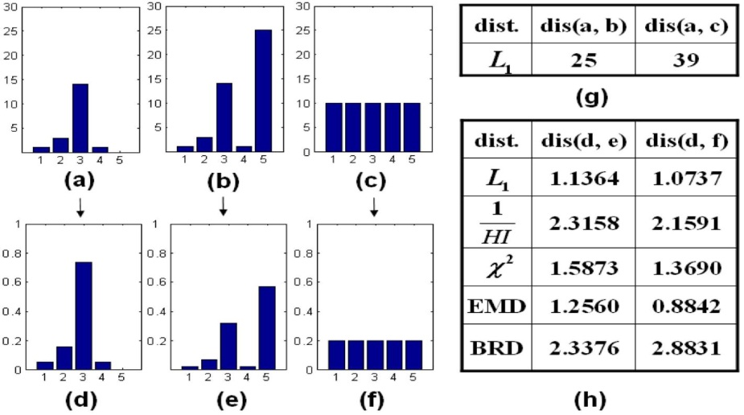
This is a toy example:
- And (b) represent histograms of images from the category. While bins 1 to 4 in (a) and (b) are exactly the same, bin (5) is very different because it simulates a large background clutters in the image where (b) is computed.

To address these two major steps bin-ratio information is used. Bin-ratios are defined as the ratios between bin values of histograms. These are robust to normalization, cluttering, and also capture co-occurrence information between all pairs of bins. The results of this are two histograms whose BRD is defined as the sum of squares of normalized differences over all matrix elements.
As shown in figure 1(h), the new dissimilarity handles simultaneously partial matching and normalization problems.
This project work is related to the histogram-based representations under the bag-of-words framework [8, 9, 21, 32, 34, etc.]. The distances allow cross bin comparison between two histograms to gain robustness to histogram distortions. This project emphasizes three recent matching algorithms with high-order statistics:
Second-order programming
Matching
High order matching
They formulate the hyper-graph matching problem as the maximization of a tensor function over all permutation of the features tuples. This work is inspired by the idea that dissimilarity measures use high-order information over different bins within a histogram.
This is the formula that they used to denote a normalized histogram hє$R^{n}$ with n bins in total.
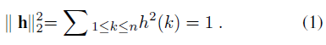
They also defined a ration matrix Hє$R^{nxn}$ to capture relationship between histogram bins.
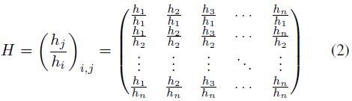
This ratio matrix is invariant to normalization since each element is invariant to normalization. Each matrix element hj/hi measures the relation between elements hi, hj in the original histogram.
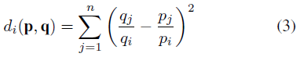
Now, to compare the ith bins of two histograms as seen in the formula p and q the dissimilarity was defined as the sum of squared differ (SSD) between ith rows of corresponding ratio matrices, that is.

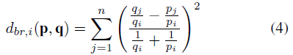
However, this definition sufferes is unstable when pi and qi are close to zero, and to avoid this problem they included the normalization part to define the followin dissimilarity.

This normalization makes the whole dissimilarity variant to normalization. However, the gaining in robustness is mor important and strict normalization is not necessary. This is why they defined the bin-ratio dissimalirity BRD dbr(p,q) between two histograms p and q as:
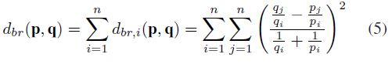
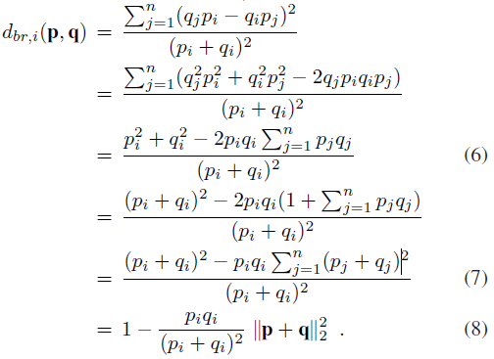
Even though BRD seems to have quadratic complexity, it can actually be computed in a simpler way as it is shown in the following image.

Using equation 8, they came up with a simpler formulation as shown below. 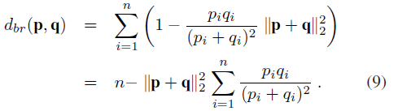
Using this equation, BRD can be calculated in linear time. This is because items have linear complexities and the combination of them take only constant time.

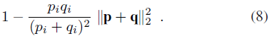
From equation (8) we saw that when either pi or qi is zero and the other is small noise, we have dbr(p,q) =1. This observation implies that BRD can be sensitive to small noises, and since histograms measures can handle small noises the combine them with other method for complementary gaining.
Below is an example of how they first combined BRD with L1 distance, known to be robust to outliers small noises.
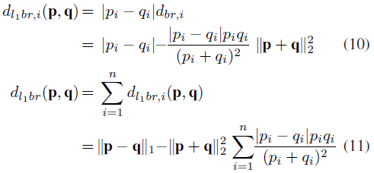

From equation (10) whe on bins pi,qi is zero, L1-BRD adopts L1 distance making more robust than the original BRD.
Another combination example represented below is with X^2.
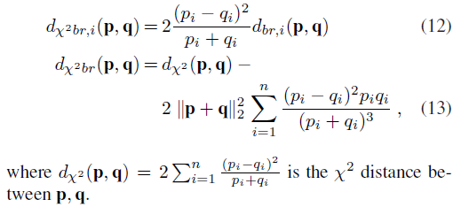

Both L1-BRD and X^2-BRD are more efficient solutions to larger scale tasks due to their linear computational complexities.
For classification tasks, they combined the BRD technique with the standard bag-of-words model. To achieve this, they first built BRD kernels using extended Gaussian Kernels as shown below.
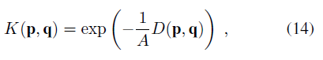

Here, D(p,q) is a dissimilarity when p and q are histograms of images, and A is a scaling parameter that can be determine by using validation.
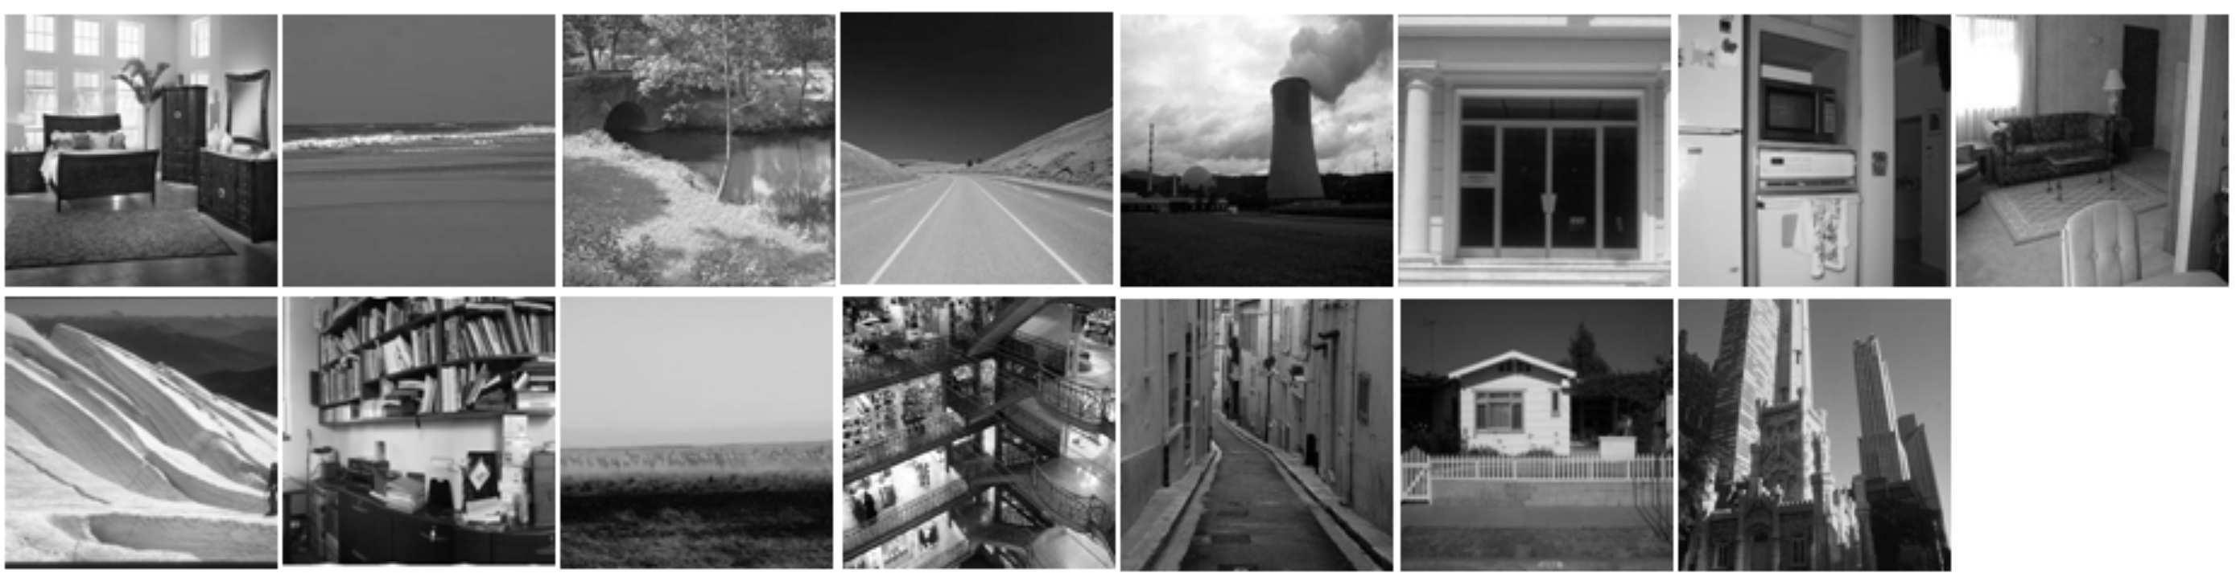
The scene-15 dataset is compiled from several datasets and, it contains 15 categories and 4485 scene images with 200 to 400 images per class. This dataset was used for comparison with different methods and the result is shown below.
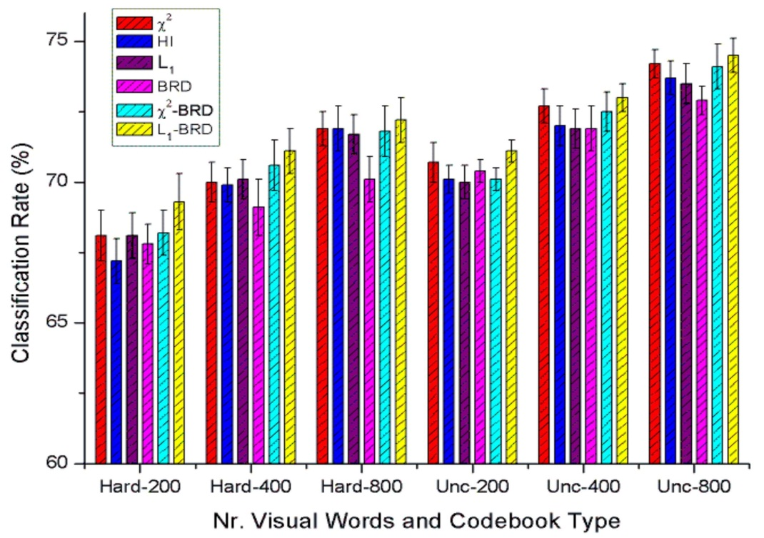

For image features, they used SIFT descriptors sampled on a regular grid with spacing of eight pixels. SIFT descriptors are calculated on 16x16 patches, and according to their scale BRD performs comparable to previous tested method.

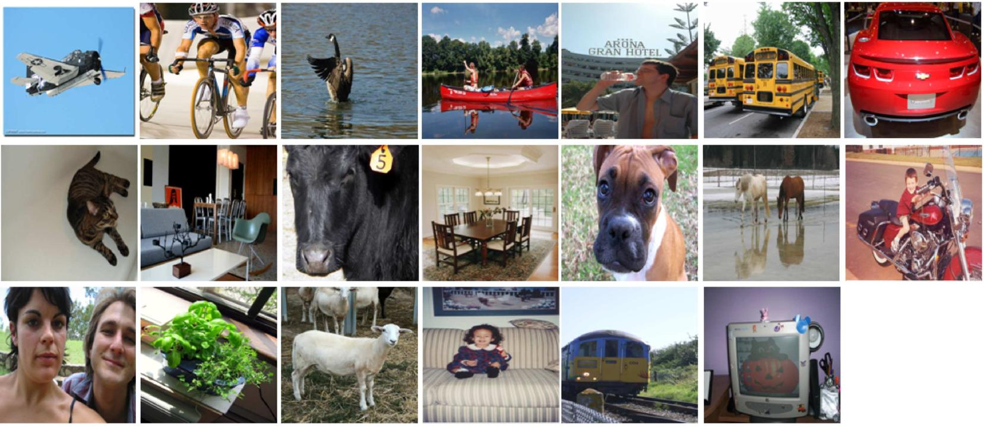

 | Validation Set |  |  |  | Test Set
 | Winner | L1-BRD |  | Winner | Best | L1-BRD
 | [32] |  |  | [32] | achieved [7]
Aeroplane | 79.2 | 77.5 |  | 79.5 | 81.1 | 79.7
Bicycle | 39.7 | 44.6 |  | 54.3 | 54.3 | 56.3
Bird | 49.1 | 50.8 |  | 61.4 | 61.6 | 61.1
Boat | 62.6 | 63.0 |  | 64.8 | 67.8 | 66.5
Bottle | 18.8 | 20.1 |  | 30.0 | 30.0 | 30.6
Bus | 52.3 | 55.1 |  | 52.1 | 52.1 | 56.5
Car | 55.5 | 54.8 |  | 59.5 | 59.5 | 58.9
Cat | 56.2 | 55.1 |  | 59.4 | 59.9 | 58.1
Chair | 42.5 | 45.4 |  | 48.9 | 48.9 | 49.4
Cow | 24.1 | 26.4 |  | 33.6 | 33.6 | 34.9
Dining table | 25.7 | 29.0 |  | 37.8 | 40.8 | 43.5
Dog | 32.8 | 36.8 |  | 46.0 | 47.9 | 47.0
Horse | 47.1 | 49.5 |  | 66.1 | 67.3 | 67.5
Motorbike | 39.9 | 41.5 |  | 64.0 | 65.2 | 62.9
Person | 88.0 | 87.2 |  | 86.8 | 87.1 | 86.6
Potted plant | 24.1 | 28.5 |  | 29.2 | 31.8 | 33.2
Sheep | 30.8 | 31.2 |  | 42.3 | 42.3 | 42.7
Sofa | 38.7 | 38.7 |  | 44.0 | 45.4 | 45.7
Train | 67.4 | 68.5 |  | 77.8 | 77.8 | 76.2
TV/monitor | 50.9 | 54.5 |  | 61.2 | 64.7 | 64.8
mean AP | 46.3 | 47.9 |  | 54.9 | N/A | 56.1
Table 1. Category and average precisions of the winner’s method and the proposed method on the validation set and the test set of PASCAL 2008.

This table shows L1-BRD outperforms the winner’s method in 14 out of 20 categories as well as the average performance.

This table shows that L1-BRD get the best average equal error rate, improving results by 2.2%.
 | Motor | Bike | Person | Car | Average
Winner (Â²) [8] | 79.8 | 72.8 | 71.9 | 72.0 | 74.1
Winner (EMD) [37] | 79.7 | 68.1 | 75.3 | 74.1 | 74.3
PDK [19] | 76.9 | 70.1 | 72.5 | 78.4 | 74.5
L1-BRD | 79.1 | 75.4 | 73.9 | 78.2 | 76.7
Table 2. Correct classification rates (at equal error rates) on the PASCAL challenge 2005 Test Set 2.

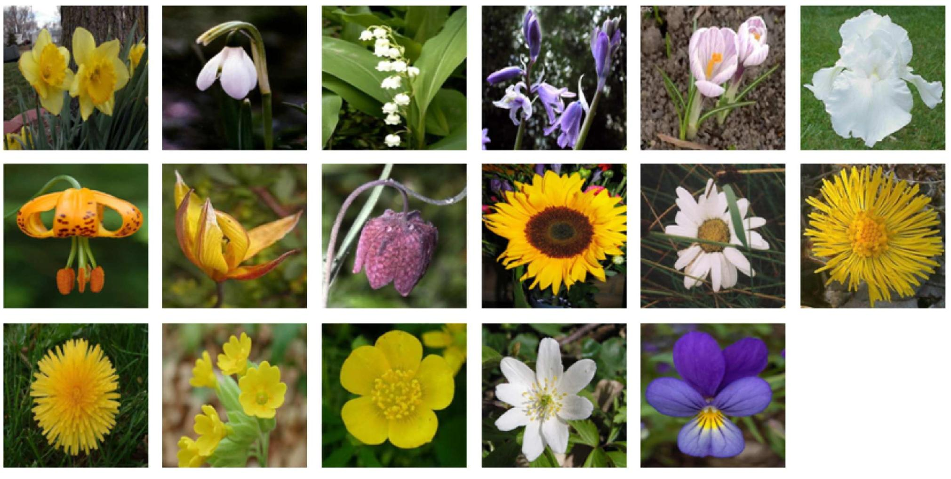

This dataset contains images from 17 flower categories with 80 images per category.
Methods | Recognition rate
Nilsback and Zisserman [22] | 71.76§1.76
Varma and Ray [33] | 82.55§0.34
Zisserman [23] | 88.33 |  | 0.3
Nilsback and |  | §
2
Â | 87.45§1.13
L1-BRD | 89.02§0.60
Table 3. The average of per-class recognition rates of different methods on the Oxford flower dataset.

The table above summarizes the recognition accuracies of different methods along with L1-BRD method, as we can see L1-BRD achieves the best performance.
Their main contribution lies in using bin-ratio information for category and scene classification because it is robust to background clutter and histogram normalization, captures rich co-occurrence information while having a linear computation complexity as we could see, and the advantage of being easily combined with different distances that provide complimentary information.

