Research Project Proposal
Department of Computer Science
Advanced Computer Vision
Rochester Institute of Technology (RIT)

Author:
Piter Garcia INSTRUCTOR:
Dr. Roger S.Gaborski

SUBMITION DATE:
02/12/2013

SUBJECT: SCENES CATEGORIES
(Color Histogram Descriptor & Other Descriptors)

Enclosed is my final project research and implementation, Scene Categories. This project is submitted for partial fulfillment of my project requirement to my outlined plan to pursuit through the project problem formulation with functional requirement, alternative solution generation with different approaches, project management, milestones, task assignments and deliverables.

Date | Weekly Updates | Details
01/15 | First Week | Start of Color Histogram descriptor.  Image input and dataset selection.  Separately obtain color histograms and combine them for classification.
01/22 | Second Week | First results of Color Histogram descriptor without any particular improvement.  Test images and try the algorithm with at least two classes for verification purpose to improve it before classifying all classes.
01/29 | Third Week | First results of Color Histogram descriptor.  Classification results applying only color histograms. This is only to prove that color histogram by itself is not taken into consideration when it comes to classifying images. This is better explained later on this project.
02/05 | Forth Week | Due to personal reasons and health condition, the author of this project could not provide this update. The reasons were further explained via email.
02/12 | Final Project Report | Update from the Forth Week was covered, as well as the over all result of the Color Histogram Descriptor and its improvement with other descriptors.  Comparison of Color Histogram combined with other approaches, and Conclusion.

TIMELINE:

Abstract
Bin ratio provides important information that in my project to categorize images. This information is collected from ratios between bin values of histograms that are used for scene and category classifications. Histogram dissimilarity or Bin Ratio Dissimilarity (BRD) is providing this project with the following advantages for category and scene classification tasks.
These advantages are as follows: First, BRD is robust to clustering, partial occlusion and histogram normalization. Second, BRD captures rich co-occurrence information, and has a linear computational complexity. Third, BRD can be easily combined with other dissimilarity measures to gather complementary information for categorization and scene classification tasks in the bag­of­words framework or any other different method.
In fact, Histogram based representation captures rich information that is used in category and scene classification such as in the bag­of­words models, where each image will be represented by the histogram of its quantized visual words to be combined with classifiers or support vector machines for categorization purpose.
CONTENT

- Introduction………………………………………3
- Color Histograms………………………………...3
- Color Histograms + Other Descriptors…………7
- Feature Vectors and Classifiers…………………8
- Concatenation Method…………………………..8
- Hierarchical Method………………………….....9
- Comparing Results………………………………9
- Conclusion……………………………………....10
Introduction

Scene classification is different from conventional object detection. The scene is a unique composition of several objects related and organized in an unpredictable layout. Relationships between objects and their organization mostly define the scene class. This makes classification task even more difficult because computers are unable to ‘understand’ such relationships. Object based judgment is able to provide satisfactory results for man­made scenes as the object functional representation may itself supply sufficient information for labeling a scene. The situation turns out to be more complicated when classifying natural scenes. In natural scenes, separate object detection does not provide enough information to relate the image to a particular category.
As a result, my study aims to obtain a high accuracy of scene classification by creating an advanced feature vectors based on color histograms combined with other methods or descriptors to improve the scene classification. The goal of this project is to produce feature vectors that describe the scene as accurately as possible. The color histogram feature extraction method is being first examined alone, and then combined with features obtained with other methods and tested on accuracy improvement.

COLOR HISTOGRAM:

In scope of scene classification problem color descriptors cannot be considered reliable because colors are the matter of constant change. The same scene appears in different colors depending on the time of a day or a season. A lot of papers still offer color descriptors in the combination of texture descriptors and overall, experiments show that such combination improves the performance of classification. Using Bin-ratio provided important information used in our project to categorize images. This information is collected from ratios between bin values of histograms that are used for scene and category classifications.

These advantages are as follows:

BRD is robust to clustering, partial occlusion and histogram normalization. It captures rich co-occurrence information, has a linear computational complexity, and easy to combine with other dissimilarity measures to gather complementary information for categorization. In our histogram-based representation, each image is represented by the histogram of its quantized visual words to be combined with classifiers for categorization purpose.

Histogram Development and Approaches:

First, partial matching information was an issue in scene classification because images contained clutter, which brought noises to the object of interest. Second, co-occurrence information captured the correlation information between pairs of histogram bins in the bag-of-words model. These approaches emphasized three matching algorithms such as the second-order programming, matching, and high order matching. As a result, two histograms BRDs summed up the squares of normalized differences over matrix elements. The cross-bin distances allow comparison between histograms to gain robustness and distortions for better scene categorization. A distance measure between two histograms use applications such as feature selection, image indexing, retrieval, pattern classification, and clustering. We propose a distance between sets of measurement values as a measure of dissimilarity of two histograms with three versions of the univariate histogram, such as nominal, ordinal, and modulo.

We describe the color and texture feature spaces, and the representation of their distributions. Color is the perceived differences between individual nearby colors used to implement the Euclidean distances between the color coordinates. In Texture, the color is a purely pointwise property of images. This involves a notion of spatial extent, a single point has no texture. Frequency-domain texture descriptors refer only to the frequency, and it is content in a local neighborhood of the point.

Image Representation & Distributions

The distribution of feature appearances of a region is described in the distribution of features and individual feature vectors. Because histograms are used as non–parametric estimators of empirical feature distributions high–dimensional feature spaces a regular binning results in poor performance. This caused issues such as coarse binning dulls resolving power, and fine binning leading to statistically sample sizes for most bins. A partial solution is offered by first adaptive binning, whereby the histogram bins are adapted to the distribution. Second, inducing the binning by a set of prototypes.

Adaptive histograms are defined by f(i;I)= $\left|\left\{\overset{→}{x}:I=\arg{min} \right.\left.\left\|I\left(\overset{→}{x}\right)-Cj\right\|\right\}\right|$, where $I\left(\overset{→}{x}\right)$ denotes the feature vector at image location. Here, the histogram entry f (i;I) corresponds to the number of image pixels in bin i. For this implementation we first restrict the notation to complete images for convenience. This caused issues in areas such as information about the joint occurrence of feature coefficients in the different dimensions slot, bin contents in the marginal may be significant; those in the full distribution are to spare. Partial solutions to these issues are. First, small sample sizes it may be better to estimate solely marginal histograms. Second, the marginal histograms of the coefficients in feature dimension rare given by f (i;I) = $\left|\left\{\overset{→}{x}:t_{i-1}^{r}<=\arg{min} \right.\left.\left\|I^{r}\left(\overset{→}{x}\right)≤t_{i}^{r}\right\|\right\}\right|$. Here, bin is defined as the feature interval $\left(t_{i-1}^{r}, \right.\left.{ t}_{i}^{r}\right]$, and the cumulative histogram for marginal histograms is defined as f (i;I) = $\left|\left\{{\overset{→}{x}: I}^{r}\left(\overset{→}{x}\right)≤t_{i}^{r}\right\}\right|$.

Implementing Dissimilarity Measures:

$D^{r}$(I; J) denotes a dissimilarity measure between the images J and I. $D^{r}$(I; J), the respective measure is applied only to the marginal distributions dimension in r. Four categories for dissimilarity measures:

i) Heuristic histogram distances for context of image retrieval:
The Minkowski-form distance Lp is defined by $D^{r}$(I; J) = ${\sum_{i}{\left({\left[f\left(i; I\right)+f (i; J)\right]}^{p}\right)}}^{1/p}$. The L1 Distance computed the dissimilarity scores between color images, the texture dissimilarity, and the Histogram Intersection (HI) that provides a generalization of L1 to partial matches.
ii) The Weighted-Mean-variance (WMV) was proposed, the distance is defined by $D^{r}$(I; J) = $\frac{\left[μ_{r}\left(I\right)- μ_{r}\left(J\right)\right]}{σ (μ_{r})}$ + $\frac{\left[σ_{r}\left(I\right)- σ_{r}\left(J\right)\right]}{σ (σ_{r})}$, where $μ_{r}\left(I\right)- μ_{r}\left(J\right)$ are the empirical means and $σ_{r}\left(I\right)- σ_{r}\left(J\right)$ are the standard deviations of the distributions.

For Image Segmentation the Kolmogorov-Smirnov distance (KS) was defined as the maximal discrepancy between the cumulative distributions by $D^{r}$(I; J) = $\max_{i }\left[f_{r}\left(i; I\right)-f_{r}\left(i; I\right)\right]$.
This provides a property to be invariant to arbitrary monotonic feature transformations. Another, a statistic of the Cramer/von Mises (CvM) defined based on cumulative distributions where the statistic is given by$\sum_{i}{\left(\frac{f\left(i;I\right)-f(i)}{f(i)}\right)}$, Where f (i) = $= \left[\frac{f\left(i;I\right)+f(i;J)}{2}\right]$denotes the joint estimate.

The classification performance was estimated in a leave–one–out procedure for all combinations of parameters. Issues are based on the cumulative histograms because their measures are defined only in one dimension and unable to exploit the ground distance in the full feature space.

Fig. 1
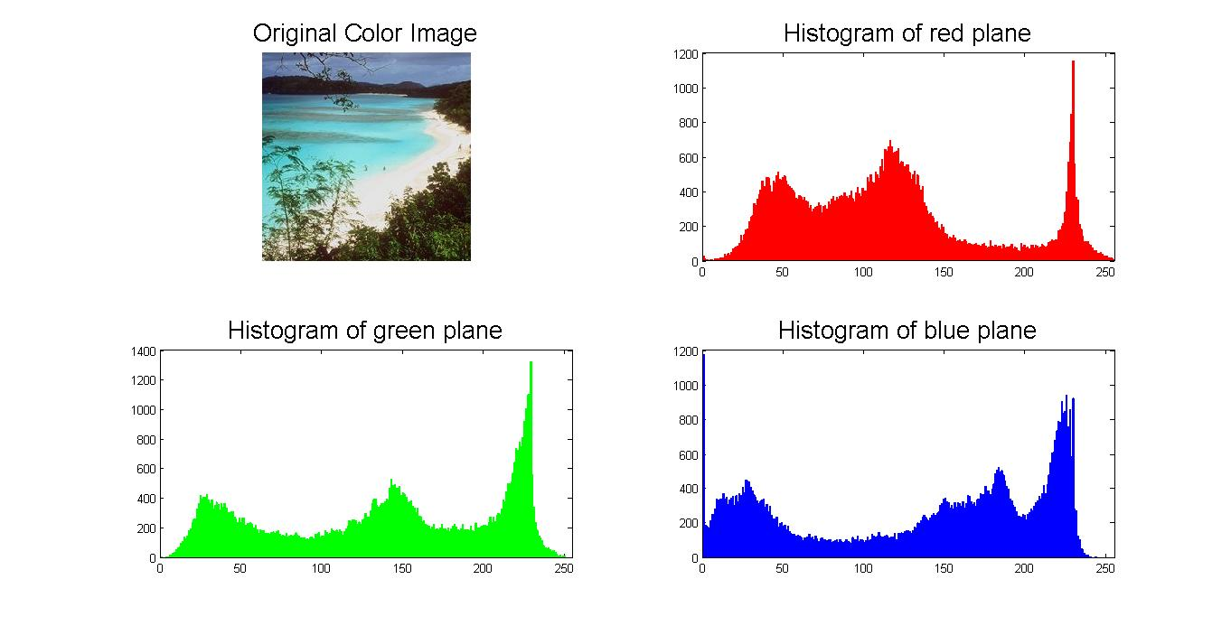
A possible solution could be employing BRD distance to improve results with the dissimilarity measure between two distributions. The progress in obtaining and analysing the bin information for feature selection, image, retrieval, pattern classification, and clustering was successful.

Combining Histograms
Fig 2.
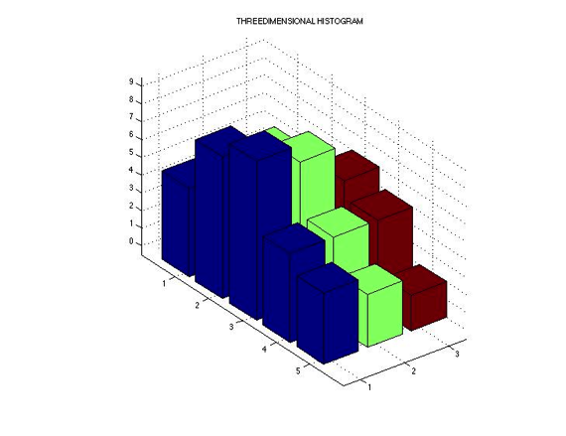

Feature Extraction
The Histogram is computed by counting number of pixels corresponding to following colors: red, yellow and blue. This is done by evaluating each plane in order to determine the number of pixels belonging to each of the selected color categories.

Below is an example of how the histograms combination of each image was used to compare different classes.

Comparing Coast & Tall-Building Classes
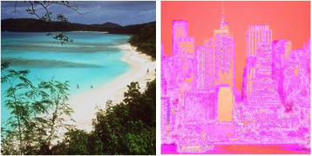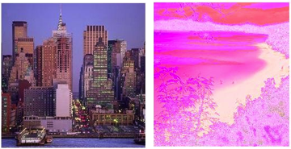
Coast & Tallbuilding Combined Histograms (Fig. 3)

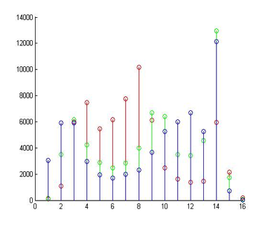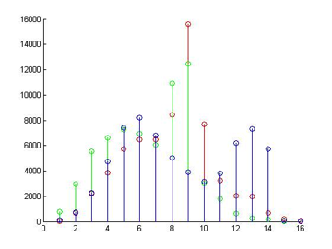
Combined Histograms (Fig. 4)

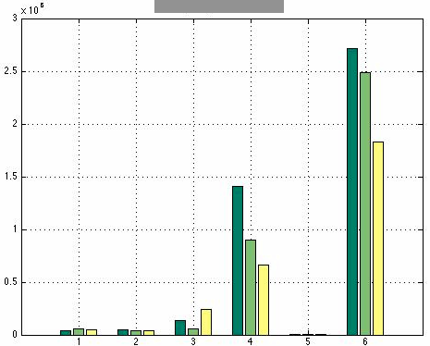
Fig 5.

Same Class Histogram Comparison
Below is another example of how histogram combination was used to compare images of same category.
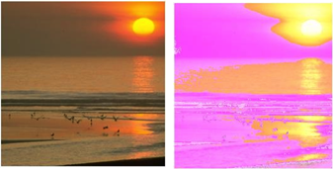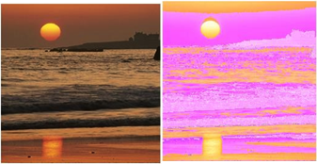
Coast Classes Combined Histograms (Fig. 6)
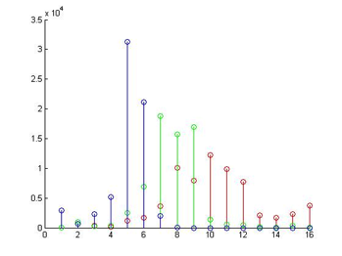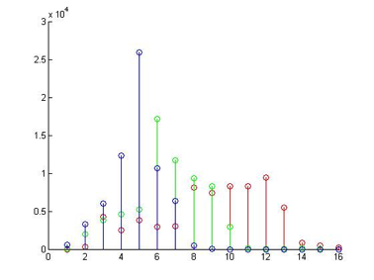
Coast Class Combined Histograms (Fig. 7)

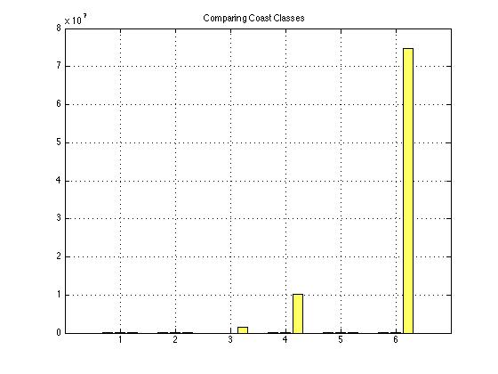Fig 8.
Every pixel color category was normalized. The models used to numeracally represent each color are the RGB, LAB, HSV, and YCrCb color spaces. The test results below show mis-classifications numbers of each method with a 4 x 30 matrix of test image.

Creating Set & Comparing Classes

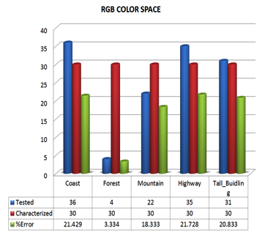
Fig. 9 - RGB Classification Test
Class Error %
Coast 21.4% Forest 3.33% Mautain 18.3% Highway 21.7% TallBuild 20.8%

Fig. 10 - HSV Classification Test
Class Error %
Coast 20.8%
Forest 0.83% Mautain 7.5% Highway 24.1% TallBuild 23.3%
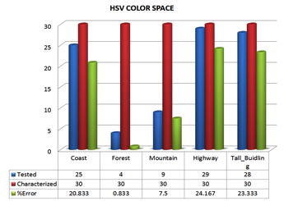
Fig. 11 - LAB Classification Test
Class Error %
Coast 18.7%
Forest 0.83% Mautain 3.33% Highway 13.3% TallBuild 4.16%

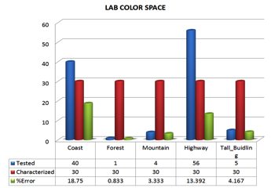
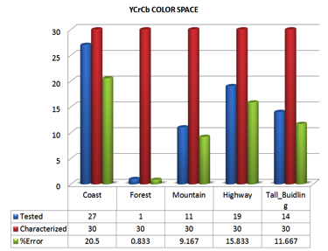
Fig. 12 - YCrCb Classification Test
Class Error %
Coast 20.5% Forest 0.83% Mautain 9.16% Highway 15.8% TallBuild 11.6%

The best performing color space was the LAB and YCrCb. Their best performing classes were forests, highways, and building. The figure below highlights the percentage error for the best case of all classes.
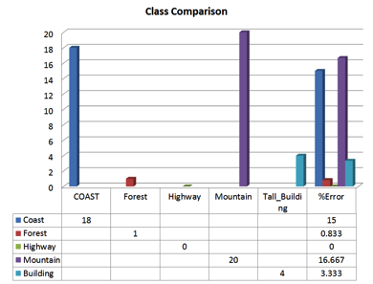
(Fig. 13)

As a perceptual feature, color composition had a clear impact on the separation between the chosen classes of outdoor scenes during the resolution experiment. The method for scene classification, color information is one of the oldest machine recognized features. The simplest method presented for scene categorization used a non-linear mapping of the RGB color space and histogram intersection, which provided adequate separation between indoors and outdoors scenes.

Average Intersection & Features Implementation
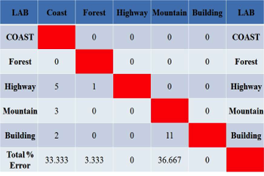
(Fig. 14)

For outdoor scenes classification the following approach was considered. Each of the training images was separated into 16 equally sized blocks to obtain a single square resolution of the image set for a better classification.

YCrCb has more misclassifications than LAB. That being said, if we combine LAB with a better accuracy it would make it the best candidate for classification.

Fig 15.
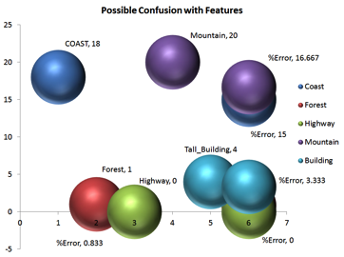

The inner four and bottom two blocks were averaged across each class to create a template once the blocks were separated. The template contained both color with limited spatial information. The selection of the middle and bottom blocks allowed any noise on the edge of the image or any non-discriminating features such as the sky to be removed from the average. Then, the average block histograms were used to compute the histogram intersection with each test image. The resulting histogram intersection, still partitioned into blocks, along with the test images histogram were concatenated and passed into a support vector machine for classification.

Final Color Histograms Results

The results of the color histogram test are organized by color space. The results listed below are the number of misclassifications over 150 test images with 30 test images per class. The numbers of principal components as well as the SVM kernels are listed as parameters.
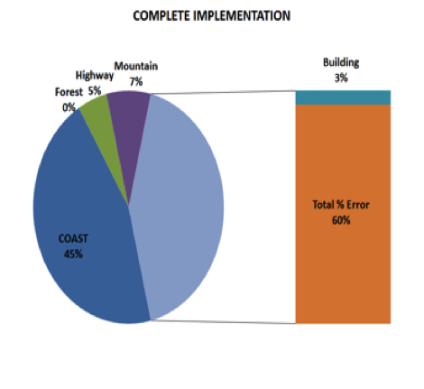
(Fig. 16)

The combination of other features will further improve the classification.

Color Histograms + Gabor

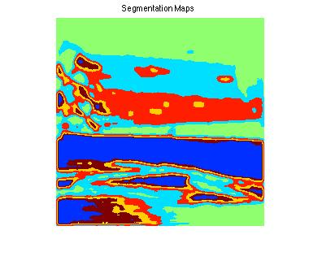
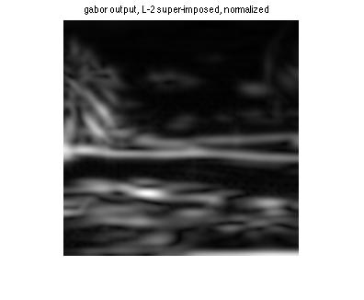
Gabor filters have long been used for texture detection, segmentation and texture synthesis. Appropriate Gabor filters can approximate these characteristics. Mathematically, a Gabor filter of a particular orientation and frequency is a sinusoid modulated by a Gaussian:

h(x; y) = s(x; y)g(x; y)
Gabor Filter Bank:

A filter bank of 3 orientation and 8 frequencies was considered for feature extraction, giving a total of 24 filters for feature vector creation. Images from each class in the test set were convolved with the filter bank to give a 256x1 feature vector. The criterion of selecting particular frequencies was based on the bin ratio dissimilarity. Features belonging to a set of natural images, like coast, appear considerably different than a set of artificial images, such as tall buildings. It was hypothesized that the feature set resulting from the filtered images would obtain a greater separation, while relying on other methods for local feature extraction. It should be mentioned that classes such a forest, which depict a uniform frequency distribution, are the ones best separated from other classes. On the other hand, coast does not perform well owing to sparse frequency distribution and many low frequency, blended features.
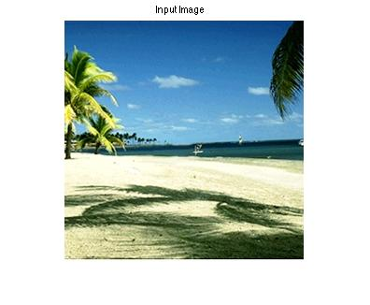
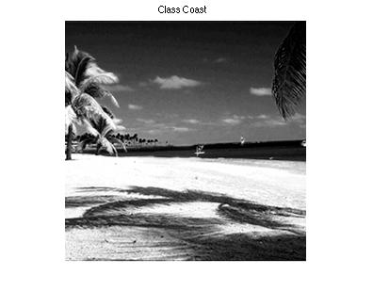
Gabor Energy

Gabor Energy features are just the absolute sum of the squares of the real and imaginary part. The feature vectors from the real and imaginary parts of the filters were combined to explore features not otherwise apparent with the Gabor filter. This is also known as motion energy, which is equal to the pair summation response with a phase difference of =2
Bag of Words

The first method investigated was a simple bag of words approach. This is a well-tested method that has performed well in the past, and fairly simple to implement. Firstly, SIFT Feature Descriptors are generated for each of the images in the entire training set, with no separation between classes. These are clustered to N different groups using k-means clustering. The end result of this is the Dictionary of words that will be used to generate and count the bag of words.

The feature vector generated from an individual image is a count of the matched words between the SIFT points on the image and the clustered points in the dictionary. Each of the SIFT descriptors found in a given image is matched to one of the cluster centers by simple 1-nearest neighbor. The index of the matching cluster is then taken, and the corresponding index in the bag is incremented. The end result is taken as the feature vector for later combination with the other feature sets.

The difficulty with this approach was to decide the number of clusters to create during the k-means clustering. As such, dictionaries were generated with 16, 32, 64, 128, and 256 clusters, with these dictionaries, the feature vectors were generated for each of the testing images. Once the feature vectors were computed, the average distance between each vector, and every vector of another class, was computed.

32 clusters

 | 1 | 2 | 3 | 4 | 5
1 | 40.53 | 76.21 | 44.05 | 46.72 | 56.22
2 | 76.21 | 43.04 | 76.69 | 60.07 | 65.41
3 | 43.02 | 76.69 | 46.67 | 51.04 | 61.45
4 | 46.78 | 60.07 | 51.04 | 37.91 | 51.61
5 | 57.21 | 65.41 | 60.45 | 51.61 | 56.35
256 Clusters
 | 1 | 2 | 3 | 4 | 5
1 | 28.793 | 33.025 | 31.065 | 24.807 | 36.169
2 | 33.025 | 26.120 | 36.382 | 30.05 | 36.916
3 | 30.069 | 34.382 | 31.672 | 31.206 | 36.356
4 | 27.807 | 30.405 | 31.216 | 24.783 | 24.416
5 | 36.169 | 36.914 | 36.956 | 34.416 | 40.012

It was decided that 64 clusters would be optimal for the separation between classes. 64 clusters gave the best separation between classes. The class separation was also considered to be sufficient for this method to be used in the classifier. Most classes were found to have good separation between themselves and the other classes, except tall buildings. This class had higher spread than distance to other classes.

The feature vectors were normalized before the distances were calculated. However, this resulted in worse separation across all examined cluster counts, so the method was discarded. The Bag of Words was evaluated as a single feature vector for classification. An SVM was trained for each class. All classes had strong responses along the diagonal. However, the results were much less promising when removing any classifications with more than one positive result:

 | 1 | 2 | 3 | 4 | 5
1 | 12 | 0 | 2 | 11 | 0
2 | 0 | 26 | 1 | 1 | 0
3 | 3 | 0 | 27 | 2 | 0
4 | 7 | 1 | 1 | 10 | 0
5 | 1 | 0 | 0 | 7 | 21

However, due to the nature of the classifier, this non-specificity is not as large an issue.

Feature Vectors and Classifiers

The color histogram method for feature extraction helps to separate between several classes. However, this method fails to be efficient. This is as was expected. The aim behind this project is to combine the color histogram descript with other methods and descriptors for a better classification system. Two separate methods to do so were investigated. The first, referred to as the Concatenation Method, involves concatenating together the different feature vectors, and then classifying using SVMs. The other method, referred to as the Hierarchical Method, involves using multiple different levels of SVM classifiers in a tiered structure.

Concatenation Method

The concatenation method is the simpler of the two methods investigated. The feature vectors from each of the feature extraction methods for a given image are concatenated into one longer vector, in an arbitrary order. Principal Component Analysis is employed on these Com-piled Vectors, with two aims in mind- one, to reduce the dimensionality of the feature vectors for computational ease; and two, to extract the most meaningful dimensions of the compiled features.

 | 1 | 2 | 3 | 4 | 5
1 | 11 | 0 | 2 | 11 | 0
2 | 0 | 26 | 1 | 1 | 0
3 | 3 | 0 | 27 | 2 | 0
4 | 7 | 1 | 1 | 10 | 0
5 | 1 | 0 | 0 | 7 | 21

This shows improvement over the SIFT features in all classes- positive results along the diagonal are higher in all cases. Compared to the LAB color space histogram results, Coast shows moderate improvement and Mountain shows significant improvement, while the other classes show a bit of degradation.

The concatenation method was also examined with the addition of the Gabor filter features.

 | 1 | 2 | 3 | 4 | 5
1 | 11 | 0 | 28 | 2 | 3
2 | 4 | 26 | 3 | 3 | 5
3 | 5 | 0 | 26 | 1 | 3
4 | 2 | 3 | 9 | 13 | 5
5 | 1 | 0 | 13 | 6 | 16

Between the two-vector concatenation, and the three-vector concatenation, in general the two-vector concatenation performed better. The tall building class performed significantly worse in the three-vector, and the forest and highway classes performed very slightly worse. Overall, adding the Gabor filter feature vectors partially improved the Color Histograms results.

Hierarchical Method

The hierarchical method takes advantage of the fact that classifying using SVMs can give more than one positive result for any given image. Firstly, the feature extraction methods were sorted in order of their broadness. In this method a broadest classifier first classifies images. If this results in exactly one positive result, this single result is taken as the classification. If there are no results, classification is considered to have failed. If there is more than one result, the image is then classified by the next narrowest classifier, but is restricted to only the classes that were positive in the previous result. The process is repeated, and the results are treated the same. When an image is tested on the method Color histograms, and the result is not a single positive output, classification is considered to have failed.

Results are fairly similar in pattern to the Concatenation method. However, this has improved in every category. The Gabor Filters were used as an intermediate step between CENTRIST and Color Histograms.

 | 1 | 2 | 3 | 4 | 5
1 | 8 | 0 | 0 | 2 | 0
2 | 0 | 4 | 0 | 0 | 0
3 | 1 | 0 | 6 | 1 | 3
4 | 0 | 0 | 0 | 2 | 0
5 | 1 | 0 | 0 | 0 | 1

Conclusion

Main issue with Color Histograms in this project is that its representation dependents of the color of the image, ignoring its shape and texture. Even though two images obtained different content they can still share the same color information, and therefore have the same color histogram. Thus, similar images may be indistinguishable based solely on color histogram comparisons. Another problem is that color histograms are sensitivity to noise such as lighting intensity changes and quantization errors.

A proposed solution for this project was color histogram intersection, color constant indexing, cumulative color histogram, and quadratic distance to combine with other methods for classification improvement. Although there are drawbacks of using histograms for indexing and classification, using color in a real-time system has several advantages when is being combined with another descriptor. One is that color information is faster to compute compared to other invariants. It has been proved in this project that color histograms can be an efficient method for identifying objects of known location and appearance. Moreover, Euclidean distance, histogram intersection, or cosine or quadratic distances were used for the calculation of image similarity ratings. Any of these values did not reflect the similarity rate of two images in itself. However, this was obtained and improved by applying bin ratio dissimilarity (BRD.) This is the reason that all the practical implementations of content-based image retrieval completed computation of all images from the database, and it turned out to be one of the advantages for the color histogram implementations.

As a result, the color histogram implementation was improved when combined with other methods such as bin ratio dissimilarity as well as other descriptor such as Gabor and CENTRIST. Nevertheless, it is a fact that colors histogram by itself cannot be considered as a trustworthy descriptor since it causes confusion when classifying images.

References

[1] Siagian, C., Itti, L., Rapid Biologically-Inspired Scene Classification Using Features Shared with Visual Attention, IEEE Transactions on Pattern Analysis and Machine Intelligence, Vol. 29, No. 2, pp. 300-312, Feb 2007.

[2] Kruizinga, P., Petkov, N., Grigorescu, S.E., ”Comparison of texture based features based on Gabor filters”, IEEE Conf. on Image Analysis and Processing, 142–147, 1999.

[3] Jain, A. K. and Farrokhnia, F., ”Unsupervised texture segmentation using Gabor filters”, Pattern Recognition, 24(12), 1991, 1167-1186.

[4] Dunn, D., Higgins, W.E., Wakeley, J., ”Texture segmentation using 2-D Gabor elementary functions”, Pattern Analysis and Machine Intelligence, IEEE Transactions on, 16(2), 1994, 130–149.
[5] Jesmin F. Khan, Reza R. Adhami, Sharif M.A. Bhuiyan, “A customized Gabor filter for unsupervised color image segmentation”, Image and Vision Computing, 489-501, 2009

[6] N. Petkov, P. Kruizinga, “Comparison of texture based features based on Gabor Filters”, IEEE Conf. on Image Analysis and Processing, 142-147, 1999

