Research Project Proposal
Department of Computer Science
Advanced Computer Vision
Rochester Institute of Technology (RIT)

Piter Garcia
KarinaDamico INSTRUCTOR:
Pauline Martial Dr. Roger S.Gaborski

SUBMITION DATE:
02/12/2013

SUBJECT: SCENES CATEGORIES (A Hybrid Descriptor)

Enclosed is our group's research final project, Scene Categories. This project is submitted for partial fulfillment of our project requirement to our outlined plan to pursuit through the project problem formulation with functional requirement, alternative solution generation with different approaches, project management, milestones, task assignments and deliverables.

INDEX

1. Introduction
2. Overview of the approach
3. Gabor - GIST
a. Method
b. Results
4. Centrist
a. Method
b. Results
5. Color Histogram?
6. Combining
a. Method
b. Results
7. Conclusion

Introduction

Scene categorization is a fundamental problem in image understanding. It is a challenging task in computer vision and widely applied in many fields, such as image retrieval, video surveillance, travel navigation, medical browsing. Large image collections such Internet require efficient organization, that’s why in recent years a lot of attempts were performed to design automated systems to solve scene classification task.

Scene classification is different from conventional object detection. The scene is a unique composition of several objects related and organized often in an unpredictable layout. The relationships between objects and their organization mostly define the scene class. This makes classification task even more difficult, as a computer is unable to ‘understand’ such relationships. Object-based judgment is able to provide more or less satisfactory results for man-made scenes as the object functional representation may itself supply sufficient information for labeling a scene. The situation is much more complicated for classifying natural scenes, where separating object detection does not provide enough information to relate the image to a particular category.

High-level features, semantic descriptors stay beyond any existing nowadays technique and not recognizable by computers. Thus, images has to be described by low level descriptors that aim to ‘mimic’ semantic content of the image and make it ‘understandable’ for computers.

Our study aims to obtain high accuracy in scene classification by creating advanced feature vectors based on multiple feature sets extracted using Gabor filters, CENTRIST and color histograms descriptors. The goal is to produce feature vectors that describe the scene as accurately as possible. Each feature extraction method will be first examined alone, and then will be combined with features obtained with other methods to test for accuracy improvement.

Each feature was investigated independently before being combined with other features. Features were evaluated using statistical methods as well as individual classification results. Statistical evidence was gathered primarily from the training set as inclusive or exclusive validation runs. This could provide further insight into how the feature would perform against similar images or how well the feature generalizes its training set.

GABOR VISUAL DESCRIPTOR

Gabor descriptors proved their efficiency as robust texture descriptors. Similarity between low level processing in biological vision and Gabor ﬁlter banks was found and proved by Daugman. Thus, Gabor descriptor is the way to make computer ‘understand’ images in the way human brain does it.

The Gabor feature extraction consists of designing a set of Gabor filters in the spatio-frequency domain, and forming a bank of filters to be applied to the images in order to transform information from the pixel space into the feature space. In the spatial domain, a 2D Gabor filter is a Gaussian kernel function modulated by a sinusoidal plane wave. The Gabor filters are self-similar: all filters can be generated from one mother wavelet by dilation and rotation [4].

In this study all the experiments were conducted with single 12 filter Gabor bank, but different techniques to preprocess data and reduce dimensionality were used.

Gabor Bank formation

Gabor descriptor for an image is computed by passing the image through Gabor ﬁlter bank. Gabor ﬁlter is a linear band-pass ﬁlter, whose impulse response is deﬁned as a Gaussian function modulated with a complex sinusoid,

Mathematically, a Gabor filter of a particular orientation and frequency is a sinusoid modulated by a Gaussian:

\begin{displaymath}
h(x,y) = s(x,y)g(x,y)
\end{displaymath}

Where s(x, y is a sinusoidal plane and g(x, y) is a 2-D Gaussian. The Gaussian is represented
by:
\begin{displaymath}
g(x,y) = \frac{1}{{\sqrt{2\pi\sigma}}}e^{-1/2(\frac{x^2}{\sigma_x^2} + \frac{y^2}{\sigma_y^2})}
\end{displaymath}
and $s(x,y)$ as:

\begin{displaymath}
s(x,y) = e^{-j2\pi(u_0x + v_0y)}
\end{displaymath}

The filter has a real and an imaginary component representing orthogonal directions. The two components may be formed into a complex number or used individually [2]. A Gabor filter in 2 dimensions can be used to approximate the frequency and spatial response of the different scene categories. Gabor filters can be viewed as specific edge detectors, which are able to percept edges in specified orientation and certain strength. A filter bank consisting of filters with 3 different scales (4, 8, 16) and 4 orientations (0, 45, 90, 135) was considered for feature extraction, giving a total of 12 filters Gabor bank.

Gabor histogram approach

The idea of this method is to calculate intensity histogram for Gabor filtered images. A color image converted into gray-scale was split into four horizontal pieces in order to preserve some spatial information and potentially increase the classification accuracy. Every quarter of an image in the training and testing sets was convolved with the filter bank. Intensity histogram was calculated from each piece of the image (32 bin histograms showed similar accuracy to 64 bins). Thus, the feature vector dimensionality is 1x128.

Testing was performed in two ways:
- First, calculating average histogram for each class from training images, and then comparing it with histograms of testing images using Euclidian distance.
- Second, using Multilayer Perceptron neural network. Both classification methods performed similarly with 52% overall accuracy. Error rate differs from category top category (see table 1 for details).

[Table1]
Confusion matrix for Gabor Histogram method
1 - Coast; 2- Forest; 3 - Highway; 4 - Mountain; 5 - Tall Building
Gabor histogram approach performed very poorly, it was decided to continue experimenting with other approaches.

Gabor ‘manual-bin’ histogram approach

As it was mentioned above, the histogram approach leads to the loss of the spatial information and it only indicates the strength of responses in certain directions and scales. The idea of this approach is to calculate value for each bin separately, and thus save the spatial information of where and what strength of response occurred.

[Image1]
Averaged histogram for Coast category with Gabor ‘manual-bin’ histogram approach

The method was tested using MLP on 150 testing images and performed even worse than previous approach - 51% misclassifications. Overall histogram dimensionality reduction approaches on gray scale images showed unsatisfactory classification accuracy, it was decided to leave histogram idea and move to Gabor Gist descriptor.

Gabor GIST visual descriptor

- Image preprocessing

Gabor Gist feature extraction was performed on color image in contrast to previous approaches. Gabor filter bank (12 filters) was applied to each color plane of RGB images. For better results color images were first preprocessed before filtering: images were whitened and contrast adjusted.

The purpose of whitening is removing pairwise, linear correlations in order to remove noise and ‘simplify’ an image. Whitening can be done through designing a filter in the frequency domain that will flatten the spectrum of a natural image. Amplitude spectrum of such filter has to rise linearly with frequency to compensate for the amplitude spectrum of natural images. It can be done through defining a grid of frequency coordinate. Convolution in the space domain is the same as multiplication in the frequency domain. This makes whitening able to be performed by multiplying the spectrum of the image with the spectrum of the filter and taking the inverse Fast Fourier Transform of the filtered image (Image 3).

Contrast normalization is the standard operation to be done after whitening. For this project normalization was done dividing the output of the whitening step by the local luminance variance [2] [3].

- Gist Feature Extraction

In the scope of this project GIST dimensionality reduction was performed as an averaging (mean) over non-overlapping square image blocks (for this project ﬁxed four-by-four grid of sub-regions over the map was considered) [1]. Thus, the size of feature vector is 1x576 (4x4 grid (16 windows where average values is computed) x 12 - filters in the Gabor bank x 3 - number of color planes for RGB image).

[Image2] [Image3]
Original Image Whitened Image

[Image4]
Contrust normalized Image

[Image5]
Gabor GIST visualization

- Classification Results

Similarly to previous approaches MLP neural network with single hidden layer was considered as classifier. All images form the training sets were converted into 1x576x69 feature matrixes for each category (1x576 feature vector, 69 images in each category in the training set). Then training matrices were converted into input matrix 576x345, corresponding target matrix has 5x345 for the training set, and 5x150 for the testing set. Testing matrix has 576x150 size (testing set is 150 images). Training set was divided into three categories: training (70% of training images), validation (15%) and testing (15%). Number of input neurons equals to number of features in the feature vector - 576, number of hidden nodes was found experimentally - the optimal number of hidden nodes is 300, number of outputs is the number of categories - 5 classes of scenes in the dataset.

Overall classification accuracy with Gabor GIST features on 150 training set reached 86%. Error rate differs from category to category, for example Forest images were classified correctly in 100% of cases, when Highway had the lowest accuracy - only 70% of correctly classified scenes. See confusion matrix (figure 6) for more details.

[Table2]
Confusion matrix for Gabor GIST
1 - Coast; 2- Forest; 3 - Highway; 4 - Mountain; 5 - Tall Building

Comparably to Gabor histogram approaches - Gabor GIST over color image performed significantly better. Gabor Gist features will be used for Hybrid feature vector formation
CENTRIST VISUAL DESCRIPTOR

CENsus TRansform hISTogram (CENTRIST), is a visual descriptor used to identify scene categories [1]. The CENTRIST feature vector is perfectly suitable for scene classification because this descriptor encodes the structural properties of a given image without keeping the detailed textural information that would not be helpful for this problem.

For the project, the CENTRIST feature vector of a given image is calculated in 2 distinct steps:

- First, the CT value for each pixel is computed. This is performed by a call to MATLAB function compare for each pixel of the image. The CT value is calculated as follows. For each pixel, the 8 neighbors are compared to the pixel value and are assigned value 0 if they are greater than the pixel value, 1 is they are smaller. Concatenating all 8 bits give a binary number with value between 0 and 255. This is the CT value (see figure).

- Once the CT values of all pixels of the image have been calculated, the histogram of the CT values is computed using function CENTRIST4lines. This histogram is called CENTRIST.

The MATLAB function CTfeatureVector creates the feature vector for all training and testing images and saves data in a .mat file. In order to obtain the best performance, different parameters have to be tested. Those parameters produced the smallest misclassification rate:

- Downsizing the image to a ratio of 0.125. This reduces the computation time and keeps the important information of the image.
- Dividing the image into 4 lines seemed to be the most efficient: instead of considering the image as a whole entity, it is divided into 4 lines. The CENTRIST vector is computed for each line and the 4 CENTRIST vectors are concatenated to obtain the CENTRIST vector of the image. This enable to keep some of the spatial information in the image that can help classifying scenes.
- Histogram Intersection Method. In order to compare the CENTRIST feature vector of a tested image to the mean of the CENTRIST vectors of images belonging to a given class, the measure of difference must be calculated. This can be done using the Euclidian distance of the Histogram Intersection Method. The Histogram Intersection Method generated much better classification than when using the Euclidian distance.
- 40 bins are used for the histograms. This is the best compromise between the good classification rate, the computation time and the size of the generated CENTRIST feature vector.

CENTRIST Results with ANN:
[Table 3]
Confusion matrix for CENTRIST features

COLOR HISTOGRAM:

In scope of scene classification problem color descriptors cannot be considered reliable because colors are the matter of constant change. The same scene appears in different colors depending on the time of a day or a season. A lot of papers still offer color descriptors in the combination of texture descriptors and overall, experiments show that such combination improves the performance of classification. Using Bin-ratio provided important information used in our project to categorize images. This information is collected from ratios between bin values of histograms that are used for scene and category classifications.

These advantages are as follows:

BRD is robust to clustering, partial occlusion and histogram normalization. It captures rich co-occurrence information, has a linear computational complexity, and easy to combine with other dissimilarity measures to gather complementary information for categorization. In our histogram-based representation, each image is represented by the histogram of its quantized visual words to be combined with classifiers for categorization purpose.

Histogram Development and Approaches:

First, partial matching information was an issue in scene classification because images contained clutter, which brought noises to the object of interest. Second, co-occurrence information captured the correlation information between pairs of histogram bins in the bag-of-words model. These approaches emphasized three matching algorithms such as the second-order programming, matching, and high order matching. As a result, two histograms BRDs summed up the squares of normalized differences over matrix elements. The cross-bin distances allow comparison between histograms to gain robustness and distortions for better scene categorization. A distance measure between two histograms use applications such as feature selection, image indexing, retrieval, pattern classification, and clustering. We propose a distance between sets of measurement values as a measure of dissimilarity of two histograms with three versions of the univariate histogram, such as nominal, ordinal, and modulo.

We describe the color and texture feature spaces, and the representation their distributions. Color is the perceived differences between individual nearby colors used to implement the Euclidean distances between the color coordinates. In Texture, the color is a purely pointwise property of images. This involves a notion of spatial extent, a single point has no texture. Frequency-domain texture descriptors refer only to the frequency, and it is content in a local neighborhood of the point.

Image Representation & Distributions
The distribution of feature appearances of a region is described in the distribution of features and individual feature vectors. Because histograms are used as non–parametric estimators of empirical feature distributions high–dimensional feature spaces a regular binning results in poor performance. This caused issues such as coarse binning dulls resolving power, and fine binning leading to statistically sample sizes for most bins. A partial solution is offered by first adaptive binning, whereby the histogram bins are adapted to the distribution. Second, inducing the bining by a set of prototypes.

Adaptive histograms are defined by f(i;I)= $\left|\left\{\overset{→}{x}:I=\arg{min} \right.\left.\left\|I\left(\overset{→}{x}\right)-Cj\right\|\right\}\right|$, where $I\left(\overset{→}{x}\right)$ denotes the feature vector at image location. Here, the histogram entry f (i;I) corresponds to the number of image pixels in bin i. For this implementation we first restrict the notation to complete images for convenience. This caused issues in areas such as information about the joint occurrence of feature coefficients in the different dimensions slot, bin contents in the marginal may be significant; those in the full distribution are to spare. Partial solutions to these issues are. First, small sample sizes it may be better to estimate solely marginal histograms. Second, the marginal histograms of the coefficients in feature dimension rare given by f (i;I) = $\left|\left\{\overset{→}{x}:t_{i-1}^{r}<=\arg{min} \right.\left.\left\|I^{r}\left(\overset{→}{x}\right)≤t_{i}^{r}\right\|\right\}\right|$. Here, bin is defined as the feature interval $\left(t_{i-1}^{r}, \right.\left.{ t}_{i}^{r}\right]$, and the cumulative histogram for marginal histograms is defined as f (i;I) = $\left|\left\{{\overset{→}{x}: I}^{r}\left(\overset{→}{x}\right)≤t_{i}^{r}\right\}\right|$.

Implementing Dissimilarity Measures:

$D^{r}$(I; J) denotes a dissimilarity measure between the images J and I. $D^{r}$(I; J), the respective measure is applied only to the marginal distributions dimension in r. Four categories for dissimilarity measures:

i) Heuristic histogram distances for context of image retrieval:
The Minkowski-form distance Lp is defined by $D^{r}$(I; J) = ${\sum_{i}{\left({\left[f\left(i; I\right)+f (i; J)\right]}^{p}\right)}}^{1/p}$. The L1 Distance computed the dissimilarity scores between color images, the texture dissimilarity, and the Histogram Intersection (HI) that provides a generalization of L1 to partial matches.
ii) The Weighted-Mean-variance (WMV) was proposed, the distance is defined by $D^{r}$(I; J) = $\frac{\left[μ_{r}\left(I\right)- μ_{r}\left(J\right)\right]}{σ (μ_{r})}$ + $\frac{\left[σ_{r}\left(I\right)- σ_{r}\left(J\right)\right]}{σ (σ_{r})}$, where $μ_{r}\left(I\right)- μ_{r}\left(J\right)$ are the empirical means and $σ_{r}\left(I\right)- σ_{r}\left(J\right)$ are the standard deviations of the distributions.

For Image Segmentation the Kolmogorov-Smirnov distance (KS) was defined as the maximal discrepancy between the cumulative distributions by $D^{r}$(I; J) = $\max_{i }\left[f_{r}\left(i; I\right)-f_{r}\left(i; I\right)\right]$.

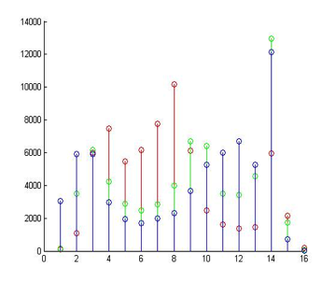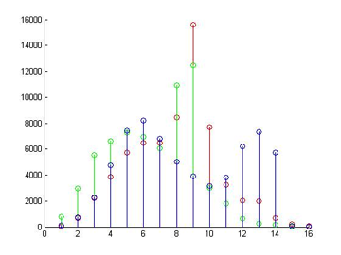
Combined Histograms
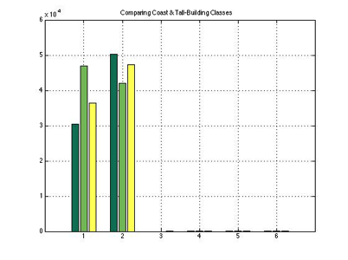
Same Class Histogram Comparison
Numbers of black and white pixels are estimated through Saturation and Value planes, and the rest of color categories are determined through Hue plane. Every pixel color category then normalized by dividing the count of the pixels on number of pixel in the image.
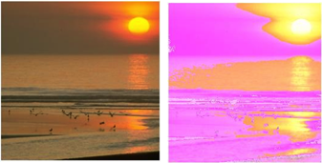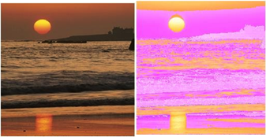
Coast Classes Combined Histograms

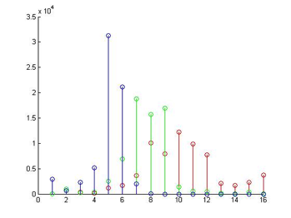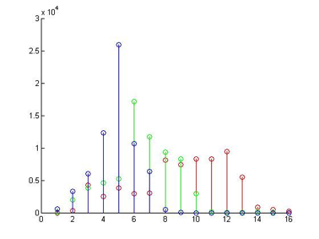
Coast Class Combined Histograms
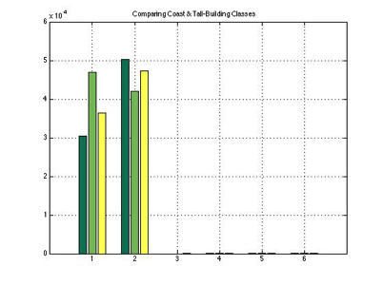
Numbers of black and white pixels are estimated through Saturation and Value planes, and the rest of color categories are determined through Hue plane. Every pixel color category was normalized by dividing the count of the pixels on number of pixel in the image. The Models used for representing colors numerically are the RGB, LAB, HSV, YcrCb color spaces. The following test results will show the number of mis-classifications of each method with a 4 x 30 matrix of test image.

Thist provides a property to be invariant to arbitrary msotonic feature transformations. Another, a statistic of the Cramer/von Mises (CvM) defined based on cumulative distributions where the statistic is given by$\sum_{i}{\left(\frac{f\left(i;I\right)-f(i)}{f(i)}\right)}$, Where f (i) = $= \left[\frac{f\left(i;I\right)+f(i;J)}{2}\right]$denotes the joint estimate.

The classification performance was estimated in a leave–one–out procedure for all combinations of parameters. The classification results are summarized in Figure1 (color) & Figure2 (texture).
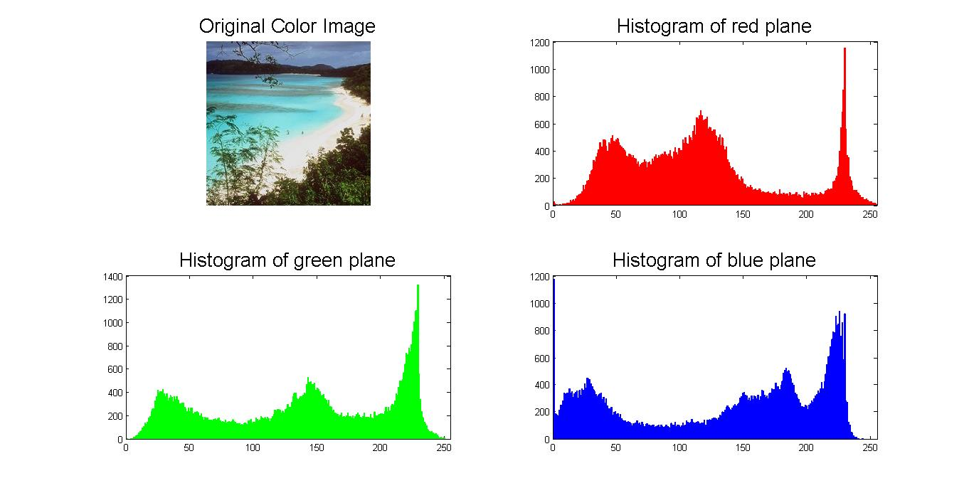
Issues are based on the cumulative histograms because their measures are defined only in one dimension and unable to exploit the ground distance in the full feature space. A possible solution could be employing BRD distance to improve results with the dissimilarity measure between two distributions. However, there was progress in obtaining and analysing the bin Information for feature selection, image, retrieval, pattern classification, and clustering.

Combining Histograms
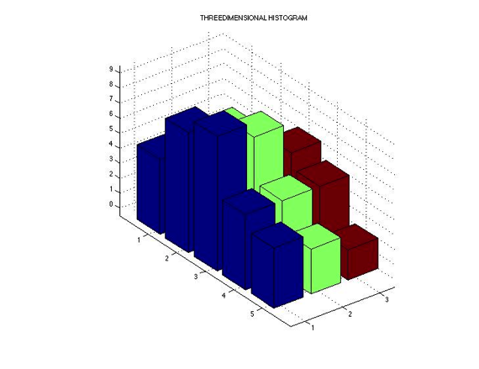
Feature Extraction
Comparing Coast & Tall-Building Classes
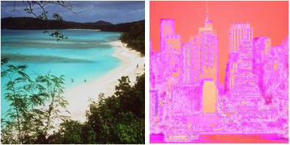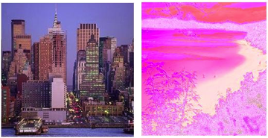
Coast & Tallbuilding Combined Histograms

Methods & Development Applied
The Histogram is computed by counting number of pixels corresponding to following colors: red, yellow, green, cyan, blue, magenta, white and black. It is performed by evaluating each plane in order to determine number of pixels belonging to each of the selected color categories.

RGB Color Space Classification Test
Class Error %
Coast 21.4% Forest 3.33% Mautain 18.3% Highway 21.7% TallBuild 20.8%

YcrCb Color Space Classification Test
Class Error %
Coast 20.5% Forest 0.83% Mautain 9.16% Highway 15.8% TallBuild 11.6%

LAB Color Space Classification Test
Class Error %
Coast 18.7% Forest 0.83% Mautain 3.33% Highway 13.3% TallBuild 4.16%

HSV Color Space Classification Test
Class Error %
Coast 20.8% Forest 0.83% Mautain 7.5% Highway 24.1% TallBuild 23.3%

Creating Set & Comparing Classes
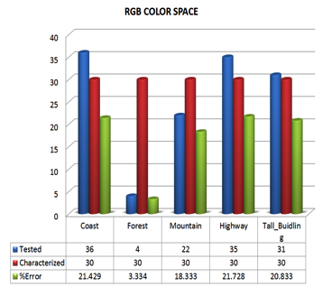
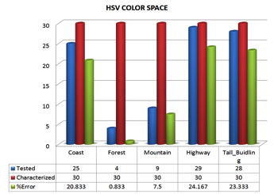
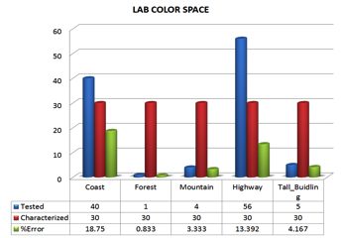
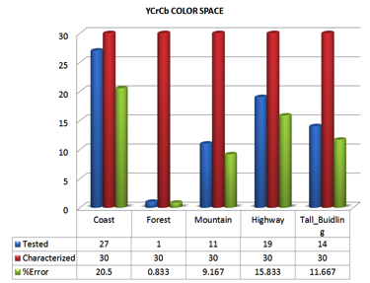

The best performing color space was the LAB and YCrCb, with the best performing classes being forests, highways, and building. The table below highlights the percentage error for the best case of all classes.
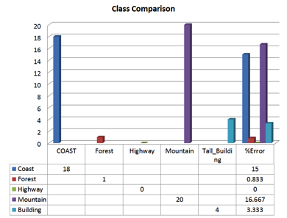

As a perceptual feature, color composition had a clear impact on the separation between the chosen classes of outdoor scenes during the resolution experiment. As a method for scene classification, color information is historically one of the oldest machine recognized features [6].

The simplest method presented for scene categorization used a non-linear mapping of the RGB color space and histogram intersection [7]; this provided adequate separation between indoors and outdoors scenes.

Average Intersection & Features Implementation
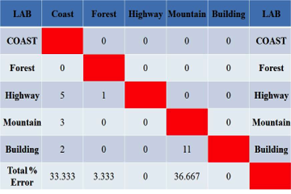
To classify different types of outdoor scenes, a similar approach was considered. Each of the training images was separated into 16 equally sized blocks, a clear advantage of the single square resolution of the image set.

LAB has fewer false positives than YCrCb, which combined with the high accuracy makes LAB the best candidate for classification.
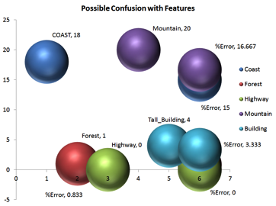
Once the blocks were separated, the inner four and bottom two blocks were averaged across each class to create a template. The template would then contain both color and limited spatial information. The selection of the middle and bottom blocks allowed any noise on the edge of the image or any non-discriminating features such as the sky to be removed from the average. The average block histograms were then used to compute the histogram intersection with each test image. The resulting histogram intersection, still partitioned into blocks, along with the test images histogram was concatenated and passed into a support vector machine for classification.

Final Results

The results of the color histogram test are organized by color space. The results listed below are the number of misclassifications over 150 test images with 30 test images per class. The numbers of principle components as well as the SVM kernels are listed as parameters.

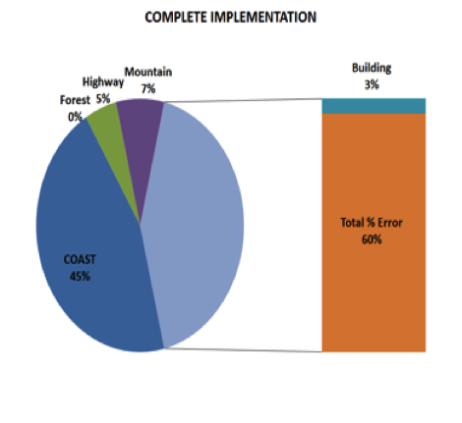
The combination of other features will further improve the classification.


HSV Color Space Classification Test
Coast with 20.8% error, Forest 0.83% error, Mautain 7.5% error, Highway 24.1% error, 23.3% error.
LAB Color Space Classification Test
Coast with 18.7% error, Forest 0.83% error, Mautain 3.33% error, Highway 13.3% Error, 4.16% error.

YCrCb Color Space Classification Test
Coast with 18.7% error, Forest 0.83% error, Mautain 3.33% error, Highway 13.3% Error, 4.16% error.

The best performing color space was the LAB and YCrCb, with the best performing classes being forests, highways, and building.

HYBRID DESCRIPTOR

Method 1: Voting Algorithm

Attempt to make a voting algorithm with function votingAlgo. The file testVotingAlgoFunction.m can be used to test the function and display the output. It can also run the tests several times and give an average performance. For the voting algorithm, random has been introduced and the testing images are not used: training images are split randomly into training and testing sets with a chosen percentage.

Method 2: Neural Network

The first step that needs to be done in order to create Hybrid feature vector is data scaling. Features extracted with each approach have to be equally weighted. Scaling features of one vector in the range of another feature vector values (any feature vector can be selected as a base), if $[b_{min} , b_{max}]$ is the value range of a descriptor chosen as a base, then value x is scaled into y:

y = (x - bmin)*(amax-amin)/(bmax-bmin)+amin

Also, all the values for each descriptor can be scaled in the [0, 1] range.

Gabor-GIST and CT feature vectors must be rescaled so that the NN can take them both into an account with same weight. The obtained feature vector when CT and Gabor-GIST are combined is displayed in file PlotFeatures. We attempt to display in a graph for each image the average of CT feature vector VS average of the Gabor-GIST feature vector. This is done in the file PlotFeatures_perImage.

In previous stages input matrixes for each descriptors were built, and targets stay the same for the same dataset. In order to create hybrids of features all that needs to be done is appending one matrix to another ([features1; features2]) and train the MLP network on new combined input matrix. The same procedure applies for testing input matrix, bellow different combinations of features are analyzed and classification accuracy is evaluated.

Gabor + CENTRIST Hybrid results

Comparison of confusion matrixes produced by testing the images based on Gabor GIST and CENTRIST descriptors indicates potential improvement from combining the features together (if mutual classification compensation occurs). On practice significant classification error disease occurred, and overall accuracy rose from 86% to 93.3%. Features compensated each other deficiencies and did not create any noticeable confusion. See Table 5 for more details.

[Table 5]
Confusion matrix for Gabor + CENTRIST hybrid features

Gabor + Color Histogram Hybrid results

Our team was pretty skeptical about combining Color Histograms with features extracted with other methods. As color histograms performed poorly, the guess was that color histogram features would add more confusion rather than do any good. However, experiments demonstrated slight performance improvement from 86% accuracy to 89.3%. In case with Gabor Gist and color histogram hybrid improvement was observed for Coast, Highway and Mountain categories. A performance decrease occurred for Forest and Tall Building scene classes.

CENTRIST + Color Histogram Hybrid results

CENTRIST + Color Histogram hybrid as Gabor + Color Histogram also performed better that pure CENTRIST. Improvement occurred for Coast, Forest and Mountain categories, but a performance decrease was observed for Highway and Tall Building scene classes.

Gabor + CENTRIST + Color Histogram

Finally, combination of all the features extracted with three methods studied in this work performed the best. Comparably to Gabor + CENTRIST hybrid classification accuracy increased from 93.3% to 95.3%. Significant improvement occurred for Highway category (83.3% category accuracy to 96.6%), and a slight accuracy decrease was demonstrated in Coast category (93.3% to 90% class accuracy). See confusion matrix for more details (table 6).

[Table 6]
Confusion Matrix for Gabor + CENTRIST + Color histogram hybrid features

Conclusion

References

[1] Siagian, C., Itti, L., Rapid Biologically-Inspired Scene Classification Using Features Shared with Visual Attention, IEEE Transactions on Pattern Analysis and Machine Intelligence, Vol. 29, No. 2, pp. 300-312, Feb 2007.

[2] Kruizinga, P., Petkov, N., Grigorescu, S.E., ”Comparison of texture based features based on Gabor filters”, IEEE Conf. on Image Analysis and Processing, 142–147, 1999.

[3] Jain, A. K. and Farrokhnia, F., ”Unsupervised texture segmentation using Gabor filters”, Pattern Recognition, 24(12), 1991, 1167-1186.

[4] Dunn, D., Higgins, W.E., Wakeley, J., ”Texture segmentation using 2-D Gabor elementary functions”, Pattern Analysis and Machine Intelligence, IEEE Transactions on, 16(2), 1994, 130–149.

