Anas Siddiqui
EET 418
Lab 12.1

;Volume of box=x*y*z

DATA SEGMENT
X DW 0ABh
Y DW 0CDh
Z DW 0EFh
DATA ENDS

CODE SEGMENT

ASSUME DS:DATA,CS:CODE

VOLUME: MOV AX,DATA ; MOVE DATA TO AX REGISTER
MOV DS,AX ; MOVE AX TO DATA SEGMENT
XOR AX,AX ; CLEAR AX REGISTER
MOV AX,X ; MOVE X TO AX
XOR BX,BX ; CLEAR BX REGISTER
MOV BX,Y ; MOVE Y TO BX
MUL BX ; MULTIPLY AX TO BX
MOV BX,Z ; MOVE Z TO BX
MUL BX ; MULTIPLY AX TO BX
HLT

CODE ENDS
END VOLUME

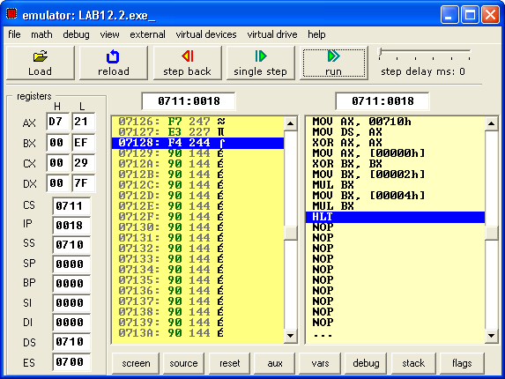

12.2
;Volume of box=x*y*z

DATA SEGMENT
X DW 0ABCDh
Y DW 0BCDEh
Z DW 0CDEFh
DATA ENDS

CODE SEGMENT

ASSUME DS:DATA,CS:CODE

VOLUME: MOV AX,DATA ; MOVE DATA TO AX REGISTER
MOV DS,AX ; MOVE AX TO DATA SEGMENT
XOR AX,AX ; CLEAR AX REGISTER
MOV AX,X ; MOVE X TO AX
XOR BX,BX ; CLEAR BX REGISTER
MOV BX,Y ; MOVE Y TO BX

MUL BX ; MULTIPLY BX BY AX

MOV CX,DX ; MOVE DX TO CX
MOV BX,Z ; MOVE Z TO BX
MUL BX ; MULTIPLY BX TO AX
MOV DI,AX ; MOVE AX TO DI
MOV AX,CX ; MOVE CX TO AX
MOV CX,DX ; MOVE DX TO CX
MUL BX ; MULTIPLY BX BY AX
ADD AX,CX ; ADD AX AND CX

MOV SI,AX ; MOVE AX TO SI

MOV BP,DX ; MOV DX TO BP

HLT
; THE ANSWER WILL BE IN BP,SI,DI BECAUSE
; IT WILL NOT FIT IN 16 BIT REGISTER

CODE ENDS
END VOLUME

