Anas Siddiqui
EET 418 L
10/5/2009
LAB 6

;SUBROUTINE TO DETERMINE THE NUMBER
;OF PAIRS OF ONES IN THE AX REGISTER

CODE SEGMENT

ASSUME CS:CODE

X10: MOV AX,038C0h ; save the value in AX register
MOV BX, 10h ; use BX register as an counter
REPEAT: SHL AX,1 ; shift AX register once to the left
JC SIGN ; jump on carry
JMP ONE ; unconditional jump to line 16
SIGN: JS PLUS ; jump on sign bit
JMP ONE ; unconditional jump to line 16
PLUS: INC CX ; increase CX register by 1
ONE: DEC BX ; decrease BX register by 1
JNZ REPEAT ; jump on non zero to repeat the program,
; until Bx register is zero
RET

CODE ENDS
END

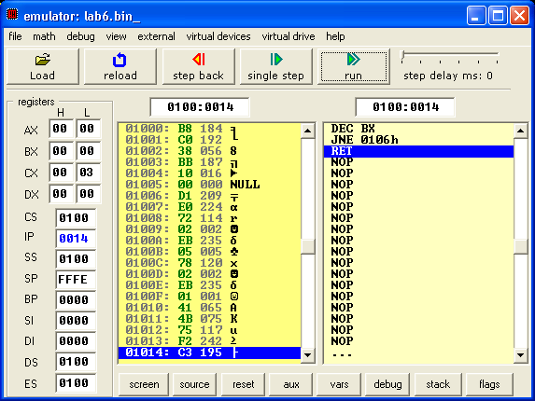

; SUBROUTINE TO DETERMINE THE NUMBER
; OF PAIRS OF ONES IN THE AX REGISTER

CODE SEGMENT

ASSUME CS:CODE

X10: MOV AX,00003h ; save the value in AX register
MOV BX, 10h ; use BX register as an counter
REPEAT: SHL AX,1 ; shift AX register once to the left
JC SIGN ; jump on carry
JMP ONE ; unconditional jump to line 16
SIGN: JS PLUS ; jump on sign bit
JMP ONE ; unconditional jump to line 16
PLUS: INC CX ; increase CX register by 1
ONE: DEC BX ; decrease BX register by 1
JNZ REPEAT ; jump on non zero to repeat the program,
; until Bx register is zero
RET

CODE ENDS
END
