Scene Classification
Update 3
Karina Damico
Pauline Martial
Piter Garcia
Karina:
Gabor descriptor
Gabor descriptor
Test on 4 line histogram methods [2] - 1x128 feature vector:
Create training input matrix: 128 x 345
Create target matrix: 5 x 345 (5 categories, 345 samples)
Create NN with Matlab NN toolbox
Split those training images into: training (70%), validation (15%), testing
(15%)
As vector has length 128 - thus, 128 input vectors
Number of hidden nodes: 70 (worked ok)
Number of output neurons: 5
Gabor descriptor
Test on 4 line hist method: trained - 67% accuracy for testing portion
Gabor descriptor
Testing on 150 test images:
Number of misclassification: 72/150 -
52% accuracy
Where confusion happened - everywhere
(more or less)
Coast
Coast
Forest
Highway
Mountain
Tall Building
8
7
7
10
Forest
Highway
Mountain
Tall Building
BAD!!!
5
3
6
5
5
16
Gabor descriptor
Test on 4 line manual collon method:
Testing on 150 test images:
Number of misclassification: 76/150 - 50%
accuracy
Where confusion happened - everywhere
again (more or less)
BAD!!!
Gabor descriptor
GIST: as someone could remember from previous Update - 1 x 576
feature vector.
But I found a nice article describing how someone applied gabor on
colored image, that needs to be preprocessed first, so:
1) Whitening the image (through difference of image and real part of
double Fourier Transformed Image) - use fft2()
2) Local contrast normalization (normalization is done by dividing by the
local luminance variance)
3) When calculating Gabor for colored - need to reshape, so that one
column is one images output
Network is modified: 576 input nodes, 300 hidden layers
Gabor descriptor
Gabor descriptor
94% accuracy for training and
validation!!!
OMG! Looks nice!!! :D
Gabor descriptor
Results of Running the trained Network on
the test set (150 images).
86% - accuracy with "Gabor GIST gray
scale no more" features
Forest - 100% correctly classified.
Tall Building - 96.6% correctly classified.
Which class was the most problematic one?
- highway
Gabor descriptor
I'm very happy with results.
Next stage - will need to get all the features of my teammates -
normalize and scale them,and then run through network.
Decided to use MLP instead of RBF, as the training time wasn't an
issue even with 300 hidden layers, and MLP has nicer
implementation in MATLAB - easier to configure and get fancy
plots!
Pauline:
CENTRIST
descriptor
CENTRIST descriptor
Voting algorithm:
CT
vote
Gabor
vote
GIST
vote
●
: high confidence (3)
: medium confidence (2)
●
●
: low confidence (1)
CENTRIST descriptor
Random training/testing images:
3
2
6
1
7
4
5
< 5?
1
1
0
1
1
1
0
Testing images
Training
images
CENTRIST descriptor
Total number of misclassifications: 80/100 = 80%
Detail:
Number of errors
15
23
10
16
16
coast
forest:
mountain:
highway:
tall building:
Total number of misclassifications: 37/50 = 74%
Detail:
Number of errors
coast06
forest:11
mountain:04
highway:07
tall building: 09
CENTRIST descriptor
Total number of misclassifications: 58/75 = 77%
Detail:
Number of errors
coast00/02
forest:34/43
mountain:02/03
highway:08/09
tall building: 14/18
CENTRIST descriptor
If 3 disagree, priority to...
CENTRIST
70% errors
GIST
Gabor
CENTRIST descriptor
Oh! Let's try to order feature
vectors and image names in the
same order...!
CENTRIST
50% errors
GIST
Gabor
CENTRIST descriptor
Performance so far: around 55%
●
GIST and CENTRIST:
histogram intersection
●
GABOR: Euclidian distance
Default category decided by CT features if 3 methods disagree
CENTRIST descriptor
Confidence = arbitrary
number
Good performance
High confidence
Piter:
Color histogram
descriptor
On The List :
Feature Extraction
- Individually, combine and average color histograms for each class
Create a Set for Comparison Purpose
- Create a list of category of the average histograms of each class
Class feature comparison
- Individually Test and Compare classes
Classification Comparison
- Test and Compare all classes data
Average Intersection & Features Implementation
- Check for intersecting features among classes
Implement SVM
Feature Extraction
The Models, used for representing colors numerically, are as
follow:
1 - RGB
2 - LAB
3 - HSV
4 - YCrCb
These methods or color spaces provide this descriptor with
relevant information for classification purpose. The following test
results will show the number of mis-classifications of each method
with a 4 x 30 matrix of test images.
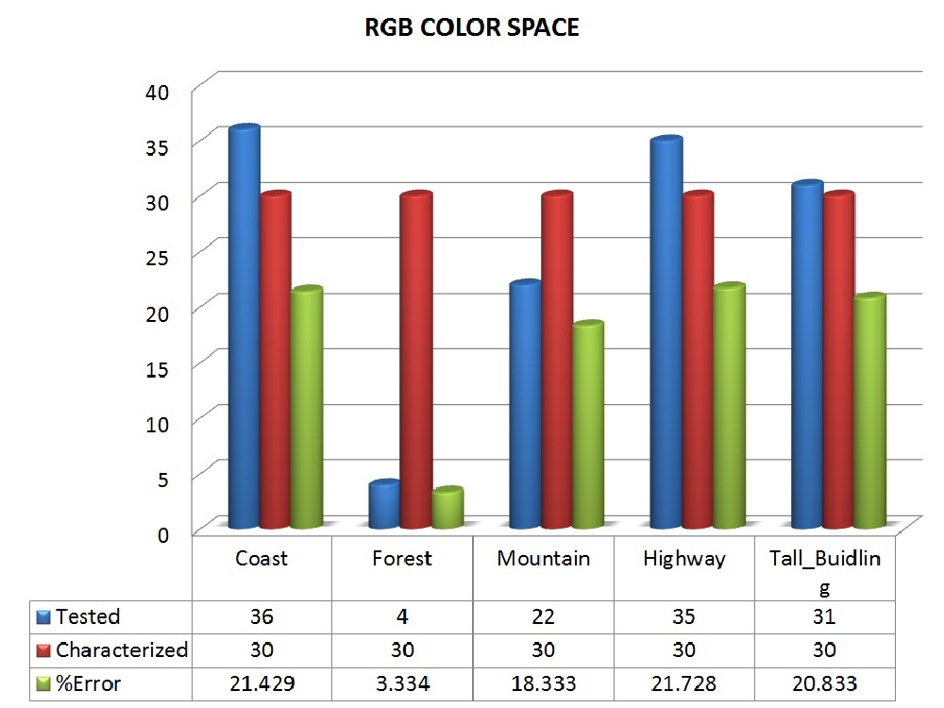
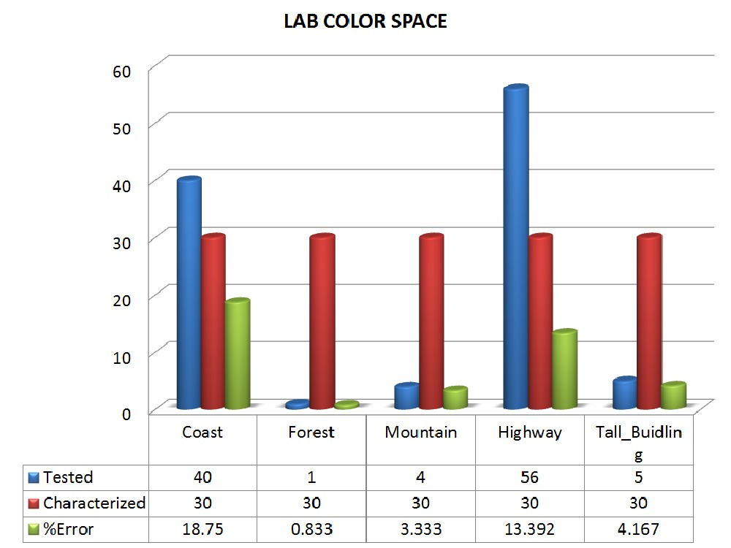
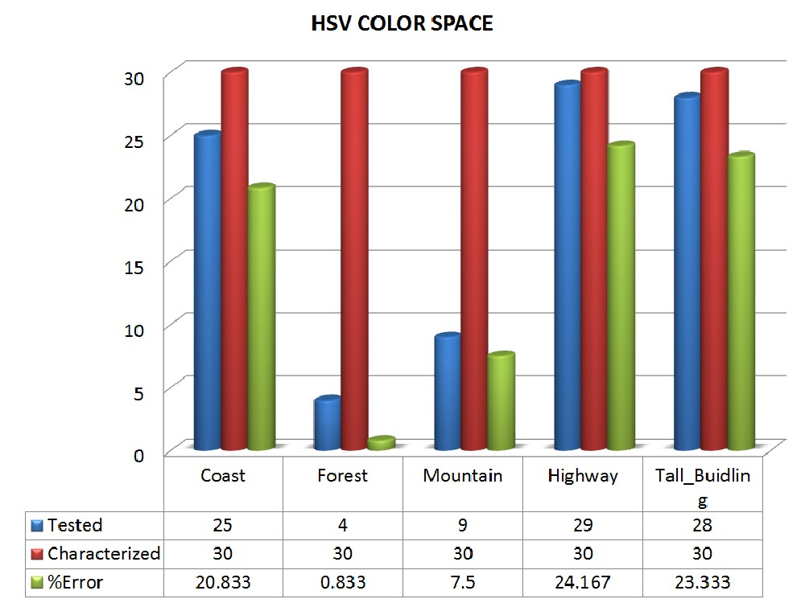
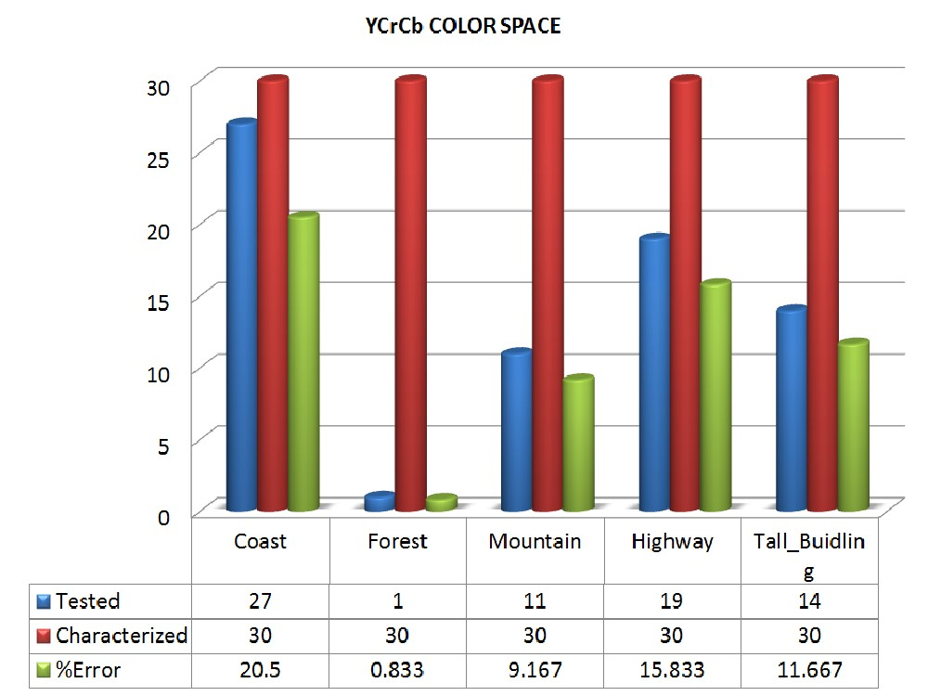
Creating Set & Comparing Classes
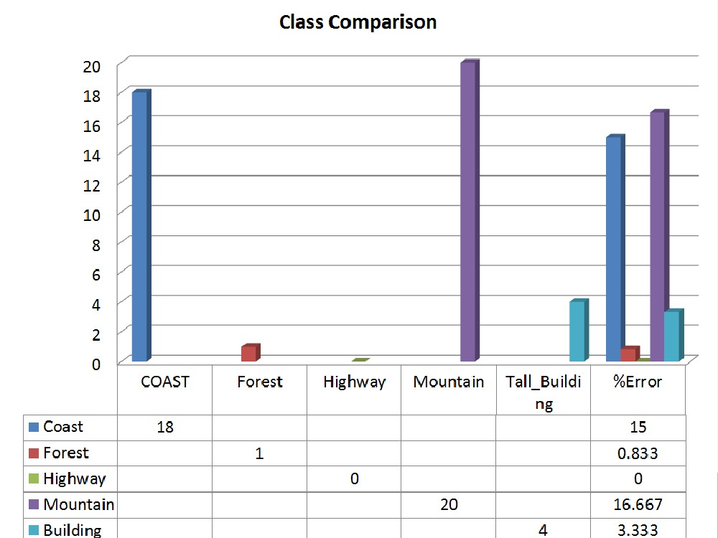
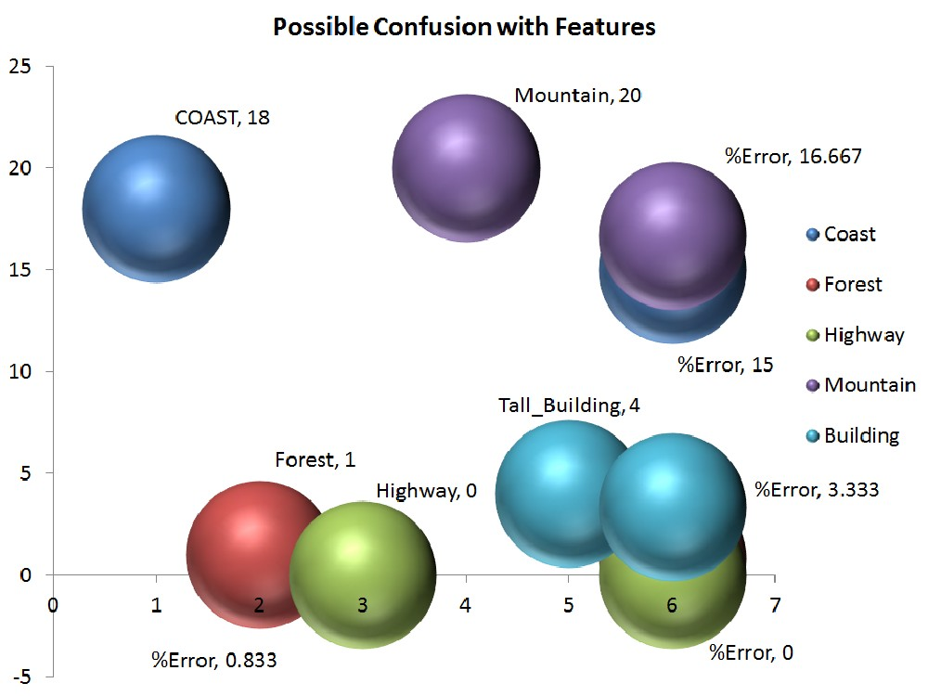
Average Intersection & Features Implementation
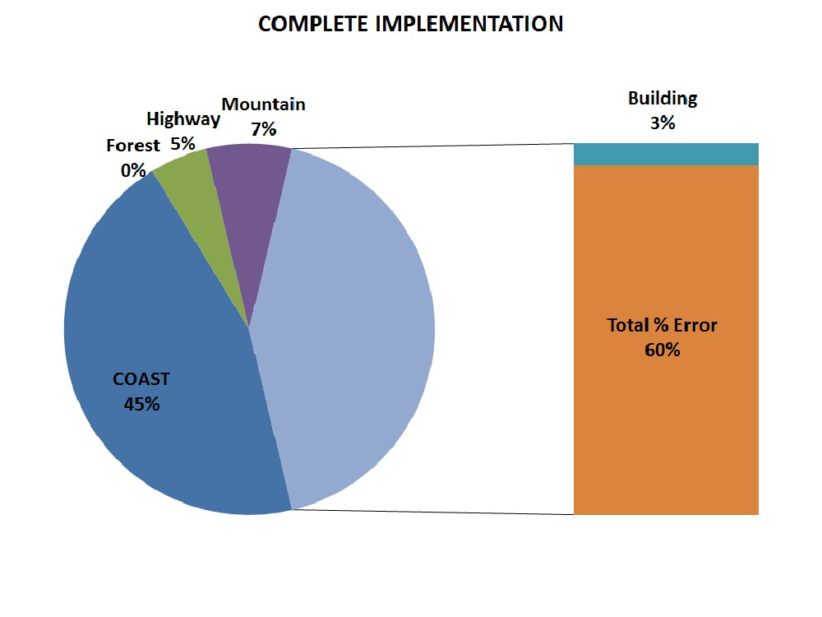
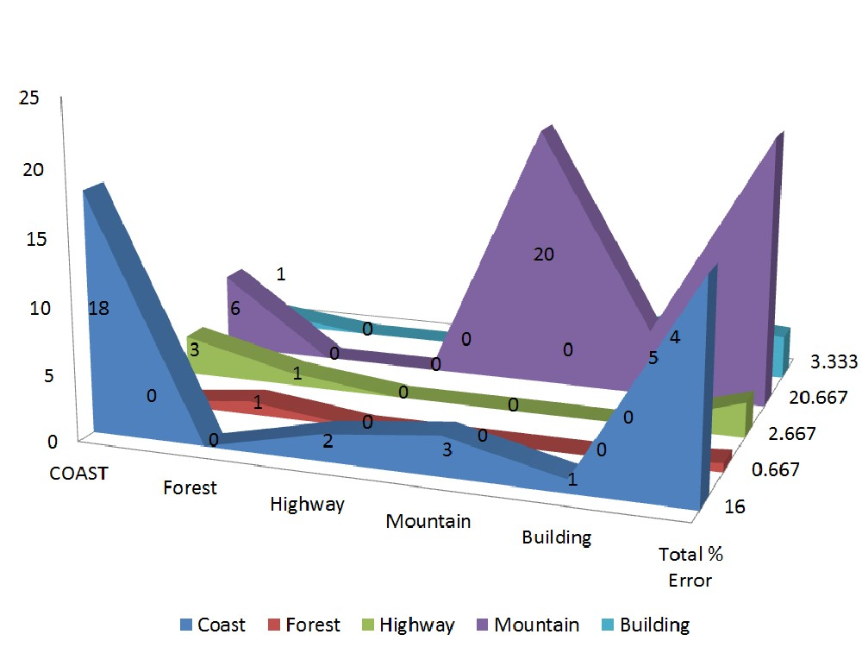
FINISHING UP

