Anas Siddiqui
EET 418
Lab 15

15.1

DATA SEGMENT
X DB 255,255,170,187
DB 204,221,238,255
DATA ENDS
CODE SEGMENT
ASSUME DS: DATA, CS: CODE

START: MOV AX,DATA ; move data to ax register
MOV DS,AX ; transfer data from ax to ds
LEA SI,X ; put data in the memory location

MOV CX,08H ; set counter for x^2 for all 8 numbers
; and then add it
JUMP: XOR AH,AH ; clear ah register
MOV AL,DS:[SI] ; move first number from the memory
;location
MUL AL ; multiply al register to al register
; to get square
ADD BX,AX ; add ax register to bx register
JC LOOP1
LOOP2: INC SI ; increment pointer by one
DEC CX ; decrement cx counter by one
JNZ JUMP ; jump on non zero to complete the loop
JMP LOOP3 ; jump to loop3
LOOP1: INC DI ; increment di by one
JMP LOOP2

LOOP3: MOV CX,03H ; set cx counter by four
LOOP4: SHR DI,01H ; shift di register on once
RCR BX,01H ; rotate bx register through carry once
DEC CX ; decrement counter
JNZ LOOP4 ; jump on non zero to run the program
HLT

CODE ENDS
END START

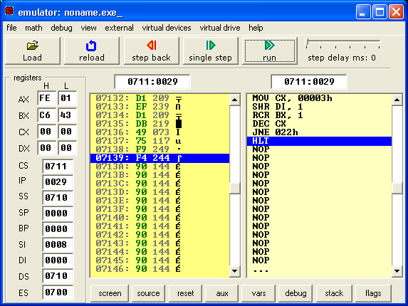

15.2
DATA SEGMENT
X DB 9,10,11,12
DB 5,6,7,8
DATA ENDS
CODE SEGMENT
ASSUME DS: DATA, CS: CODE

START: MOV AX,DATA ; move data to ax register
MOV DS,AX ; transfer data from ax to ds
LEA SI,X ; put data in the memory location

MOV CX,08H ; set counter for x^2 for all 8 numbers
; and then add it
JUMP: XOR AH,AH ; clear ah register
MOV AL,DS:[SI] ; move first number from the memory
;location
MUL AL ; multiply al register to al register
; to get square
ADD BX,AX ; add ax register to bx register
JC LOOP1
LOOP2: INC SI ; increment pointer by one
DEC CX ; decrement cx counter by one
JNZ JUMP ; jump on non zero to complete the loop
JMP LOOP3 ; jump to loop3
LOOP1: INC DI ; increment di by one
JMP LOOP2

LOOP3: MOV CX,03H ; set cx counter by four
LOOP4: SHR DI,01H ; shift di register on once
RCR BX,01H ; rotate bx register through carry once
DEC CX ; decrement counter
JNZ LOOP4 ; jump on non zero to run the program
HLT

CODE ENDS
END START

