Anas Siddiqui
EET 418 L
September 21, 2009
LAB 4

; X^2 + y^2 SUBROUTINE
CODE SEGMENT
X10:
MOV AX, 00777h;
MOV BX, 00888h;

MUL AX
MOV CX, AX
MOV AX, BX
MOV BX, DX
MUL AX
ADD AX, CX
ADC BX, DX
XCHG AX, BX

RET

CODE ENDS

END

- Input

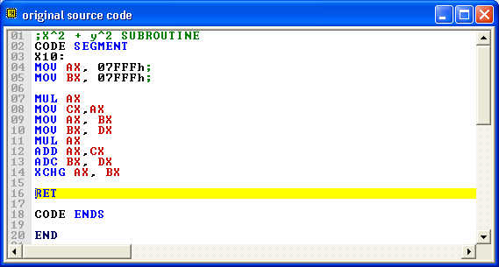

- Output

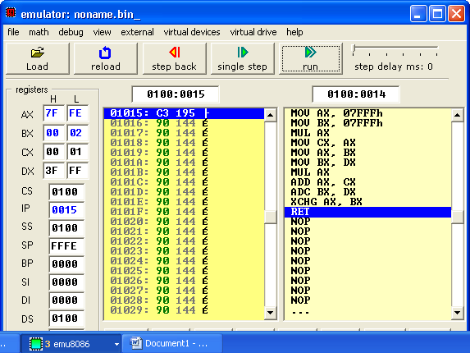
- Input

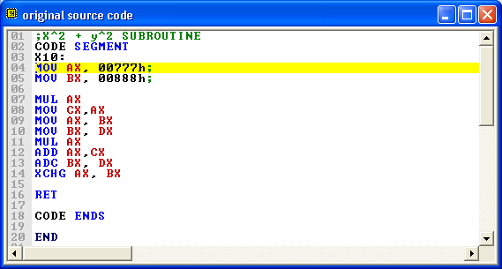

- Output

