8 BIT MULTIPLICATION
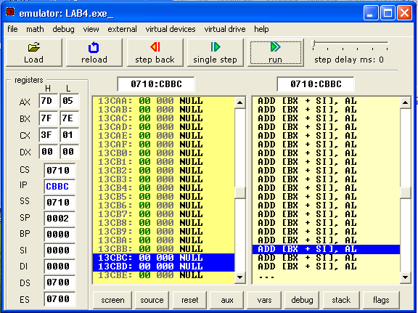

16 BIT MULTIPLICATION
