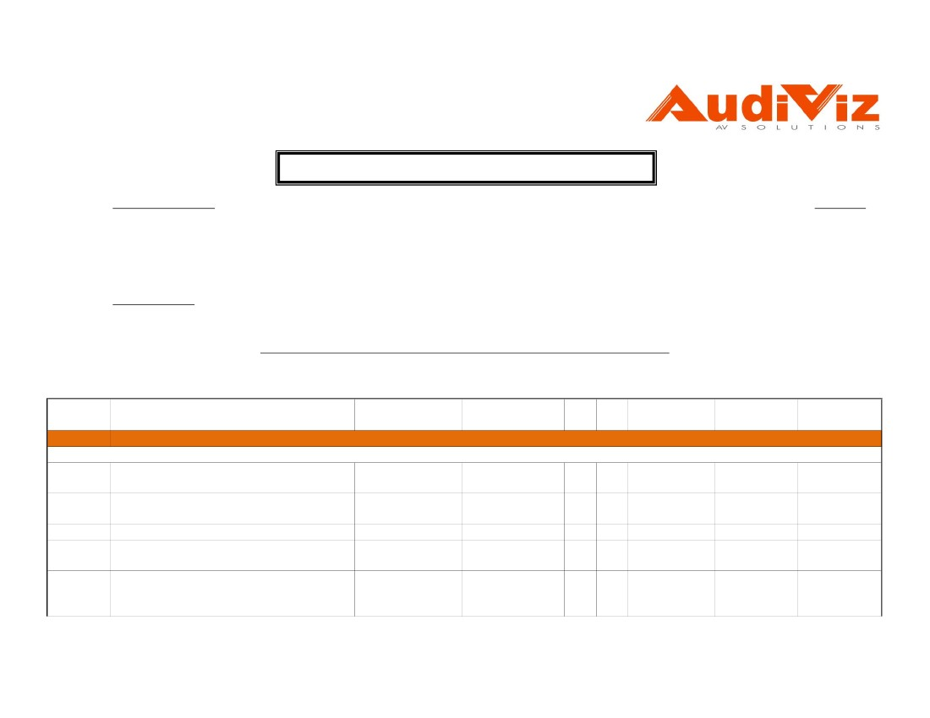
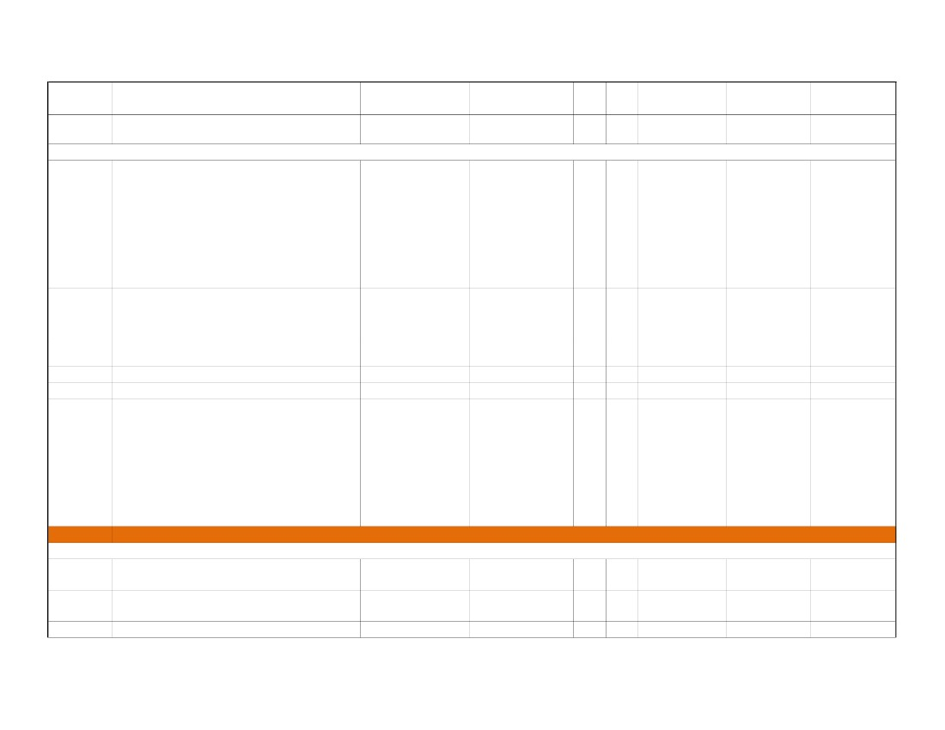
AudiViz Technologies LLC
P.O. Box 49209
Dubai - UAE
QUOTATION/ COMMERCIAL PROPOSAL
Our Ref:
M/s
PRD/1952/11-Rev.3
Dutco Styles & Wood L.L.C
P.O.Box No: 233, Dubai, U.A.E
Tel No: + 971 4 2660311 Fax No: +971 4 2665157
Email : brian.egan@dutcosw.com
Mr. Brian Egan
Date:
28-Feb-11
Attn.
Dear Sir,
Sub: Quote for Audio Visual System for Al Ain Whitewater Rafting Facility
We are pleased to submit our 'Revised' Commercial Proposal for the above requirement as follows:
Item Sl.
Product Description
No.
Building 1 - Zone 1A
BGM System
Outdoor Wall Mount Speaker, 30 W (70.7 V,
A-1
100 V line)
Power Amplifier, 220 - 240 V AC, or 24 - 30 V
A-2
DC
A-3Wall Plate Inteface for local audio
2 mic/line analog inputs and 2 line outputs to
A-4
CobraNet output
Remote Ethernet Remote Control with high
A-5contrast OLED display & 32 selectable system
volumes and actions
Brand
Model
Unit Qty
Unit Price
(AED)
Total Price
(AED)
Grand Total
(AED)
TOA
TOA
AudiViz
BIAMP
BIAMP
BS-1030
P-2240
Custom
AudiaEXPI/O-2
RED-1
1
1
1
1
1
20
1
1
1
1
445.00
1,900.00
350.00
4,000.00
2,500.00
8,900.00
1,900.00
350.00
4,000.00
2,500.00
Show room: Suite # 118/119, Al Khaleej Center, Burdubai. Tel: 04 3528626, Fax: 04 3528627
Suite # 1308, Kalfan Al Suhaidi Building Airport Road Abu Dhabi UAE Tel: 02 6433447, Fax: 02 6433448
1
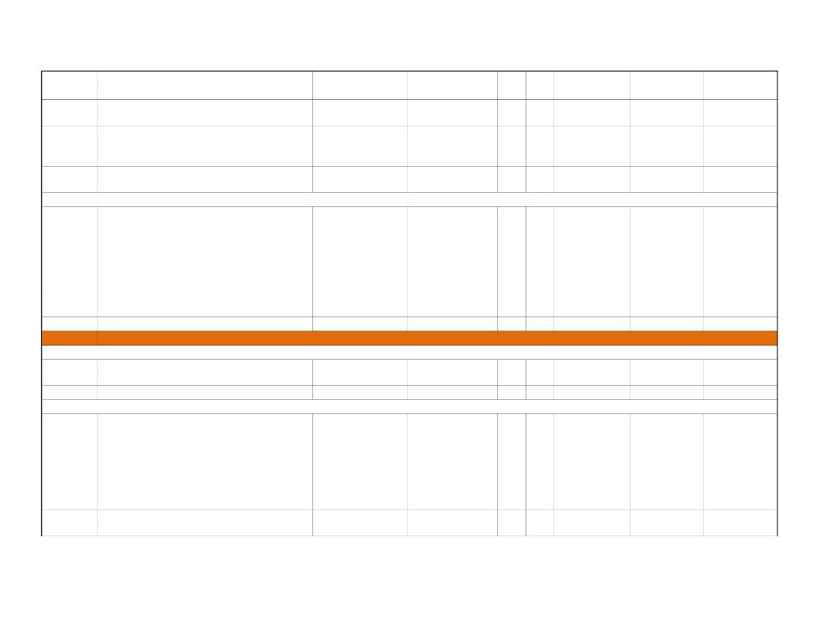
Item Sl.
No.
A-6
Product Description
Brand
MiniPro
Model
Various
Unit Qty
1
1
Unit Price
(AED)
1,100.00
Total Price
(AED)
1,100.00
Grand Total
(AED)
AV Rack including shelves, blank panels,
PDU, etc., to accommodate equipments
Display System
42" LCD TV Series LD 550, Full HD 120Hz
LCD, Refresh Rate120 Hz, Intelligent Sensor,
NetCast™ Entertainment Access
(Broadband), Wireless HD Ready, Wi-Fi
A-7
Ready, DNLA Certified, Pictures, Music and
Video via USB 2.0 + Wall Mount Bracket
(Note: model & price may vary depends on
availability upon order confirmation)
42" Full HD Monitor Display, Resolution :
1920*1080, High Brightness : 700cd/m2,
A-8Dynamic Contrast Ratio : 3000:1, approx. 41.1
lbs. + Wall Mount Bracket (for the ticketing in
portrait style)
A-9PC with OS
A - 10Two Output VGA Distribution Amplifier
55" LCD TV Series LD 650, Full HD LCD,
TruMotion 240Hz, Intelligent Sensor,
NetCast™ Entertainment Access
(Broadband), Wireless HD Ready, Wi-Fi
A - 11
Ready, DNLA Certified, Pictures, Music and
Video via USB 2.0 + Wall Mount Bracket
(Note: model & price may vary depends on
availability upon order confirmation)
Building 2 - Zone 2B
BGM System for Restaurant
Outdoor Wall Mount Speaker, 30 W (70.7 V,
B-1
100 V line)
Power Amplifier, 220 - 240 V AC, or 24 - 30 V
B-2
DC
B-3Wall Plate Inteface for local audio
LG
42LD550
1
2
3,299.00
6,598.00
LG
M4225C
1
2
4,299.00
8,598.00
Various
Extron
Various
P/2 DA2xi
1
1
1
1
2,500.00
690.00
2,500.00
690.00
LG
55LD650
1
2
8,999.00
17,998.00
TOA
TOA
AudiViz
BS-1030
P-2240
Custom
1
1
1
16
2
1
445.00
1,900.00
350.00
7,120.00
3,800.00
350.00
Show room: Suite # 118/119, Al Khaleej Center, Burdubai. Tel: 04 3528626, Fax: 04 3528627
Suite # 1308, Kalfan Al Suhaidi Building Airport Road Abu Dhabi UAE Tel: 02 6433447, Fax: 02 6433448
2

Item Sl.
No.
B-4
Product Description
Brand
Model
AudiaEXPI/O-2
RED-1
Various
Unit Qty
1
1
1
1
1
1
Unit Price
(AED)
4,000.00
2,500.00
1,100.00
Total Price
(AED)
4,000.00
2,500.00
1,100.00
Grand Total
(AED)
2 mic/line analog inputs and 2 line outputs to
BIAMP
CobraNet output
Remote Ethernet Remote Control with high
B-5BIAMPcontrast OLED display & 32 selectable system
volumes and actions
AV Rack including shelves, blank panels,
B-6MiniPro
PDU, etc., to accommodate equipments
Display System
42" LCD TV Series LD 550, Full HD 120Hz
LCD, Refresh Rate120 Hz, Intelligent Sensor,
NetCast™ Entertainment Access
(Broadband), Wireless HD Ready, Wi-Fi
B-7LG
Ready, DNLA Certified, Pictures, Music and
Video via USB 2.0 + Wall Mount Bracket
(Note: model & price may vary depends on
availability upon order confirmation)
B-8Ceiling Mount BracketVarious
Building 2 - First Floor [ Training & Meeting Rooms ]C
Control Room Equipment
AV Rack including shelves, blank panels,
C-1MiniPro
PDU, etc., to accommodate equipments
C-2DVD PlayerLG
CRESTRON Controller
Complete compact fixed resource series 2
control system, 32 Bit Motorola ColdFire
Processor, Connector for Cresnet® Bus, 3 bi-
C-3CRESTRONdirectional RS-232/422/485 outputs, 8
IR/one-directional RS-232 outputs, 8 Relais
outputs, 8 Digital In-/Outputs or analog
inputs and ethernet port
Power Pack, Desktop, 24VDC, 2A (50 Watts),
C-4CRESTRON
Regulated, US/International (power cord
42LD550
1
5
3,299.00
16,495.00
Various
1
4
650.00
2,600.00
Various
Latest
1
1
1
3
5,200.00
399.00
5,200.00
1,197.00
CP2E
1
1
7,940.00
7,940.00
PW-2420RU
1
1
1,025.00
1,025.00
Show room: Suite # 118/119, Al Khaleej Center, Burdubai. Tel: 04 3528626, Fax: 04 3528627
Suite # 1308, Kalfan Al Suhaidi Building Airport Road Abu Dhabi UAE Tel: 02 6433447, Fax: 02 6433448
3

Item Sl.
No.
Product Description
Brand
Model
QM-RMC
Unit Qty
1
1
Unit Price
(AED)
2,832.00
Total Price
(AED)
2,832.00
Grand Total
(AED)
Room Media Controller - Ethernet Control
C-5CRESTRONSystem and Ethernet to Serial/IR Interface
Module. Includes PW-1205 Power Supply
Isys 5.7“ Wall Mount Touchpanel, Textured.
Includes TPS-6L-FPB-T_BLANK button
C-6CRESTRON
faceplate, TPS-6L-FPB-T-NB_BLANK no-
button faceplate, and (1) set mounting clips.
6-Button Decorator Keypad, Fits Standard
C-7CRESTRONElectrical Gang Boxes and Decora® Style
Faceplates, Black
Infrared (IR) Emitter Probe with 2-pin Mini ConnectorCRESTRONC-8
Display System
52" LCD TV Series LD 550, Full HD 120Hz
LCD, Refresh Rate120 Hz, Intelligent Sensor,
NetCast™ Entertainment Access
(Broadband), Wireless HD Ready, Wi-Fi
LGC-9
Ready, DNLA Certified, Pictures, Music and
Video via USB 2.0 + Wall Mount Bracket
(Note: model & price may vary depends on
availability upon order confirmation)
Projection System
4500 ANSI Lumens DLP Projector, 4:3 (XGA)
Native: 1024x768 Resolution, 2000:1 Contrast
C - 10Mitsubishi
Ratio, RS232 & HDMI Port, Wired
Networking, 3D Ready. 3.6 kg,
100" Diagonal Motorized - 4:3 Video Format
C - 11Projection Screen including screen controlGRANDVIEW
interface
Audio System
Two-Way Ceiling Speakers with 8" Back Can
ExtronC - 12
and 70/100 V Transformer, Pair
Two-Way Surface Mount Speakers with 6.5"
C - 13Extron
Woofer, Pair - Black
TPS-6L
1
1
9,400.00
9,400.00
C2N-DB6 + DB6-
BTNB
IRP2
1
1
2
3
1,086.00
200.00
2,172.00
600.00
52LD550
1
3
7,499.00
22,497.00
XD600U
1
1
6,499.00
6,499.00
WM-M100" +
1GD 315
1
1
2,450.00
2,450.00
SI 26CT
SI 26
Pair
Pair
3
2
1,040.00
1,100.00
3,120.00
2,200.00
Show room: Suite # 118/119, Al Khaleej Center, Burdubai. Tel: 04 3528626, Fax: 04 3528627
Suite # 1308, Kalfan Al Suhaidi Building Airport Road Abu Dhabi UAE Tel: 02 6433447, Fax: 02 6433448
4
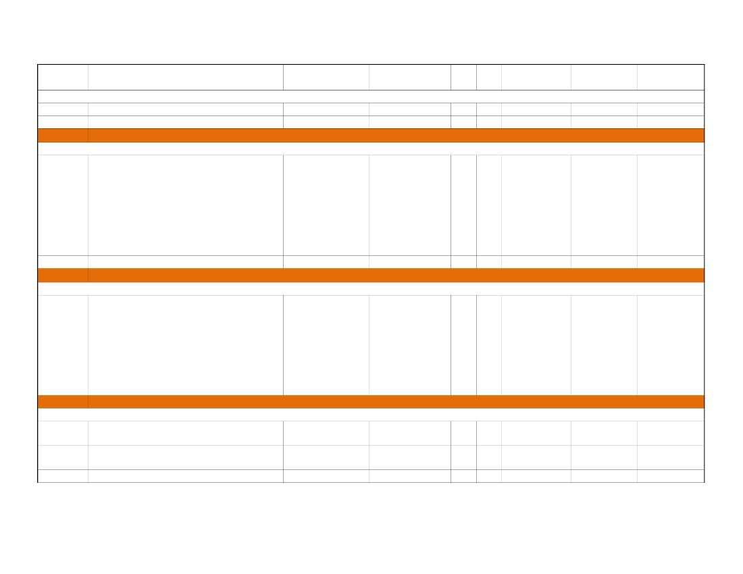
Mono 70/100 V Power Amplifier - 200 Watts
2000 Series Wireless ATW-2110 UniPak UHF
C - 15Wireless System with Bodypack Transmitter
and Receiver
2000 Series Wireless ATW-2120 Handheld
Wireless System with ATW-R2100 Receiver
C - 16
and ATW-T220 Handheld Unidirectional
Dynamic Microphone/Transmitter
SR1212 - Highly Advanced Digital Matrix
C - 17
Mixer (ConvergePro Series™)
18.94-inch cardioid condenser quick-mount
gooseneck microphone designed to plug
C - 18
directly into a panel- or desk-mounted XLRF-
type connector (for Lectern)
Video & Audio Switcher
8x8 Ultra-Wideband Matrix Switcher with
C - 19
ADSP™ for RGB and Stereo Audio
C - 20VGA and Audio Line Driver
Four Input Video and RGB Scaler with DVI
C - 21
Output
BGM System
Ceiling Mount Speaker, 15 W (100 V, 70 V
C - 22
line)
Power Amplifier, 220 - 240 V AC, or 24 - 30 V
C - 23
DC
C - 24Volume Control with Relay (100W)
Three Output Stereo Audio Mini Distribution
C - 25
Amplifier
Item Sl.
No.
C - 14
Product Description
Brand
Extron
Audio Technica
Model
XPA 2001
ATW-2110
Unit Qty
1
1
3
2
Unit Price
(AED)
1,940.00
1,804.00
Total PriceGrand Total
(AED)(AED)
5,820.00
3,608.00
Audio Technica
ATW-2120
1
1
2,051.00
2,051.00
ClearOne
910-151-900
1
1
9,100.00
9,100.00
Audio Technica
U857QL
1
1
1,243.00
1,243.00
Extron
Extron
Extron
CrossPoint Ultra
88 HVA
Extender AAP
DVS 304 DVI
1
1
1
1
2
1
15,160.00
1,294.00
7,453.00
15,160.00
2,588.00
7,453.00
TOA
TOA
TOA
Extron
PC-2852
P-2240
AT-100UPR
MDA 3A
1
1
1
1
6
1
2
1
200.00
1,900.00
643.00
590.00
1,200.00
1,900.00
1,286.00
590.00
Show room: Suite # 118/119, Al Khaleej Center, Burdubai. Tel: 04 3528626, Fax: 04 3528627
Suite # 1308, Kalfan Al Suhaidi Building Airport Road Abu Dhabi UAE Tel: 02 6433447, Fax: 02 6433448
5
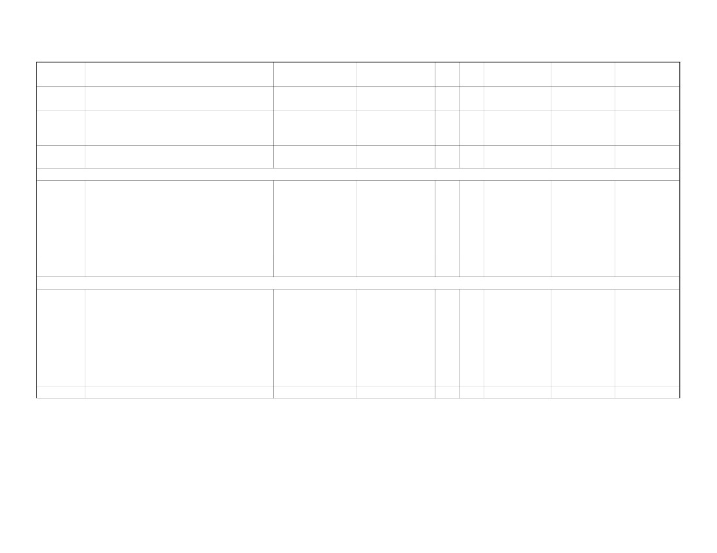
Item Sl.
Product Description
No.
Miscellaneous
C - 26Fixed Ceiling Mount Kit for projector
C - 27Wall Plate Inteface
Building 3D
Display System
42" LCD TV Series LD 550, Full HD 120Hz
LCD, Refresh Rate120 Hz, Intelligent Sensor,
NetCast™ Entertainment Access
(Broadband), Wireless HD Ready, Wi-Fi
D-1
Ready, DNLA Certified, Pictures, Music and
Video via USB 2.0 + Wall Mount Bracket
(Note: model & price may vary depends on
availability upon order confirmation)
D-2DVD Player
Building 4E
Display System
42" LCD TV Series LD 550, Full HD 120Hz
LCD, Refresh Rate120 Hz, Intelligent Sensor,
NetCast™ Entertainment Access
(Broadband), Wireless HD Ready, Wi-Fi
E-1
Ready, DNLA Certified, Pictures, Music and
Video via USB 2.0 + Wall Mount Bracket
(Note: model & price may vary depends on
availability upon order confirmation)
Building 5 - Zone 3F
BGM System
Outdoor Wall Mount Speaker, 30 W (70.7 V,
F-1
100 V line)
Power Amplifier, 220 - 240 V AC, or 24 - 30 V
F-2
DC
F-3Wall Plate Inteface for local audio
Brand
LEADA
AudiViz
Model
PM10080
Custom
Unit Qty
1
1
1
4
Unit Price
(AED)
350.00
350.00
Total Price
(AED)
350.00
1,400.00
Grand Total
(AED)
LG
42LD550
1
2
3,299.00
6,598.00
LG
Latest
1
1
399.00
399.00
LG
42LD550
1
2
3,299.00
6,598.00
TOA
TOA
AudiViz
BS-1030
P-2240
Custom
1
1
1
11
1
1
445.00
1,900.00
350.00
4,895.00
1,900.00
350.00
Show room: Suite # 118/119, Al Khaleej Center, Burdubai. Tel: 04 3528626, Fax: 04 3528627
Suite # 1308, Kalfan Al Suhaidi Building Airport Road Abu Dhabi UAE Tel: 02 6433447, Fax: 02 6433448
6
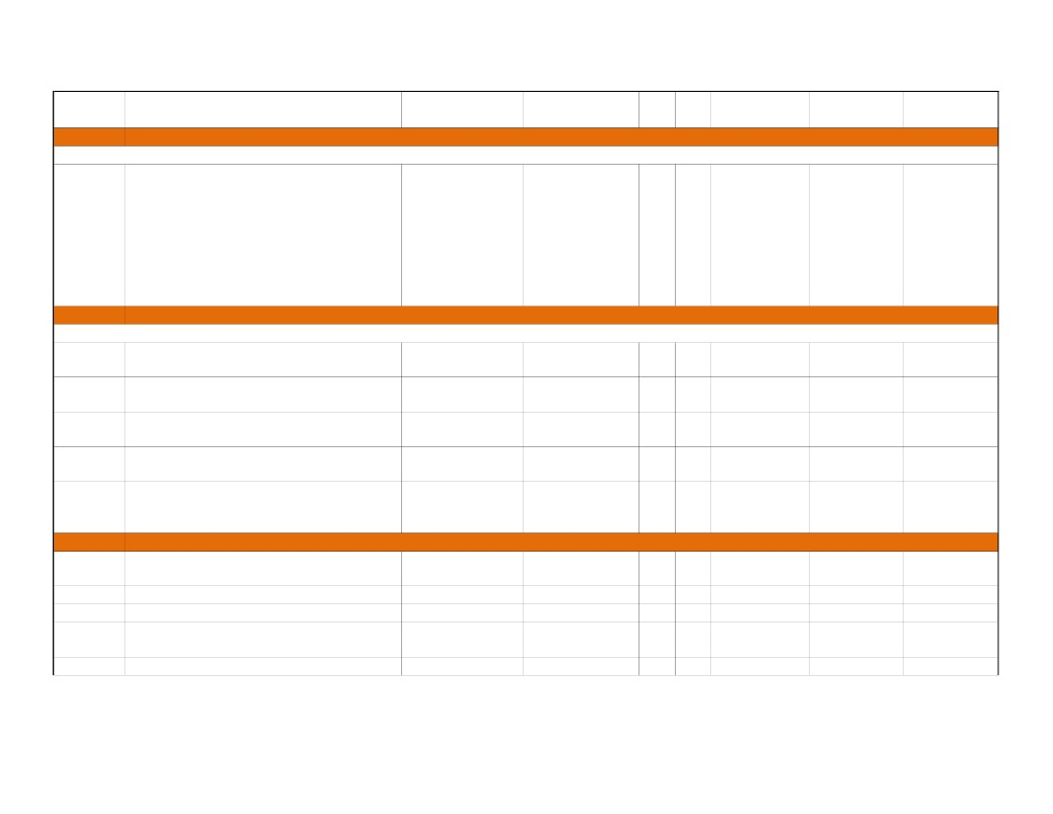
Item Sl.
No.
F-4
Product Description
Brand
BIAMP
BIAMP
MiniPro
Model
AudiaEXPI/O-2
RED-1
Various
Unit Qty
1
1
1
1
1
1
Unit Price
(AED)
4,000.00
2,500.00
1,100.00
Total Price
(AED)
4,000.00
2,500.00
1,100.00
Grand Total
(AED)
2 mic/line analog inputs and 2 line outputs to
CobraNet output
Remote Ethernet Remote Control with high
F-5contrast OLED display & 32 selectable system
volumes and actions
AV Rack including shelves, blank panels,
F-6
PDU, etc., to accommodate equipments
Display System
42" LCD TV Series LD 550, Full HD 120Hz
LCD, Refresh Rate120 Hz, Intelligent Sensor,
NetCast™ Entertainment Access
(Broadband), Wireless HD Ready, Wi-Fi
F-7
Ready, DNLA Certified, Pictures, Music and
Video via USB 2.0 + Wall Mount Bracket
(Note: model & price may vary depends on
availability upon order confirmation)
Breefing Room
42" LCD TV Series LD 550, Full HD 120Hz
LCD, Refresh Rate120 Hz, Intelligent Sensor,
NetCast™ Entertainment Access
(Broadband), Wireless HD Ready, Wi-Fi
F-8
Ready, DNLA Certified, Pictures, Music and
Video via USB 2.0 + Wall Mount Bracket
(Note: model & price may vary depends on
availability upon order confirmation)
F - 19DVD Player
LG
42LD550
1
1
3,299.00
3,299.00
LG
42LD550
1
1
3,299.00
3,299.00
LG
Latest
1
1
399.00
399.00
Show room: Suite # 118/119, Al Khaleej Center, Burdubai. Tel: 04 3528626, Fax: 04 3528627
Suite # 1308, Kalfan Al Suhaidi Building Airport Road Abu Dhabi UAE Tel: 02 6433447, Fax: 02 6433448
7
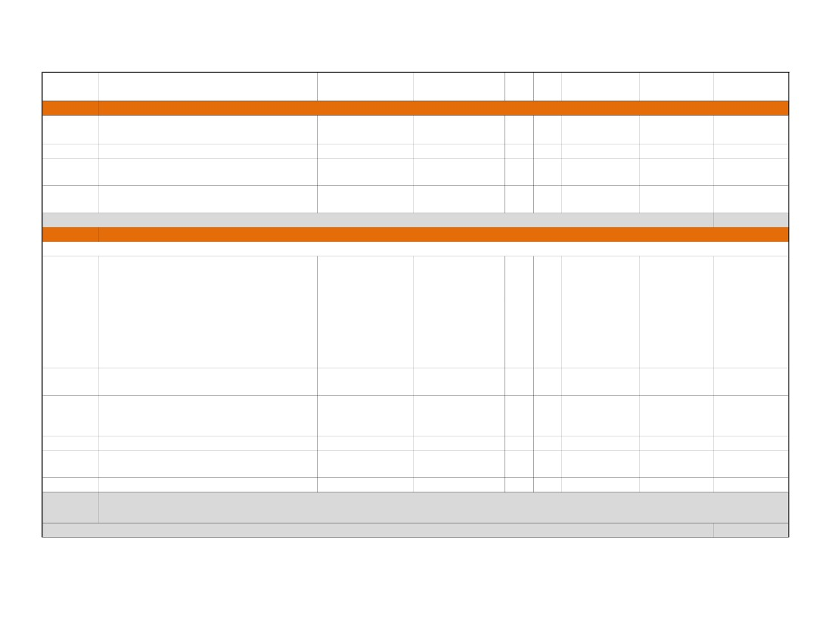
Item Sl.
Product Description
No.
Building 7 - Zone 4G
Display System
42" LCD TV Series LD 550, Full HD 120Hz
LCD, Refresh Rate120 Hz, Intelligent Sensor,
NetCast™ Entertainment Access
(Broadband), Wireless HD Ready, Wi-Fi
G-1
Ready, DNLA Certified, Pictures, Music and
Video via USB 2.0 + Wall Mount Bracket
(Note: model & price may vary depends on
availability upon order confirmation)
Outdoor Speaker - Zone 5H
BGM System
Wide Range Weatherproof Speaker, IP 65
H-1
Rated, 15 W (100 V, 70 V line)
Outdoor Wall Mount Speaker, 30 W (70.7 V,
H-2
100 V line)
Power Amplifier, 220 - 240 V AC, or 24 - 30 V
H-3
DC
2 mic/line analog inputs and 2 line outputs to
H-4
CobraNet output
Remote Ethernet Remote Control with high
H-5contrast OLED display & 32 selectable system
volumes and actions
Centralized EquipmentsI
AudiaFLEX chassis with CobraNet® Module,
I-1
2RU
I-22-channel mic/line input card
I-32-channel mic/line output card
CD Changer 5-Disc, CD-R/RW, MP3
I-4
Compatible
I-54 Channel Sound Server
Brand
Model
Unit Qty
Unit Price
(AED)
Total Price
(AED)
Grand Total
(AED)
LG
42LD550
1
1
3,299.00
3,299.00
TOA
TOA
TOA
BIAMP
BIAMP
CS-304
BS-1030
P-2240
AudiaEXPI/O-2
RED-1
1
1
1
1
1
20
5
3
1
1
450.00
445.00
1,900.00
4,000.00
2,500.00
9,000.00
2,225.00
5,700.00
4,000.00
2,500.00
BIAMP
BIAMP
BIAMP
DENON
iMERGE
AudiaFLEX CM
IP-2
OP-2e
DCM-500-AE
S3004
1
1
1
1
1
1
3
5
2
1
19,000.00
910.00
560.00
1,300.00
14,000.00
19,000.00
2,730.00
2,800.00
2,600.00
14,000.00
Show room: Suite # 118/119, Al Khaleej Center, Burdubai. Tel: 04 3528626, Fax: 04 3528627
Suite # 1308, Kalfan Al Suhaidi Building Airport Road Abu Dhabi UAE Tel: 02 6433447, Fax: 02 6433448
8
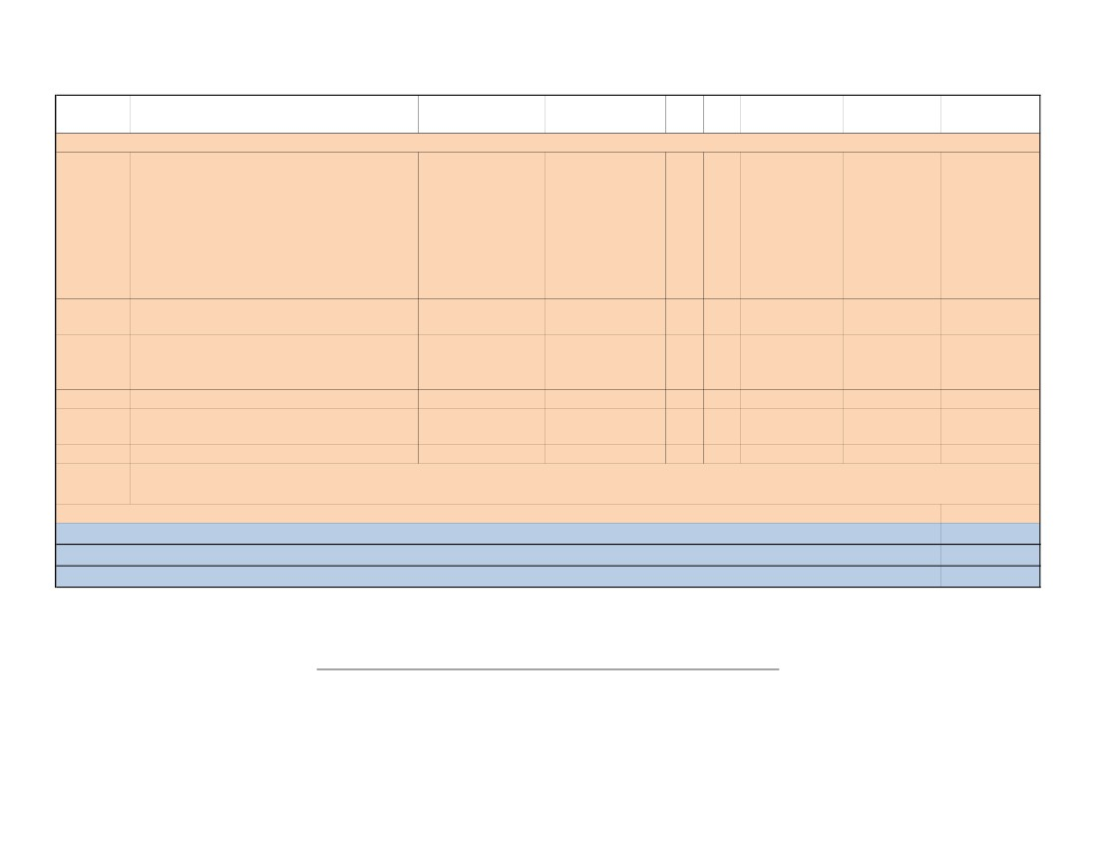
Item Sl.
No.
J
J-1
J-2
J-3
J-4
Product Description
Services
Cables, Connectors and other installation
accessories
Installation, Testing & Commissioning
BIAMP & CRESTRON System Programming
Documentation, Project Management &
Training
Brand
Percon/Extron/Bel
den
AudiViz
AudiViz
AudiViz
Model
Unit Qty
Unit Price
(AED)
22,000.00
32,000.00
13,000.00
3,000.00
Total Price
(AED)
22,000.00
32,000.00
13,000.00
3,000.00
Grand Total
(AED)
Various
Custom
Custom
Custom
Lot
Ls
Ls
Ls
1
1
1
1
Sub-Total for AV & BGM System :
387,171.00
Digital Signage System for Public DisplaysK
OPTION 1 - with Standard Definition IPTV Encoder
Multi-media player. Video, animations,
Stills, Text and Audio, Intel processor
accepting more media formats (inc. MPEG4,
AVI & QT), Portrait or Landscape display,
K-1ONELANNTB-620P119,000.009,000.00
Drag & drop design capability, Zone
transparency, Multilingual GUI and Media
Playout (Content, network & data point has to
be provided by Client)
AvediaPlayer r9200 receiver with HDMI
K-2Exterityavply-r92001161,640.0026,240.00
output (802.3af PoE)
AvediaStream e2532, SD HDMI MPEG-4
K-3Exterityavstr-e25321116,130.0016,130.00H.264 encoder (no HDCP support) with
scaling
K-4AvediaStream c1101, 1-slot chassisExterityavstr-c1101-111,250.001,250.00
Cables, Connectors & other installation
Percon/BeldenVariousLot12,500.002,500.00K-5
accessories
K-6Installation, Testing & CommissioningAudiVizCustomLs15,000.005,000.00
IPTV works on the existing LAN, provided multi-casting is supported with atleast IGMPV2. This means IGMP needs one querier switch and
Note:
all other switches need to support IGMP snooping.
Sub-Total for Digital Signage System :60,120.00
Show room: Suite # 118/119, Al Khaleej Center, Burdubai. Tel: 04 3528626, Fax: 04 3528627
Suite # 1308, Kalfan Al Suhaidi Building Airport Road Abu Dhabi UAE Tel: 02 6433447, Fax: 02 6433448
9
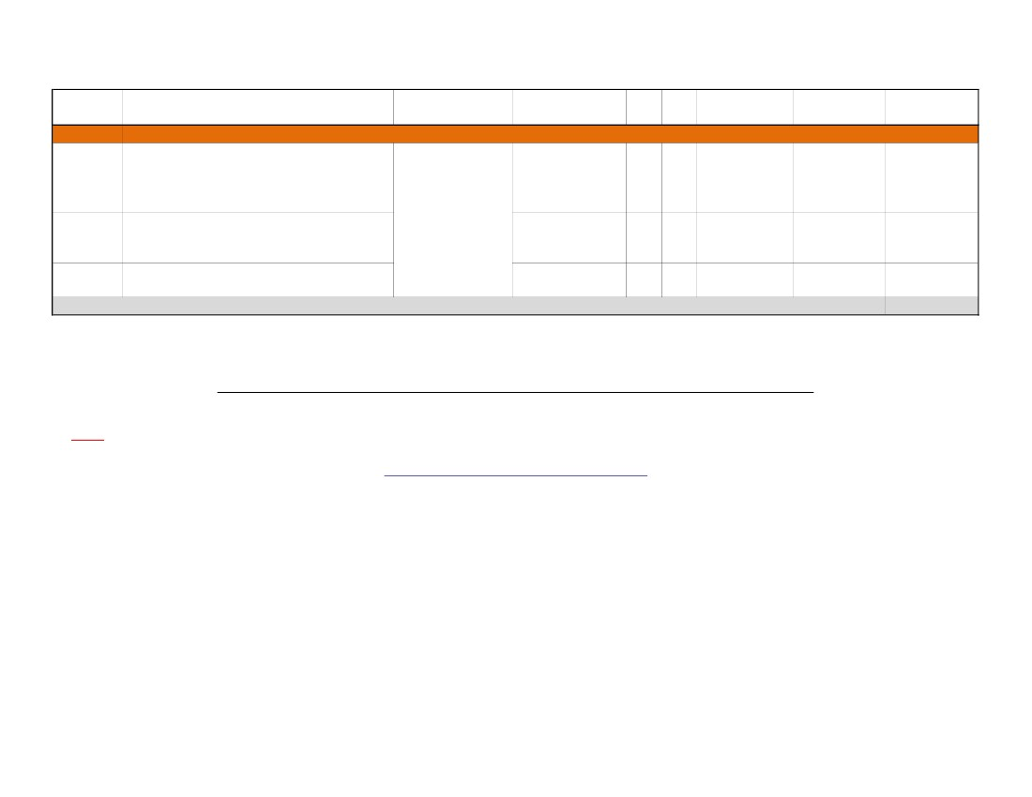
Item Sl.Unit PriceTotal PriceGrand Total
Product DescriptionBrandModelUnit Qty
No.(AED)(AED)(AED)
OPTION 2 - with High Definition IPTV Encoder [ will replace OPTION 1 if selected ] - price not included in the main proposal
Multi-media player. Video, animations,
Stills, Text and Audio, Intel processor
accepting more media formats (inc. MPEG4,
AVI & QT), Portrait or Landscape display,
K-1ONELANNTB-620P119,000.009,000.00
Drag & drop design capability, Zone
transparency, Multilingual GUI and Media
Playout (Content, network & data point has to
be provided by Client)
AvediaPlayer r9200 receiver with HDMI
K-2Exterityavply-r92001161,640.0026,240.00
output (802.3af PoE)
AvediaStream e3532, HD HDMI MPEG-4
K-3Exterityavstr-e35321140,725.0040,725.00H.264 encoder (to 1080p60, no HDCP) with
scaling
K-4AvediaStream c1101, 1-slot chassisExterityavstr-c1101-111,250.001,250.00
Cables, Connectors & other installation
K-5Percon/BeldenVariousLot13,000.003,000.00
accessories
K-6Installation, Testing & CommissioningAudiVizCustomLs15,000.005,000.00
IPTV works on the existing LAN, provided multi-casting is supported with atleast IGMPV2. This means IGMP needs one querier switch and
Note:
all other switches need to support IGMP snooping.
Sub-Total for OPTION 2 - Digital Signage System :85,215.00
Grand Total :
Less Round-Off :
Final Total for AV :
Total Value of Proposal in Words:
447,291.00
291.00
447,000.00
AED FOUR HUNDRED FORTY SEVEN THOUSAND ONLY.
Show room: Suite # 118/119, Al Khaleej Center, Burdubai. Tel: 04 3528626, Fax: 04 3528627
Suite # 1308, Kalfan Al Suhaidi Building Airport Road Abu Dhabi UAE Tel: 02 6433447, Fax: 02 6433448
10
Item Sl.
No.
L
L-1
Product Description
Brand
Model
Unit Qty
Unit Price
(AED)
Total Price
(AED)
Grand Total
(AED)
L-2
L-3
Additional Cabling and Switches Requirements
24-port 10/100Mbps PoE L3 Switch with 2-
port Copper Gigabit & 2 Combo Copper/SFP
Gigabit Ports Note: 1-2 Weeks delivery upon
confirmation
Asian Continental
Additional Cabling (Bldg. 3,4,5 & 7) -
(G.T.) L.L.C.
Truncking, end-to-End termination, testing,
crimpping.
Installation, configuration and programming
of manageable switches
DES-3828P/E
1
6
4,783.60
28,701.60
1
Ls
19
1
250.00
2,500.00
4,750.00
2,500.00
35,951.60
Grand Total for IT :
Total Value of Proposal in Words:
AED THIRTY FIVE THOUSAND NINE HUNDRED FIFTY ONE AND 60/100 ONLY.
Note:
All civil works, conduits, electrical points, related IP/network infrastructure has to be provided by Client.
Please refer to the attached Terms & Conditions
Show room: Suite # 118/119, Al Khaleej Center, Burdubai. Tel: 04 3528626, Fax: 04 3528627
Suite # 1308, Kalfan Al Suhaidi Building Airport Road Abu Dhabi UAE Tel: 02 6433447, Fax: 02 6433448
11

