2 0 1 0
N e w Y o r k S t a t e a S S e m b l Y
session internship ApplicAtion
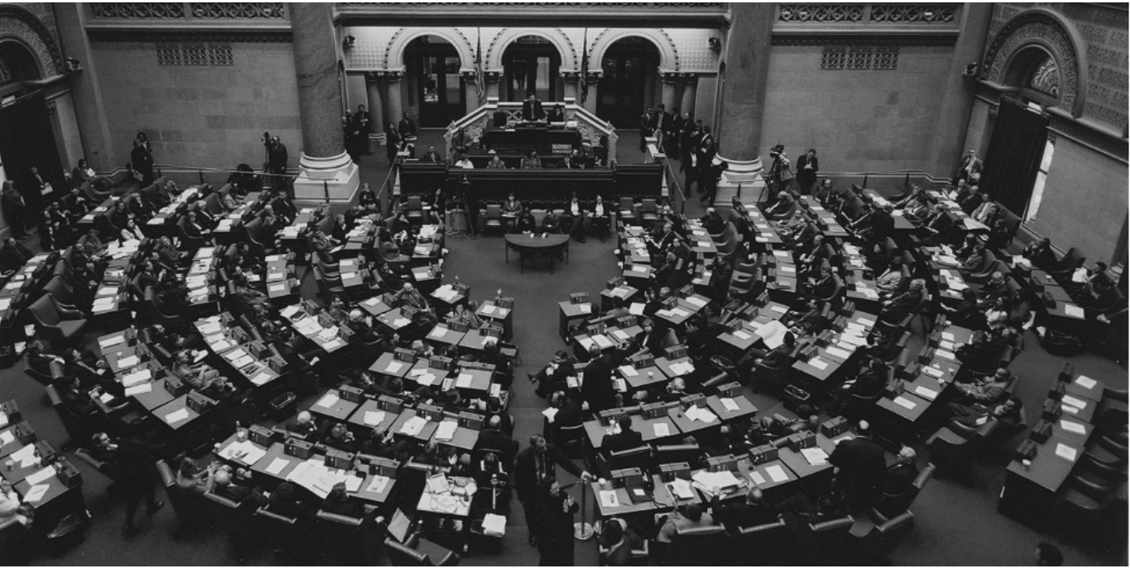



S h e l d o N S I l v e r , S p e a k e r
•

I N t e r N C o m m I t t e e
r o N a l d C a N e S t r a r I , C h a I r



New York State Assembly SeSSioN iNterNShip

The SESSION INTERNSHIP offers college students a chance to participate in state government and the legislative process through a well-structured academic and practical learning experience. Most colleges grant Session Interns a full semester of credit, as recommended by the Regents National Program on Noncollegiate Sponsored Instruction (National PONSI). The Assembly Intern Committee awards a $4,140 stipend (includes book allowance) to each Session Intern in the January 4, 2010 to May 12, 2010 Internship.

DEADLINE:
Applicants generally have a mid-October deadline set by their college liaison officer. Applicants should check for the exact deadline with their college liaison officer. Liaison officers should submit completed applications for all of their students to the Assembly Intern Committee with a postmark no later than
October 30, 2009.

University at Albany, State University of New York Applicants
PLEASE NOTE:
Applications are due to
Ms. Karen Acosta McNeill, Liaison Officer

518-442-3950
Undergraduate Education Office, Lecture Center 30, by October 9, 2009

ELIGIBILITY:
Applicants must be juniors and seniors matriculated in a college degree program. Upper level matriculated students in an associates degree program are also encouraged to apply. Applicants may be from any major. All applicants must demonstrate academic ability, intellectual curiosity and receive the positive recommendation of their campus liaison. International Students should have academic requirements in the United States to be eligible. Any questions regarding eligibility or special circumstance should be addressed to the Assembly Intern Committee office.
THE INTERNSHIP:
The Assembly offers up to 150 college students an opportunity to get involved in state government and gain firsthand knowledge of the legislative process. Interns are enrolled in a course taught by the Intern Committee Faculty-in-Resi- dence and complete a comprehensive orientation. They are assigned research and administrative responsibilities in an Assembly office. Students receive an academic and practical educational experience. The Session Internship is a comprehensive program requiring specific academic hours.
APPLICATION PROCEDURES:
The following supporting documents are required of all Session Internship applicants:
✦ A personal statement (item #19 on the application).
✦ Official transcripts of all college courses completed and in progress. If the college will not release official transcripts to students, they may be sent directly to the Assembly Intern Committee under separate cover. The applicant should note this in the application.

1 continued on page 6
FOR OFFICE USE ONLY
AP PS T WS L:1 2 3(E) R PC

APPLICATION
NeW YorK StAte ASSeMBLY SeSSioN iNterNShip

JANUArY 4, 2010 – MAY 12, 2010

Applications and all supporting documents, including official transcripts, as described in the previous pages, must be postmarked in a complete package by October 30, 2009. SESSION INTERNSHIP applications and all supporting documents must be mailed by the College Liaison Officer to the New York State Assembly Intern Committee, Room
104-A, Legislative Office Building, Albany, New York 12248.

TYPE OR PRINT CLEARLY IN DARK INK

1. NAME

2. PRESENT ADDRESS (until )

(City) (State) (Zip)

3. TELEPHONE ( )
CELL ( )

4. E-MAIL ADDRESS

5. PERMANENT ADDRESS

(City) (State) (Zip)

6. COUNTY

7. TELEPHONE ( )

8. CURRENT STATUS ❐ Junior ❐ Senior ❐ Other (Please specify)

9. UNDERGRADUATE SCHOOL(S)

College/University
College/University

Major
Major

Degree
Degree

Date Received
Date Received

GPA
GPA

10. PLANS FOR 2010

11. ACADEMIC HONORS

12. EXTRACURRICULAR ACTIVITIES

13. WORK EXPERIENCE (list dates, employer, address and duties)

 | DATES | EMPLOYER | POSITION | DUTIES
PLEASE CHECK IF RESUME IS ATTACHED.

14. LIST THE TWO INDIVIDUALS WRITING THE REFERENCE LETTERS FOR THIS INTERNSHIP.

(1)

(2)

15. LIST ANY PUBLIC POLICY AREAS IN WHICH YOU ARE INTERESTED IN WORKING. INDICATE ANY STUDIES OR EXPERIENCES IN EACH AREA WHICH QUALIFIES YOU FOR THAT ASSIGNMENT.
16. LIST ANY PLACEMENT PREFERENCES YOU MAY HAVE, IF ANY, AND EXPLAIN YOUR REASONS FOR THIS PREFERENCE.

17. LIST THE NAME, PHONE, AND EMAIL ADDRESS OF THE COLLEGE LIAISON OFFICER PROCESSING YOUR APPLICATION:

18. PLEASE INDICATE THE AMOUNT OF COLLEGE CREDITS YOU WILL RECEIVE TOWARDS GRADUATION UPON COMPLETION OF THIS INTERNSHIP PROGRAM.

AMOUNT OF CREDIT(S)

FACULTY SUPERVISOR’S NAME

DEPARTMENT
PHONE

COLLEGE/UNIVERSITY

19. ON THE BACK OF THIS APPLICATION, TO EVALUATE AND DETERMINE PLACEMENT, PLEASE WRITE A PERSONAL STATEMENT OUTLINING YOUR ABILITIES, RELEVANT EMPLOYMENT HISTORY, INTEREST IN STATE GOVERNMENT, AND WHY YOU FEEL PREPARED TO BE AN ASSEMBLY SESSION INTERN.

20. ENCLOSE A WRITING SAMPLE THAT ILLUSTRATES YOUR RESEARCH AND WRITING SKILLS. THIS WRITING SAMPLE WILL NOT BE RETURNED.

21. ALL OF THE INFORMATION PROVIDED IS TRUE TO THE BEST OF MY KNOWLEDGE. I UNDERSTAND THAT ALL MATERIALS SUBMITTED WITH THIS APPLICATION WILL NOT BE RETURNED AND ARE FOR THE CONFIDENTIAL USE OF THE ASSEMBLY INTERN COMMITTEE IN CONNECTION WITH MY ACCEPTANCE AND PLACEMENT IN THE SESSION INTERNSHIP. I HAVE ANSWERED ALL QUESTIONS AS DIRECTED AND ENCLOSED ALL OF THE REQUIRED SUPPORTING DOCUMENTS. TO ENSURE THAT OTHER APPLICANTS RECEIVE FULL CONSIDERATION, I WILL NOTIFY THE ASSEMBLY INTERN COMMITTEE IMMEDIATELY IF I WITHDRAW MY APPLICATION FOR ANY REASON.

22. For immediate confirmation of the Assembly’s receipt of your application, please check one of the following:

E-mail address:

Enclosed stamped, self-addressed postcard.

23. SIGNATURE
DATE

✦ Two letters of recommendation from individuals who have directly observed the applicant (in school or at work) and can give an evaluation in one or more of the following areas: character, research skills, familiarity with public policy issues, understanding of the governmental process, and ability to learn in a work setting. Letters should not be requested from anyone who has not directly taught or observed the applicant. At least one must be from a professor at the college you now attend.
✦ A letter from an appropriate college official endorsing the student’s participation and indicating the amount of credit to be granted by the college and whether or not the student will be taking the internship on a “pass-fail” basis or receiving a letter grade. If this letter is written by the same person as one of the above, it should be clearly stated as performing this dual purpose.
✦ A concise writing sample which provides a good indication of the student’s research and communication abilities (item #20 on the application).

Submit Session Internship applications and all supporting documents to the designated college liaison officer. If you cannot locate your college liaison officer, contact the Assembly Intern Committee. In this case, an appropriate faculty member or administrator at your college should forward your application and supporting materials along with a cover letter indicating the college’s endorsement of your participation.

Be sure to answer all of the questions thoroughly. The Assembly Intern Committee notifies applicants of their status within two weeks of receiving their completed applications with all supporting documents. For immediate confirmation of the Assembly’s receipt of your application, please provide an e-mail address or enclose a stamped, self-addressed postcard.

ASSEmBLY POLICY:
For the Assembly Policy Prohibiting Fraternization with Student Interns, please visit our website:
http://assembly.state.ny.us/internship/

HOURS AND STIPEND:
Interns spend a minimum of 30 hours, exclusive of academic course requirements, at the capital each week completing their Assembly assignments. The Assembly Intern Committee provides a $4,140 (biweekly $445.17 before taxes) stipend to help cover expenses. Some eligible students receive supplementary stipends, partial tuition waivers, or temporary loans from their colleges and universities.

EDUCATIONAL COmPONENT AND COLLEGE CREDIT:
The Assembly Session Internship includes an academic component beginning with a four-day Orientation to state government and the legislative process. Each student is enrolled in the course, “Politics and Policy in the New York State Legislative Process,” taught by the Assembly’s Intern Committee Professors-in-Residence, Dr. Helen R. Desfosses and Dr. Dennis C. Smith. Some required reading materials are made available to Session Interns by the Assembly Intern Committee. The Faculty also provides supervision and research advisement through individual meetings and group discussions. Faculty conduct at least three meetings with Interns during which their progress is monitored. Evaluations of their performance are made at the mid-term and end of the Internship.

The Intern Committee allows flexibility in credit arrangements. Interns should enroll in no more than three credit hours in addition to the credit granted for the Internship.

Orientation includes sessions on legislative research, the role of legislative staff and interns, legislative/executive relations, political parties in the Legislature, communication skills, the legislative process and budget.

Issue Forum attendance is required and calculated in grade evaluations. The forums are designed to complement the academic internship curriculum. Experts in areas of government and academia join legislators in presenting a review of the legislative process. Lectures include topics such as the State budget, the economy, education, criminal justice and elections. Issue Policy Forums are held on Monday nights from 5:30 pm to 7:30 pm, and Tuesday nights as scheduled.

Mock Session represents the culmination of the learning experience for the Session Internship. Mock Session will be at 5 p.m. on Tuesday, May 4, 2010, in the Assembly Chamber.

6 continued on page 7

The Regents National Program on Noncollegiate Sponsored Instruction evaluates the Session Internship. Its recommendation is that “15 semester hours…be awarded in the upper division baccalaureate category in appropriate departments or general elective credit” for participation in the Session Internship. The Intern Committee’s credit recommendation is reviewed by National PONSI. A copy of the 2007 National PONSI credit recommendation is available upon request to the Assembly Intern Office.

PLACEmENTS:
All placements are made by the Assembly Intern Committee in January. They relate to the student’s experience, abilities and interest to the extent that these are compatible with Assembly needs. Every attempt is made to provide Interns with their stated policy preference or with a comparable placement. Specific assignment responsibilities evolve from a work/learning contract, which is negotiated by the Intern and supervisor once placements begin.
Interns’ assignments in Assembly Member offices or with research staffs consist of a variety of responsibilities. Short-term research and responding to constituent mail are frequent assignments. Often the two are closely integrated with constituent questions leading to research projects. Interns keep track of bills moving through the legislative process. Some routine duties are always part of the functions of an Assembly office. Bill memo preparation and statistical analysis are also common assignments. Interns frequently attend and report on committee meetings, public hearing and Assembly Sessions.

HOUSING:
The Assembly Intern Committee does not provide housing for Interns. Following acceptance into the Session Internship Program; Interns in need of housing are encouraged to utilize resources such as capital district newspapers, i.e., Times Union Classified Section; www.timesunion.com; local academic institutions, i.e., University at Albany, and libraries to find housing possibilities.
If you have any questions, call or write the Assembly Intern Committee as follows: 518-455-4704
E-Mail address: intern@assembly.state.ny.us Website: http://assembly.state.ny.us/internship/


S h e l d o N S I l v e r , S p e a k e r
•

I N t e r N C o m m I t t e e
r o N a l d C a N e S t r a r I , C h a I r

The New York State Assembly Intern Committee seeks to attract to its Internships qualified persons of diverse backgrounds, and pursuant to this policy, no applicant is discriminated against because of race, color, creed, sex, religion, sexual orientation, national origin, disability, genetic predisposition or carrier status, marital status, or military status. A copy of the Assembly’s Affirmative Action Policy is available upon request.

7

