First, sign out of the application get back to the screen that ask you for the pattern password as follows:
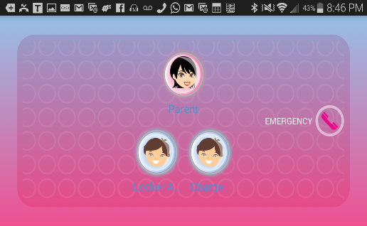
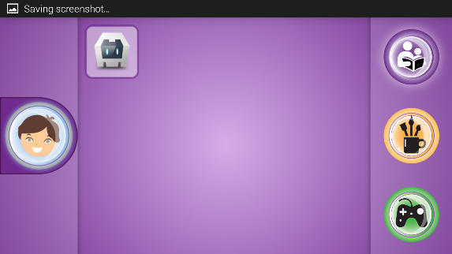
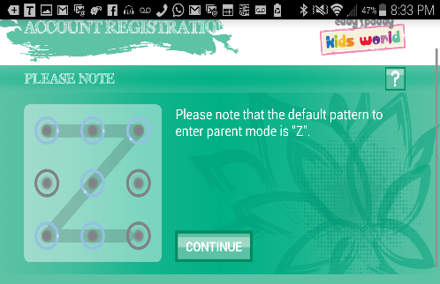
You can do this by clicking the back button, home button or the button of with the child face on the left image. Then, this will take you to the second image. Click on the image with the lady, then enter the pattern password as shown on the right image.
Second, you need to uninstall the old application because it you don’t it will not let you install the most recent app. To do so, you can do it as follows:
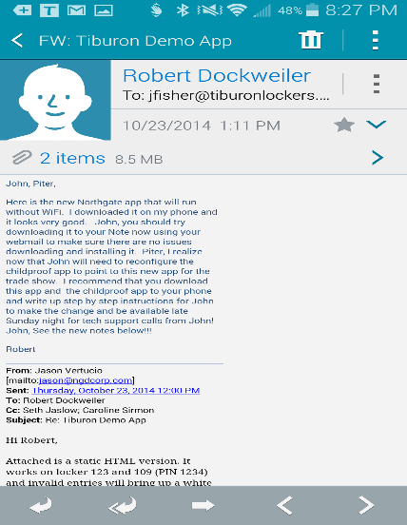
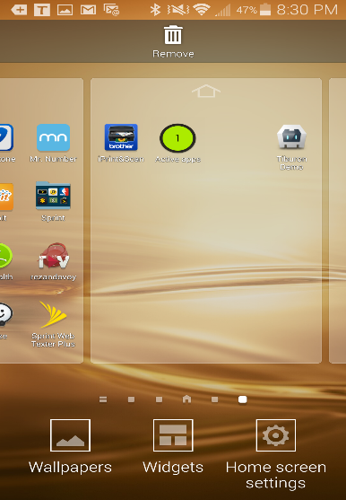
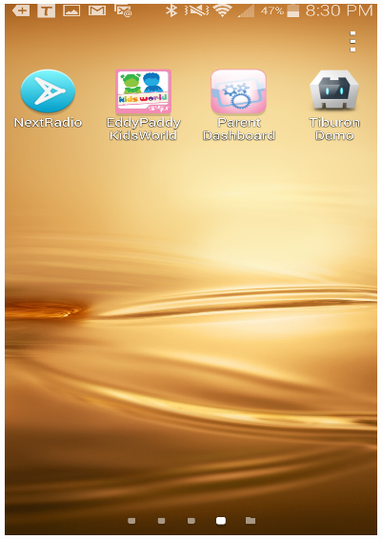
Look for the app on the phone and once you are on the page that contains the app press down on the screen of the page, then move the app to the garbage basket icon that says “uninstall.” After you uninstall this app go to your email and download you most recent app.
To access the most recent application you have downloaded, you can access by clicking the downloading arrow shown on the top menu of phone or as follows:
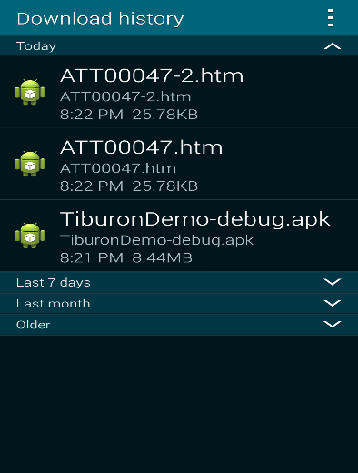
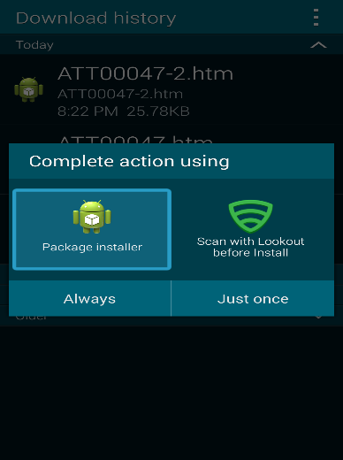
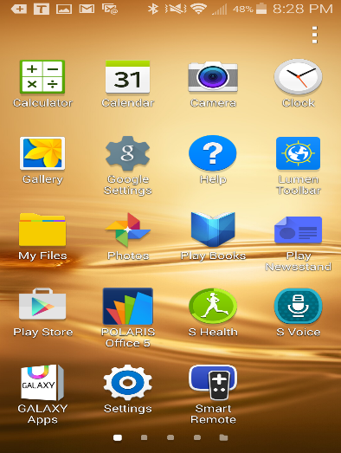
Go to my files as shown on the left image below, then go to “Download History,” and then click on the Tiburon app and click always to complete action as shown in the image on the right.
I have already checked the section that allows you to download apps for unknown sources, but if by any chance you get the message on the left image do the following:
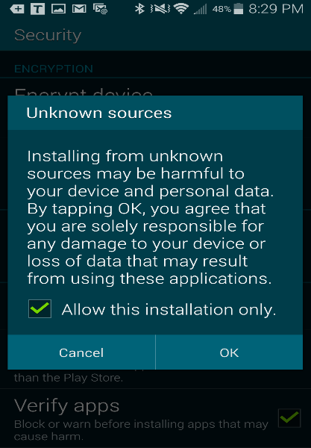
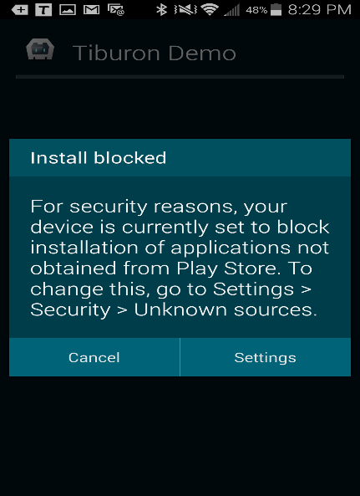
Click on settings, which will take you to security. If the message does not give the option to go to settings, security, then just exit and go straight to settings in your phone, and go to security. Once in security check the box that says unknown sources. Once done, repeat the process above to install the application. In the image on the right, below, select all and click install.

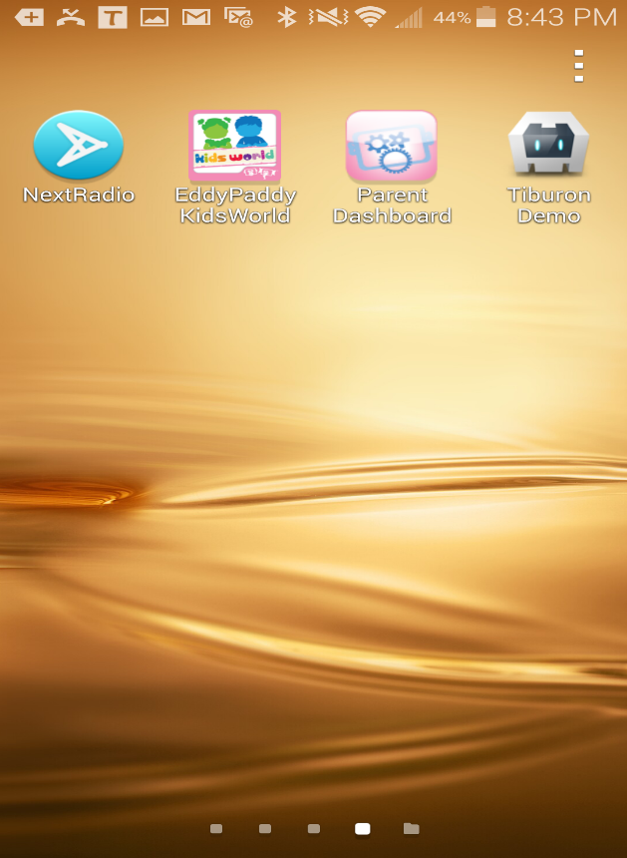
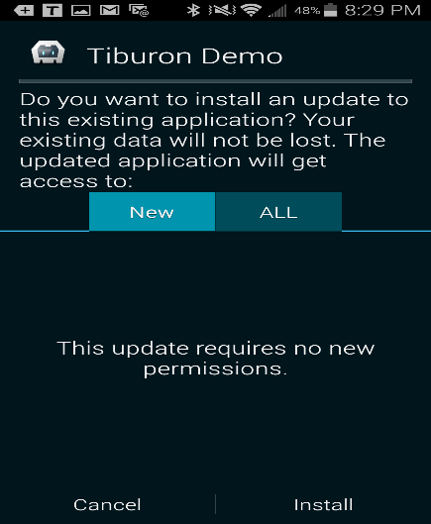
Third, you need to access the control application and set it up so users can see only the Tiburon App as follows:
In the cell phone go to app and click on the icon that says “Parent Dashboard,” it looks exactly like the third icon in the image on the right.
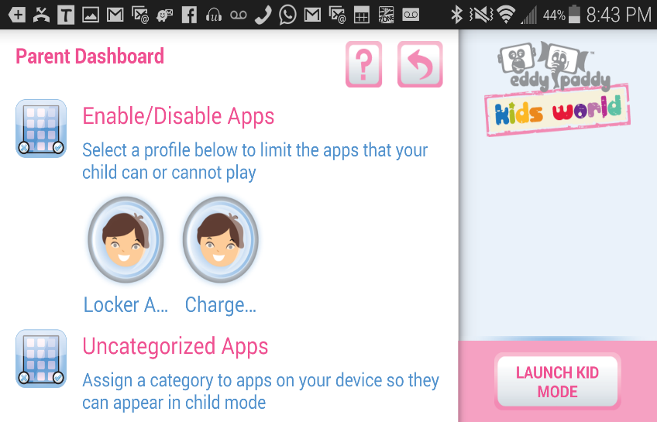
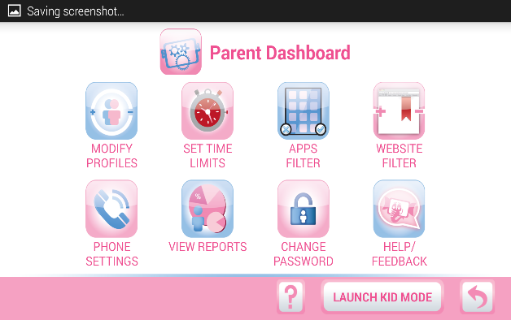
Once on the “Parent Dashboard,” which looks exactly like the image on the right, click on “Apps Filter.” This is the third icon on the image. This will take you to the page below.
Click on the button that has the child image. For this phones you should have only one face, not two as it is shown in the image to the left. After clicking on the image, it will take you the following page.
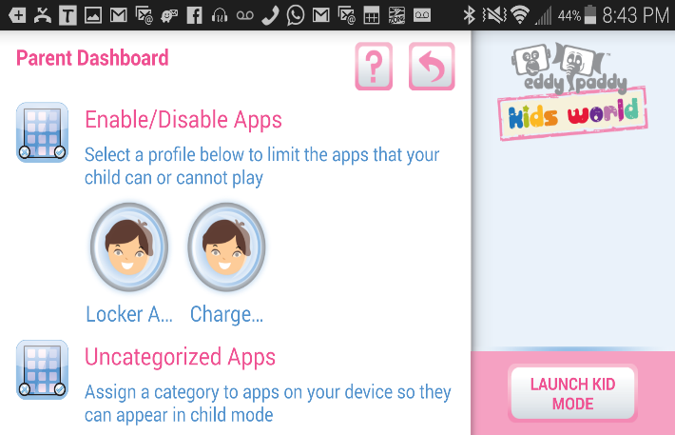
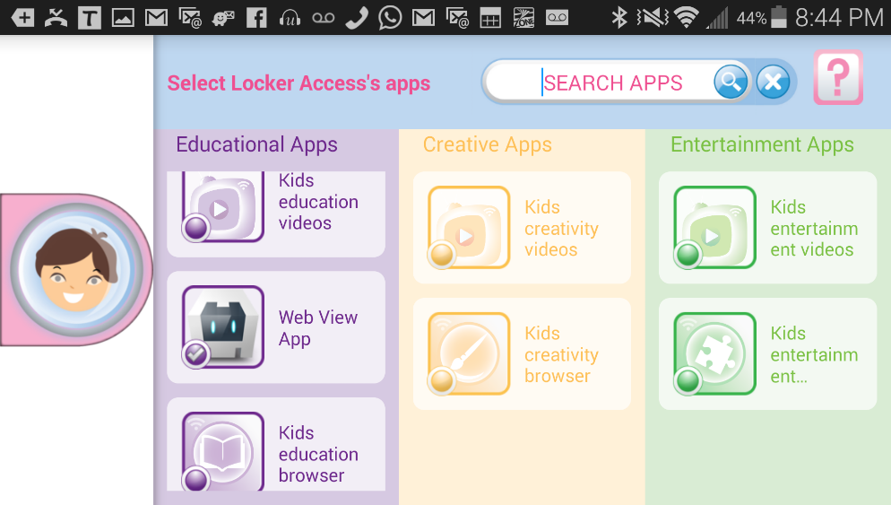
Once here, you need to make sure that all applications are unchecked and that the only application checked is the Tiburon app as shown in the image on the left. Then, touch the back button on the phone and it will take to the Dashboard page again.
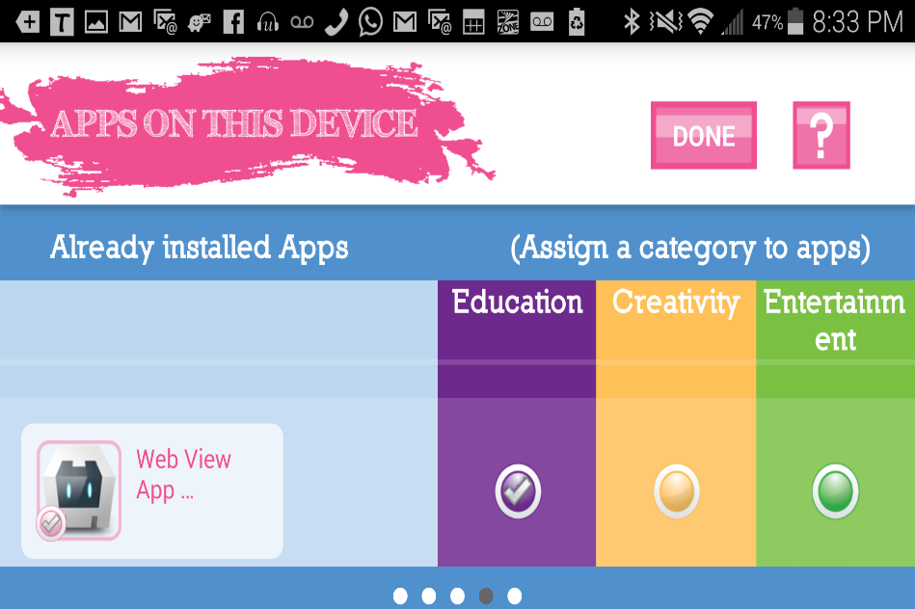
Here, click on the “uncategorized apps” button and it will take you to the image shown below

Once here, you need to make sure that the only application checked is the Tiburon app. It must look exactly as the image on the left. All other applications must not be checked, because we only one users to have access to the Tiburon App.
After the step above, click on the “DONE” button right next to the question mark to go back to the Dashboard page again.

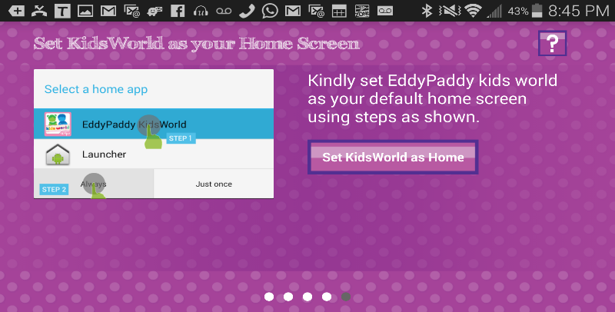
In the Dashboard page click on “Lunch Kid Mode,” it is on the bottom right of the left image. This will take you to the page on the right below, click on Set Kids World as Home.
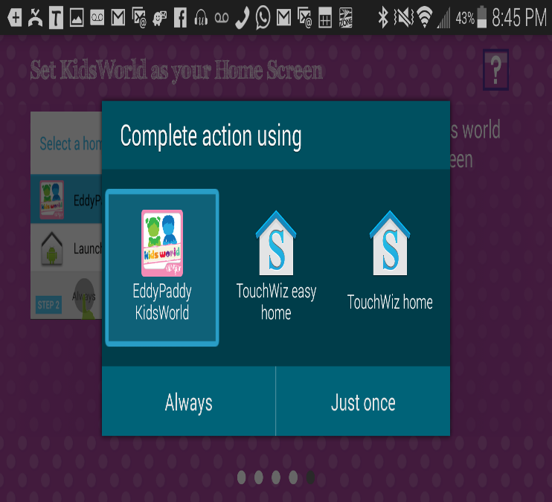
Once here, make sure you complete the action by selecting the “EddyPaddy” app the icon in the left on the left image below and then click “ALWAYS.” This will allow the app to take complete control of the phone, and to only allow the use of the Tiburon App.
Finally, it will take you to the control area where the Tiburon application must be. It should look exactly as the image below, on the right. Make sure that the only app there is the Tiburon app, as shown on the image below on the right. Then, click on the Tiburon application to launch the app and leave it running forever!

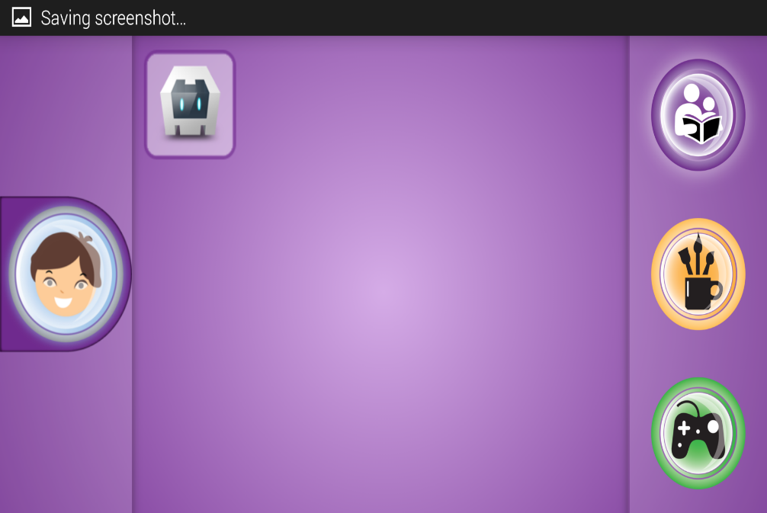
The image above, on the left, should be your end result. And if you try accessing anything else on the phone, the application will not allow it and it will always send you back to the area where the Tiburon application is. In other words, to the image above location on the right.

