In the following formulas, let a, b, c, n be constants, and
General Formulas
1 | 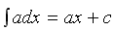
2 | 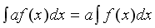
3 | 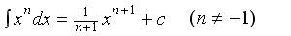
4 | 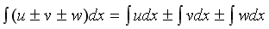
5 | 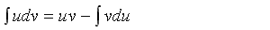Integration by parts
6 | 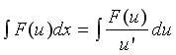
7 | 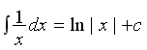
8 | 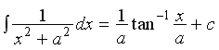
9 | 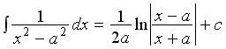

Trigonometric Functions
10 | 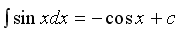 | 11 | 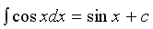
12 | 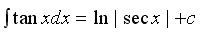 | 13 | 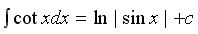
14 | 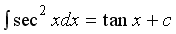 | 15 | 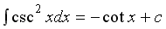
16 | 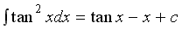 | 17 | 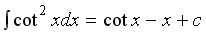
18 | 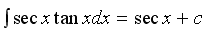 | 19 | 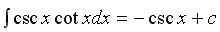
20 | 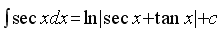 | 21 | 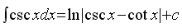
22 | 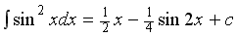 | 23 | 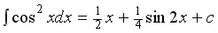
24 | 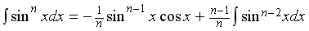
25 | 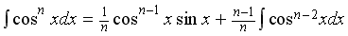
Hyperbolic Functions
26 | 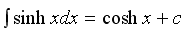 | 27 | 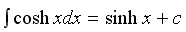
28 | 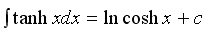 | 29 | 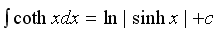
30 | 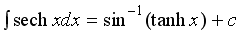 | 31 | 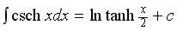
32 | 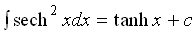 | 33 | 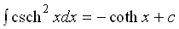
34 | 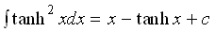 | 35 | 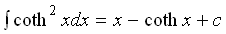
36 | 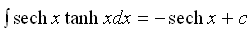 | 37 | 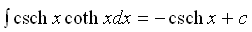
38 | 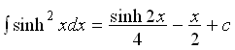 | 39 | 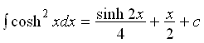
Exponential and Logarithmic Functions
40 | 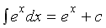 | 41 | 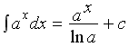
42 | 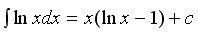 | 43 | 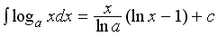
44 | 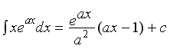 | 45 | 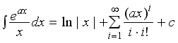
46 | 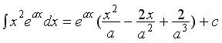
47 | 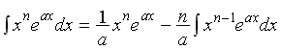
48 | 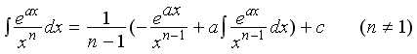
49 | 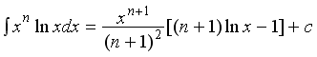

Table of Trigonometric Identities
Reciprocal identities
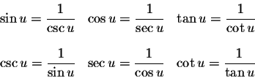
Pythagorean Identities
Quotient Identities
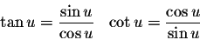
Co-Function Identities
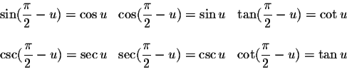
Even-Odd Identities
Sum-Difference Formulas
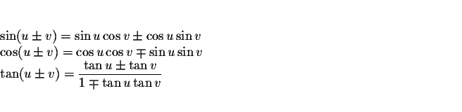

Double Angle Formulas
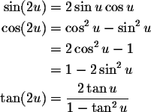
Power-Reducing/Half Angle Formulas
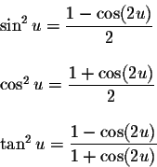

Sum-to-Product Formulas
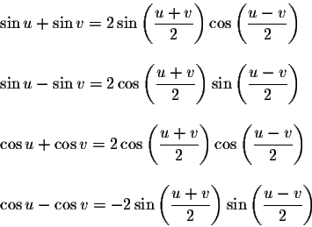
Product-to-Sum Formulas
