IV. EXPERIMENTAL SETUP

The proposed project research industrial machineries will be controlled & regulated by the switching actions performed by FFD side. This FFD side also displays the status of the RFD side system on the LCD connected on its panel. Alarm & Indications as shown that corresponds to status monitoring effects on server side due to remote machine parameter dependency.
Both the devices will be wirelessly linked by ZigBee with STAR topology. Industrial Automation profile of the ZigBee will be implemented here. As the whole data is transferred via Wireless radio link system will eliminates the loopholes of the traditional wired system.
In the proposed module, transmitter module receives the parameters from the device; display
parameters on the LCD display and send it to the receiver side through ZigBee connectivity. In the same

ISSN : 0975-3397 Vol. 3 No. 5 May 2011 2031
Archana R. Raut et al. / International Journal on Computer Science and Engineering (IJCSE)

way receiver module receive data sent by the transmitter through ZigBee connectivity and display it on LCD display connected to the receiver side. Both transmitter and receiver side will generate the alarm if any parameter exceeds its preset value. Thus, it avoids the malfunctioning of the devices due to the variations in the current and voltage parameters and also avoids the system failure.

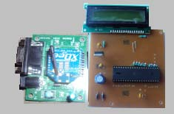
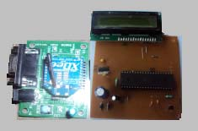

(a) Transmitter module with Zigbee base PCB (b) Receiver Module with Zigbee base PCB Fig. 4. Transmitter and receiver module
Figure 4 shows the transmitter and receiver module used in the system. Figure 5 shows the real implemented system. As shown RFD side will be switched by FFD for production controlled mechanisms. Secondly electrical parameters will also be sensed on this side for the purpose of data transmission to FFD.

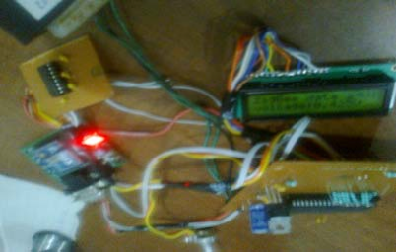
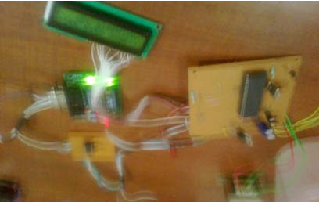

Fig. 5. Implimented Transmitter and Receiver module

V. CONCLUSION & FUTURE SCOPE

Wireless communication is a cheap and easy way to provide network communication at places where there is no wired infrastructure. In addition, because the communicating entities can freely move, one can place the monitoring system wherever it is required without the cost incurred with cabling when adopting the wired communication approac
Wireless communication technologies can often be useful within industrial applications. As a unique protocol of IEEE 802.15.4 satisfy these entire requirements, a compliant technology for this will be required. ZigBee provides all suitable data rates as compared to other wireless technology so this withstands suitably for such applications. This paper presents a system for measuring the power supply parameters using the ZigBee protocol for communicating with other elements. The device presented here in fulfils the objective of a power automation interconnected by ZigBee. So, ZigBee technology is completely suitable for the application in power monitoring system, and it can provide reliable protection for the operation of electric power systems. ZigBee has a lot to offer industrial automation applications because of Low cost deployment and redeployment, Mesh networking to cover entire industrial plants and factories, Open standard with multiple vendors and its Battery operation features. Hence Industrial automation will demand the wide scope to utilize ZigBee for improve control & operations in terms of Power Monitoring System.

ISSN : 0975-3397 Vol. 3 No. 5 May 2011 2032
Archana R. Raut et al. / International Journal on Computer Science and Engineering (IJCSE)

REFFERENCES

[1] Shizhuang Lin, Jingyu Liu, Yanjun Fang. “ZigBee Based Wireless Sensor Networks and Its Applications in Industrial”, IEEE International Conference on Automation and Logistics, 2007 .pp:1979 – 1983.
[2] Jui-Yu Cheng and Min-Hsiung Hung, Jen-Wei Chang, “A ZigBee-Based Power Monitoring System with Direct Load
Control Capabilities”, 2007 IEEE International Conference on TuesE04 Networking, Sensing and Control, London, UK,
15-17 April 2007.
[3] Bhavneet Sidhu, Hardeep Singh, and Amit Chhabra. “Emerging Wireless Standards - WiFi, ZigBee and WiMAX”, World
Academy of Science, Engineering and Technology 25, 2007.
[4] Niu Dou, Yang Mei, Zhao Yanjuan, Zhang Yan. “The networking technology within Smart Home system --ZigBee
Technology”, 2009 International Forum on Computer Science-Technology and Applications, 2009 IEEE
[5] Hu Guozhen. “Key Technologies Analysis of ZigBee Network Layer”, IEEE 2nd International Conference on Computer
Engineering and Technology, 2010 IEEE
[6] Jo Woon Chong, Ho Young Hwang, Chang Yong Jung, and Dan Keun Sung. “Analysis of Throughput and Energy
Consumption in a ZigBee Network under the Presence of Bluetooth Interference”. IEEE GLOBECOM 2007, 1930-
529X/07, 2007 IEEE
[7] Jin-Shyan Lee, Chun-Chieh Chuang, and Chung-Chou Shen. “Applications of Short-Range Wireless Technologies to
Industrial Automation: A ZigBee Approach”, 2009 Fifth Advanced International Conference on Telecommunications,
2009 IEEE
[8] “The emergence of ZigBee in building automations and industrial controls”, IEE Computing &Control Engineering, April/May 2005
[9] Gunter Schmitt, Alessandro Trinca Voigt & Haeffner. “Remote Control and Monitoring of Telecommunication Power
Systems A big challenge for Telcos, Suppliers and Standardization Committees”, 2007 IEEE
[10] Christoph Spiegel, Sebastian Rickers, Guido H. Bruck, Peter Jung, Woojin Shim, Rami Lee, Jaehwang Yu. “Low Power
Networks – The ZigBee Competition”, 2009 IEEE
[11] Il-Kyu Hwang, Member, IEEE and Dae-Sung Lee, Jin-Wook Baek. “Home Network Configuring Scheme for All Electric
Appliances Using ZigBee-based Integrated Remote Controller”, IEEE Transactions on Consumer Electronics, Vol. 55, No.
3, AUGUST 2009
[12] “What is ZigBee?” Digi international, 2 Dec 2007. <http://www.maxstream.net/wireless/zigbee.php >
[13] Ding, G., Sahinoglu, Z., Orlik, P., Zhang, J., Bhargava B., “Tree-Based Data Broadcast in IEEE 802.15.4 and ZigBee
Networks”, IEEE Transactions on Mobile Computing. Vol. 5.No.11, 2006 pp: 1561 – 1574.
[14] L. Zheng, “ZigBee wireless sensor network in industrial Applications,” SICE-ICASE International Joint Conference, pp.
1067-1070, October 2006.
[15] ZigBee Alliance, Network Specification, Version 2.0, Dec. 2006.
[16] Antonopoulos E., Kosmatopoulos K., Laopoulos Th. “Reducing Power Consumption in Pseudo-ZigBee Sensor
Networks”, I2MTC 2009 - International Instrumentation and Measurement Technology Conference Singapore, 5-7 May
2009.
[17] Zengyou Sun, Tao Zhao,Chenghua Che “Design Of Electric Power Monitoring System Based On ZigBee And GPRS”, June 2009 IEEE.

ISSN : 0975-3397 Vol. 3 No. 5 May 2011 2033
Copyright of International Journal on Computer Science & Engineering is the property of Engg Journals Publications and its content may not be copied or emailed to multiple sites or posted to a listserv without the copyright holder's express written permission. However, users may print, download, or email articles for individual use.

