DATA EXPLORATION
The process focuses on constructing a dataset from multiple data sources to explore and model the data according to the design and database architecture. The data is being extracted from a verity of data sources to transform and load the data into its destination. The goal is to discover insights into the data and have a good understanding of any possible data quality issues. In this manner, avoid analyzing data that has not been carefully screened and reduce misleading results. The success of data analysis and reporting heavily depends on the quality of the prepared data. The aim is to describe the data by means of statistical and visualization techniques to bring important aspects of that data into focus for further analysis. Moreover, explore relationships between objects, whether there exists an association and the strength of this association. Lastly, organize and present the knowledge gained in a way that the user can use it by generating a report and, or, implementing a repeatable data mining process.

- DATA SOURCES
Notation: Interfaces (In ←, Out →)

Existing Data Sources -> Talk to Matt for the Existing Data Sources
- CMS
  - Flat File:
    - Customer Master ← Mat Tidd * Need to see the file + mean terms
- CSR
  - Flat File:
    - Material Master ← Item/Material Record -> Matt Tidd
  - Folder Share:
    - Item Image ← Matt Tidd (Use same code)
  - Web Service:
    - Order Lookup ← Matt Tidd
    - Inventory Availability ←
    - Order Creation → XML-> Return

New Data Sources
- DS
  - Flat File
    - Demand Solution History ← Forecast History
PLANNIING/ Demand Solutions Data Daily Extract
    - Demand Solution Sales History ← All sales history
- CSR
  - Flat File
    - Item Image ←
- SAP
  - Flat File
    - Excess Inventory ← Build SAP Excess Inventory – Notify Michael
    - Finance Accrual Release B4 Documents ← LTB has to build it
  - Flat File Export
    - Royalty Tables ← LTB has to build it
    - Commission Tables ← LTB has to build it
  - Export
    - Material Default Delivery Plan by Sales Org → LTB has to build it
- SPE
  - Flat File:
    - Forecast Sales Portal → Demand Solutions
    - Customer Program Drivers → ZDNN MAT
    - Customer Price Records → SAP
- OTHERS
  - Meeting Create in Exchange Server 2010 SP3 →
Time rebate accrual injection -> Scott R.

- DATA EXTRACTION

Demand Solution Record Attribute Fields – Record Managed Item/Plant/Customer Level
------------------------------------------------------------------------------------------------------------------------------------------
- Desc.: Material Description from SAP
- UPC Code: Code
- Birthdate: Date record was created in Demand Solution
- Disc. Date: Date Forecast is to be discontinued in Demand Solutions
- Class: SAP Cross Plant Status for Item (for example: 10, 21, 40, etc)
- FCST: Forecast flag that denotes whether we are allowing Demand Solution to Calculate a Forecast.
- S&OP: Flag that denotes whether we are flagged, this Item to be included in the Forecast Error KPI.
- Int Ctr: Interpolation counter that counts the number of Months in which we record Positive Sales.
- Formula: Denotes the date of latest update of the System Forecast, and shows the current formula being used.
- Forced Formula: Denotes if we are “hard coding” specific Forecast Formula to be used each Month.
- MRP: MRP controller denotes which specific Demand Planner is assigned to that(a) record.
- X Plant Status: Shows SAP Company Wide Status
- Plant Specific Status: Shows SAP SKU Status at Plant Level (i.e. 1000 v SYML)

Item Status Attributes Fields – We will need a few more though.
CA = Coming Attraction
RTG = Ready to Go
AIS = Always in Stock
DNR = Do not Reorder
DISC = Discontinued

Material Record Attribute Fields
------------------------------------------------------------------------------------------------------------------------------------------

ITEM
ITEM_DESC
BRAND_DESC
CATEGORY_DESC
VARIANT_DESC"
PATTERN_DESC
BASIC_MATERIAL
XSTATUS
LENGTH
WIDTH
HEIGHT
DIMENSION_UNIT
WEIGHT
WEIGHT_UNIT
PLANT
UPC
COLOR
DIST_CHANNELS

Demand Solution Data Daily Export Attribute Fields –
------------------------------------------------------------------------------------------------------------------------------------------

Company: Company
Division: Division
Ship To: Customer
Item: Item
Future Price: Price

Adjusted History 1:
Adjusted sales history (First record date - 1 month)

Adjusted History 12:
Adjusted sales history (First record date - 12 month)

Birth Date: Record Start
Discontinue Date: Record Disc

Demand Solution Data Daily Import Attribute Fields –
------------------------------------------------------------------------------------------------------------------------------------------

Company: Company
Planner: Planner
Available User Field 3: MRP Controller
Division: Plant
Ship To: Customer
Item: Item
SOP Flag: SOP Flag
Forecast Flag: Forecast Flag
Future Price: Price
Unsigned Error: Absolute Error

Original History 1: Sales history (First record date - 1 month)
Original History 12: Sales history (First record date – 12 month)

Original History 13: Sales history (First record date - 13 month)
Original History 24: Sales history (First record date - 24 month)

Original History 25: Sales history (First record date - 25 month)
Original History 36: Sales history (First record date - 36 month)

Adjusted History 1:
Adjusted sales history (First record date - 1 month)
Adjusted History 12:
Adjusted sales history (First record date - 12 month)

Birth Date: Record Start
Discontinue Date: Record Disc

Demand Solution Data Extract Attribute Fields –
------------------------------------------------------------------------------------------------------------------------------------------

Company: Company
Planner: Planner
Available User Field 3: MRP Controller
Division: Plant
Ship To: Customer
Item: Item
SOP Flag: SOP Flag
Forecast Flag: Forecast Flag
Future Price: Price
Unsigned Error: Absolute Error

Original History 1: Sales history (First record date - 1 month)
Original History 12: Sales history (First record date – 12 month)

Original History 13: Sales history (First record date - 13 month)
Original History 24: Sales history (First record date - 24 month)

Original History 25: Sales history (First record date - 25 month)
Original History 36: Sales history (First record date - 36 month)

Adjusted History 1:
Adjusted sales history (First record date - 1 month)
Adjusted History 12:
Adjusted sales history (First record date - 12 month)

Adjusted History 13:
Adjusted sales history (First record date - 13 month)
Adjusted History 24:
Adjusted sales history (First record date - 24 month)

Adjusted History 25:
Adjusted sales history (First record date - 25 month)
Adjusted History 36:
Adjusted sales history (First record date - 36 month)

Adjusted Forecast 1: Forecast (First record date + 1 month)
Adjusted Forecast 12: Forecast (First record date + 12 month)

System Forecast 1 :
System forecast (if applicable) (First record date + 1 month)
System Forecast 12:
System forecast (if applicable) (First record date + 12 month)

Birth Date: Record Start
Discontinue Date: Record Disc

Historical Price1: Price (First record date - 1)
Historical Price12: Price (First record date - 12)

Historical Price13 Price (First record date - 13)
Historical Price24: Price (First record date - 24)

Interpolation Counter: IntCounter

Planning Attribute Fields

Field Label | Source
Company | Admin Table
Planner | Demand Solutions
Customer | Use existing table from CMS system
Division | Use existing table from CMS system
Item | CSR Material Master
Plant | SAP Material Table
PY Forecast | Initial Demand solutuons, then save forecast end of each month
PY Sales | Initial Demand solutuons, then save forecast end of each month
Var | Calculation
Forecast | Demand Solutions, or user input
MTD Sales | If possible use the web service, else will supply daily import file.
Open Orders | If possible use the web service, else will supply daily import file.
UPC | CSR Material Master
X-Plant-Status | CSR Material Master
Item Status | Not sure yet.
Proforma Qty | Will come from the proforma create in this portal.
Record Start | Demand Solutions, default to First time record is created though.
Record Disc | Come from user input
# of doors | Will come from the proforma create in this portal or user input
Forecast Flag | Demand Solutions
S&OP | Demand Solutions
IntCounter | Demand Solutions
MRP | Demand Solutions
CO (ABC for Company) | Demand Solutions
PL (ABC for planner)
CU (ABC for Customer)
Err (XYZ) | CSR Material Master (new field needs to be added)
Net Error | Calculation using last 12 months of past data
Abs Error | Calculation using last 12 months of past data
Lag Error | Calculation using last 12 months of past data, use saved forecast offest from items leadtime in months.
Lead-time | CSR Material Master (new field needs to be added)
Excess: | Daily import from flat file.

Planning Attribute Fields –
---------
Field Label Source Formula Example Internal notes
Company Admin Table Two fields concatenate, Code - Desc SYUS - US
Planner Demand Solutions Planner name in DS needs to get mapped to Active directoy User Scott Wit
Customer Use existing table from CMS system Customer Desc - Customer Code Bed Bath & Beyond
Division Use existing table from CMS system Division Desc - Division Code - User cannot edit data, its based on the Material
Item CSR Material Master Material - Material Desc
Plant SAP Material Table Default to defaut plant on material master load.
PY Forecast Initial Demand solutuons, then save forecast end of each month
PY Sales Initial Demand solutuons, then save forecast end of each month
Var Calculation PY Sales - PY Forecast ((PY Sales - PY Forecast)/PY Sales)
Forecast Demand Solutions, or user input Need a checkout and in process. When checkout is run it exports the forecast data to a flat file. During checkout the forecast on existing records cannot be changed, new records can be added and those can have forecast changes. For checking-in a flat file will be dropped into a shared location and it will be imported, if successful the forecast fields are unlocked for editing. if there is excess qty on the record all fields are white, if the excess is consumed or does not exist turn the cells in lead-time red.
MTD Sales If possible use the web service, else will supply daily import file.
Open Orders If possible use the web service, else will supply daily import file.
UPC CSR Material Master
X-Plant-Status CSR Material Master
Item Status Not sure yet.
Proforma Qty Will come from the proforma create in this portal.
Record Start Demand Solutions, default to First time record is created though.
Record Disc Come from user input
# of doors Will come from the proforma create in this portal or user input
Forecast Flag Demand Solutions
S&OP Demand Solutions
IntCounter Demand Solutions
MRP Demand Solutions
CO (ABC for Company) Demand Solutions
PL (ABC for planner)
CU (ABC for Customer)
Err (XYZ) CSR Material Master (new field needs to be added)
Net Error Calculation using last 12 months of past data (Sum(Forecast) - sum(Sales) )/ sum(forecast)
Abs Error Calculation using last 12 months of past data abs(Sum(Forecast) - sum(Sales) )/sum(forecast)
Lag Error Calculation using last 12 months of past data, use saved forecast offest from items leadtime in months. abs(Sum(Forecast) - sum(Sales) )/sum(forecast)
Lead-time CSR Material Master (new field needs to be added) Planned delivery time + GR processing time convereted to calendar days, if no fixed vendor use 120 days
Excess: Daily import from flat file.
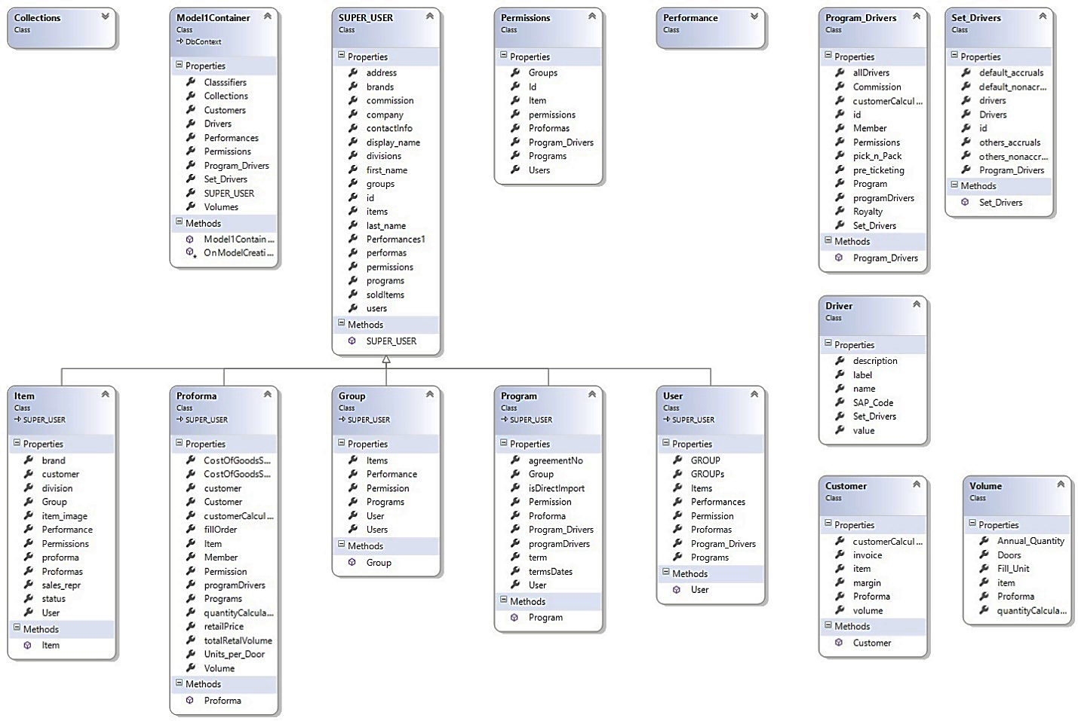
- DATA TRANSFORMATION

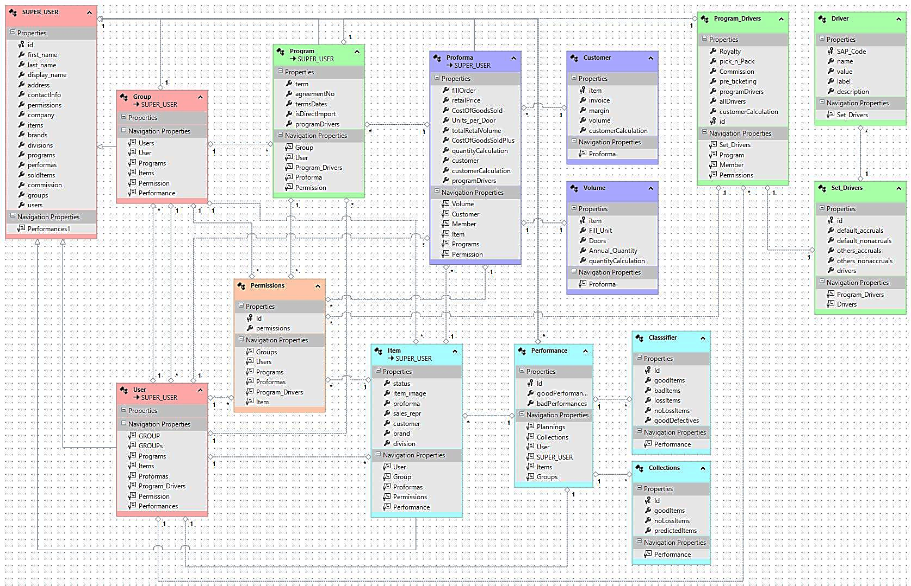
- DATA LAODING

