LTB Sales Portal System

System Summary
LTB Sales Portal system is based on a strategic plan to establish goals and objectives over the long run to describe sales plans, costs and investments. This plan expresses management’s operating and financial plans to generate a set of budgets better known as “Pro Forma”, which puts together all revenue and expense estimates from the forecasted data. In order to develop these budgets, the process start by forecasting what drives much of the financial activity; the sales. The sales forecast provides an estimate of sales based on past histories and various factors that influence sales. The start point of the system is the financial planning, which is a continuous process of directing and allocating financial resources to meet strategic goals and objectives. Then, the strategic plan is implemented by developing the operating plan, or action plan, which identifies needed resources and how to acquire them for all day-to-day activities such as sales and services, production, purchasing, marketing, research and development. The goal is to prepare several detail budgets to develop a Pro Forma Balance Sheet that will determine the expected sales and inventory to plan for production cost. After the Pro Forma income statement is generated, a Pro Forma balance sheet is created to estimate how much external financing is required to support estimated sales.
The current system is vulnerable to issues and challenges that include a long preparation time, outdated data, many interactions and repetitions, many people involved, uncontrollable budget allocations, unable to understand data, budgets not meeting strategic plan, among others. The new system is to address these issues by incorporating the strategic plan model features into a formal software program that will automate the entire process for planning to be value-added, accepting revisions quickly and easily. The automated system will be able to link planning and planning procedures to the strategic plan, minimize the time spent gathering data and maximize the time for strategic decision making, automate collections and consolidation of budgets, update plans quickly and easily, provide lower level managers with some form of fiscal control, and establish a data warehouse for financial planning and reporting. The aim is to provide the teams of LTB-Sales Portal with solutions to the problems they are currently facing. Similarly, to develop new tools that will facilitate finance and sales tasks while improving their performance and interaction with customers.

Work Evaluation
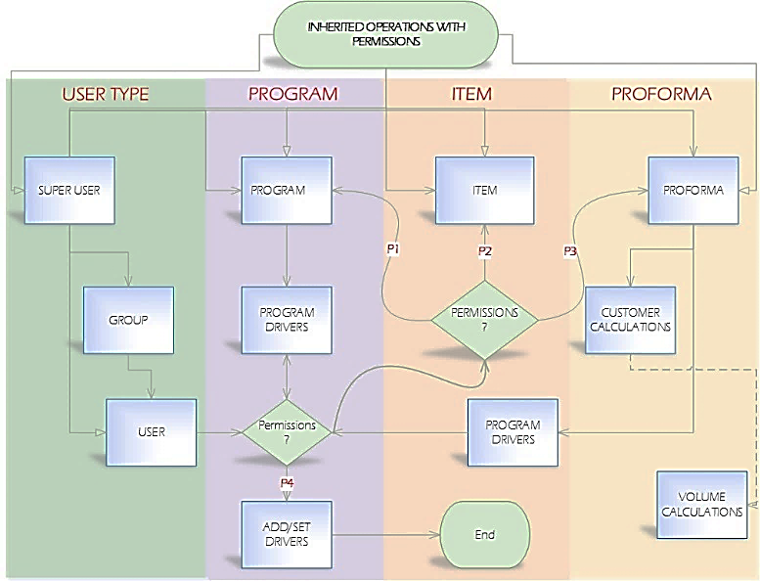
The evaluation process of the system is based on the analysis of three models, which are necessary to implement a complete system that can assign users permissions to utilize an automated strategic plan model in an efficient and easily manner, optimize the interaction time, and maximize data exploration to analyze sales, groups and users’ performance.
Permissions Based System Model
- The SUPER USER is the parent class and it contains most functions in the system. It can create groups and users with either basic or full permissions. Functions in the parent class are inherited by groups and users, which permissions are set by a super user. Users’ permissions, excluding super users, are determined by the group they belong to. A USER object can represent an employee such as a Sales and Finance Person, Owner, among others. A user with management permissions is able to add group(s) and user(s). Lastly, a GROUP object can represent a group of users such as a Sales, Finance, Company, Customers, among others.

- Sale permissions provide employees with tools to estimate sales, in units, at their expected selling prices. Similarly, employees obtain access to forecasted sales level, production capacity and long and short term objectives for the preparation of a sales plan.

- Finance permissions provide employees access to a set of budgets to identify sources of funds for the planned operation and the uses for these funds during a period to carry out the budget activities.

- Programs are created by users with Production permissions to set the global and default values that drive the pricing of items for customers. A customer can have multiple programs since drivers can vary per division.

  - Add/Set Drivers:
A super user, or a user with this specific Production permissions, is able to create and, or, add drivers that can be used during the pricing process of an item.

- An item object is created for every product that the company has, which can be accessed by users with permissions.

- A pro forma is created to provide customers with a projection of an estimated margin, cost and price of items. Only the head of a division has full permissions of a Pro forma to accept or reject it. All Sales people inherit Basic permissions to create, save, edit and delete a pro forma.
Planning System Model
The system uses a strategic planning to stablish goals and objectives over the long run by describing sales plans, cost in investments needed to achieve sales goals, anticipated cash flow and potential financing needs. The master plan translates this strategy and long term objectives into action steps to set specific goals for the organization’s major operations, and to provide a detailed plan for acquisitions and commitments of financial resources during a budget period. Therefore, the plan of operations is based on the goals of the organization’s strategic and long-range plans, expected future events, and the recent actual operating results. In short, the system implements a master plan that expresses management’s operating and financial plans for a specified period, usually a year, to reflect positive impact in the operating and financing decisions.
The planning system can be broken down into planning for operations and financing. Operating people focus on sales and production while financial planners are interested in how to finance the operations. In other words, we can have an operating plan and a financial plan.
- Operating Plan: It identifies needed resources and how these will be acquired. The emphasis is on obtaining and using current resources.
- Financing Plan: It identifies sources of funds for the budgeted, or planned, operation and the uses for these funds during a period to carry out the budget activities.

On the other hand, this model contemplates the development of the annual business plan to anticipate Pro Forma Financial Statements at a particular level of activity. Thus, the company can adopt different approaches for different pieces of its master plan such as:
- Flexible, a control mechanism that evaluates the performance of managers by comparing actual revenue and expenses to the budgeted amount for the actual activities.
- Project, used to create a budget for specific programs rather than for an entire company.
- Continuous, it continually removes data from last period and adds estimated data to next period.
- Kaizen, a continuous improvement, based on changes yet to be made.
- Activity-based, classifies costs based on activities and applies activity-based costing principles.
- Zero-based, each manager must justify his/her department’s entire budget every budget cycle.

Data Analysis
It is extremely important to understand the system objectives and requirements from a domain perspective to convert this knowledge into a data mining problem definition with a preliminary plan designed to achieve the objectives. As a result, an intensive research has been done to develop the right structure to meet the specified needs of the system.
On the other hand, this process focuses on constructing a dataset from multiple data sources to explore and model the data according to the design and database architecture. The data is being extracted from a verity of data sources to transform and load the data into its destination. The goal is to discover insights into the data and have a good understanding of any possible data quality issues. In this manner, avoid analyzing data that has not been carefully screened and reduce misleading results. The success of data analysis and reporting heavily depends on the quality of the prepared data. The aim is to describe the data by means of statistical and visualization techniques to bring important aspects of that data into focus for further analysis. Moreover, explore relationships between objects, whether there exists an association and the strength of this association. Lastly, organize and preset the knowledge gained in a way that the customer can use it by generating a report or implementing a repeatable data mining process.

System Integration
The integration of the permissions based and planning systems models propose a complete system that meets the needs and handles the challenges of the current system. The system architecture provides management features to allow users create users and groups, such as customers and departments, to provide these with permissions to multiple, or all, functions within the operation planning and, or, financial planning, among other objects. Furthermore, the system architecture can provide planning features that can significantly improve sales performance and optimize the interaction process. In brief, the system has been designed to optimize time and resources while improving the planning process for the future. Thus, determine if it is meeting its pre-determined targets, estimate the amount of external funding needed to support its projected sales growth; and perform sensitivity analysis to identify the impacts of estimates, operating, am/policy changes on selected financial ratios, among others.

Milestones

Milestone I:
---------------------------------------------------------------------------------------------------------------------
System and Data Structure Design

Milestone II:
---------------------------------------------------------------------------------------------------------------------
Data Analysis

Milestone III:
---------------------------------------------------------------------------------------------------------------------
System Development

Milestone IV:
---------------------------------------------------------------------------------------------------------------------
System Implementation

Milestone V:
---------------------------------------------------------------------------------------------------------------------
System Evaluation

