FORECAST
- Forecast Promotions
- Forecast History Saves
- ABC Forecast Corporate Volume
- XYZ Forecast Performance & Scores
- Records Management & Inventory Checking

FLEX FEATURES
- Deadline Alerts
- Small Account Updates
- Flex Changes & Records
- Flex, Budgets & Forecast
- Flex Plan Adjustments & Comparison

NON-FORECAST
- NPD Data
- Plan-O-Gram
- Calendar & Meeting-Items
- Challenge & Collections
- SWOT & SWOT Room Data
- Quotes & Order Lookup & Sample Orders
- Material & Customer Master Information
- Royalty

- What is a Forecast?
Sales forecasts are estimates of your sales for the forecast period. The sales forecast establishes the level of activity used in all the other forecasts and budgets for the business. If your sales forecast varies wildly from your actual results, your cash flow and profitability forecast swill similarly be inaccurate.

- What is Flex?
Flex: a flexible budget that adjusts or reflexes based on changes in the volume of activity. The flexible budget is more sophisticated and useful than a static budget, which remains at one amount regardless of the volume of activity.
A flexible budget includes formulas that adjust expenses based on changes in actual revenue or other activities. The result is a budget that is fairly closely aligned with actual results.
In its simplest form, the flex budget uses percentages of revenue for certain expenses, rather than the usual fixed numbers. This allows for an infinite series of changes in budgeted expenses that are directly tied to actual revenue incurred. However, this approach ignores changes to other costs that do not change in accordance with small revenue variations. Consequently, a more sophisticated format will also incorporate changes to many additional expenses when certain larger revenue changes occur, thereby accounting for step costs. By incorporating these changes into the budget, a company will have a tool for comparing actual to budgeted performance at many levels of activity.

- What is a Flex Plan?
It is a flexible budget. A flexible budget is a performance evaluation tool. It cannot be prepared before the end of the period. A flexible budget adjusts the static budget for the actual level of output. The flexible budget asks the questions: “If I had known at the beginning of the period what my output volume (units produced or units sold) would be, what would be my budget have looked like?”

The motivation for the flexible budget is to compare apples to apples.

- What is a Plan?
A budget is a plan for the future. Hence, budgets are planning tools, and they are usually prepared prior to the start of the period being budgeted. However, the comparison of the budget to actual results provides valuable information about performance. Therefore, budgets are both planning and performance evaluation tools.

- What is a Pro Forma?
A Pro Forma is a flexible budget, prior to the start of the period, for various anticipated levels of outputs.

Flexible budgets are prepared at the end of the period, when actual output is known. However, the same steps to create a flexible budget at the end of the period can be used to create a flexible budget prior to the start of the period to anticipate costs and revenues for any projected level of output, where the projected level of output is incorporated at step3. If these steps are applied to various anticipated levels of output, the analysis is called pro forma analysis.

- What are Collections?
- What is SWOT?
- What is a Sample Order?
- What is the difference between Quote and Proforma?
- What is a Challenge?
- What are small Accounts?
- What is a Customer Assortment?
- What is an Excess Inventory Report?
Excess Inventory is any supply in excess of demand. Supply consists of raw material, purchased components, WIP, and finished goods. Demand is defined as a requirement for the next step in a manufacturing process or a finished good to fulfill a customer order.

Excess Inventory exists when a company inaccurately orders inventory and is left with more than the market demands or market demand dramatically falls after inventory is generally regarded as bad for business because of what it means for inventory turnover and the costs associated with managing it.
- What are MTD Sales?
Month To Date Sales
- What is Fiscal View?
- What is a JS-Record?
- What are Lag Rules?
- What is Lag3 Level?
- What is SKU Level?
- What is POG?
- What is NPD Data?

Forecast
- Corporate Volume
- Performance
- History
- Scores
- Promotions
- Records
- Inventory

FLEX
- Corporate Volume
- Performance
- History
- Scores
- Promotions
- Records
- Inventory
- Variances

Budget (Planning)
- Operating Planning
- Financial Planning
- Strategic Planning
  - Operating Plan or Action Plan
- Operating Financial Statements (Pro Forma)
- Forecast (Estimated Sales)
- Flexible (Actual Sales)
- Financial
- Sales
- Production

Financial planning is a continuous process of directing and allocating financial resources to meet strategic goals and objectives. The output from financial planning takes the form of budgets. The most widely used form of budgets is Pro Forma or Budgeted Financial Statements. The foundation for Budgeted Financial Statements is Detail Budgets. Detail Budgets include sales forecasts, production forecasts, and other estimates in support of the Financial Plan. Collectively, all of these budgets are referred to as the Master Budget.

We can also break financial planning down into planning for operations and planning for financing. Operating people focus on sales and production while financial planners are interested in how to finance the operations. Therefore, we can have an Operating Plan and a Financial Plan.

Financial Planning starts at the top of the organization with strategic planning. Since strategic decisions have financial implications, you must start your budgeting process within the strategic planning process.

Strategic planning is a formal process for establishing goals and objectives over the long run. Strategic planning involves developing a mission statement that captures why the organization exists and plans for how the organization will thrive in the future. Strategic objectives and corresponding goals are developed based on a very thorough assessment of the organization and the external environment. Finally, strategic plans are implemented by developing an Operating or Action Plan. Within this Operating Plan, we will include a complete set of financial plans or budgets.

In order to develop budgets, we will start with a forecast of what drives much of our financial activity; namely sales. Therefore, the first forecast we will prepare is the Sales Forecast. In order to estimate sales, we will look at past sales histories and various factors that influence sales.

After we have collected and analyzed all of the relevant information, we can estimate sales volumes for the planning period.

(Percent of Sales)
We now need to estimate account changes because of estimated sales. One way to estimate and forecast certain account balances is with the Percent of Sales Method. By looking at past account balances and past changes in sales, we can establish a percentage relationship.

(Detail Budgets)
We also need to prepare several detail budgets for developing a Budgeted Income Statement. The Production Department will need to budget for materials, labor, and overhead based on what we expect to sell and what we expect in inventory.

Once we have established our level of production, we can prepare a Materials Budget. The Materials Budget attempts to forecast the level of purchases required, taking into account materials required for production and inventory levels. We can summarize materials to be purchased as:

Materials Purchased = Materials Required + Ending Inventory - Beginning Inventory

The second component of production is labor. We need to forecast our labor needs based on expected production. The Labor Budget arrives at expected labor cost by applying an expected labor rate to required labor hours.

As production moves up or down, support services and other costs related to production will also change. These overhead costs represent the third major costs of production. Each item that comprises overhead may warrant independent analysis so that we can determine what drives the specific cost.

Once production costs (direct materials, direct labor, and overhead) have been budgeted, we can work these numbers into our beginning inventory levels for Direct Materials, Work In Progress, and Finished Inventory. Beginning inventory levels are actual amounts from the last reporting period. We need to apply our costs based on what we want ending inventory to be. The end-result is a Budget for Cost of Goods Sold, which we will use for our Forecasted Income Statement.

We can now finish our estimate of expenses by looking at all remaining operating expenses. The first major type of operating expense is marketing. Marketing and Sales Manager's will prepare and submit a Marketing Budget to upper level management for approval.

The final area of operating expenses is the administrative costs of running the overall business. These types of expenses will be estimated based on past trends and what we expect to happen in the future.

we can finalize our budgets in the form of a Budgeted Income Statement. A few new line items are added to account for non-operating items, such as income received on investments and financing costs. The Finance and Tax Departments will assist in estimating items like financing expenses and income tax expenses. The Budgeted Income Statement will pull together all revenue and expense estimates from our previously prepared detail budgets.
Now that we have a Budgeted Income Statement, we can prepare a Budgeted Balance Sheet. The Budgeted Balance Sheet will provide us with an estimate of how much external financing is required to support our estimated sales.

The main link between the Income Statement and the Balance Sheet is Retained Earnings. Therefore, preparation of the Budgeted Balance Sheet starts with an estimate of the ending balance for Retained Earnings. In order to estimate ending Retained Earnings, we need to project future dividends based on current dividend policies and what management expects to pay in the next planning period.

Next, we need to account for the acquisition of fixed assets. As a business depletes its asset base, it must re-invest to sustain assets which are the basis for generating revenues.

Based on the beginning balance in assets and the budget for capital assets, we can estimate an ending asset balance for the Budgeted Balance Sheet.

We will assume that liabilities and interest expense will remain the same. However, after we have determined our level of external financing, we will need to revise these amounts. Additionally, we need to analyze trends and ratios in order to ascertain accounts that do not fluctuate with sales. For example, prepaid expense is a current asset that has little to do with sales.

Since the Balance Sheet is a year-end estimate, it assumes that all other estimates have been met. In a world of rapid change, annual forecasts are rarely close. Therefore, we will simplify our preparation of the Budgeted Balance Sheet by relying on relationships. Stable relationships over the last five years are particularly helpful. The Budgeted Balance Sheet will show either a surplus (excess financing over assets) or a deficit (additional financing needed to cover assets). This difference is derived from the Accounting Equation: Assets = Liabilities + Equity.

We also can calculate External Financing Required (EFR) based on the relationships between assets, liabilities, and sales. The following formula can be used:
EFR = (A / S x ΔSales) - (L / S x ΔSales) - (PM x FS x (1 - d))
A / S: Assets that change given a change in sales, expressed as a percentage of sales.
ΔSales: Change in sales between the last reporting period and the forecasted sales.
L / S: Liabilities that change given a change in sales, expressed as a percentage of sales.
PM: Profit Margin on Sales; i.e. net income / sales.
FS: Forecasted Sales
(1 - d): Percent of earnings retained after paying out dividends; d is the dividend payout ratio.

Additionally, our budgets were prepared on an annual basis. Many unplanned events can take place during the year, making our annual budgets extremely inaccurate. Therefore, financial planning is often improved by simply forecasting on a monthly or quarterly basis as opposed to an annual basis.

The Cash Budget
A good example of short-term financial planning is the Cash Budget. The Cash Budget is an estimate of future cash inflows and outflows. Cash Budgets are often included with the Budgeted Balance Sheet. However, it should be noted that Cash Budgets are not widely used as a general forecasting tool since they are specific to one account, namely cash. Instead, Cash Budgets are often used by Cash Managers and Treasury personnel for managing cash. We can use our previous forecasts to help us prepare a Cash Budget.

Summary of the Budgeting Process
We started our budgeting process by looking at strategic planning. Strategic Planning should always be the starting point for financial planning. From the Strategic Plan, we develop a Plan of Action so we can implement the Strategic Plan. This is often called an Operating Plan. Within the Operating Plan, we will include a set of budgets for successful implementation of the Strategic Plan. The entire set of budgets can be categorized as follows:
< - - - - - - - - - - - - - - - - - - - - - - - - - - Master Budget - - - - - - - - - - - - - - - - - - - - - - - - - >
< - - - - - - - - - - - Operating Plan - - - - - - - -> < - - - - - - - - - Financial Plan - - - - - - - - ->
Sales Forecast Budgeted Retained Earnings
Budgeted Production Budgeted Capital Expenditures
Budgeted Production Costs Change in Fixed Assets
Budgeted Cost of Goods Sold Budgeted Balance Sheet
Budgeted Operating Expenses Cash Budget
Budgeted Income Statement

Additional Concepts in Budgeting
So far, we have emphasized simple approaches to preparing budgets, such as looking at relationships between account balances and sales. We also should have a clear understanding of past financial performance to help us predict future financial performance. Extending past trends and adjusting for what is expected is a common approach to preparing a forecast. However, we can improve forecasting by using several techniques. The first step is recognizing certain fundamentals about forecasting:

1. Forecasting relies on past relationships and existing historical information. If these relationships change, forecasting becomes increasingly inaccurate.
2. Since forecasting can be inaccurate due to uncertainty, we should consider developing several forecast under different scenarios. We can assign probabilities to each scenario and arrive at our expected forecast.
3. The longer the planning period, the more inaccurate the forecast. If we need to increase reliability in forecasting, we should consider a shorter planning period. The planning period depends upon how often existing plans need to be evaluated. This will depend upon stability in sales, business risk, financial conditions, etc.
4. Forecasting of large inter-related items is more accurate than forecasting a specific itemized amount. When a large group of items are forecast together, errors within the group tend to cancel out. For example, an overall economic forecast will be more accurate than an industry specific forecast.

Quantitative and Qualitative Techniques
You should forecast for a specific reason - to help make better decisions. Forecasting is extremely difficult and you must pull from all relevant sources. We previously discussed the Percent of Sales Method and Trend Analysis as a way of forecasting. These forecasting techniques are quantitative. Quantitative techniques of forecasting are best used when changes are infrequent. In today's world of rapid change, quantitative techniques tend to be of little use.

We need to add more qualitative techniques into the budgeting process. Qualitative techniques include surveys, interviews with people who are "in the know", market reports, articles, and other information sources that allow us to make a better judgement. Qualitative or Judgmental Forecasting can help improve the budgeting process, especially if we are operating in a rapidly changing environment.

Smoothing out the Numbers
One simple approach to forecasting is to setup a model that relies on averages from past historical data. For example, we can take an average of the last five years. As we move forward to the next planning period, a new moving average is calculated and used as the forecast for the next planning period. Exponential smoothing can be used whereby we place more weight on the most recent set of actual numbers. This can be important where changes have occurred, making older data less reliable.

Regression Analysis
A statistical approach can be used for forecasting. We can rely on the average relationships between a dependent variable and an independent variable. Simple regressions look at one independent variable (such as sales pricing or advertising expenses) whereas multiple regressions consider two or more variables (such as sales pricing and advertising expenses together). Regression analysis is very popular for forecasting sales since it helps us find the right fit over a range of observations.

Sensitivity Analysis
We can measure how sensitive our forecast is to changes in certain variables. We can develop a range of possibilities under different assumptions and prepare alternative plans. If Plan A fails, we can quickly move to Plan B. Sensitivity analysis also tells us which assumptions have the biggest impact on the forecast. Managers can concentrate most of their resources on the biggest impact areas for improving the forecast. The main benefit of sensitivity analysis is to measure the possibility of errors in the forecast.

Financial Models
Budgets can be prepared with the use of formal models which take advantage of techniques like regressions and sensitivity analysis. Models are built around the collection of equations, logic, and data that flows according to the relationships between operating variables and financial outputs. Financial variables (costs, sales, investments, taxes, etc.) can be manipulated by the user so that the user can see the outcome of a decision before it is made. This can help facilitate strategic thinking within the budgeting process. Two types of financial models are simulation and optimization. Simulation attempts to duplicate the effects of a decision and show its impact. Optimization seeks to optimize (maximize or minimize) a forecast objective (revenues, production costs, etc.).

Financial models provide decision support services for improvements within budgeting. Some of the benefits of financial models include:
- Shows the results of planning under a variety of assumptions, allowing the user to assess the impacts of estimates that have been used.
- Generates the Budgeted Income Statement and Budgeted Balance Sheet as well as forecasted financials by business unit or department.

In order to build a financial model, we need to establish variables, parameters, and relationships. Additionally, we can divide variables into three types:
1. Control Variables: The inputs that the company can control, such as the level of debt financing or the level of capital spending.
2. External Variables: Inputs that the company cannot control, such as economic conditions, consumer spending, interest rates, etc.
3. Policy Variables: Goals and objectives of the company can impact the expected outcomes. For example, management may set targets for sales, profitability, and costs.

Parameters are the baselines or boundaries for the financial model. For example, the level of debt may have a minimum and maximum value. We also will set our beginning account balances within the financial model.

Relationships are the logic and specifications required for making things work. For example, the Budgeted Balance Sheet will require that Assets = Liabilities + Equity. Several equations will be used within the financial model. Many of these equations will be relational; i.e. if we change sales prices, total revenues will change. Equations are tested and added to the financial model to make it complete. Equations can be expanded into business and decision rules so that users do not have to worry about calculating things like return on equity. The financial model takes care of critical rules for running the business or making decisions.

Making the Budgeting Process Work
Now that we understand what goes into financial planning, it is time to focus on how to make the process into a value-added activity. Many organizations are attempting to re-engineer budgeting practices since budgeting is usually a non-value added activity; i.e. it does not add value to the decision making process. The goal is to make the entire financial planning process into a decision support service within the organization whereby the benefits of the process exceed the costs.

In order to fully comprehend the problems associated with budgeting, let's quickly list the top ten problems with budgeting according to Controller Magazine:
1. Takes too long to prepare.
2. Doesn't help us run our business.
3. Budgets are out-of-date by the time we get them.
4. Too much playing with the numbers.
5. Too many iterations / repetitive tasks within the process.
6. Budgets are cast in stone in a constantly changing business environment.
7. Too many people are involved in the budgeting process.
8. Unable to control budget allocations.
9. By the time budgets are complete, I don't recognize the numbers.
10. Budgets do not match the strategic goals and objectives of the organization.

We will now discuss several ways of making budgeting into a value-added activity within the organization.
- Automate the Process in order for budgeting to be value-added, it must accept revisions quickly and easily. A highly automated budgeting process can help streamline the process for quick and easy updating. As a minimum, budgets should be maintained on spreadsheets. A spreadsheet (such as Excel, Lotus 1-2-3, etc.) can have an input panel for entering variables and automatic generation of budgets within a fully integrated set of spreadsheets. For example, we can use a formula to calculate interest expense as: Interest Rate x (Beginning Long Term Debt + Current Portion of Long Term Debt + External Financing Using Long Term Debt) Spreadsheets also allow us to perform sensitivity analysis. We can simply enter new variables into the input panel and review the impact on our budgets.

- We can also use more formal software programs for budgeting. The best software programs will give us the option of controlling the level of detail. For example, do we want a cash budget by customer or do we want cash budgets by account or can we simply enter the cash flow data ourselves? It is very important that we have control over the detail since commercial programs sometimes over-analyze transactions and provide way too much detail. This is why many financial planners prefer spreadsheets over commercial programs.

Ten Best Practices in Budgeting
Finally, here are some best practices that can transform budgeting into a value-added activity:
1. Budgeting must be linked to strategic planning since strategic decisions usually have financial implications.
2. Make budgeting procedures part of strategic planning. For example, strategic assessments should include historical trends, competitive analysis, and other procedures that might otherwise take place within the budgeting process.
3. The Budgeting Process should minimize the time spent collecting and gathering data and spend more time generating information for strategic decision making.
4. Get agreement on summary budgets before you spend time preparing detail budgets.
5. Automate the collection and consolidation of budgets within the entire organization. Users should have access to budgeting systems for easy updating.
6. Budgets need to accept changes quickly and easily. Budgeting should be a continuous process that encourages alternative thinking.
7. Line item detail in budgets should be based on material thresholds and not rely on a system of general ledger accounts.
8. Budgets should give lower level managers some form of fiscal control over what is going on.
9. Leverage your financial systems by establishing a data warehouse that can be used for both financial reporting and budgeting.
10. Multi-National Companies should have a budgeting system that can handle inter-company elimination's and foreign currency conversions.

Summary
Financial Planning is a continuous process that flows with strategic decision making. The Operating Plan and the Financial Plan will both support the Strategic Plan. The best place to start in preparing a budget is with sales since this is a driving force behind much of our financial activity. However, we have to take into account numerous factors before we can finalize our budgets.
Budgeting should be flexible, allowing modification when something changes.
For example, the following will impact budgeting:
- Life cycle of the business
- Financial conditions of the business
- General economic conditions
- Competitive situation
- Technology trends
- Availability of resources
Budgeting should be both top down and bottom up; i.e. upper level management and middle level management will both work to finalize a budget. We can streamline the budgeting process by developing a financial model. Financial models can facilitate "what if" analysis so we can assess decisions before they are made. This can dramatically improve the budgeting process. One of the biggest challenges within financial planning and budgeting is how do we make it value-added. Budgeting requires clear channels of communication, support from upper-level management, participation from various personnel, and predictive characteristics. Budgeting should not strive for accuracy, but should strive to support the decision making process. If we focus too much on accuracy, we will end-up with a budgeting process that incurs time and costs in excess of the benefits derived. The challenge is to make financial planning a value-added activity that helps the organization achieve its strategic goals and objectives.

MASTER BUDGET
There are numerous types of budget systems that meet a variety of purposes. The most common budget system contemplates the development of the annual business plan or master budget, a budget that essentially anticipates the pro forma financial statements at a particular level of activity, so it is also called static budget.
The company can even adopt different approaches for different pieces of its master budget, six common different budgeting systems that a company can use to create its budgets are:
- Flexible budgeting — serves as a control mechanism that evaluates the performance of managers by comparing actual revenue and expenses to the budgeted amount for the actual activities (and not the budgeted activities)
- Project budgeting — used for creating a budget for specific projects or programs rather than for an entire company, such as the design of a new airliner or the building of a single ship.
- Continuous (or rolling) budgeting — allows the budget to be continually updated(revised) by
- removing information for the period just ended (e.g., March of this year) and adding estimated data for the same period next year (e.g., March of next year).
- Kaizen budgeting -The Japanese term kaizen means continuous improvement, and kaizen
- budgeting assumes the continuous improvement of products and processes. Accordingly, kaizen budgeting is based not on the existing system but on changes yet to be made.
- Activity-based budgeting (ABB) — focuses on classifying costs based on activities rather than based on departments or products; ABB applies activity-based costing principles to budgeting. It focuses on the numerous activities necessary to produce and market goods and services and requires analysis of cost drivers.
- Zero-based budgeting (ZBB)— starts each new budgeting cycle from scratch as though the
- budgets are prepared for the first time; ZBB is a budget and planning process in which each manager must justify his/her department’s entire budget every budget cycle.
- Other types of budgets.

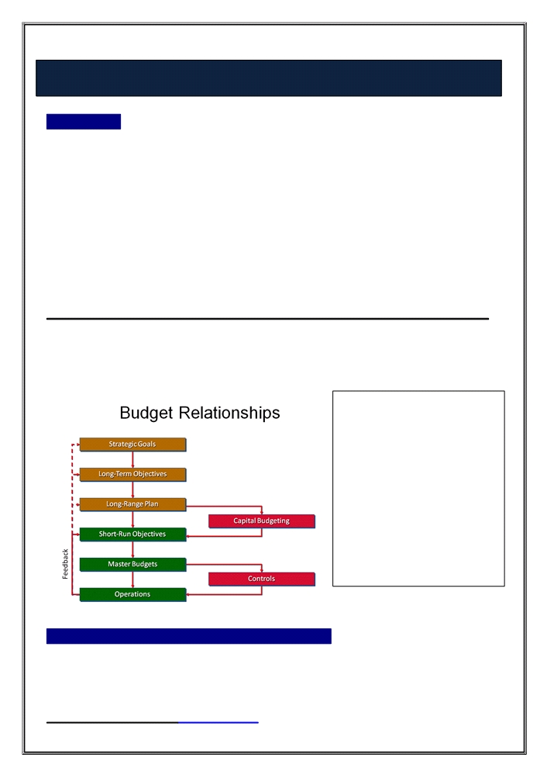
Annual business plans (or master budgets) are sometimes referred to as profit planning or targeting budgets. Budgets of this character are based one level of activity and are, consequently also referred to as static budgets. A compilation of all the separate operational and financial budget schedules of the organization.

Relationship between strategic goals, objectives, budgets, operations, and controls.

The budget expresses the strategy by describing the sales plans, the costs and investments that would be needed to achieve sales goals, the anticipated cash flows, and the potential financing needs.

The master budget translates the organization's strategy and long-term objectives into action steps. A master budget sets specific goals for all of the organization's major operations and provides a detailed plan for acquisitions and commitments of financial resources during the budget period. The plan of operations is based on the goals of the organization's strategic and long-range plans, expected future events, and the recent actual operating results.

Annual Plan Budgeting

Budget Components
The annual plan anticipates the coming year's activities that will contribute to the accomplishment of the long-term and short-term goals outlined in the company's strategic plan.

The master budget expresses management's operating and financial plans for a specified
period (usually a year) and it reflects the impact of both operating and financing decisions.
• Operating decisions deal with the use of scarce resources.
• Financing decisions deal with how to obtain the funds to acquire those resources.

The previous two types of decisions covered by the budgetary components of the master budget as follows:
a. Operating budget
b. Financial budget

a. Operating budget
Operating budgets are plans that identify needed resources and the way that these resources will be acquired for all day-to-day activities such as sales and services, production, purchasing, marketing, and research and development. In the operating budget, the emphasis is on obtaining and using current resources.

Components of operating budget:
• Sales budget
• Production budget:(Direct materials budget, Direct labor budget, Manufacturing overhead budget, ending finished goods inventory budget, Cost of goods sold budget)
• Nonmanufacturing (Selling, General & Administration) budget (The value chain activities)
o Research and development budget
o Design budget
o Marketing budget
o Distribution budget
o Customer service budget
o Administrative budget
• Pro forma income statement

b. Financial budgets
Financial budgets are plans that identify sources of funds for the budgeted operation and the uses for these funds during a period to carry out the budget activities. In the financial budget, the emphasis is on obtaining the funds needed to purchase operating assets. It contains the
1. Capital budget (completed before operating budget is begun)
2. Cash budget
3. Pro forma balance sheet
4. Pro forma statement of cash flows

Interrelationships in the Master Budget
Exhibit 1-5 shows a diagram of the various parts of the master budget for a manufacturer firm. Most of what you see in Exhibit 1-5 comprises a set of budgets the budgeted income statement and its supporting budget schedules - together called the operating budget.

These schedules are budgets for various business functions of the value chain, from research and development to customer service.

The financial budget is that part of the master budget made up of the capital expenditures budget, the cash budget, the budgeted balance sheet, and the budgeted statement of cash flows. A financial budget focuses on how operations and planned capital outlays affect cash. The master budget is finalized only after several rounds of discussions between top management and managers responsible for various business functions of the value chain.
Overview of the Master Budget
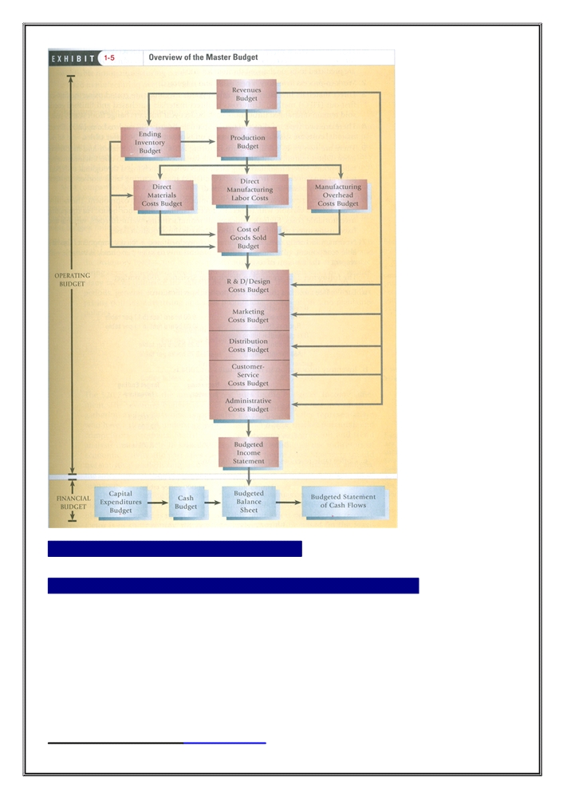
DEVELOPMENT OF AN ANNUAL PLAN

BENEFITS AND LIMITATIONS OF THE MASTER BUDGET
The benefits of having a master budget are numerous and the drawbacks are few. Virtually every company needs some form of master budget.

1. Benefits
Master budgets are relatively easy to prepare and are the most commonly developed budget system. Annual budgets focus managers on common and familiar terminology and formats and ensure that comprehensive attention is given to the resource requirements if necessary to sustain budgeted sales volumes.

2. Limitations
Master budget amounts are confined to one year at a single level of activity. Budget amounts may be much different from actual results, even though the relationship between expenses and revenues is consistent. An annual static budget divided by 12 (to establish a monthly budget) may exaggerate variances due to seasonal or volume fluctuations. The product of the process is a set of pro forma financial statements. Although familiar, pro forma financial statements may not provide the type of management information most useful to decision-making.

Master (static) budget Includes:
Actual budget
Static budget
Static Variance
Contrast this with a flexible budget, which is a series of budgets prepared for many levels of activity.

At the end of the period, management can compare actual performance with the appropriate budgeted level in the flexible budget, so we have to prepare another budget but based on the actual activity.

When a company develops its budget for a future period, it doesn't know what its actual sales and
production volumes will be during that period. All revenues and costs in the master budget are based on forecasted volumes. The master budget is a static budget, because it is developed for one specific sales level. When variance reports comparing actual results to budgeted results in the master budget are prepared and causes for the variances are reported, one of the causes will always be that actual sales volume was different from planned sales volume. Since variances due to volume variations are expected, it does not make much sense to continue reporting them on the variance report as causes of variances. It is more important to focus on variances caused by other factors. For example, a variance caused by an Increase in the cost of direct labor above what is expected for the actual sales could signal a problem in production and should be investigated. But an increase in the cost of direct labor above what is expected for the budgeted sales and that is caused by increased production is not a production problem, if the cost of the direct labor per unit is equal to the budgeted amount per unit for the number of units actually sold.

FLEXIBLE BUDGETING
GENERAL
1. Purpose: Flexible budgets represent adjustable economic models that are designed to predict outcomes and accommodate changes in actual activity. Revenues and expenses are adjusted to display anticipated levels for achieved outputs.
2. Appropriate Use: Flexible budgets are most effective when a per Unit revenue (e.g., unit sold) can be associated with a per unit cost (e.g., unit manufactured) and is highly effective when a significant level of uncertainty exists regarding sales volume. Flexible budgets are most appropriate for a firm facing a significant level of uncertainty in unit sales volumes for next periods.
3. Timeframe
Flexible budgets are normally designed around periods that are one year or less to accommodate the potential changing relationship between per unit revenues and costs. The flexible budget can be prepared only after the end of a period, when the actual sales volume for the period is known.

MECHANICS OF FLEXIBLE BUDGETING
1. Budget Components
Flexible budgets include consideration of revenue per unit, variable costs per unit, and fixed costs over the relevant range. Flexible budgets also consider the amount of cost per unit allowed for units of output.
2. Interrelationships among the Components
Flexible budgets derive the expenses and revenues allowed from the output achieved for purposes of comparison to actual activity and performance evaluation. Achieved volumes that are different from planned volumes do not distort performance evaluation using flexible budgets. Flexible budgets anticipate that actual results will fall within the relevant range where the relationship between revenues and variable costs will remain unchanged and fixed costs will remain stable. The difference between revenues and variable costs represents the contribution to cover fixed costs, called the contribution margin.

DEVELOPMENT OF FLEXIBLE BUDGETING
• Flexible budgets represent a series of budgets that provide the ability to accommodate comparison with many levels of actual sales or production volume.

BENEFITS AND LIMITATIONS OF THE FLEXIBLE BUDGETING
1. Benefits
• Flexible budgets can be displayed on any number of volume levels within the relevant range.
o Comparisons or actual and budgeted activity are not distorted by mere volume differences and can better pinpoint areas were efficiencies have been achieved or where waste has occurred, thus flexible budget allows management to focus on the variances that may be caused by production or administrative problems that need attention.
• Flexible budgets offer managers a more realistic comparison of budget and actual revenue and cost items under their control, i.e., control of direct labor and direct materials but not fixed factory overhead.
• FB is the most appropriate for a firm facing a significant level of uncertainty in unit sales volumes for next year.
2. Limitations
• Flexible budgets are highly dependent on the accurate identification of fixed and variable costs and the determination of the relevant range.
• Errors in determination of the relevant range or misestimates in the anticipated output expected from variable costs could inappropriately distort performance evaluations and result in poor decisions.

PROJECT BUDGETING (PROGRAM BUDGETING)
GENERAL
1. Purpose
Project budgets are used when a project is completely separate from other elements of a company or is the only element of the company.
2. Appropriate use
Project budgets are appropriate for specific tasks (e.g., construction of building, infrequent events such as discontinuation of a division or a product line, or groups of projects such as new product development, marketing, and refinement, the design of a new airliner or the building of a single ship).
3. Timeframe
The time frame for a project budget is simply the duration of the project, but a multi-year project could be broken down by year. Timelines that display project budgets in coordination with annual budgets vertically while displaying project budgets horizontally.
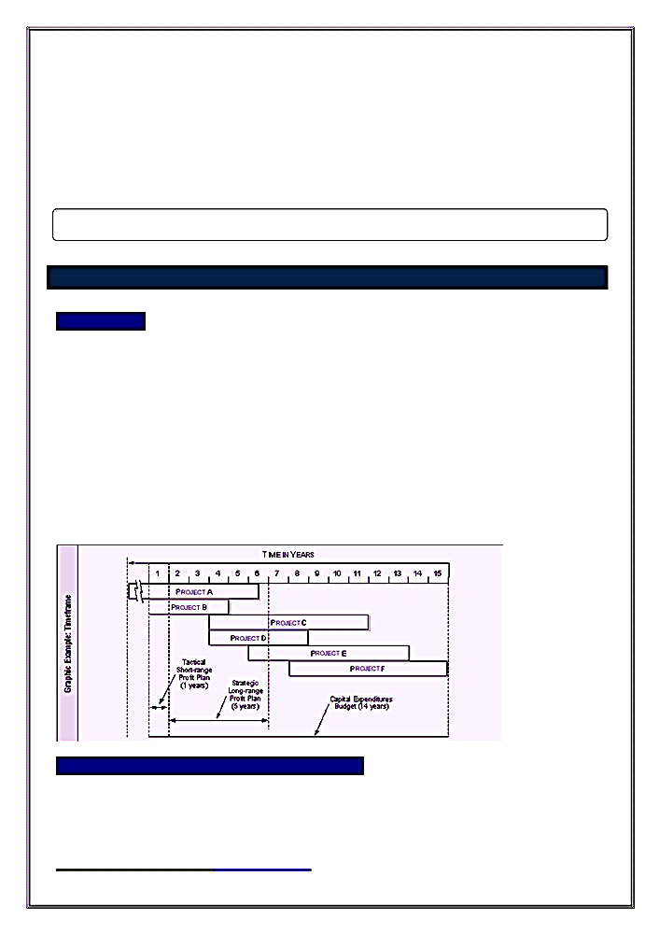
MECHANICS OF PROJECT BUDGETING
1. Budget Components
Project budgeting assumes development of operational and non-operational commitments associated with the unique time dimensions of the project. The budget also considers the context of the project budget in relation to other projects and annual budget.
2.Interrelationships among the Components Project budgeting can easily consider resource demands in isolation. Actually supplying the resources must be viewed in the context of their availability.

DEVELOPMENT OF A PROJECT BUDGET
• Development of a project budget often requires development of a timetable for administrative approvals, reviews, and evaluation of the project's priority in relation to all other projects.
• The project budget will also involve development of all sources If and uses of funds associated with the project, including the timetable for completion of the project itself.

BENEFITS AND LIMITATIONS OF THE PROJECT BUDGET
1. Benefits
• Project budgets allow for a focused look at a particular project's resource requirements and timing & the ability to contain all of a project’s costs so that its individual impact can be easily measured.
2. Limitations
• If the budget process improperly done, project budgets may not afford a comprehensive look at the manner in which the project impacts the organization.
• A potential limitation of project budgets occurs when projects use resources and staff that are committed to the entire organization rather than dedicated to the project.

CONTINOUS (ROLLINGS) BUDGET
GENERAL
1. Purpose
Continuous (rolling or perpetual) budgets add a new budget month - rolls forward- (or quarter) as each current month (or quarter) expires. Managers are involved in the budget process on a continues, rather than an annual, basis. Continuous budgeting techniques are intended to force a long-range and dynamic focus for financial planning. This approach keeps managers focused at least one year ahead so that they do not become too narrowly focused on short-term results.

2. Appropriate Use
Continuous (rolling) budgets are most effective in dynamic environments where constant reevaluation of products and activities are required by the market place or where results of activities are critical to operations.

3. Timeframe
Although a continuous (rolling) budget contemplates a year of activity, it usually does not coincide with the organization's fiscal period because it adds either a month or a quarter to the budget as each month or quarter is completed.

MECHANICS OF CONTINOUS (ROLLINGS) BUDGET
1. Budget Components
Continuous budgets will focus on resource inputs (revenue) and resource outputs
(expenditures) over periods less than one year. The most recently completed period would be used to update the subsequent forecasted period.

2. Interrelationships among the Components
Each budget period depends upon the results of the budget period that precedes it. Forecasted revenues for the next budget month will be based on the current month's actual activity.

DEVELOPMENT OF CONTINOUS (ROLLINGS) BUDGET
Rolling or continuous budgets represent a technique in which a month or quarter is added in
the future with the passage of each like period. According to this model, budgeting becomes
a perpetual process and long-range planning is performed continually rather than annually.

BENEFITS AND LIMITATIONS OF CONTINOUS (ROLLINGS) BUDGET
1. Benefits
• Longer strategic perspective for managers that allows them more time to make operating decisions and the opportunity to assess the accuracy of forecasts.
• Firms using continuous budgets are also more likely to have up-to-date budgets because the preparation of a budget for a new quarter or month often leads to revision of the existing budget.

2. Limitations
Continuous budgets have the potential of foe using managers exclusively on financial rather than operational issues. Continuous budgets can be weakened by incomplete analysis.

ACTIVITY BASED BUDGETING (ABB)
GENERAL
1. Purpose
Activity-based budgeting (ABB) is a budgeting process that focuses on costs of activities or cost drivers necessary for operations, in other words Activity based budgeting focuses the budgeting process on the activities of the organization rather than its outputs. The organization that successfully uses activity based budgeting coordinates and synchronizes organizational activities to the benefit of the customer.

2. Appropriate use
ABB is most appropriate in businesses that have complexity in their number of products, number of departments, or other factors such as setups. This is because the more complex a situation becomes, the less useful is the broad brush of traditional costing. Activity based budgeting can be used for any number of applications, including both service industries and manufacturing industries.

3. Timeframe
Activity based budgeting is generally applied to annual time periods or less.

MECHANICS OF ACTIVITY BASED BUDGETING (ABB)
1. Budget Components
The components of an activity based budgeting include identification of resources, resource drivers, activities, activity drivers, and ultimately the output or cost object.

2. Interrelationships among the Components
Cost pools and related cost drivers are used to apply costs to outputs. Systems must carefully identify the cost pool to the cost driver to the activity and the activity driver to ultimately assign costs to the output or cost object. ABB use Non-output-based cost drivers, such as the number of part numbers, number of batches, and number of new products can be used with ABB.

DEVELOPMENT OF ACTIVITY BASED BUDGETING (ABB)
Development of an activity based budget involves a number of specifically identifiable discrete steps discussed in depth in U.3.

BENEFITS AND LIMITATIONS OF ACTIVITY BASED BUDGETING (ABB)
1. Benefits
• A key advantage of ABB is greater precision in determining costs, especially when multiple departments or products need to be tracked.
• ABB facilitates continuous improvement.
• ABB facilitates identification of value-added activities and elimination of non-value-added activities.

2. Limitations
• This advantage comes at a cost, and a potential drawback to ABB can occur if the cost of designing and maintaining the ABB system exceeds the cost savings from better planning.
• Traditional budgeting systems that focus on direct labor direct material and overhead functions as a basis for product costing are easy to implement and understand. The study and effort associated with determining the cost pools and related cost drivers may be too time consuming or difficult to understand for managers and workers alike.

MASTER BUDGET
The master budget is the document an organization relies on as it carries out its strategic plan to meet its goals. The master budget for the period is prepared following the budget guidelines; this is the organization's operating plan and budget.

Sales Budget
A sales budget shows expected sales in units at their expected selling prices. Preparation of the sales budget for a period usually starts with the firm's forecasted sales level, production capacity, and long-term and short-term objectives.

A sales budget is the cornerstone of budget preparation because a firm can complete the plan for other
activities only after it identifies the expected sales level. A manufacturing firm cannot complete its production schedule without knowing the number of units it must produce, and the number of units to be produced can be ascertained only after the firm knows the number of units budgeted to be sold for the period. Once the number of units to be sold and produced has been determined, the units of materials to be purchased, the number of employees needed for the operation, and the required factory overheads can be determined. Expected selling and administrative expenses also are determined by the desired sales level.

Production Budget
The production budget follows the sales budget. Once a firm knows its expected sales, production can be
estimated. The production budget is based on assumptions appearing in the sales budget. A production
budget is a plan for acquiring and combining the resources needed to carry out the manufacturing operations that allow the firm to satisfy its sales goals and have the desired amount of inventory at the end of the budget period. The total number of units to be produced depends on the budgeted sales, the desired amount of finished goods ending inventory, and the units of finished goods beginning inventory as described in the following:

Direct Materials Usage and Purchases
The information in the production budget becomes the basis for preparing several other budgets for the period.

Direct Materials Usage Budget
Material Purchases Budget

Direct labor Budget
The production budget also serves as the basis for preparing the direct labor budget. A firm's labor force must include sufficient skilled employees required to produce the finished goods scheduled for the period. The direct labor budget enables the personnel department to plan for direct labor and to avoid emergency hiring or labor shortages and the need to lay off workers. Erratic labor employment can decrease employees' sense of loyalty, increase their insecurity, and lead to inefficiency.

Many firms have stable employment policies or labor contracts that prevent them from hiring and laying off
employees in direct proportion to their production needs. A direct labor budget enables the firm to identify
circumstances when it can either reschedule production or plan temporary employee reassignments to perform other tasks. Manufacturing cells common to many firms that adopt new manufacturing technologies can use the direct labor budget to plan for maintenance, minor repair, installation, testing, learning to use new equipment, or other activities.

Fringe Benefits
Consider the classification of manufacturing labor payroll fringe costs (for example, employer payments for
employee benefits such as Social Security, life insurance, health insurance, and pensions). Some companies classify these costs as manufacturing overhead costs. In other companies, the fringe benefits related to direct manufacturing labor are treated as an additional direct manufacturing labor cost. The latter approach is
preferable because the stated wage and the fringe costs together are a fundamental part of acquiring direct manufacturing labor services.

Factory Overhead Budget

Overhead Components
The factory overhead budget includes all production costs other than direct materials and direct labor. The manufacturing overhead budget reflects the nature of overhead as a mixed cost, i.e., one that has a variable component and a fixed component. The total of these costs depends on how individual overhead costs vary with respect to the cost driver.

Unlike direct materials and direct labor, which tend to vary in direct proportion with the number of units
manufactured, manufacturing overhead costs include costs that do not vary in direct proportion with the units manufactured but with the facilities the firm has and the way the production is performed.

1. Variable overhead contains those elements that vary with the level of production.
- Indirect materials
- Some indirect labor
- Variable factory operating costs (e.g., electricity)

2. Fixed overhead contains those elements that remain the same regardless of the level of production.
• Real estate taxes
• Insurance
• factory depreciation expenses and
• Salaries of production supervisors.

3. Other costs of facilities and costs that vary with the batch size and number of setups in production.
Classification in practice
Many firms separate the factory overhead budget into variable and fixed overhead items. All factory overhead costs other than those that vary in direct proportion to the units manufactured are treated as fixed costs. Such practices are justified because non-variable factory overhead costs usually remain the same within a given range of production activities.

Data needed to prepare Overhead budget
Budgeting for factory overhead costs requires:
• forecasting the number of units to be produced,
• determining the way in which production is to be performed, and
• Incorporating factors that affect factory overhead.

Ending Inventory Budget
Cost of Goods Sold Budget
Nonmanufacturing Costs Budget
Budgeted Statement of Income

Financial Budgets

Cash Budget
Cash Budget a table showing cash flows (receipts, disbursements, and cash balances) for a firm over a specified period.

The budget preparation process normally begins with the sales budget and continues through the preparation of pro forma financial statements. The last schedule prepared before the financial statements is the cash budget. The cash budget is the most important part of a company’s budget program. The cash budget is a schedule of estimated cash collections and payments. The various operating budgets and the capital budget are inputs to the cash budgeting process. A cash budget may be prepared monthly or even weekly to facilitate cash planning and control. A cash budget is an example of a feedforward control because it anticipates cash needs and allows for the provision of resources to meet those needs.

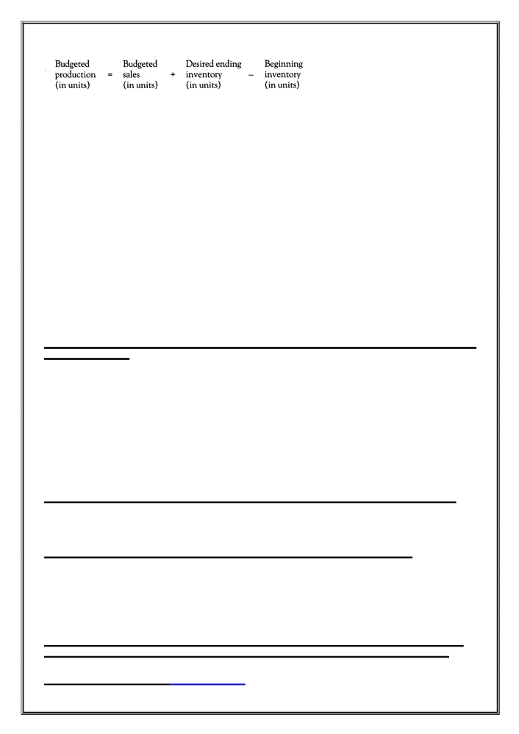

Major sections in the cash budget
A cash budget generally includes three major sections:
1. Cash available
2. Cash disbursements
3. Financing
• The cash budget is a primary tool of short-run financial planning.
- It allows the financial manager to identify short-term financial needs (and opportunities).
- It will tell the manager the required borrowing for the short term.
- It is the way of identifying the cash-flow gap on the cash flow time line.
- The idea of the cash budget is simple: It records estimates of cash receipts and disbursements.

Define the purpose of a pro forma income statement, a pro forma statement of financial position, and a pro forma cash flow statement and identify the relationship among these statements and all other budgets (evaluate whether a company has achieved strategic objectives based on pro forma income statements).

These financial statements are key elements in helping a company plan for the future. Based on these pro forma statements, a company can: determine if it is meeting its pre-determined targets, estimate the amount of external funding needed to support its projected sales growth; and perform sensitivity analysis to identify the impacts of estimates, operating, am/policy changes on selected financial ratios.

This topic traces the process of creating pro forma financial statements using the percentage of sales method, which builds a pro forma income statement and then a pro forma balance sheet, and it shows an example of creating a pro forma statement of cash flows. It describes the process of assessing anticipated performance using pro forma financial statements, including performing sensitivity analyses.

Pro forma statements represent a company’s projected financial statements and they are useful in the company’s planning process because these statements support four major functions. They help a company to:
1. Assess whether its anticipated performance is in line with its established targets.
2. Anticipate the amount of funding needed to achieve its forecasted sales growth.
3. Estimate the effects of changes in assumptions of key numbers by performing sensitivity analysis (i.e., what-if analysis). Sensitivity analysis helps to identify potential conditions that could lead to major problems for the company. This enables the company to plan for appropriate actions in case such an event should occur. In addition, sensitivity analysis also provides the company with the opportunity to analyze the impact of changing its operating plans.

4. Pro forma financial statements are used to determine whether the company will be able to remain in compliance with the required covenants on its long-term debt. Long-term debt usually involves requirements for the company to maintain certain ratios in its financial statements, and these requirements are called covenants. Covenants are part of most loan agreements. One example of a covenant is a requirement that the company maintain a certain current ratio, such as at least 2 ;1. If the company's current ratio falls below the required level, the company is technically in default on its debt, even though it may be making every scheduled payment. If that happens, the lender can legally demand payment of the entire loan balance immediately, which could force the company into bankruptcy. Therefore, it is very important that the company maintain compliance with its debt covenants. Some of the usual covenants Include maintenance of a minimum current ratio, maintenance of a minimum debt ratio, and maintenance of a minimum Interest coverage ratio. 5o calculation and analysis of these ratios need to be a part of the analysis of the pro forma statements.

The debt to total assets ratio (also called the debt ratio) The total debt ratio measures the percentage of funds provided by creditors. It determines long-term debt-payment ability and the degree to which creditors are protected from the firm’s insolvency. Hence, creditors prefer this ratio to be low as a cushion against losses.

The pro forma income statement is used to decide whether the budgeted activities will result in an acceptable level of income. If the initial pro forma income shows a loss or an unacceptable level of income, adjustments can be made to the component parts of the master budget.

Other strategic objectives can also be observed from the pro forma income statement, such as desired rates of return, debt ratio, and the interest coverage ratio (times interest earned). The adequacy of earnings per share can also be observed from the pro forma income statement. Once the company’s dividend policy has been factored in to determine the amount of dividends to be paid, the amount of projected retained earnings will then be added to its current balance sheet to create the pro forma balance sheet, information from the company’s capital expenditure budget and cash budget will also be used to help formulate the pro forma balance sheet, Once the pro forma income statement and balance sheet are compiled, the information can then be used to create the pro forma statement of cash flows.

Earnings Per Share.
Complete the Income statement. Interest expense is subtracted from EBIT to calculate EBT. We then subtract tax at a given tax rate to calculate net Income before preferred dividends; and then we subtract preferred dividends to calculate net Income available to common shareholders. Net Income available to common shareholders divided by the number of shares of common stock will give us Earnings Per Share. (For forecasting purposes, we do not distinguish between Basle Earnings Per Share and Diluted Earnings Per Share.) Common dividends per share multiplied by the number of common shares equals the total dividends paid on common stock. The forecasted addition to retained earnings is net Income available to common stockholders minus total common dividends. (Note that this is the same as net Income minus preferred dividends minus common dividends.)

The pro forma balance sheet is prepared using the cash and capital budgets and the pro forma income statement.
1) The pro forma balance sheet is the beginning-of-the-period balance sheet updated for projected changes in cash, receivables, payables, inventory, etc.
2) If the balance sheet indicates that a contractual agreement may be violated, the budgeting process must be repeated.
a) For example, some loan agreements require that owners' equity be maintained at some percentage of total debt or that current assets be maintained at a given multiple of current liabilities.

The pro forma statement of cash flows classifies cash receipts and disbursements depending on whether they are from operating, investing, or financing activities.
1) The direct presentation reports the major classes of gross cash operating receipts and 'payments and the difference between them.
2) The indirect presentation reconciles net income with net operating cash flow.

Under GAAP, this reconciliation must be disclosed whichever presentation is chosen.
a) The reconciliation requires balance sheet data, such as the changes in accounts receivable, accounts payable, and inventory, as well as net income.
d. All the pro forma statements are interrelated (articulated), e.g., the pro forma cash flow statement will include anticipated borrowing. The interest on this borrowing will appear in the pro forma income statement.

What is budgeting?
A budget is a plan expressed in quantitative (numerical) terms. The development of an annual budget for a large corporation may take many months to complete. This is because some budgets cannot be completed until other budgets have been completed.

What are the advantages for a corporation from properly developed and administered budgets?
When properly developed and administered, budgets provide the following advantages to the corporation:
1) Promote coordination and communication among organization units and activities,
2) Provide a framework for measuring performance,
3) Provide a means for controlling operations,
4) Provide a means to check on progress toward the organization's objectives,
5) Provide motivation for managers and employees to achieve the company's plans, &
6) Promotes the efficient allocation of organizational resources.

What are the first 5 characteristics of successful budgeting?
There are a number of characteristics of successful budgeting.
The first five examples include:
1) It starts with the short- and long-term plans.
2) Support of management exists at all levels.
3) A sense of ownership exists amongst people who are responsible for implementation.
4) The budget is viewed as a motivating device to help everyone to do a better job.
5) The budget is used to take actions today to address possible future problems that are anticipated in the firms strategic planning.

What are the second 5 characteristics of successful budgeting?
There are a number of characteristics of successful budgeting.
The second five examples include:
6) Flexibility exists to allow for changes in operating conditions that may occur after the budget is finalized.
7) The budget should be an accurate representation of what is expected to occur.
8) Coordination exists between operating activities of diverse business units
9) Budgeting should not be rigid. Management decision making should not be based upon the budget alone.
10) The time period for a budget should reflect the purpose of the budget.

What are best practice guidelines for the budget process?
Best practices guidelines for budgeting include:
1) Linking the development of the budget to corporate strategy.
2) Extensive communication.
3) procedures so that the budget results in strategic allocation of funding resources.
4) ensuring that managers are evaluated on performance measures other than meeting budget targets.
5) Cost management efforts linked to budgeting.
6) Ensuring that the budget will result in strategic use of variance analysis.
7) Reduced complexity and budget cycle time.
8) Developing budgets that can be revised if necessary.
9) Reviewing the budget on a regular basis throughout the year.

Define budgetary slack and explain how it impacts goal congruence.
Budgetary slack is the difference between the budgeted performance and the performance that is actually expected. It is the practice of underestimating budgeted revenues and overestimating budgeted costs to make the overall budgeted profit more
achievable.
Goal congruence is defined as "aligning the goals of two or more groups." As used in planning and budgeting, it refers to the aligning of goals of the individual managers with the goals of the organization as a whole.
There is a hazard in the budgeting process. It may lead to behaviors on the part of managers that benefit them but are not congruent with the goals of the company. This is more likely to occur if managers' performance will be evaluated based upon budget achievement. Managers who develop the budgets that they are going to be accountable to meet may build budgetary slack into their budgets in order to make sure their budgets are achievable. Sometimes, the performance of an individual manager's unit will benefit from an action, but the overall performance of the company is either not impacted or is negatively impacted. When this disconnect occurs, it is because the goals of the individual managers are not aligned with company goals.

What are the budget manual and planning calendar?
A budget manual details the budget process. One of the areas that must be included in the budget manual is the communication and distribution process. As one budget is completed it must be sent to all of the departments whose budgets are based off of, or include, the previously completed budget.
A planning calendar is the document that sets forth all of the deadlines, policies and procedures of the budgeting process.

What is the sequence in which the different budgets are prepared?
The first budget to develop is the sales budget. After the sales budget is prepared the company can determine the production budget. This is followed by finished goods, inventory and the rest of the operating schedules (such as Direct Labor, Materials, Marketing and Selling expense, Administrative budgets, etc.), which together lead to the pro forma Income Statement. The above budgets are called operating budgets.
The capital budget (fixed assets) is prepared independently from the other budgets because it is long-term in nature.

All of the above converge in the cash budget (the last budget prepared) and the pro forma balance sheet. Financial budgets include the capital budget, cash budget
and pro forma balance sheet.
Operating and financial budgets together form the master budget.

What are a flexible budget and a static budget?
A static budget, or fixed budget, is a budget that is prepared for only one level of activity (a certain level of sales) within the company. A flexible budget is one that includes what the budget would be for different levels of sales. This means that throughout and at the end of the period, the management of the company is able to compare the actual results with a budget that is indicative of the actual level of sales. In order to do this, a company will have to use a standard cost system. When preparing actual to budgeted comparative reports, the flexible budget needs to be adjusted for the actual number of units before comparing the actual results to the budgeted amount. The difference between the actual amount and the flexible budget amount is called the flexible budget variance.

How do you calculate the flexible budget amount?
In some questions you will be given the master budget and asked to determine what the flexible budget would have been. In this type of question, you need to remember
that the fixed costs will not change in total.
To calculate the fixed costs, multiply the master budget amount of production by the fixed costs per unit. This amount will not change, no matter the level of actual production. After you have calculated the total fixed costs, you must address the variable costs. The variable cost per unit will not change as the level of output changed.
This question requires that you know the difference between how fixed and variable costs change.

What are other types of budgets, such as zero-base, life-cycle, activity-based, and continuous?
Zero-based budgeting is the budgeting method in which the current year's budget is prepared without any reference to, or use of, the prior period's budget. This is opposed
to incremental budgeting where there is a simple multiplying of the last year's budget by a certain percentage.

A life-cycle budget follows a product through its entire life - from development through its decline. Activity-based budgeting focuses on activities that drive costs to be incurred. This is like activity-based costing, but done at the budgeting stage.

Governmental budgeting is done for governments and has the power of law. Spending in excess of the budget requires new legislation.
A continuous budget is automatically prepared for a certain period of time ahead of the present. For example, a 1-year continuous budget will be prepared at the end of
every month for the next 12 months.

What is the control loop?
The control loop is the process by which the activities of the company are controlled. The major steps in this process are:
1) Establish the budget, or standards of performance.
2) Measure the actual performance.
3) Analyze and compare actual results with the budgeted results.
4) Investigate unexpected variances.
5) Devise and implement any necessary corrective actions.
6) Review and revise the standards if necessary.

How do you calculate the number of units to produce or purchase?
In order to calculate the number of units to purchase or produce during the period, use the following formula:
Units needed for use in the current period + Units needed for next period's beginning inventory (ending inventory) - Units on hand at the start of this period (beginning inventory) = Units needed to make or purchase this period. This can also be used for periods longer than a month, though most questions are about a month. It may also be used for finished goods or for raw materials in the production process.

