A Persona-Based Content Marketing Strategy
Each member of a buying team has different challenges and interests.
- To be successful with content marketing, the content must be catered to the customer. More specifically, the content should speak to customer struggles throughout the buyer’s journey such as:
  - pain points
  - challenges

However, to create content that is truly targeted the system needs to understand exactly who the buyers are and what their journey looks like.

Defining and Developing Buyer Personas
Buyer personas are representations of actual customers taking into account:
- Who customers are
- What customers are trying to accomplish
- Customers goals
- How customers behave throughout the buying cycle.

Buyer personas are typically based on both:
- Independent Search
- Market research

Combining insights from actual customers (gleaned through surveys and interviews) with trends seen in the overall market.

In general, the process to create buyer personas includes:
- Interviewing or surveying current customers to understand their buying process and how they came about purchasing your product or service.
- Considering content consumption, or how customers consume and engage with the content.
- Utilizing aggregated demographic information from lead forms and any insight captured from interactive content like quizzes and calculators.
- Conferring with the sales team about prospects, sales cycle and customer generalizations.
- Taking market research like current statistics and trends into consideration.
- Personas should include a full portrait of the ideal buyer — including information like:
  - Demographic/background information:
  - Job title, career, roles and responsibilities
  - Family/life outside work, household income
  - Company size, location and industry
  - Budget
  - Behavioral information:
  - What keeps them up at night
  - Pain points and challenges
  - Role in purchasing
  - Content consumption

Consider The Buying Team
Depending on the product or service on sell, this may have to be sold to one buyer or an entire buying team. In the case of most e-commerce businesses, the sale will be direct to one consumer (one persona). However, in many B2B sales, a whole team of buyers, all with different personas, have a part in the decision-making process.
- If you’re selling to a buying team, persona-based content marketing is crucial. Each member of the buying team likely has a different title or job function and a certain role in purchasing.

- Additionally, the bigger the investment, usually the bigger the buying team — making it even more important for businesses selling big-ticket products or services to create and promote content based on buyer personas.

Mapping Content to The Buyer’s Journey
In addition to creating content that relates to each buyer persona’s pain points, the content should also map back to a stage in the buyer’s journey. Though buyers will fluctuate between stages — the buying cycle is often nonlinear — the following are generally the three stages each buyer goes through before making a purchase decision:
- Awareness: The buyer knows he or she has a problem that needs to be solved and searches for content that confirms that need and the business’ ability to fix it. Awareness-stage content also typically includes thought-leadership and third-party content that aligns a brand’s message with experts in the industry, though is often vendor neutral.
- Consideration: In the consideration stage, the buyer is researching solutions and is looking for content that speaks directly to specific pain points. In this stage, buyer personas are essential, as each persona experiences different challenges that must be addressed through vendor-published content.
- Decision: At this stage, the buyer is ready to make a purchase decision — a pivotal point in the buying cycle. Decision-stage content often features differentiating information, demos, trials, tools and comparison pieces, as well as content pertaining to the next steps once the purchase has been made.

Creating persona-targeted content that is well-aligned to each stage of the buying cycle offers buyers a better content consumption and overall buying experience. Without a persona-based content marketing initiative, the business runs the risk of letting competitors influence buyers by speaking to their needs and addressing uncertainties through targeted content, increasing purchase consideration along the way. Though researching and developing personas can be a daunting task, start small and work the way to a full-blown persona-based content marketing strategy to move prospects through the sales cycle and close more business.

3 Steps to Personalized Marketing:
Teams need to have developed an alternative for the new, more personalized era of marketing. Persona segmentation is the strongest building block for customers’ personalization efforts.

Persona Segmentation
Persona analysis and segmentation considers the collections of items that different types of shoppers buy over their whole lifetime and groups those shoppers by their shopping preferences. This gives teams more opportunities for cross-selling, a deeper understanding of which customer groups are most valuable, and a better ability to personalize communications to customers.

For example, a women’s apparel brand could have customer personas like:
- Jeans lovers (buyers who are into denim and t-shirts)
- Experienced business shoppers (professionals buying the chicest pant-suits and blouses)
- Upscale casual (shoppers looking for accessories that go with their leather jogging pants)

Instead of sending one email to the entire email list (or trying to build ten emails for specific product categories), the marketing team could send different versions of daily emails, seasonal sale emails and so on, catering to the different personas. Teams also get the additional benefit of being able to compare the customer lifetime value of these different personas, and also to better cross-sell products within personas according to customers’ preferences.

Below it is outlined three steps to strong sustainable personas for a customer database. The steps have been split into basic and advanced to keep it interesting regardless where the team falls on the spectrum.

Persona Segmentation
1. Define System Personas
A qualitative and quantitative process that looks to group customers based on their preferences.
- Basic Customers
It may not be worth it for the team to run a full-blown persona analysis in the beginning. The initial personas could be based around:
- Product categories
- Grouping customers together based on what they have bought previously.
- The system should start with as simple as three basic groups and then build up from there. Abide by a cheesy rule-of-thumb acronym, which is to keep segments (personas in this case) REAL (relevant, efficient, actionable, and lasting).

- Advanced Customers
If you’re ready for more, you may want to invest in predictive persona analysis. The type that we recommend involves statistical methods that take in customer data, and then cluster customers based on their previous and predicted future purchases. In addition to just purchase history, this analysis can incorporate age, geography, device preferences, etc., and use those variables to better group customers based on their personal product affinities. You then look at these personas (we recommend building no more than five different ones to start), understand what’s unique about the different groups, and name them accordingly.

2. Test & Refine all Personas
Once segments are bucketed out the system needs to give them a spin to see if they are meaningful and improve them as time goes.

- Basic Personas
The system should pick one of the new segments that would be most impactful or interesting. After the system would have sent a sale email, it tries one version for the general audience and then one version that speaks to a persona the system is testing. The system needs to use control groups to accurately gauge impact. Once tested, it should sprinkle personas more regularly into the marketing (with proper testing parameters), and improve the definitions as needed.

- Advanced Personas
The system needs to test the different personas, and depending on what the team has on its plate, it can start with trying out just one persona or design a more complicated experiment that tests more than one of the personas at a time (include control groups for each one).

As the system relies more on these personas over time, it also may see them evolve as customers’ preferences do by monitoring and re-classifying as needed.

3. Incorporate Personas into Existing Marketing Efforts
After having built segments and started the ongoing process of understanding and improving them, the system needs to hard-code these personas into the marketing processes.

- Basic Marketing Efforts
  - Email team should be completely on board and ready for the responsibility beforehand.
  - Develop a calendar and some milestones as it gets started.
  - Stick to the plan.
  - Have regular check-ins to access progress.

- Advanced Marketing Efforts
This is similar to the “basic” requirements (get buy-in, keep a calendar, etc.). However, for a more advanced team, the roadblocks often come from fitting this new approach into pre-existing processes and agendas.

The system needs to communicate what personas will mean for current priorities. It needs to document current processes, workflow, and map out how this new layer of segmentation and email targeting impacts team members going forward.

Conclusion
Improved email segmentation - deeper cross-selling insights, and an understanding of which personas are the most valuable for your business long-term.

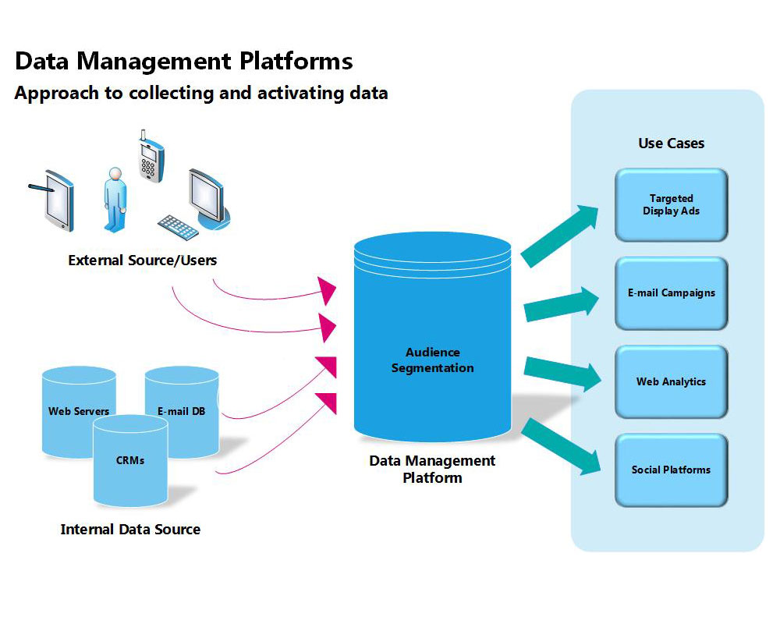

Technology
Personalized marketing is dependent on many different types of technology for:
- data collection
- data classification
- data analysis
- data transfer and
- data scalability.

Technology enables marketing professionals to collect first-party data such as
- gender
- age group
- location and
- income

and connect them with
- third-party data like click-through rates of online banner ads and
- social media participation.

Data Management Platforms:
A data management platform (DMP) is a centralized computing system for:
- collecting
- integrating and
- managing large sets of structured and unstructured data from disparate sources.

Personalized marketing enabled by DMPs, is integral to consumers receiving
- relevant
- timely
- engaging and
- personalized messaging
- advertisements that resonate with their unique needs and wants.
Customer Relationship Management Platforms:
Customer relationship management (CRM) is used to manage and analyze customer interactions and data throughout the customer lifecycle to:
- improve business relationships with customers
- assist in customer retention and
- drive sales growth.

CRM systems are designed to compile information on customers across different channels (points of contact between the customer and the company) which could include the company’s website, LifeChat, direct mail, marketing materials and social media. CRM systems can also give customer-facing staff detailed information on customers' personal information, purchase history, buying preferences and concerns.

Strategies
One-to-one marketing refers to marketing strategies applied directly to a specific consumer. Having a knowledge of the consumer's preferences enables suggesting specific products and promotions to each consumer. One-to-one marketing is based in four main steps in order to fulfill its goals:
- Identify: In this stage the major concern is to get to know the customers of a company, to collect reliable data about their preferences and how their needs can best be satisfied.

- Differentiate: To get to distinguish the customers in terms of their lifetime value to the company, to know them by their priorities in terms of their needs and segment them into more restricted groups.

- Interact: In this phase it is needed to know by which communication channel and by what means contact with the client is best made. It is necessary to get the customer's attention by engaging with him in ways that are known as being the ones that he enjoys the most.

- Customize: It is needed to personalize the product or service to the customer individually. The knowledge that a company has about a customer needs to be put into practice and the information held has to be taken into account in order to be able to give the client exactly what he wants.

Benefits
Personalized marketing benefits it brings in both the businesses and their customers.
- Businesses:
Personalized marketing allows businesses to learn more about customers based on:
- Demographic
- contextual, and
- behavioral data.
The behavioral data, as well as being able to track consumers’ habits, allows the system to better determine what advertising campaigns and marketing efforts are bringing customers in and what demographics they are influencing. This allows firms to drop efforts that are ineffective, as well as put more money into the techniques that are bringing in customers.

Once the necessary systems and technology have been put in place, some personalized marketing can also be automated, increasing the efficiency of a business’s marketing strategy. For example, an automated email could be sent to a user shortly after an order is placed, giving suggestions for similar items or accessories that may help the customer better use the product he or she ordered, or a mobile app could send a notification about relevant deals to a customer when he or she is close to a store. All of these benefits eventually lead to the most crucial benefit: an increase in revenue. Businesses implementing personalized marketing have seen an average increase of 19% in total sales.

- Customers:
In today’s technology-driven marketplace, consumers face an overwhelming variety and volume of products and services available to purchase. A single retail website can offer thousands of different products, and few have the time or are willing to make the effort to browse through everything retailers have to offer. At the same time, customers expect ease and convenience in their shopping experience. The top two reasons customers unsubscribe from marketing emailing lists are
- they receive too many emails and
- the content of the emails is not relevant to them.

Personalized marketing helps to bridge the gap between the vastness of what is available and the needs of customers for streamlined and relevant shopping experiences. By providing a uniquely customized experience for customers, frustrations of endless purchase choices may be avoided. Customers may more quickly find what they are looking for and avoid wasting time scrolling through irrelevant content and products. Consumers have come to expect this sort of user experience that caters to their interests, and companies that have created ultra-customized digital experiences, such as Amazon and Netflix, have quickly become customer favorites in their markets.

Personalized Marketing
Personalized marketing is the inevitable baseline for the future of marketing strategy and for future business success in competitive markets.

- Adapt to technology:
Get in touch with the new and popular forms of social media, data-gathering platforms, and technologies that not all current employees and businesses may be familiar with.

- Restructuring current business models:
The company needs an organized planning, communication and restructuring within businesses to successfully implement personalized marketing. The system needs to reconsider the ways customer data and information circulate within the company and possibly beyond. Company databases would be flooded with expansive personal information, and there may be complications regarding how that information is gathered, circulated internally and externally, and used to increase profits.

- Legal liabilities:
To address concerns about sensitive information being gathered and utilized without obvious consumer consent, liabilities and legalities have to be set and enforced. Privacy is always an issue, in some countries more than others, so companies have to manage any legal hurdles before personalized marketing can be adopted.

Personalized Marketing
There are several ways in which predictive marketing can create better marketing–discover the leads that are most likely to convert, drive better lead scoring, and match prospects with upsell and cross-sell opportunities. However, Predictive Marketing can also help you create higher engagement with your marketing messages by delivering the most effective message to the right prospect. Personalized customer experience is the future of marketing and data, and algorithms are going to power it.

Using big data and predictive analytics algorithms, marketers can optimize the customer experience in real time and make sure that prospects are getting the message that they are most likely to engage with. Here are three steps for personalizing your marketing:

1. Gathering data
Robust customer data helps understand customers better. However, according to our experience, the average company has only 10 data points on each customer in its database, which is not always up to date. However, online, you can find deep, updated and robust data, including thousands of data points about companies and individuals. These include technologies, organizational structures, hiring and much more. This robust data is the first step towards understanding customers and their needs.

2. Finding your buyer personas (or Customer DNA™)
In many cases it is hard to identify the most likely customers for each product in advance. The Customer DNA™ works as a mathematical model could characterize buyer personas by analyzing the robust data on customers and comparing it with those who did not end up as customers.

The majority of leads in the database may not buy anything. However, by applying the mathematical model to all of the leads in the database most likely buyers can be identified. Identifying buyers from the tire kickers can help craft better and more engaging marketing assets.

3. Segmentation
Using a Customer DNA™ and additional data about customers can help find interested segments and develop content that resonates with them. Segmentation can be as granular as needed, by industry, use of technology, or any other variable that makes sense. Leads can be segmented in a marketing automation platform in real time.

Personalization can be a driving force behind effective marketing that resonates with prospects rather than alienates them. The result is higher engagement and more effective and relevant customer experience.

