1. Profile your orders. Most popular SKUs likely change with the seasons, re-slot the warehouse to accommodate a business model, and review the setup at least once a year. This ensures that "A" SKUs are in the correct storage media and physical location, reducing unnecessary travel for order pickers.
2. Analyze your current picking methodology. Make sure your picking methodology suits your organization. Whether you choose single order, multi-order, batch picking with a single picker, or zone picking, the correct picking methodology is critical for optimizing productivity.
3. Use software to sequence orders. Sequencing your orders by pick path, and batching together single lines, same-zone orders, and difficult picks—such as non-conveyable picks—saves tremendous time on the DC floor. Software can help organize the workflow, and optimize system performance.
4. Create a warehouse within a warehouse. You can gain tremendous efficiency by grouping together the 20 percent of your SKUs that complete 80 percent of your orders. This cuts down on travel time for your pickers. Be sure, however, that the 80/20 area or zone is properly designed to accommodate high-volume activity.
5. Evaluate your storage equipment to ensure proper application. Placing slow-moving, low-cube items in bin shelving, and fast-moving items in carton/pallet flow—or other appropriate storage options—improves storage density and picker productivity. This also allows you to better utilize the DC's cube.
6. Create golden zones in your picking area. You can increase picking productivity and improve order picker ergonomics by slotting your fastest-moving SKUs in the waist-to-shoulder or golden zone area of your storage media.
7. Designate only two or three standard shipping cartons. With only two or three boxes to choose from—plus a few custom sizes if necessary—pickers will put orders together faster. Cutting down on sizes optimizes freight expenses and reduces corrugated spend. It also makes it easier to support a pick-path methodology.
8. Consider automation. Order pickers spend about 60 percent of their time walking product or moving product around. Consider an automated solution, such as conveyance, to reduce their extensive travel time.
9. Understand your technology options. Plenty of options are available to increase efficiency—including bar codes, RF, pick-to-label, pick-to-light, and voice-activated technologies. These technologies are designed to provide different levels of increased picking productivity and improved accuracy.
10. Implement an incentive program for pickers. Incentive programs can be extremely valuable to an organization. To ensure your program is effective, you must guarantee that productivity measurements are accurate, fair, and equitable.

Warehouse Pick and Packing

A comprehensive profile based on historical and current data reveals characteristics that allow you to make decisions on storage and handling alternatives, slotting options, pick line requirements, system requirements, pick methods, and order releasing strategies. With more detailed analysis you can even predict how your warehouse will operate, providing you the invaluable opportunity of being able to prepare for the future.

Two main categories of profiles make up a basic warehouse profiling set: customer order profiles and item activity profiles. Customer order profiles represent the outbound activity, i.e., how the customers are ordering the products. Item activity profiles provide insight into viable storing and slotting options for each item within the warehouse.

Customer Order Profiles
The three most basic Customer Order Profiles are defined below.
- Order Mix Distribution:
These distributions answer warehouse zoning questions such as “Should my fast, medium, and slow movers be zoned separately in the warehouse?”
To answer this question, a distribution of the orders for fast, medium, or slow movers is compared with any combination of the three.

If warehouse data indicates that most orders call for a mix of fast and slow movers, zoning the items by velocity will have order consolidation impacts that need to be considered.

Order mix profiles are also used to analyze the percentage of order lines for full cartons, broken cartons, or a combination of the two. Analysis of this information provides options on storing full and broken cartons together. The goal is to determine what percentage of the customers is ordering full and broken carton quantities of the same item, before investing time and money in changing the current storage strategy.

- Order Increment Distribution: The order line distribution of the percent of a full carton ordered is beneficial when evaluating if the current packaging is in logical increments for the customer. For example, if results indicate that 90% of the customers are ordering carton quantities, the warehouse can consider effective alternatives. Options could involve first the supplier by changing the carton size, second the warehouse operations by breaking down cartons at receiving in order to save time during picking, and third, the marketing department by encouraging customers to order in full carton quantities.
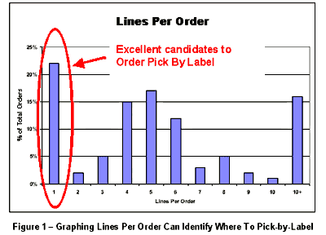
- Order Lines Distribution: This distribution of the number of lines contained on each order is important when evaluating operating strategies. A warehouse with mainly one and two line orders would most likely have a very different picking strategy than a warehouse with many large multi-line orders. If your graph looks like figure 1 and you have a significant number of single-line piece-pick orders you may want to consider batch label picking these orders.

Item Activity Profiles
Item Activity Profiles are beneficial when analyzing products activities for the purposes of determining:
- storage mode
- product slotting, and
- facility layout options

There are several types of item profiles, the three most basic are defined next.
- Popularity profile
It is a ranking of the items based on how often they are ordered or picked (frequency).
- Volume profile
It is a ranking of the items based on how much is ordered (cube movement).
- Item order completion profile
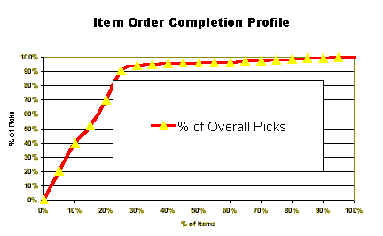
Displays the items ranked from most to least popular against the order set. This profile reveals the percentage of the orders that will be completed by a subset of the items and is valuable when conducting cost benefit analysis for improved productivity. This information is useful because it allows operations to make improvements, such as automation of a smaller area, yet still benefit 90% of all orders.

A TACTICAL APPROACH: Slotting a Forward Pick Line
Three common methods for organizing and operating a forward pick area are:
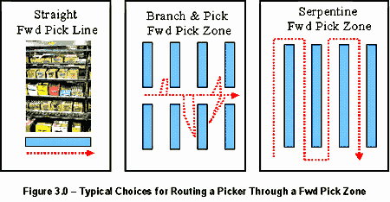
- In a straight forward pick line/zone
Most popular items need to be at the start of the pick path to reduce the likelihood of walking to the end of the pick line to complete an order.
- In a Branch and Pick Forward Pick Zone
More popular items need to be placed near the center aisle minimizing the time spent walking to the back of each cross aisle.
- In a Serpentine Forward Pick zone
The more popular items are placed in the aisles at the start of the tour, thus reducing the chances that an operator will have to visit every aisle in the zone to pick an order.

If there are no seasonal or promotional items in the group it is simple to take item activity information from a warehouse management system, or inventory control system, and sort it in order of popularity. Using this information to rearrange SKUs on shelves, or in flow rack, can significantly cut an operators walking distance to reduce cost. This is “Activity Profiling” in its simplest form.

If there are a number of promotional or seasonal items in the forward pick area, or a number of new products has been introduced, the analysis is a little more difficult. Items need to be isolated and decided on as to whether to include them in the “golden zone” within the forward pick area or not. This is done by generating a graph that looks like the one below.

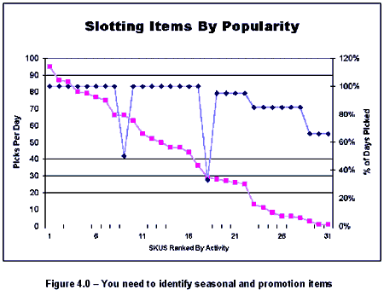
By graphing the percent of total days that each item is picked, it is easy to isolate the popular, seasonal and promotional items. Seasonal items tend to stick out like a sore thumb on these graphs. They will have high activity but the percent of days picked will be low. Seasonal and promotional items should be positioned towards the end of the line or not in the line when out of season.

A STRATEGIC APPROACH: Choosing a Picking Method for a Set of Orders
Activity Profiling helps with many tactical improvements to operations, such as re-slotting the forward pick area, but even greater benefits can be achieved by using it as a tool to evaluate major changes to your operations. Deciding on a method to release and pick orders is an example of this type of analysis.
- Traditionally, most firms have picked orders using paper pick lists; however, many of the new warehouse management system applications allow users to pick orders in a variety of different ways such as
  - batch,
  - single-order, or
  - multi-order.
- These systems support using labels, paper or RF terminals to communicate to such picklists.
- Activity Profiling can help make the decision on how to pick within a zone much clearer and easier.
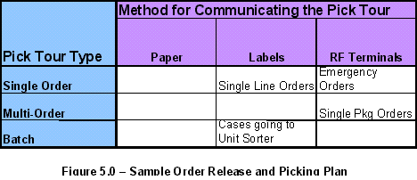
It is helpful for a facility to use a warehouse management system to develop a chart like the one in figure 5. Managers can then document how they would like certain types of orders processed in the facility. Using activity profiling results can make completing this chart easier.

- Managers of pick and pack operations often overlook options such as batch label picking orders. Label picking is fast; pick the item, place it in a shipping container, apply the label, and put it on the conveyor or pallet going to shipping. This process bypasses the packing operation altogether.

- In case of many multi-line orders, profiling the Order Cube information is helpful. If a large proportion of the orders are multi-line, consider multi-order picking those orders using carts with multiple slots, each slot dedicated to one order at a time. The same material handling concept can be applied to larger orders that are less than a shipping pallets worth of material. In this case a pull-train of pallets, each order having its own pallet, may be useful. Each of these approaches, reduces the travel time spent picking orders in the facility.
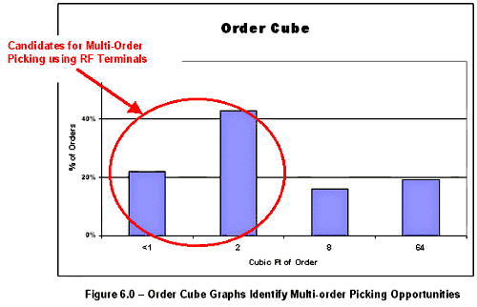
Notice that in this scenario, almost 60% of the orders require less than a shipping cartons worth of material.

GETTING STARTED
There are three main sources of data needed. Since much of this information is usually stored on computers, they are commonly referred to by their “MIS” name, i.e.
- item master records,
- order header and
- detail information, and
- inventory records.

The Data Needed
- The item master should be a static file with each item’s stock keeping:
  - number,
  - classification,
  - weight,
  - cube,
  - pallet build, and
  - dollar value.
- The order header information contains the name of the customer receiving the:
  - order,
  - the customer’s location, and
  - other information that is common to all lines on an order.
- The order detail record has information specific to a single line on an order. It contains the:
  - item ordered,
  - the date ordered,
  - quantity, etc.
- Inventory records provide the quantity on hand of a given item, in a given location, at a specific time.

Most of this data should be available from the warehouse management system or inventory control application. If inaccessible by PC users, the IT staff should transfer this data from the mainframe to the PC via the web. It is important to collect at least 6 months and preferably a year’s worth of data so that the profiles account for seasonal items.

Data Manipulation
In most cases the data will require some manipulation and cleaning prior to analysis.
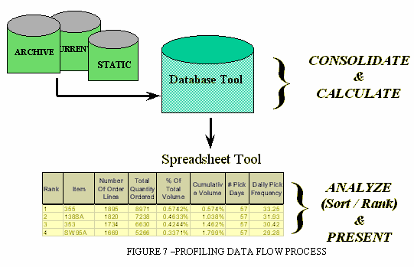
- Obsolete items will need to be removed and
- Incorrect item numbers corrected before the data set is loaded.
- The clean data is loaded into a PC database product, and
- Once the tables are created in the database package, these are exported to spreadsheet software for sorting and ranking of the data to create the profiles. Typically, spreadsheet tools are better than database tools for sophisticated analysis such as developing a histogram of Order Cube. However, other type of files can be used.

Activity Profiling Schedule Estimates
A profiling project’s schedule depends on:
- data availability,
- fidelity, and
- the amount of analysis performed.
Once it is identified where the data resides, the database loading process takes typically one week. This time includes:
- creating the tables,
- running some preliminary queries, then
- exporting results to a spreadsheet for graphing or further analysis.

The preliminary results need to be reviewed by the team. This stage can take a couple of weeks.
- The first step is to review findings (patterns) related to previously identified opportunities.
- Second, selecting and evaluating new improvement areas.
Overall, the profiling process should take about three to four weeks to determine reasonably good opportunities.

Profiling
- It is important to have a clear understanding of the major warehouse goals and to decide on the data diagnostic set that will provide insight into the main objectives.
- As customers, products, and operations change, re-employ the profiling tool to confirm current practices and to look for new improvement opportunities. In this way, profiling can earn clients a return for years to come and the warehouse can continue to provide with clues for operations improvement opportunities.

