Data Warehousing
A data warehouses should provide a generalized and consolidated data in multidimensional view, along with a set of Online Analytical Processing (OLAP) tools. These tools should help in interactive and effective analysis of data in a multidimensional space, which results in data generalization and data mining. Data mining functions such as:
- association,
- clustering,
- classification, and
- prediction
can be integrated with OLAP operations to enhance the interactive mining of knowledge at multiple level of abstraction. That's why building a data warehouse is an important platform for data analysis and online analytical processing.

Data Warehouse (OLAP)
- It involves historical processing of information.
- OLAP systems are used by knowledge workers such as executives, managers, and analysts.
- It is used to analyze the business.
- It focuses on Information out.
- It is based on Star Schema, Snowflake Schema, and Fact Constellation Schema.
- It focuses on Information out.
- It contains historical data.
- It provides summarized and consolidated data.
- It provides summarized and multidimensional view of data.
- The number of users is in hundreds.
- The number of records accessed is in millions.
- The database size is from 100GB to 100 TB.
- These are highly flexible.

Data Warehouse Outline
- The database is kept separate from the organization's operational database.
- There is no frequent updating done.
- Possesses consolidated historical data to help the organization analyze its business.
- It helps executives organize, understand, and use their data to take strategic decisions.
- Its systems help in the integration of diversity of application systems.
- The system should help in consolidated historical data analysis.

Data Warehouse Features
- Subject Oriented - Provides information around a subject rather than the organization's ongoing operations. These subjects can be products, customers, suppliers, sales, revenues, among others. It only focuses on modelling and analysis of data for decision making.
- Integrated – It is constructed by integrating data from heterogeneous sources such as relational databases, flat files, etc. This integration enhances the effective analysis of data.
- Time Variant - The data collected is identified with a particular time period, and it provides information from the historical point of view.
- Non-volatile - The previous data is not erased when new data is added to it. A data warehouse is kept separate from the operational database and therefore frequent changes in operational database is not reflected in the data warehouse.

Note: A data warehouse does not require transaction processing, recovery, and concurrency controls, because it is physically stored and separate from the operational database.

Data Warehouse Applications
A data warehouse serves as a sole part of a plan-execute-assess "closed-loop" feedback system for the enterprise management, and can widely be used in the following fields:
- Financial services
- Banking services
- Consumer goods
- Retail sectors
- Controlled manufacturing

Information processing, analytical processing, and data mining are the three types of data warehouse applications. However, due to the complexity of the data and high demand we are going to focus only on the data mining type of data warehouse application. Data mining supports knowledge discovery by finding hidden patterns and associations, constructing analytical models, performing classification and prediction. These mining results can be presented using the visualization tools.

Using Data Warehouse Information
There are decision-support technologies that help utilize the data available in a data warehouse. These technologies help executives to use the warehouse quickly and effectively. They can gather data, analyze it, and take decisions based on the information present in the warehouse. The information gathered in a warehouse can be used in any of the following domains:
- Tuning Production Strategies - Repositioning the products and managing the product portfolios by comparing the sales quarterly or yearly.
- Customer Analysis - Analyzing customers' buying preferences, time, budget cycles, etc.
- Operations Analysis - Helps in customer relationship management, and making environmental corrections. The information also allows us to analyze business operations.

Functions of Data Warehouse Tools and Utilities
- Data Extraction - Involves gathering data from multiple heterogeneous sources.
- Data Cleaning - Involves finding and correcting the errors in data.
- Data Transformation - Involves converting data from legacy format to warehouse format.
- Data Loading - Involves sorting, summarizing, consolidating, checking integrity, and building indices and partitions.
- Refreshing - Involves updating from data sources to warehouse.

Note: Data cleaning and transformation are important to improve data quality and mining results.

Metadata Repository
An integral part of a data warehouse system that contains the following metadata:
- Business – Contains data ownership info, business definition, and changing policies.
- Operational – Includes currency of data that refers to data being active, archived, or purged, and lineage of data, a data history migrated and transformation applied on it.
- Mapping data from operational environment to data warehouse - Includes source databases and their contents, data extraction, partition and cleaning, transformation rules, data refresh and purging rules.
- The algorithms for summarization - Includes dimension algorithms, data on granularity, aggregation, summarizing, among others.

Data Cube
A data cube represents data in multiple dimensions. It is defined by dimensions and facts. The dimensions are the entities with respect to which an enterprise preserves the records.

Illustration of Data Cube
Suppose a company wants to keep track of sales records with the help of sales data warehouse with respect to time, item, branch, and location. These dimensions allow to keep track of monthly sales and at which branch the items were sold. There is a table associated with each dimension. This table is known as dimension table. For example, "item" dimension table may have attributes such as item_name, item_type, and item_brand.

Example
The sales for New Delhi are shown with respect to time, and item dimensions according to type of items sold. If we want to view the sales data with one more dimension, say, the location dimension, then the 3-D view would be useful. The 3-D view of the sales data with respect to time, item, and location is shown in the table below:
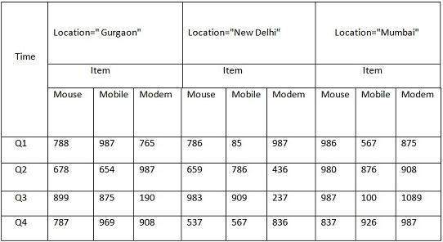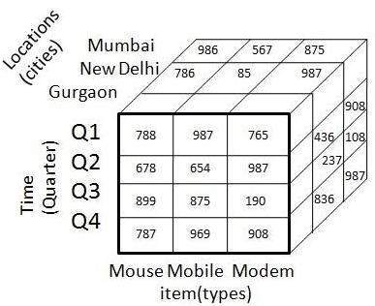
The above 3-D table can be represented as 3-D data cube as shown above.

Data Mart
Data marts contain a subset of organization-wide data that is valuable to specific groups of people in an organization. In other words, a data mart contains only those data that is specific to a particular group. For example, the marketing data mart may contain only data related to items, customers, and sales. Data marts are confined to subjects.

Points to Remember About Data Marts
- Windows-based or Unix/Linux-based low-cost servers are used to implement data marts.
- The implementation cycle of a data mart is measured in short periods of time.
- The life cycle of data marts may be complex in the long run, if their planning and design are not organization-wide.
- Data marts are small in size.
- Data marts are customized by department.
- The source of a data mart is departmentally structured data warehouse.
- Data marts are flexible.
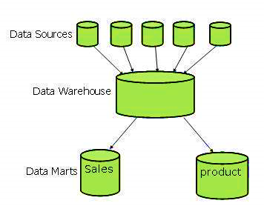
following figure shows a graphical representation of data marts.

Data Warehousing - System Processes
Data warehousing solutions on top open-system technologies like Unix and relational databases.

Process Flow in Data Warehouse
There are four major processes that contribute to a data warehouse:
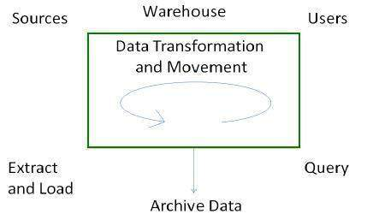
- Extract and load the data.
- Cleaning and transforming the data.
- Backup and archive the data.
- Managing queries and directing them to the appropriate data sources.

- Extract and Load Process
  - Data extraction takes data from the source systems.
  - Data load takes the extracted data and loads it into the data warehouse.
Note: Before loading data into the data warehouse, the information extracted from the external sources must be reconstructed.
  - Controlling the Process
Involves determining when to start data extraction and the consistency check on data. It ensures that the tools, logic modules, and programs are executed in correct sequence and at correct time.
  - When to Initiate Extract
Data needs to be in a consistent state when it is extracted, i.e., the data warehouse should represent a single, consistent version of the information to the user.
  - Loading the Data
Data is loaded into a temporary data store to clean it and make it consistent after extraction.
Note: Consistency checks are executed only when all data sources have been loaded into the temporary data store.

- Clean and Transform Process
Once the data is extracted and loaded into the temporary data store, it is time to perform Cleaning and Transforming.

- Clean and transform the loaded data into a structure
- Partition the data
- Aggregation

- Clean and Transform the Loaded Data into a Structure
Cleaning and transforming the loaded data helps speed up the queries. It can be done by making the data consistent:
- within itself.
- with other data within the same data source.
- with the data in other source systems.
- with the existing data present in the warehouse.

Transforming involves converting the source data into a structure. Structuring the data increases the query performance and decreases the operational cost. The data contained in a data warehouse must be transformed to support performance requirements and control ongoing operational costs.

Partition the Data
It will optimize the hardware performance and simplify the management of data warehouse.

Aggregation
Aggregation is required to speed up common queries. It relies on the fact that most common queries will analyze a subset or an aggregation of the detailed data.

Backup and Archive the Data
In order to recover the data in the event of data loss, software failure, or hardware failure, it is necessary to keep regular backups. Archiving involves removing the old data from the system in a format that allow it to be quickly restored whenever required.

Query Management Process
This process performs the following functions:
- manages the queries.
- helps speed up the execution time of queries.
- directs the queries to their most effective data sources.
- ensures that all the system sources are used in the most effective way.
- monitors actual query profiles.

The information generated in this process is used by the warehouse management process to determine which aggregations to generate. This process does not generally operate during the regular load of information into data warehouse.

Data Warehousing - Architecture
Business Analysis Framework
The business analyst gets the information from the data warehouses to measure the performance and make critical adjustments in order to win over other business holders in the market, offering the following advantages:
- Since it can gather info quickly and efficiently, it can enhance business productivity.
- It provides a consistent view of customers and items to help manage customer relationship.
- Helps bring down the costs by tracking trends, patterns over a long period in a consistent and reliable manner.

To design an effective and efficient data warehouse understand and analyze the business needs to construct a business analysis framework as follows:
- Top-down view - Allows the selection of relevant info needed for a data warehouse.
- Data source view - Presents info captured, stored and managed by an operational system.
- Data warehouse view – Includes fact and dimension tables and represent info stored inside the data warehouse.
- Business query view - It is the view of the data from the viewpoint of the end-user.

Three-Tier Data Warehouse Architecture
Generally, a data warehouses adopts a three-tier architecture.
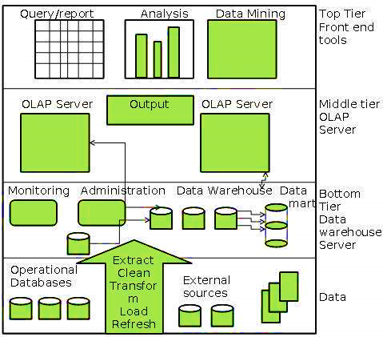
- Bottom Tier – It is the data warehouse database server, and relational database system. It uses the backend tools and utilities to feed data into the bottom tier. These back end tools and utilities perform:
        - Extraction
        - Cleaning
        - Loading and
        - refresh functions.

- Middle Tier – The OLAP Server that can be implemented in the following ways.
  - By Relational OLAP (ROLAP), which is an extended relational database management system. The ROLAP maps the operations on multidimensional data to standard relational operations.
  - By Multidimensional OLAP (MOLAP) model, which directly implements the multidimensional data and operations.
- Top-Tier - Front-end client layer that holds the query tools and reporting tools, analysis tools and data mining tools.
- The diagram above depicts the three-tier architecture of data warehouse.

Data Warehouse Models
From the perspective of data warehouse architecture, we have the following models:
- Virtual Warehouse: Construction requires excess capacity on operational database servers.
- Data mart: This subset of data is valuable to specific groups of an organization.
- Enterprise Warehouse
  - Collects all the information and the subjects spanning an entire organization
  - Provides enterprise-wide data integration.
  - The data is integrated from operational systems and external information providers.
  - This info can vary from a few gigabytes to hundreds of gigabytes or beyond.

Load Manager
It performs the operations required to extract and load process. The size and complexity of the load manager varies between specific solutions from one data warehouse to other.

Load Manager Architecture - The load manager performs the following functions:
- Extract the data from source system.
- Fast Load the extracted data into temporary data store.
- Perform simple transformations into structure similar to the one in the data warehouse.
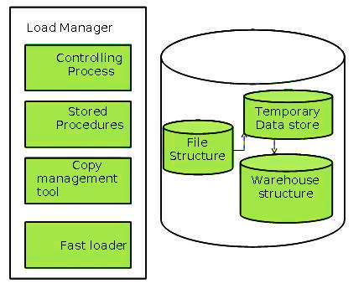

Extract Data from Source
The data is extracted from the operational databases or the external information providers. Gateways is the application programs that are used to extract data. It is supported by underlying DBMS and allows client program to generate SQL to be executed at a server.

Fast Load
- Loading data into the warehouse in the fastest possible time minimizes total load window.
- Transformations affect the speed of data processing.
- Loading data into relational database prior to transformations and checks is more effective.
- Gateway technology tend not be performant when large data volumes are involved.

Simple Transformations
While loading it may be required to perform simple transformations. After this has been completed we are in position to do the complex checks. Suppose we are loading the EPOS sales transaction we need to perform the following checks:
- Strip out all the columns that are not required within the warehouse.
- Convert all the values to required data types.

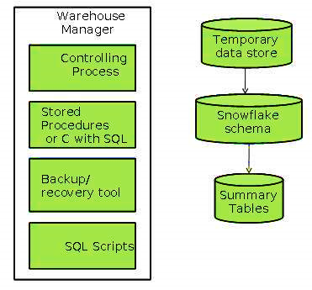
Warehouse Manager
It consists of third-party system software, C programs, and shell scripts. The size and complexity of warehouse managers varies between specific solutions.

Warehouse Manager Architecture - A warehouse manager includes the following:
- The controlling process
- Stored procedures or C with SQL
- Backup/Recovery tool
- SQL Scripts

Operations Performed by Warehouse Manager
- Analyzes the data to perform consistency and referential integrity checks.
- Creates indexes, business views, partition views against the base data.
- Generates new aggregations and updates existing aggregations. Generates normalizations.
- Transforms and merges the source data into the published data warehouse.
- Backup the data in the data warehouse.
- Archives the data that has reached the end of its captured life.
Note: It also analyzes query profiles to determine index and aggregations are appropriate.

Query Manager
- It is responsible for directing the queries to the suitable tables.
- By directing the queries, the speed of querying and response generation can be increased.
- It is responsible for scheduling the execution of the queries posed by the user.

Query Manager Architecture
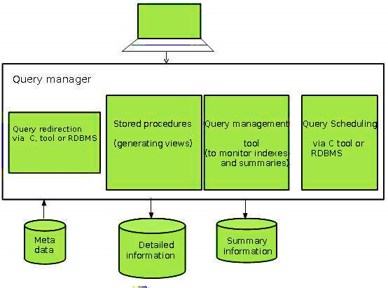
The following screenshot shows the architecture of a query manager.
- Query redirection via C tool or RDBMS
- Stored procedures
- Query management tool
- Query scheduling via C tool or RDBMS
- Query scheduling via third-party software

Detailed Information
It is not kept online, rather it is aggregated to the next level of detail and then archived to tape. The detailed information part of data warehouse keeps the detailed information in the starflake schema. Detailed information is loaded into the data warehouse to supplement the aggregated data.
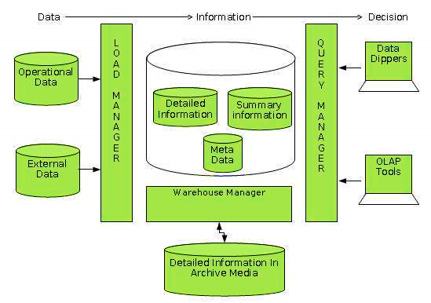
This diagram shows a pictorial impression of where detailed information is stored and how it is used.
Note: If detailed information is held offline to minimize disk storage, make sure that data has been extracted, cleaned up, and transformed into starflake schema before it is archived.

Summary Information
It must be treated as transient. It stores predefined aggregations that are generated by the warehouse manager. Also, it changes on-the-go in order to respond to the changing query profiles.

Points to remember about summary information.
- Speeds up the performance of common queries.
- It increases the operational cost.
- It needs to be updated whenever new data is loaded into the data warehouse.
- It may not have been backed up, since it can be generated fresh from the detailed information.

Data Warehousing – Schemas
It includes the name and description of records of all record types including all associated data-items and aggregates. Much like a database, a data warehouse also requires to maintain a schema. A database uses relational model, while a data warehouse uses Star, Snowflake, and Fact Constellation schema. In this chapter, we will discuss the schemas used in a data warehouse.

Star Schema
- Each dimension in a star schema is represented with only one-dimension table.
- This dimension table contains the set of attributes.
- The following diagram shows the sales data of a company with respect to the four dimensions, namely time, item, branch, and location.
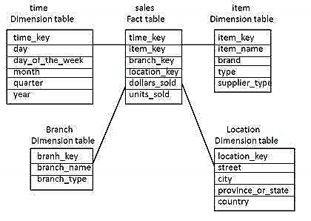
- There is a fact table at the center. It contains the keys to each of four dimensions.
- The fact table also contains the attributes, namely dollars sold and units sold.

Note: Each dimension has only one-dimension table and each table holds a set of attributes. For example, the location dimension table contains the attribute set {location_key, street, city, province_or_state, country, country}. This constraint may cause data redundancy.

Snowflake Schema
- Some dimension tables in the Snowflake schema are normalized.
- The normalization splits up the data into additional tables.
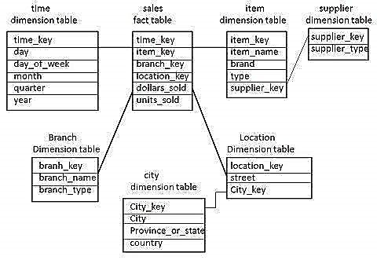
- Unlike Star schema, the dimensions’ table in a snowflake schema are normalized. For example, the item dimension table in star schema is normalized and split into two dimension tables, namely item and supplier table.
- Now the item dimension table contains the attributes item_key, item_name, type, brand, and supplier-key.
- The supplier key is linked to the supplier dimension table. The supplier dimension table contains the attributes supplier_key and supplier_type.
Note: Due to normalization in the Snowflake schema, the redundancy is reduced and therefore, it becomes easy to maintain and the save storage space.

Fact Constellation Schema
- A fact constellation has multiple fact tables. It is also known as galaxy schema.
- The following diagram shows two fact tables, namely sales and shipping.

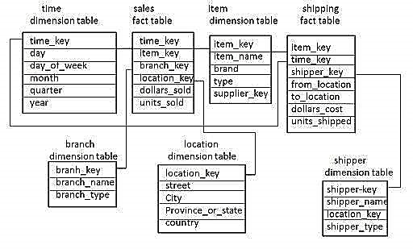
- The sales fact table is same as that in the star schema.
- The shipping fact table has the five dimensions, namely item_key, time_key, shipper_key, from_location, to_location.
- The shipping fact table also contains two measures, namely dollars sold and units sold.
- It is also possible to share dimension tables between fact tables. For example, time, item, and location dimension tables are shared between the sales and shipping fact table.

Data Warehousing - Partitioning Strategy
Enhances performance and facilitates easy management of data. It also helps in balancing the various requirements of the system, optimizes the hardware performance and simplifies the management of data warehouse by partitioning each fact table into multiple separate partitions.

Horizontal Partitioning
We have to keep in mind the requirements for manageability of the data warehouse.

Partitioning by Time into Equal Segments
The fact table is partitioned on the basis of time period. Here each time period represents a significant retention period within the business.

Partition by Time into Different-sized Segments
This kind of partition is done where the aged data is accessed infrequently. It is implemented as a set of small partitions for relatively current data, larger partition for inactive data.

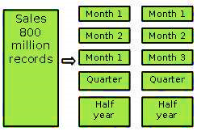
Points to Note
- The detailed information remains available online.
- The number of physical tables is kept relatively small, which reduces the operating cost.
- This technique is suitable where a mix of data dipping recent history and data mining through entire history is required.
- This technique is not useful where partitioning profile changes on a regular basis, because repartitioning will increase the data warehouse operation cost.

Partition on a Different Dimension
The fact table can also be partitioned on the basis of dimensions other than time such as product group, region, supplier, or any other dimension. Let's have an example.
Suppose a market function has been structured into distinct regional departments like on a state by state basis. If each region wants to query on information captured within its region, it would prove to be more effective to partition the fact table into regional partitions. This will cause the queries to speed up because it does not require to scan information that is not relevant.
Points to Note
- The query does not have to scan irrelevant data which speeds up the query process.
- This technique is not appropriate where the dimensions are unlikely to change in future. So, it is worth determining that the dimension does not change in future.
- If the dimension changes, then the entire fact table would have to be repartitioned.
Note: We recommend to perform the partition only on basis of time dimension, unless you are certain that the suggested dimension grouping will not change within the data warehouse life.

Partition by Size of Table
When there is no clear basis for partitioning the fact table on any dimension, then we should partition the fact table on the basis of their size. We can set the predetermined size as a critical point. When the table exceeds the predetermined size, a new table partition is created.
Points to Note
- This partitioning is complex to manage.
It requires metadata to identify what data is stored in each partition.

Partitioning Dimensions
If a dimension contains large number of entries, then it is required to partition the dimensions. Here we have to check the size of a dimension.

Round Robin Partitions
In the round robin technique, when a new partition is needed, the old one is archived. It uses metadata to allow user access tool to refer to the correct table partition. This technique makes it easy to automate table management facilities within the data warehouse.

Vertical Partition
Vertical partitioning, splits the data vertically. The following images depicts how vertical partitioning is done. Vertical partitioning can be performed in the following two ways:
- Normalization
- Row Splitting

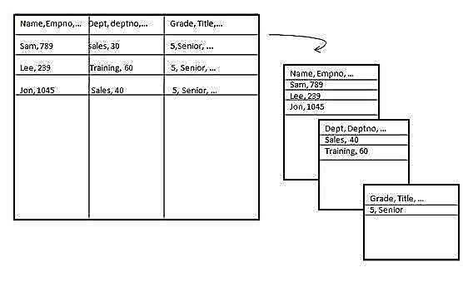
Normalization
Normalization is the standard relational method of database organization. In this method, the rows are collapsed into a single row, hence it reduces space. Take a look at the following tables that show how normalization is performed.

Row Splitting
Row splitting tends to leave a one-to-one map between partitions. The motive of row splitting is to speed up the access to large table by reducing its size.
Note: While using vertical partitioning, make sure that there is no requirement to perform a major join operation between two partitions.

Identify Key to Partition
It is very crucial to choose the right partition key. Choosing a wrong partition key will lead to reorganizing the fact table.

Data Warehousing - System Managers
The most important system managers are:
- System configuration manager
- System scheduling manager
- System event manager
- System database manager
- System backup recovery manager

System Configuration Manager
- It is responsible for the management of the setup and configuration of data warehouse.
- The structure of configuration manager varies from one operating system to another.
- In Unix structure of configuration, the manager varies from vendor to vendor.
- Configuration managers have single user interface.
- The interface of configuration manager allows us to control all aspects of the system.
Note: The most important configuration tool is the I/O manager.

System Scheduling Manager
It is responsible for the successful implementation of the data warehouse. Its purpose is to schedule ad hoc queries. Every operating system has its own scheduler with some form of batch control mechanism. The list of features a system scheduling manager must have is:
- Work across cluster or MPP boundaries
- Deal with international time differences
- Handle job failure
- Handle multiple queries
- Support job priorities
- Restart or re-queue the failed jobs
- Notify the user or a process when job is completed
- Maintain the job schedules across system outages
- Re-queue jobs to other queues
- Support the stopping and starting of queues
- Log Queued jobs
- Deal with inter-queue processing
Note: The above list can be used as evaluation parameters for the evaluation of a good scheduler.
Some important jobs that a scheduler must be able to handle are as follows:
- Daily and ad hoc query scheduling
- Execution of regular report requirements
- Data load
- Data processing
- Index creation
- Backup
- Aggregation creation
- Data transformation
Note: If the data warehouse is running on a cluster or MPP architecture, then the system scheduling manager must be capable of running across the architecture.

System Event Manager
The event manager manages the events that are defined on the data warehouse system. We cannot manage the data warehouse manually because the structure of data warehouse is very complex. Therefore, we need a tool that automatically handles all events without any intervention of users.
Note: The Event manager monitors events occurrences and deals with them. The event manager also tracks the myriad of things that can go wrong on this complex data warehouse system.

Events
Events are the actions that are generated by the user or the system itself. It may be noted that the event is a measurable, observable, occurrence of a defined action.
Given below is a list of common events that are required to be tracked.
- Hardware failure
- Running out of space on certain key disks
- A process dying
- A process returning an error
- CPU usage exceeding an 805 threshold
- Internal contention on database serialization points
- Buffer cache hit ratios exceeding or failure below threshold
- A table reaching to maximum of its size
- Excessive memory swapping
- A table failing to extend due to lack of space
- Disk exhibiting, I/O bottlenecks
- Usage of temporary or sort area reaching certain thresholds
- Any other database shared memory usage
The most important thing about events is that they should be capable of executing on their own. Event packages define the procedures for the predefined events. The code associated with each event is known as event handler. This code is executed whenever an event occurs.

System and Database Manager
System and database manager may be two separate pieces of software, but they do the same job. The objective of these tools is to automate certain processes and to simplify the execution of others. The criteria for choosing a system and the database manager are as follows:
- increase user's quota.
- assign and de-assign roles to the users
- assign and de-assign the profiles to the users
- perform database space management
- monitor and report on space usage
- tidy up fragmented and unused space
- add and expand the space
- add and remove users
- manage user password
- manage summary or temporary tables
- assign or un-assign temporary space to and from the user
- reclaim the space form old or out-of-date temporary tables
- manage error and trace logs
- to browse log and trace files
- redirect error or trace information
- switch on and off error and trace logging
- perform system space management
- monitor and report on space usage
- clean up old and unused file directories
- add or expand space.

System Backup Recovery Manager
The backup and recovery tool makes it easy for operations and management staff to back-up the data. Note that the system backup manager must be integrated with the schedule manager software being used. The important features that are required for the management of backups are:
- Scheduling
- Backup data tracking
- Database awareness
Backups are taken only to protect against data loss.
- The backup software will keep some form of database of where and when the piece of data was backed up.
- The backup recovery manager must have a good front-end to that database.
- The backup recovery software should be database aware.
- Being aware of the database, the software then can be addressed in database terms, and will not perform backups that would not be viable.

-----------------------------------------------------------------------------------------------------------------------------------------------

Data Warehousing - Process Managers
Process managers are responsible for maintaining the flow of data both into and out of the data warehouse. There are three different types of process managers:
- Load manager
- Warehouse manager
- Query manager

