DATA EXPLORATION
The process focuses on constructing a dataset from multiple data sources to explore and model the data according to the design and database architecture. The data is being extracted from a verity of data sources to transform and load the data into its destination. The goal is to discover insights into the data and have a good understanding of any possible data quality issues. In this manner, avoid analyzing data that has not been carefully screened and reduce misleading results. The success of data analysis and reporting heavily depends on the quality of the prepared data. The aim is to describe the data by means of statistical and visualization techniques to bring important aspects of that data into focus for further analysis. Moreover, explore relationships between objects, whether there exists an association and the strength of this association. Lastly, organize and preset the knowledge gained in a way that the customer can use it by generating a report or implementing a repeatable data mining process.

- DATA SOURCES
Notation: Interfaces (In ←, Out →)

Existing Data Sources
- CMS
  - Flat File:
    - Customer Master ←
- CSR
  - Flat File:
    - Material Master ←
  - Folder Share:
    - Item Image ←
  - Web Service:
    - Order Lookup ←
    - Inventory Availability ←
    - Order Creation →

New Data Sources
- DS
  - Flat File
    - Demand Solution History ←
    - Demand Solution Sales History ←
- CSR
  - Flat File
    - Item Image ←
- SAP
  - Flat File
    - Excess Inventory ←
  - Flat File Export
    - Royalty Tables ←
    - Commission Tables ←
  - Export
    - Material Default Delivery Plan by Sales Org →
- SPE
  - Flat File:
    - Forecast Sales Portal →
    - Customer Program Drivers →
    - Customer Price Records →
- OTHERS
  - Meeting Create in Exchange Server 2010 SP3 →

- DATA EXTRACTION

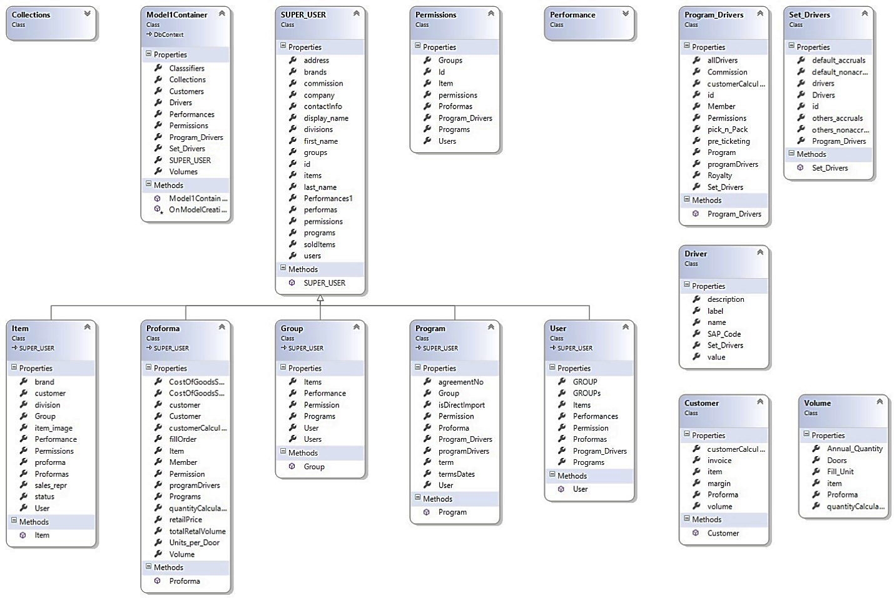
- DATA TRANSFORMATION

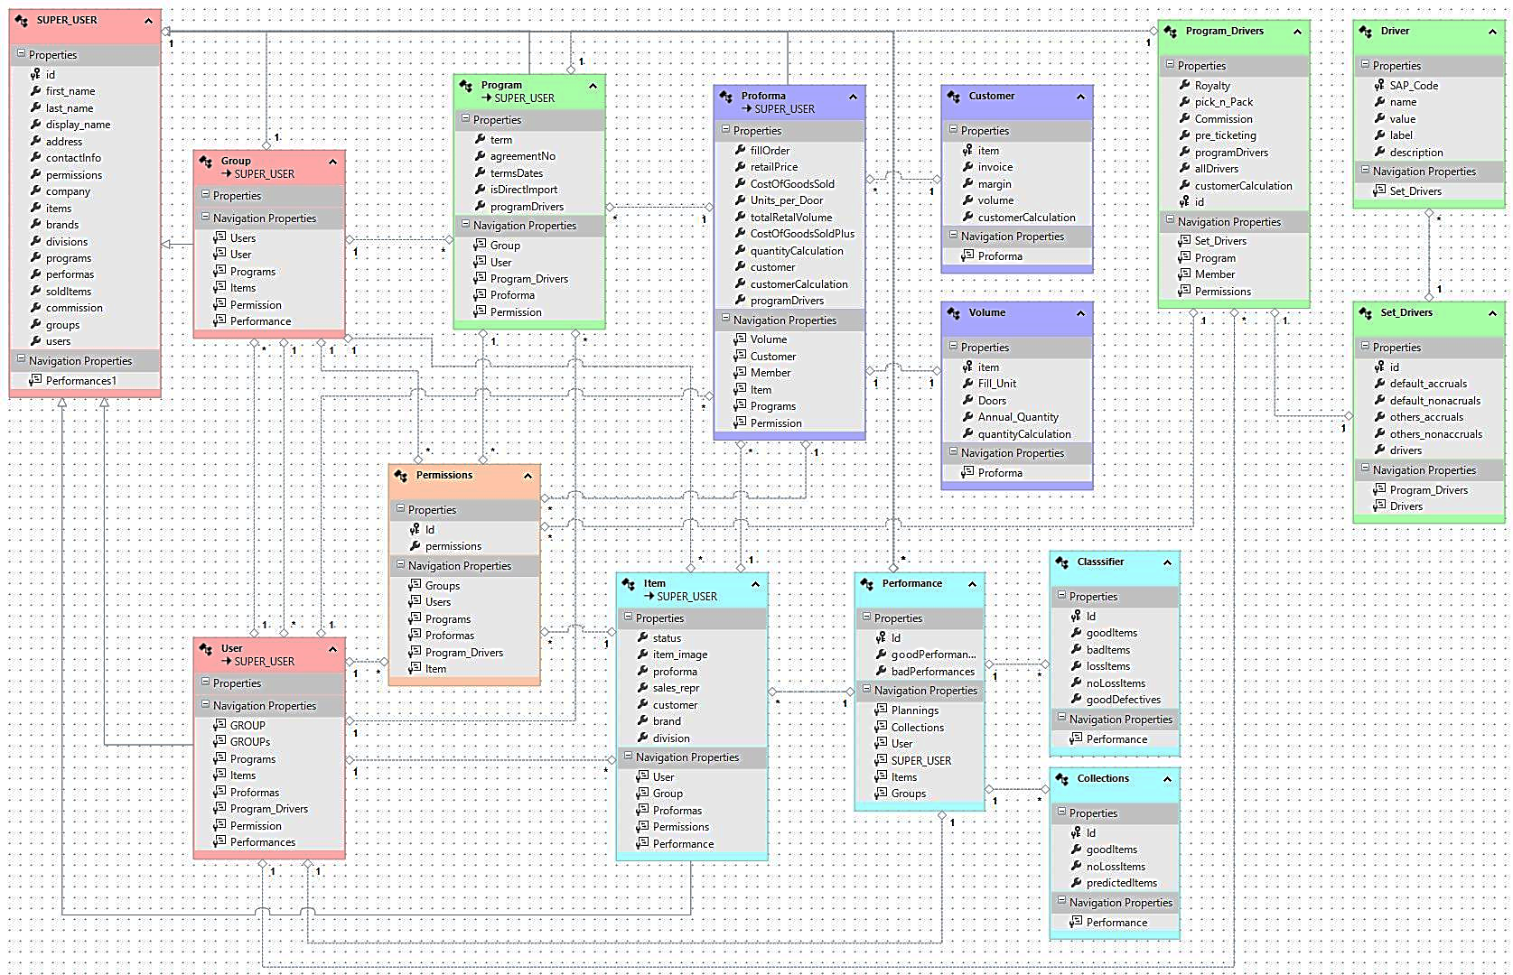
- DATA LAODING

