Text Understanding from Lip Motion: Reproduction and Deployment of the Auto-AVSR Visual Speech Recognition System
Peirou Zhang
Faculty of Engineering, University of Auckland, Auckland, New Zealand
pzha386@aucklanduni.ac.nz

Abstract—This report presents the design, implementation, and evaluation of a visual speech recognition (VSR) prototype based on the Auto-AVSR framework. The publicly released 3,291-hour visual-only checkpoint was re-evaluated on the LRS3 test set, obtaining 26.71% word error rate (WER); the gap to the officially reported 20.3% is attributed to video re-encoding losses in the mirrored copy of LRS3 that had to be used after the original distribution was discontinued. To measure generalisation, a 91-utterance out-of-domain test set was constructed from BBC-style presenter footage and processed with the same mouth region-of-interest (ROI) pipeline, yielding 28.97% WER, only 2.26 percentage points above the in-domain result. The model was then deployed as a remote inference service on an A100 GPU with an asynchronous task interface, a local Gradio GUI, and a real-time webcam front-end; a full end-to-end test on a raw internet video achieved 10.53% WER. Latency profiling shows the deployment bottleneck is the visual front-end (face detection and alignment, ~76% of wall time) rather than the recognition model itself (~6%). This finding will guide the real-time robotic integration planned for the second semester.
Keywords—visual speech recognition, lip reading, Auto-AVSR, Conformer, out-of-domain evaluation, model deployment
I. Introduction
Visual speech recognition (VSR), or lip reading, transcribes speech from silent video by analysing lip and facial motion. It is valuable when audio is unavailable or degraded: silent surveillance footage, noisy multi-speaker environments, and assistive interfaces for people with hearing impairments. Driven by better architectures, self-supervised pre-training, and larger datasets, visual-only WER on the standard LRS3 benchmark has fallen from roughly 50–60% in 2017–2018 [1], [2] to 12.8% in 2025 [3], with large language model (LLM) integration emerging as a further direction [4].
This project is the first semester of a two-semester programme whose end goal is real-time lip-motion understanding on a robotic platform. The present semester’s objectives were to (i) reproduce the Auto-AVSR framework [5] with its released pre-trained models, (ii) evaluate it quantitatively on LRS3, (iii) assess out-of-domain generalisation on self-collected footage, and (iv) deliver a working deployed inference pipeline with a user-facing interface. All four objectives were met. The contributions of this report are:
- A verified reproduction of Auto-AVSR visual-only evaluation on LRS3 (26.71% WER), with a documented analysis of the gap to the published figure;
- A new 91-utterance out-of-domain test set built from BBC-style presenter video with the official preprocessing pipeline, showing a modest +2.26 pp degradation (28.97% WER);
- A deployed serving architecture (GPU inference server, tunnel transport, asynchronous task API, Gradio GUI, and webcam front-end) validated end-to-end at 10.53% WER on a raw internet video;
- A latency decomposition identifying the visual front-end, not the recognition model, as the dominant deployment cost.
II. Related Work
The deep-learning era of lip reading began with CNN/LSTM sequence models on the LRW and LRS datasets from the Oxford VGG group [1], [11], followed by Transformer-based comparisons [2] and the LRS3-TED benchmark [12] that remains the field’s standard. Ma et al. developed the Auto-AVSR framework [5], [13], [14]: a 3D-convolution + ResNet-18 visual front-end, a 12-layer Conformer encoder [17], and a Transformer decoder trained with joint CTC [18] and attention loss, ~250M parameters in total. Its key contribution was scaling supervision by auto-transcribing unlabelled audio-visual data with pre-trained ASR, reaching 19.1% visual-only WER when trained on 3,448 h. Chang et al. [9] confirmed the Conformer as the dominant VSR backbone.
Parallel lines of work include self-supervised pre-training (AV-HuBERT [6], BRAVEn [15]), unified multi-modal models (USR [8]), supervised multi-task training (MultiAVSR [10]), phoneme-to-LLM decoding (VALLR [4]; Zero-AVSR [16]), and large multilingual data scaling (MultiVSR, 12,000 h / 13 languages, 12.8% WER [3]). This project reproduces the Auto-AVSR line because it offers released checkpoints, a maintained codebase, and a documented preprocessing pipeline, making it the strongest practical foundation for deployment work. A fuller review is provided in the accompanying literature review report.
III. System Design
A. Overview
The system comprises an offline evaluation pipeline and an online serving pipeline that deliberately share the same preprocessing. Offline, videos pass through mouth-ROI extraction and are scored against reference transcripts with eval.py from the upstream codebase. Online, a FastAPI server on the GPU host exposes the identical model; a local Gradio GUI communicates with it through an HTTPS tunnel, and a webcam client provides a live view of the model-input ROI.
B. Recognition model
The evaluated checkpoint is the released visual-only model trained on LRS2 + LRS3 + VoxCeleb2 + AVSpeech (3,291 h). Architecture follows [5]: a 3D convolutional stem (5×7×7) and ResNet-18 visual front-end, a 12-layer Conformer encoder (768-d, 16 heads), and a 6-layer Transformer decoder decoded with joint CTC/attention beam search over a SentencePiece vocabulary. A weaker 1,759-h checkpoint was also evaluated to observe the effect of training-data scale.
C. Preprocessing pipeline
Following the official preparation tools, each frame is processed with RetinaFace (ResNet-50) face detection and AWing-FAN 98-point landmark estimation (converted to 68 points); the per-frame landmarks drive the upstream VideoProcess mouth cropper, producing 96×96 grey-scale ROI clips at 25 fps. Frames with missed detections are filled by nearest-neighbour landmark propagation; clips with detection coverage below 50% are rejected. Exactly this pipeline is used both for constructing the out-of-domain test set and inside the serving path, so online results remain comparable to offline benchmarks.
D. Serving architecture
The GPU host runs a FastAPI application exposing health, preload, and inference endpoints. Because the free HTTPS tunnel used for transport terminates any request after roughly 100 s, which is less than the ROI-extraction time of a typical clip. The design therefore adopts an asynchronous task pattern: POST /submit stores the upload, spawns a background worker, and returns a task identifier immediately; the client polls GET /status/{id} every few seconds until the worker publishes the prediction, per-request latency, and (when a reference transcript is supplied) the WER. Inference reuses ModelModule.forward() from the upstream code, i.e., the same code path as eval.py.
E. User interfaces
The Gradio GUI allows uploading an arbitrary video, optionally requesting server-side ROI extraction, and displays the prediction, timing, and WER. The real-time client captures webcam frames, tracks the mouth with the MediaPipe FaceLandmarker task model, and renders the live 96×96 ROI (the exact model-input view) beside the camera feed, maintaining a rolling 75-frame (3 s) buffer for on-demand recognition (Fig. 2).
IV. Implementation
All GPU work ran in BitaHub containers with a single NVIDIA A100-SXM4-80GB and a PyTorch CUDA image; the local client environment is Anaconda Python on Windows (CPU only). The original LRS3 distribution is no longer available for download, so the preprocessed test split (1,321 utterances) was obtained from a public HuggingFace mirror; the mirrored files are re-encoded MP4s, a fact that becomes relevant in Section VI. The out-of-domain set was built from BBC-style presenter footage (Tom Scott): utterances were cut into 91 clips (25 fps, MPEG-4), passed through the Section III-C pipeline, and paired with tokenised transcripts in the Auto-AVSR CSV manifest format.
Notable engineering issues and their resolutions are documented in the repository, including the dataloader’s implicit labels/ path prefix, a required standalone PyAV installation, an OpenMP runtime conflict on Windows (KMP_DUPLICATE_LIB_OK), the absence of libx264 on the host (MPEG-4 used instead), and the tunnel timeout that motivated the asynchronous API. The full source, evaluation logs, and reproduction commands are available in the project repository (github.com/pzha386-rgb/lipreading-auto-avsr).
V. Experiments and Results
A. Word error rate
Table I summarises all quantitative results. The 3,291-h checkpoint achieves 26.71% WER on the 1,321-utterance LRS3 test set; the 1,759-h checkpoint achieves 31.15%, i.e., roughly doubling supervision buys 4.44 pp, consistent with the data-scaling trend reported in [5]. On the 91-clip out-of-domain set the strong checkpoint records 28.97%.
Table I. Word error rate results
Experiment | Dataset | N | WER (%) | Checkpoint (h)
In-domain | LRS3 test | 1,321 | 26.71 | 3,291
In-domain | LRS3 test | 1,321 | 31.15 | 1,759
Out-of-domain | BBC clips | 91 | 28.97 | 3,291
GUI end-to-end | Raw video | 1 | 10.53 | 3,291
B. End-to-end serving test
A raw, unedited internet video (public speech, frontal face, 9 s, 225 frames) was submitted through the GUI with server-side ROI extraction enabled. The system returned the transcript in 34 s wall time, with a single word-boundary error against the reference (10.53% WER). The result is much better than the LRS3 average because the recording conditions are favourable: frontal face, good lighting, and clear articulation. More importantly, the test exercises every component of the pipeline together, from upload and re-encoding through detection, alignment, and cropping to recognition and scoring. Fig. 1 shows the GUI after this test.
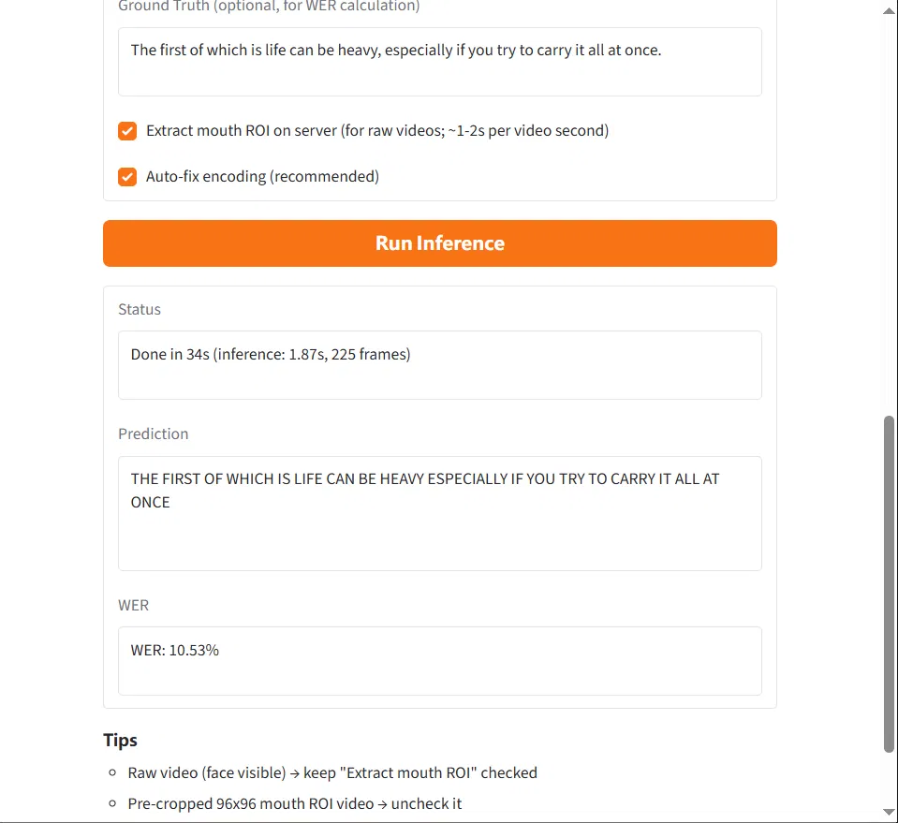
Fig. 1. GUI result for the end-to-end test: prediction, timing, and 10.53% WER.
C. Latency decomposition
Table II breaks down the 34 s end-to-end time. The visual front-end dominates: per-frame RetinaFace detection plus AWing-FAN alignment costs ~26 s for 225 frames, whereas Conformer inference with beam search takes 1.87 s on the A100. Model computation is therefore not the deployment bottleneck.
Table II. End-to-end latency breakdown (9 s input video)
Pipeline stage | Time (s) | Share (%)
Upload + ffmpeg re-encode | ~5 | 15
Mouth-ROI extraction (RetinaFace + AWing-FAN, per frame) | ~26 | 76
VSR inference (Conformer encoder + beam search) | 1.87 | 6
Total (9 s / 225-frame input) | 34 | 100
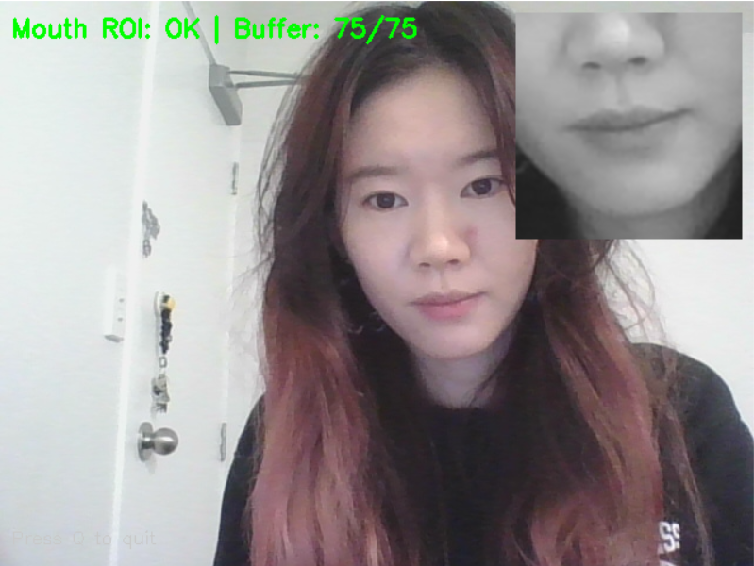
Fig. 2. Real-time webcam client: camera feed with the live 96×96 mouth-ROI model input (top right).
VI. Discussion
A. Gap to the published LRS3 figure
The official model card reports 20.3% WER for the evaluated checkpoint; our measurement is 26.71%. The evaluation code, checkpoint, manifest, and decoding configuration are identical to upstream, leaving the input data as the principal difference: the mirrored LRS3 copy is re-encoded, and lossy re-compression visibly degrades the 96×96 mouth crops on which the visual front-end operates. The 6.4 pp gap is therefore attributed to dataset acquisition constraints rather than implementation error. This is a systematic, dataset-wide effect and does not undermine relative comparisons made within this report, which all use the same data processing.
B. Out-of-domain generalisation
The +2.26 pp degradation from LRS3 to the BBC set is small. For comparison, MultiAVSR reports 44.7% on the WildVSR out-of-domain benchmark against roughly 21% in-domain [10]. Two factors likely contribute: the presenter footage is well-lit and near-frontal, and the identical ROI pipeline removes preprocessing shift. The result nonetheless indicates that the 3,291-h model transfers usefully to unseen speakers and recording conditions, which supports its use in the planned robotic application.
C. Deployment implications
The latency measurements contradict the intuition that the neural network should dominate the cost: the ~250M-parameter recognition model accounts for only ~6% of end-to-end time, while classical per-frame face analysis accounts for ~76%. Real-time operation on a robot therefore hinges on the visual front-end. Options include lighter detectors (the MediaPipe tracker in our webcam client runs in real time on CPU), detection at reduced frame rate with landmark interpolation, and batched GPU alignment. Since these choices alter preprocessing, any substitution must be re-validated against the offline benchmark. This is why the serving and evaluation pipelines were kept identical in this project.
D. Limitations
The out-of-domain set is small (91 utterances, one speaker) and its transcripts were manually verified rather than professionally produced. The GUI end-to-end figure is a single-video demonstration, not a benchmark. Real-time recognition on the local CPU client remains slow (~10–20 s per 3 s buffer), so live use currently depends on the GPU server.
VII. Conclusion and Future Work
This semester delivered a complete, verified VSR prototype: a reproduced Auto-AVSR evaluation on LRS3 (26.71% WER) with a documented account of the reproduction gap, a new out-of-domain evaluation showing modest degradation (28.97% WER), and a deployed inference service with GUI and webcam front-ends validated end-to-end (10.53% WER on raw video). The latency analysis identifies the visual front-end as the key obstacle to real-time operation. The second semester will integrate the system on a robotic platform, focusing on a lightweight streaming front-end, incremental decoding, and human-robot interaction evaluation, in line with the user-study planning already under way.
References
[1] J. S. Chung and A. Zisserman, “Lip reading in the wild,” in Proc. ACCV, 2016, pp. 87–103.
[2] T. Afouras, J. S. Chung, and A. Zisserman, “Deep lip reading: A comparison of models and an online application,” in Proc. INTERSPEECH, 2018, pp. 3514–3518.
[3] K. R. Prajwal, S. B. Hegde, and A. Zisserman, “Scaling multilingual visual speech recognition,” in Proc. IEEE ICASSP, 2025, pp. 1–5.
[4] M. Thomas, E. Fish, and R. Bowden, “VALLR: Visual ASR language model for lip reading,” in Proc. IEEE/CVF ICCV, 2025.
[5] P. Ma, A. Haliassos, A. Fernandez-Lopez, H. Chen, S. Petridis, and M. Pantic, “Auto-AVSR: Audio-visual speech recognition with automatic labels,” in Proc. IEEE ICASSP, 2023, pp. 1–5.
[6] B. Shi, W.-N. Hsu, K. Lakhotia, and A. Mohamed, “Robust self-supervised audio-visual speech recognition,” arXiv:2201.01763, 2022.
[7] P. Ma, Y. Wang, J. Shen, S. Petridis, and M. Pantic, “Lip-reading with densely connected temporal convolutional networks,” in Proc. IEEE/CVF WACV, 2021, pp. 2857–2866.
[8] A. Haliassos, R. Mira, H. Chen, Z. Landgraf, S. Petridis, and M. Pantic, “Unified speech recognition: A single model for auditory, visual, and audiovisual inputs,” in Proc. NeurIPS, 2024.
[9] O. Chang, H. Liao, D. Serdyuk, A. Shah, and O. Siohan, “Conformer is all you need for visual speech recognition,” in Proc. IEEE ICASSP, 2024, pp. 10136–10140.
[10] S. Torrie, K. Wright, and D.-J. Lee, “MultiAVSR: Robust speech recognition via supervised multi-task audio–visual learning,” Electronics, vol. 14, no. 12, art. 2310, 2025.
[11] J. S. Chung, A. Senior, O. Vinyals, and A. Zisserman, “Lip reading sentences in the wild,” in Proc. IEEE CVPR, 2017, pp. 3444–3453.
[12] T. Afouras, J. S. Chung, and A. Zisserman, “LRS3-TED: A large-scale dataset for visual speech recognition,” arXiv:1809.00496, 2018.
[13] P. Ma, S. Petridis, and M. Pantic, “End-to-end audio-visual speech recognition with conformers,” in Proc. IEEE ICASSP, 2021, pp. 7613–7617.
[14] P. Ma, S. Petridis, and M. Pantic, “Visual speech recognition for multiple languages in the wild,” Nature Mach. Intell., vol. 4, pp. 930–939, 2022.
[15] A. Haliassos, A. Zinonos, R. Mira, S. Petridis, and M. Pantic, “BRAVEn: Improving self-supervised pre-training for visual and auditory speech recognition,” in Proc. IEEE ICASSP, 2024, pp. 11431–11435.
[16] J. H. Yeo, M. Kim, C. W. Kim, S. Petridis, and Y. M. Ro, “Zero-AVSR: Zero-shot audio-visual speech recognition with LLMs by learning language-agnostic speech representations,” in Proc. IEEE/CVF ICCV, 2025, pp. 6693–6703.
[17] A. Gulati et al., “Conformer: Convolution-augmented transformer for speech recognition,” in Proc. INTERSPEECH, 2020, pp. 5036–5040.
[18] A. Graves, S. Fernández, F. Gomez, and J. Schmidhuber, “Connectionist temporal classification: Labelling unsegmented sequence data with recurrent neural networks,” in Proc. ICML, 2006, pp. 369–376.

