**A New Solution of The Social Distancing and Face Mask Monitor Using Deep Learning Algorithms**

**By Bangcheng Li, Tristan Huang, and Xin Wang**

**Introduction**

Since the end of 2019, the COVID-19 pandemic has drastically affected the lives of people all around the world. The global economy has been deflating due to a loss of jobs, while face to face communication has been restricted to decrease the infection rate. Even though it has been six months, medical professionals are still unable to determine the end of the pandemic or when a vaccine will be developed. Based on this situation, scholars and researchers have pointed out that society will go through a long period of abnormality as governments continue to enforce social distancing and quarantines. This new way of life means many changes for us, such as online education, mandatory facial masks, and the vast majority of people working from home.

In the current situation, people have begun to use artificial intelligence (AI) as a way to solve problems dealing with the pandemic. Johns Hopkins University Center for Systems Science and Engineering (CSSE) launched a global mapping website that tracks the spread of the virus, while in the medical field, image recognition software has been used to analyze viral gene sequences, which aids the effort of strain isolation. In almost all aspects of socially beneficial projects, AI technology has revealed its strong developmental potential.

Even though the concept and technique of social distancing and face mask detections have been proposed, the level of industrial development has not been reached. The contribution of this research is to present the industrial solution. Besides, we summarize the current challenges and possible solutions in the future work.

**Social Distancing Detector**

Under the globe pandemic of COVID-19, social distancing has been emphasized as an effective measure to slow down the spread of the virus. Although most people remain at home, many essential workers in the transportation, manufacturing, and pharmaceutical industries still work even with the risk of infection. In order to make sure that such workers are safe, a monitoring system that checks for social distancing can be implemented. Andrew Ng’s Landing AI has developed a social distancing detection tool, presented in Figure 1, which uses AI technology to analyze real time video streams and detect whether people are keeping a safe distance apart in a public area.

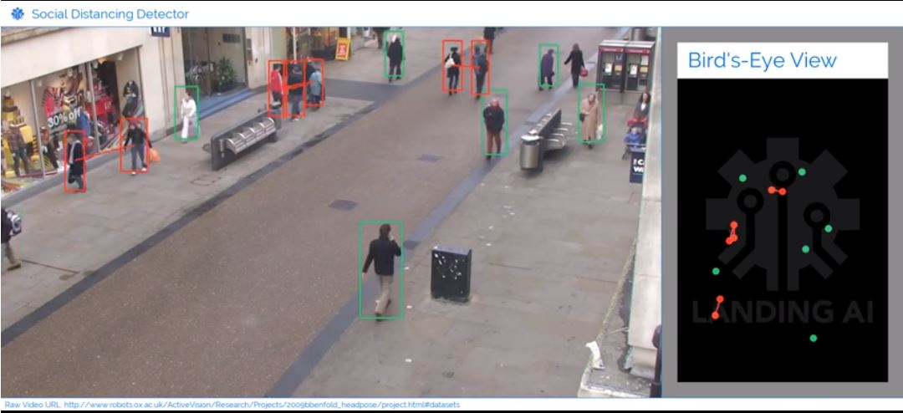

**Figure 1:** Landing AI Social Distancing Detector Demo

Source: <https://landing.ai/landing-ai-creates-an-ai-tool-to-help-customers-monitor-social-distancing-in-the-workplace/>

This social distancing tool applies a new class of surveillance technology that watches over people to make sure we keep a safe distance of at least six feet between each other in public areas. This system is realized through three major steps: calibration, detection, and measurement. In the stage of calibration, the monocular (single-camera) video stream can be transformed to a bird’s-eye view. The calibration method takes four points in the frame and maps them to the corners of a rectangle in the bird’s-eye view. During the detection stage, the system draws a bounding box around each pedestrian using an open-source R-CNN architecture based pedestrian detection network. Minimal post-processing is also applied to clean up the output bounding boxes in this stage. In the measurement stage, the coordinates (x, y) for each person’s location is estimated in the bird’s-eye view plane and then calculates the bird’s-eye view distance between every instance. When the distance is below the minimum acceptable distance, the system highlights these people in red and draws up a line between this pair of people to emphasize and issue a reminder to keep social distancing.

This social distancing detection tool launched by Landing AI is aimed to help maintain distancing protocol in the workplace and public areas. For instance, at a factory could install this social distancing detection tool in their security camera systems to monitor the working circumstances. The detector would then highlight the people who are too close to each other in red on the monitor. The system can also issue a reminder to keep social distancing.

**Face Mask Detector**

With the coronavirus quickly spreading, Centers for Disease Control has suggested people to wear cloth masks in public areas where social distancing would be difficult, such as subway and grocery stores. Adrian Rosebrock, a Ph.D. in Computer Science from University of Maryland Baltimore County, has built a face mask detector with OpenCV and Keras/ TensorFlow, which can be used to ensure people’s safety against virus.

To use the COVID-19 face mask detector, two phases are involved:

* Training face mask detector.
* Applying face mask detector.

Using a dataset in order to train the face mask detector with Keras/ TensorFlow is crucial for the first phase. The dataset consists of 690 images labeled as “with_mask”, and 686 images as “without_mask”. In order to create a dataset for training the face mask detector, they take normal images of faces and have the AI detect facial landmarks to localize the position of the eyes, nose, and mouth. Then the AI is trained to detect if a mask is covering the face. In order to avoid the bias of model training, the original images are not reused to create the “without_mask” samples. After data preparation, the detection model can be trained by executing a Python script:

> python train_mask_detector.py –dataset dataset

In the end, the serialized model is saved in the disk and the training outputs the plot of loss and accuracy to show how effective the trained model is.

In the phase of applying the AI, the detector is able to classify faces in the image as either “with_mask” or “without_mask” through running this Python Script:

> python detect_mask_image.py --image imagetest_01.jpg

In the above command line, “--image” means the path to the input image containing faces that you want to detect. The output images are shown as Figure 2 and Figure 3 below.

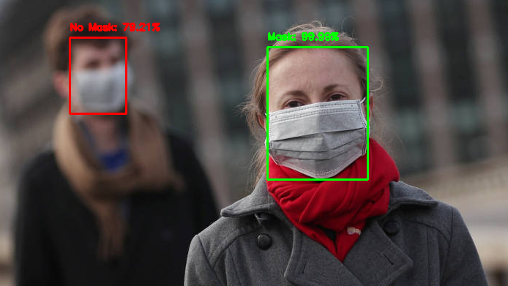

**Figure 2:** Face mask detector output image on few people

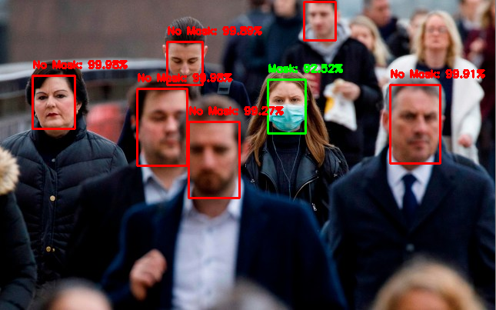

**Figure 3**: Face mask detector output image on more gathered people

Additionally, this face mask detector can be implemented in real-time video stream using the following command:

> python detect_mask_video.py

**Industrial Application Solution**

Using the two detection AIs, a new system can be created to detect if people are keeping social distancing and wearing facial mask in public spaces. The execution processing flowchart of this system is indicated as Figure 4.

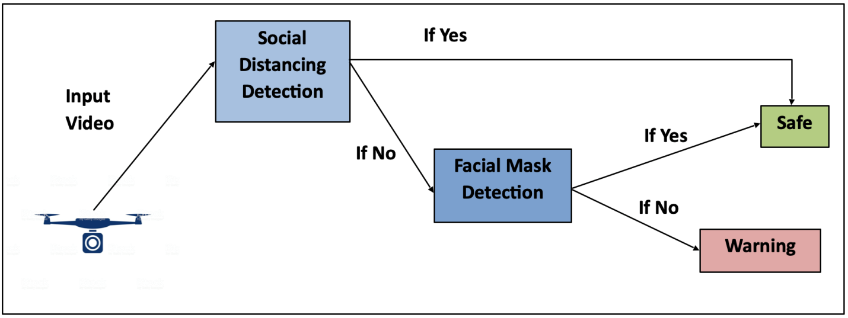

**Figure 4:** System processing flow diagram

Firstly, we input the real-time video to do social distancing checking as Figure 5.

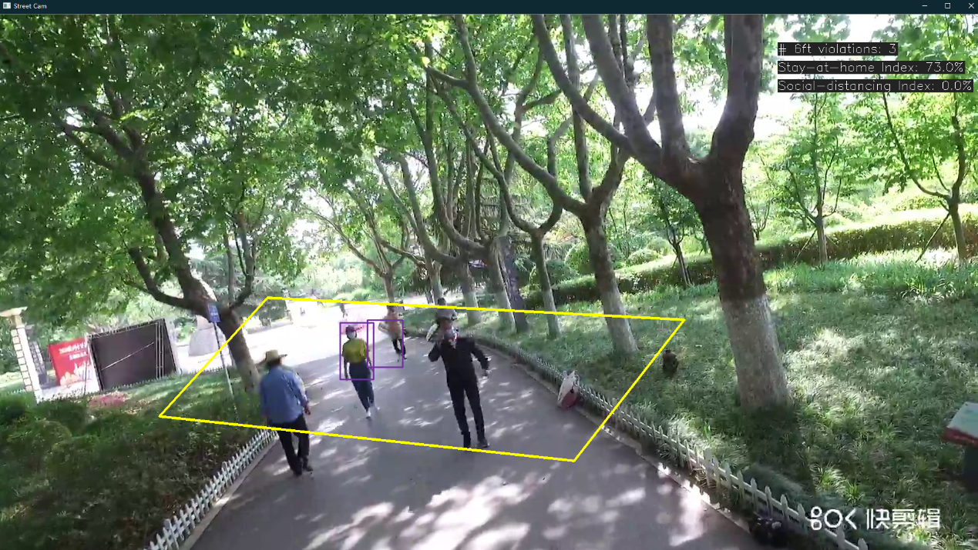

**Figure 5:** Social Distancing Detection on real-time video stream

When two people are less than six feet apart, the system will be given “No” signal to capture a close-up image and utilize the face mask detection software. The output result is indicated as Figure 6.

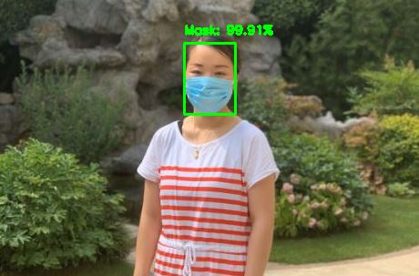

**Figure 6:** Face mask detection on close-up image

In this step, when the system detects “No Mask”, a “No” signal will be sent to trigger a voice of warning to remind the people to maintain social distancing and wear masks. Otherwise, the system will receive “Yes” signal to indicate that the situation is safe.

**Discussion**

While the social distancing and face mask detection softwares can be used to control the spread of the virus, from a technical level there are still unresolved issues.

Even though face mask detector has presented its remarkable performance with high accuracy, we still can see some bias in the output result of detection. In Figure 2, a blurry man wearing mask is misclassified as “No Mask” with 79.21% of probability. Furthermore, when the camera lens was pulled away to capture the whole image, nothing could be recognized by the software, as the image became too blurry for the AI to analyze properly. These detection biases are caused by the limitation of the dataset. Most of the images in the dataset are close-up images showing people’s faces and shoulders. We should expand the size and variety of the training set by adding images of different distances and angles.

In addition, it is meaningless to sound a warning when a couple or a family is detected by the social distancing detector. These groups of people are naturally closer to each other in both private and public places, meaning that they have a lesser impact on the community than strangers that are not social distancing. Therefore, we should utilize big data technique to analyze their relationships before the step of social distancing detection to increase the accuracy of detection.

Furthermore, the software will become less reliant in close quarters and inside buildings, due to the nature of the camera angles required. Usually, the wide angle views that the social distancing detector uses are only found on street and external cameras. Moreover, it can be seen in Figure 5 that certain cameras are simply unable to provide optimal circumstances for the software, as the positioning and quality of the camera has a major impact on the detection result. Thus, the next research will focus on creating a more flexible camera system and ways to adjust the workplace environment for the betterment of the software.

运用深度学习算法解决社交距离与口罩监测的新方案

简介

自2019年底以来，COVID-19大流行严重影响了世界各地人们的生活。由于失业，全球经济萎缩，而面对面的交流受到限制，以降低感染率。即使已经过去了六个月，医疗专业人员仍无法确定大流行的结束时间或何时研发疫苗。基于这种情况，学者和研究人员指出，随着政府继续加强社交距离和隔离，社会将经历一个长期的异常时期。这种新的生活方式对我们意味着许多变化，例如在线教育，强制戴口罩和绝大多数人在家工作。

在当前情况下，人们已经开始使用人工智能（AI）作为解决与大流行有关的问题的方法。约翰·霍普金斯大学系统科学与工程中心（CSSE）启动了一个全球制图网站，跟踪病毒的传播，而在医学领域，图像识别软件已用于分析病毒基因序列，从而有助于菌株分离。在对社会有益的项目的所有方面，人工智能技术几乎都展现了其强大的发展潜力。

尽管已经提出了社交距离和口罩检测的概念和技术，但尚未达到工业发展水平。本研究的贡献是提出了工业性解决方案。此外，我们总结了当前的挑战以及未来工作中可能的解决方案。

社交距离探测器

在全球大流行COVID-19的大流行下，人们已将社交距离作为减缓病毒传播的有效措施而着重强调。尽管大多数人都留在家里，但运输，制造和制药行业的许多重要工人仍面临感染的危险。为了确保这些工人的安全，可以实施检查社交距离的监视系统。 Andrew Ng的Landing AI开发了一种社交距离检测工具，如图1所示，该工具使用AI技术分析实时视频流并检测人们在公共区域是否保持安全距离。



图 **1:** Landing AI社交距离探测器演示

来源: <https://landing.ai/landing-ai-creates-an-ai-tool-to-help-customers-monitor-social-distancing-in-the-workplace/>

这种社交距离工具采用了新型监视技术，可以监视我们的人员，以确保我们在公共区域之间彼此之间的安全距离至少保持六英尺。该系统通过三个主要步骤实现：校准，检测和测量。在校准阶段，单眼（单摄像机）视频流可以转换为鸟瞰图。校准方法会在框架中获取四个点，然后将其映射到鸟瞰图中的矩形角。在检测阶段，系统使用基于开源R-CNN架构的行人检测网络在每个行人周围绘制一个边界框。在此阶段，还可以使用最少的后处理来清理输出边界框。在测量阶段，在鸟瞰平面中估算每个人所在位置的坐标（x，y），然后计算每个实例之间的鸟瞰距离。当距离低于最小可接受距离时，系统会以红色突出显示这些人，并在这对人之间划出一条线，以强调并发出提醒以保持社交距离。

Landing AI推出的这种社交距离检测工具旨在帮助在工作场所和公共区域保持社交距离。例如，在工厂，可以将此社交距离检测工具安装在其安全摄像头系统中，以监视工作环境。然后，检测器将在监视器上以红色突出显示彼此靠近的人。该系统还可以发出提醒，以确保社交距离。

口罩检测器

随着冠状病毒的迅速传播，疾病控制中心建议人们在难以保持社会保持距离的公共区域（例如地铁和杂货店）戴上口罩。来自马里兰州巴尔的摩县大学计算机科学系的Adrian Rosebrock博士，已经使用OpenCV和Keras / TensorFlow构建了一种口罩检测器，可用于确保人们安全性以对抗病毒。

使用COVID-19口罩检测器，涉及两个阶段：

* 训练口罩检测器
* 应用口罩检测器

使用数据集以使用Keras / TensorFlow训练口罩检测器对于第一阶段至关重要。该数据集包括690张图像标记为“ with_mask”和686张图像标记为“ without_mask”。为了创建用于训练口罩检测器的数据集，他们会拍摄正常的人脸图像，并让AI检测人脸标志，以定位眼睛，鼻子和嘴巴的位置。然后训练AI以检测口罩是否覆盖了面部。为了避免模型训练的偏差，原始图像不会再用于创建“ without_mask”样本。在准备数据之后，可以通过执行Python脚本来训练检测模型：

> python train_mask_detector.py –dataset dataset

最后，序列化的模型保存在磁盘中，训练输出损失和精度图，以显示训练后的模型的有效性。

在应用AI的阶段，通过运行以下Python脚本，检测器能够将图像中的面部分类为“ with_mask”或“ without_mask”：

> python detect_mask_image.py --image imagetest_01.jpg

在上面的命令行中，“--image”表示包含要检测的脸部的输入图像的路径。输出图像如下图2和图3所示。



图 **2:**人员稀疏时口罩检测器输出图像



图 **3**: 人员密集时口罩检测器输出图像

此外，可以使用以下命令在实时视频流中实现此口罩检测器：

> python detect_mask_video.py

工业应用解决方案

使用这两个AI检测器，可以创建一个新系统来检测人们是否保持社交距离并在公共场所戴着口罩。该系统的执行处理流程图如图4所示。



图 **4:**系统处理流程图

首先，我们输入实时视频以进行社交距离检查，如图5所示。



图 **5:**实时视频流上的社交距离检测

当两个人的距离小于六英尺时，系统将收到“No”信号以捕获特写图像并使用口罩检测软件。输出结果如图6所示。



图 **6:**近景特写图像口罩检测

在此步骤中，当系统检测到“No Mask”时，将发送“No”信号以触发警告声，提醒人们保持社交距离并戴口罩。否则，系统将收到“Yes”信号，表明情况是安全的。

讨论

尽管可以使用社交距离和口罩检测软件来控制病毒的传播，但从技术角度来看，仍然存在尚未解决的问题。

即使口罩检测器以高精度显示了其非凡的性能，我们仍然会在检测的输出结果中看到一些偏差。在图2中，戴着面具的模糊男士将其概率为79.21％误分类为“No Mask”。此外，将摄像头镜头拉开以捕获整个图像时，软件无法识别任何内容，因为图像变得太模糊以至于AI无法正确分析。这些检测偏差是由数据集的限制引起的。数据集中的大多数图像是显示人脸和肩膀的特写图像。我们应该通过添加不同距离和角度的图像来扩展训练集的大小和种类。

另外，当社交距离检测器检测到一对夫妇或一个家庭时，发出警告是没有意义的。这些人在私人场所和公共场所自然地彼此靠近，这意味着它们对社区的影响要比没有社会隔离的陌生人小。因此，在进行社交距离检测之前，应利用大数据技术分析它们之间的关系，以提高检测的准确性。

此外，由于所需摄像机角度的性质，该软件在近距离区域和建筑物内部的依赖性将降低。通常，社交距离探测器使用的广角视图只能在路边和外部摄像机上找到。此外，从图5中可以看出，某些摄像头根本无法为软件提供最佳环境，因为摄像头的位置和质量会对检测结果产生重大影响。因此，下一个研究将集中在创建更灵活的摄像头系统以及调整工作环境以改善软件的方法上。

来智兔研究平台了解更多关于此项目的细节：[***pzhao@intelrabbit.com***](mailto:pzhao@intelrabbit.com)