1. Animal related injuries

|  |  |
| --- | --- |
| Animal | Count |
| Dog | 3049 |
| Horse | 1475 |
| Fish | 1125 |
| Cat | 372 |
| Bird | 81 |
| Cows and Bulls | 77 |
| Chicken | 50 |
| Snake | 47 |
| Pig | 6 |
| Sheep | 2 |
| Shark | 1 |

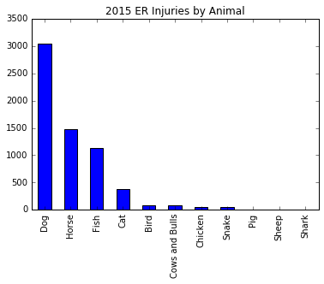

One of the questions we were interested in answering is which animals cause people to go to the emergency room the most. Not surprisingly, people are injured by dogs the most. The assumption is that the animal humans are most exposed to are dogs. Surprisingly, the animal that causes the second most injuries are horses. The injuries caused by fish are mostly related to fishing. The safest safest household animal is a cat with only 372 incidents of cat related injuries in the year 2015 in our dataset of 359,129 ER visits.

Obtaining this data did have its limitations. We had to parse the data from the notes field by using keywords. This limits our findings to the combinations of words we could think of relating to each animal. We also had to eliminate occurrences that are unrelated to this question. For example, when looking up injuries caused by chickens, we had to remove anything related to cooking.

The most interesting animal related injury is a patient who “71YOM FELL OFF A HORSE& A COW STEPPED ON HIM”.

2) Injuries by Body Part. Top 10 Body Parts

|  |  |  |
| --- | --- | --- |
| Body Park | Median Age | Count |
| HEAD | 36 | 58912 |
| FACE | 16 | 31104 |
| LOWER TRUNK | 48 | 30704 |
| FINGER | 26 | 30594 |
| ANKLE | 21 | 20148 |
| UPPER TRUNK | 46 | 19578 |
| KNEE | 27 | 19029 |
| HAND | 27 | 17140 |
| FOOT | 25 | 15961 |
| SHOULDER | 33 | 14874 |

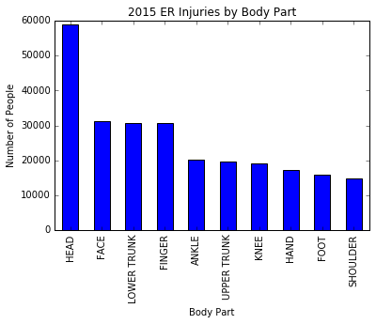

These are the top ten body parts that are injured and results in emergency room visits. The most common body part that is injured is the head followed by the face, lower back, and finger. The interesting take away is the disparity in age between the different body parts that are injured. The oldest category is the lower trunk. This consists mostly of lower back pain and lumbar issues. The data validates the general assumption that the older a person is, the more likely they are to have injuries sustained to their lower back. The face is the youngest category in the top ten. Most of the injuries sustained in this category involve physical activity or running around and falling on their face.

3) Farm injuries

|  |  |  |
| --- | --- | --- |
| Farm Activity | Median Age | Count |
| HORSEBACK RIDING (ACTIVITY, APPAREL OR EQUIPMENT) | 24.5 | 36 |
| FENCES OR FENCE POSTS | 26 | 10 |
| CARTS, OTHER OR NOT SPECIFIED | 10 | 5 |
| TWO-WHEELED, POWERED, OFF-ROAD VEHICLES (INCL. DIRT BIKE | 21.5 | 4 |
| DOORS, OTHER OR NOT SPECIFIED | 15 | 3 |
| NAILS, SCREWS, CARPET TACKS OR THUMBTACKS | 32 | 3 |
| FOOTWEAR | 14 | 3 |
| CEILINGS AND WALLS (PART OF COMPLETED STRUCTURE) | 23 | 3 |
| SPORTS AND RECREATIONAL ACTIVITY, N.E.C. | 20 | 2 |
| LADDERS, OTHER OR NOT SPECIFIED | 11 | 2 |

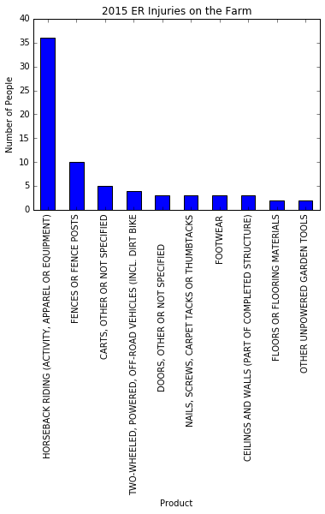

One of the more interesting locations where injuries occurred was on a farm. The second most injuries caused by an animal came from a horse as shown from our earlier question of which animal causes the most injuries. Horseback riding is the leading cause of emergency room visits from a farm. Another dangerous place to avoid on a farm is the fence. Numerous injuries occurred with people falling onto and off of fences, getting caught in fence doors, or touching electric fences.

4) Injuries by Sport

|  |  |  |
| --- | --- | --- |
| Sport | Median Age | Count |
| BASKETBALL, ACTIVITY AND RELATED EQUIPMENT | 16 | 6987 |
| FOOTBALL (ACTIVITY, APPAREL OR EQUIPMENT) | 14 | 6034 |
| SOCCER (ACTIVITY, APPAREL OR EQUIPMENT) | 14 | 5127 |
| BASEBALL (ACTIVITY, APPAREL OR EQUIPMENT; EXCL SOFTBALL) | 14 | 2022 |
| EXERCISE (ACTIVITY OR APPAREL, W/O EQUIP) | 34 | 1999 |
| SOFTBALL (ACTIVITY, APPAREL OR EQUIPMENT) | 17 | 1558 |
| MONKEY BARS OR OTHER PLAYGROUND CLIMBING APPARATUS | 6 | 1083 |
| WEIGHT LIFTING (ACTIVITY, APPAREL OR EQUIPMENT) | 29 | 894 |
| GYMNASTICS AND ASSOCIATED EQUIPMENT | 11 | 767 |
| SWIMMING (ACTIVITY, APPAREL OR EQUIPMENT) | 15 | 748 |

|  |  |  |  |
| --- | --- | --- | --- |
| Sport | Body Part | Median Age | Count |
| BASKETBALL | ANKLE | 17 | 1482 |
| FOOTBALL | HEAD | 13 | 1046 |
| BASKETBALL | FINGER | 14 | 985 |
| FOOTBALL | FINGER | 14 | 789 |
| SOCCER | HEAD | 14 | 782 |
| BASKETBALL | KNEE | 17 | 775 |
| SOCCER | ANKLE | 15 | 744 |
| SOCCER | KNEE | 16 | 631 |
| FOOTBALL | KNEE | 15 | 630 |
| BASKETBALL | HEAD | 14 | 611 |

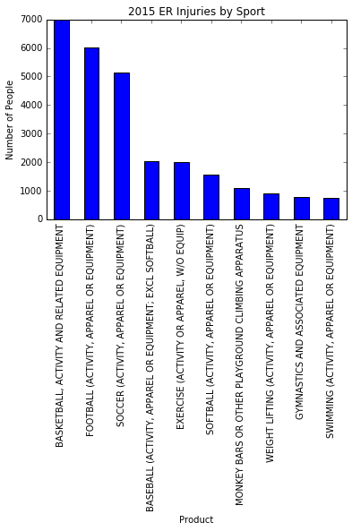

The sport that caused the most injuries is basketball, followed by football and soccer. The average age of the top sports injuries are all teenagers. We also looked at the top ten injured body parts that are obtained from sports. Ankle injuries in basketball are the most prevalent followed by head injuries in football.