Full tutorial online: https://sourceforge.net/p/mageck/wiki/demo/#the-first-tutorial-starting-from-read-count-tables
Our tutorial is a bit shorter, but in case you run into issues I would take a look at the wiki page. And it is worth noticing that different version of MAGeCK will produce variable results, so if we analyze the same dataset, we should use the same version number.

A. Installation
1. Download Anaconda: https://www.anaconda.com/distribution/
2. Install MAGeCK from Anaconda
conda install -c bioconda mageck
3. Verify installation
conda list
or
mageck --version

B. Magek count
1. Once James provides the read count tables, do any QC that is necessary (remove below 10 count sgRNAs, convert to RPM, etc.)
2. Create text file of your read table in RPM. I started with an excel spreadsheet which I then copied into text wrangler. The read count file should list the names of the sgRNA, the gene it is targeting (Symbol ID!), followed by the read counts in each sample. Each item should be separated by the tab ('\t').
3. Save the text file in a properly labeled folder.

In Excel:
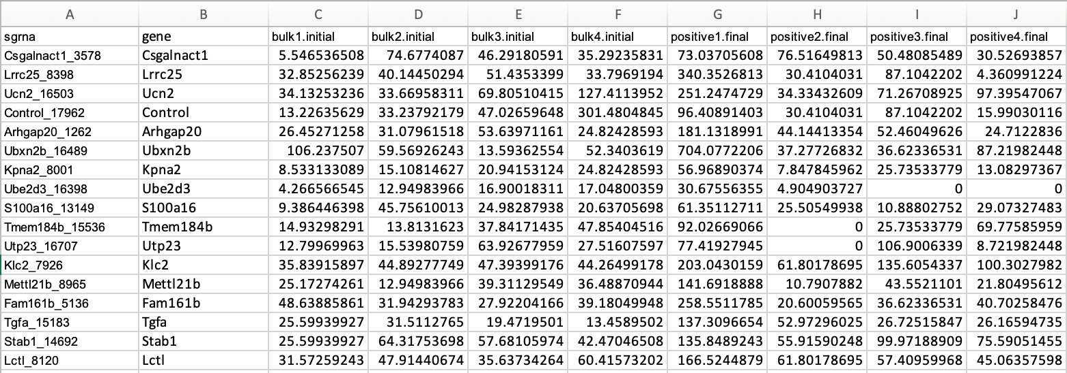

In BBEdit:
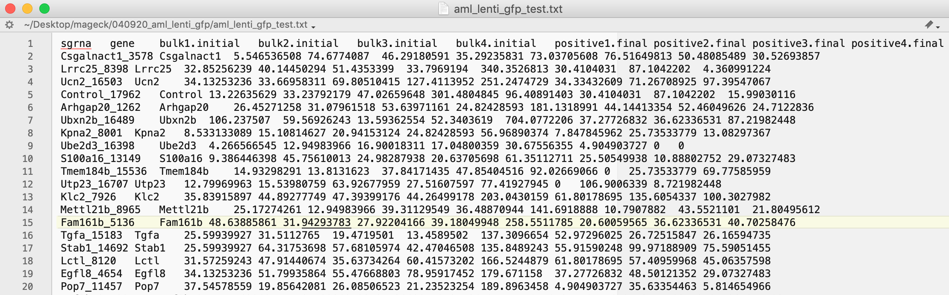
4. Once you have your read table as a .txt file, there is one basic command:

mageck test -k /path/to/file/sgrna_count.txt -t rep1.final,rep2.final,rep3.final,rep4.final -c rep1.initial,rep2.initial,rep3.initial,rep4.initial -n /Path/to/file/prefix

Broken down:
mageck
the main portal of the MAGeCK program
test
a sub-command to ask MAGeCK to perform sgRNA and gene ranking based on the provided tables
-k /path/to/file/sgrna_count.txt
The provided read count table file (file containing sgRNA name, gene, and counts for control and treatment samples. The format of the file is specified here. Each item should be separated by a tab
-t rep1.final,rep2.final,rep3.final,rep4.final
The treatment samples (must match column headers in the sgrna_count file). Include all biological replicates
-c rep1.initial,rep2.initial,rep3.initial,rep4.initial
The control samples (names must match column headers in the sgrna_count file). Include all biological replicates
-n /Path/to/file/prefix
The prefix of the output file in this case is ‘demo’. This creates files named “demo.sgrna_summary.txt, demo.gene_summary.txt, etc.” change ‘demo’ to the title you wish your files to be named after.

B. Additional parameters can be found by typing into command line:
mageck test -h

Some parameters I found useful:
--sort-criteria pos
Sorts output by positively selected sgrnas (default is negatively selected)
--pdf-report
Generates PDF report of results
--control-sgrna
Input list of control sgrnas as a .txt file (1 sgrna name per line)

--norm-method control
Normalizes to control grnas

--paired
Performs paired analysis

Example input:
mageck test -k /Users/mch47/geck/040920_aml_lenti_gfp/aml_lenti_gfp_test.txt -t positive1.final,positive2.final,positive3.final,positive4.final -c bulk1.initial,bulk2.initial,bulk3.initial,bulk4.initial -n /Users/mch47/Desktop/mageck/040920_aml_lenti_gfp/positive_over_bulk --pdf-report --sort-criteria pos --norm-method control --control-sgrna /Users/mch47/Desktop/mageck/040920_aml_lenti_gfp/control_sgrna.txt

mageck test -k hepg2_mageck_count.txt -t hepg2_top12_rep_1,hepg2_top12_rep_2,hepg2_top12_rep_3,hepg2_top12_rep_4 -c hepg2_bot12_rep_1,hepg2_bot12_rep_2,hepg2_bot12_rep_3,hepg2_bot12_rep_4 -n hepg2_hchol_efflux_top12_bot12 --paired --sort-criteria pos --norm-method control --control-sgrna control_sgrnas.txt --pdf-report

Note: feeding a list of negative control sgRNAs (non-targeting gRNAs) will be helpful to improve FDR test. Usually, MAGeCK recommended >100 non-targeting gRNAs, but feeding 100 sgRNA is no problem. Meanwhile, MAGeCK also mentioned that the genes with <4 guides will lead to conservative FDR, so for library design, including more guides per gene is definitely helpful. There is another parameter to use to improve FDR.

--additional-rra-parameters this commend will allows to add more parameters from internal RRA problem:

--permutation [permutation_round] The number of rounds of permutation. Increase this value if the number of genes is small. Default 100. This can be played around base on the gene numbers in the library.

--no-permutation-by-group By default, gene permutation is performed separately, by their number of sgRNAs. Turning this option will perform permutation on all genes together. This makes the program faster, but the p value estimation is accurate only if the number of sgRNAs per gene is approximately the same. If there are positive control gRNAs in the library, such as a lot of GFP-targeting guides, the positive control gRNAs should be blocked before setting this parameter by adding --skip-gene [EGFP]

--min-percentage-goodsgrna [min_percentage] Filter genes that have too few percentage of 'good sgrnas', or sgrnas that fall below the -p threshold. Must be a number between 0-1. Default 0 (do not filter genes).

--min-number-goodsgrna [min_number] Filter genes that have too few number of 'good sgrnas', or sgrnas that fall below the -p threshold. Must be an integer. Default 0 (do not filter genes).

To use extra parameter for permutation
Example input:
mageck test -k /Users/mch47/geck/040920_aml_lenti_gfp/aml_lenti_gfp_test.txt -t positive1.final,positive2.final,positive3.final,positive4.final -c bulk1.initial,bulk2.initial,bulk3.initial,bulk4.initial -n /Users/mch47/Desktop/mageck/040920_aml_lenti_gfp/positive_over_bulk --sort-criteria pos --norm-method control --control-sgrna /Users/mch47/Desktop/mageck/040920_aml_lenti_gfp/control_sgrna.txt --additional-rra-parameters "--min-number-goodsgrna 2 --permutation 200" --pdf-report

3. The output files are:
Open using excel. The gene_summary file with mageck ranks is the most useful file for analysis.
