# 遇到问题

# 用redis操作集群时报错:

# at redis.clients.jedis.JedisSlotBasedConnectionHandler.getConnection(JedisSlotBasedConnectionHandler.java:57)

# at redis.clients.jedis.JedisSlotBasedConnectionHandler.getConnectionFromSlot(JedisSlotBasedConnectionHandler.java:74)

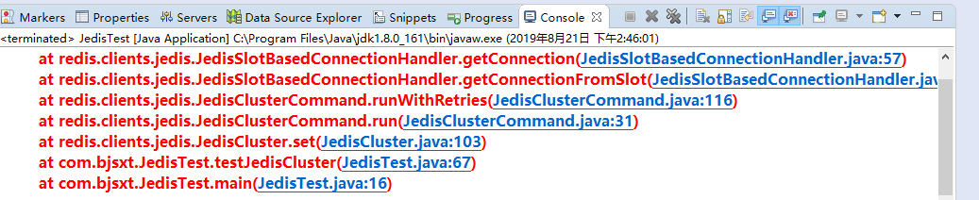

# 原因分析

字面意义是Jedis的连接异常,估计是集群连接出了错误,服务未开启或者防火墙未关闭

# 解决方案

开启集群服务