Z-Recognition

License Plate Recognition

AUTHORS: PATRICK ZIAJSKI AND ZARAK KHATTAK

SUBJECT: TECHNOLOGY PROJECT – TPJ655

PROGRAM: COMPUTER ENGINEERING TECHNOLOGY

INSTRUCTOR: B. SHEFLER

DATE: SEPTEMBER 22, 2019

Contents

Introduction 1

Functional Features 2

Functional Specifications 2

Block-Diagram 3

Project Plan 4

Software 4

Hardware 4

Expected Cost 5

Contact Information 6

# Introduction

Security is an important feature for a company providing a service to their customer. The company must ensure that its service can only be used by authorized personnel. This is where Z-Recognition comes into play. Z-Recognition is a license plate recognition system that ensures only authorized personnel have access to a designated area. Z-Recognition accomplishes this by taking an image of the approaching vehicle and processing it. If the vehicle is authorized, the vehicle is given access, if it is not, appropriate measures will be taken to have the vehicle leave the premises. Our group has decided on a license plate recognition system due to its uses in modern day society. Today, one can still find areas that are monitored by a single employee, or by a ticket-based entry system. These systems could be found inferior because of their reliance on periodic human interaction or supervision. Z-Recognition is designed to run autonomously with minimal costs, and a single requirement of an active internet. This license plate recognition system also implements a core feature in the future of computer technology, machine learning. With machine learning, an artificial intelligence (AI) can provide systems the ability to learn and improve without being explicitly programmed. This means that automated systems become more secure and reliable, without the need of constant supervision. Finally, this project will require both hardware and software implementation to be fully functional. It will require us to work with and learn both software development and hardware assembly which we, as Computer Engineering and Technology students, would prefer.

# Functional Features

* All functionality will be executed using a local Python script that will run autonomously
* The Raspberry Pi will take an image using the webcam, and send it to the Azure service
* The Azure service will be used to find all image text information from the image it was sent
* The Raspberry Pi will take the information found by the Azure service, and either
  + If a match is found, the servo motor will be activated in a certain fashion
  + If no match is found, a sound will be played through the speaker

# Functional Specifications

* The Image will be taken and stored using the “camera” module in Python
* Microsoft’s Azure Application Programming Interface (API) will be used to communicate data over Wi-Fi
* The Azure service will process the image for any text found
* Using the API, image data will be retrieved using the “Requests” module and compared to a local JavaScript Object Notation (JSON) database using the “json” module
* The python script will interface with the servo motor using the “pigpio” module
* If a match is found, the servo motor will be activated for a moment to simulate a gate lift and then activated once more to simulate a gate lowering
* If no match is found, a sound will be played through the speaker using Python’s “playsound” module
* The python script will then sleep for a set time delay and then execute once more

# Block-Diagram

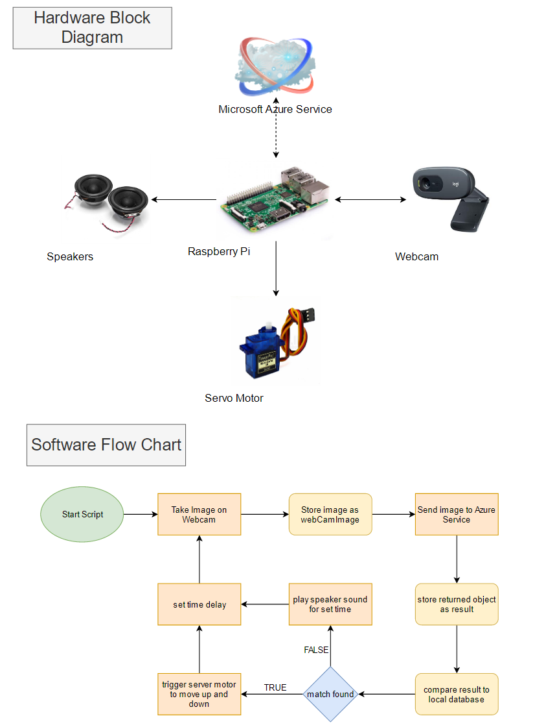

# Project Plan

## Software

* Train the Azure service on text recognition from images
* Create a script that will run, sleep for a set time delay, and execute again
* Implement the “taking images” aspect of the project
* Implement the Azure service API calls to send and receive data
* Create a local JSON database, and implement it in the script
* Implement servo motor movement
* Implement speaker audio functionality

## Hardware

* Connect the webcam though USB
* Connect the speaker using the 3.5mm jack on the Raspberry Pi
* Research the GPIO ports on the Raspberry Pi, and figure out which will need to be used
* Connect the servo motor to the GPIO ports on the Raspberry Pi

# Expected Cost

|  |  |  |
| --- | --- | --- |
| **BILL OF MATERIALS** | | |
| **Component Name** | **Quantity** | **Price** |
| Raspberry Pi 3 Model B | 1 | $35.00 |
| Logitech C270 HD Webcam | 1 | $32.00 |
| RioRand 5PCS x SG90 Micro 9d Servo | 1 | $16.99 |
| Gikfun 2" 8 Ohm 2W Audio Speaker | 1 | $16.88 |
| Microsoft Azure Service | 1 | Student Subscription |
| **TOTAL COST w/ Tax** | | $113.98 |

# Contact Information

|  |  |
| --- | --- |
| Contact Name | Patrick Ziajski |
| Contact Phone | 647 339 2847 |
| Contact Email | [pziajski@myseneca.ca](mailto:pziajski@myseneca.ca) |
|  |  |
| Contact Name | Zarak Khattak |
| Contact Phone | 587 226 3196 |
| Contact Email | [zkhattak@myseneca.ca](mailto:zkhattak@myseneca.ca) |