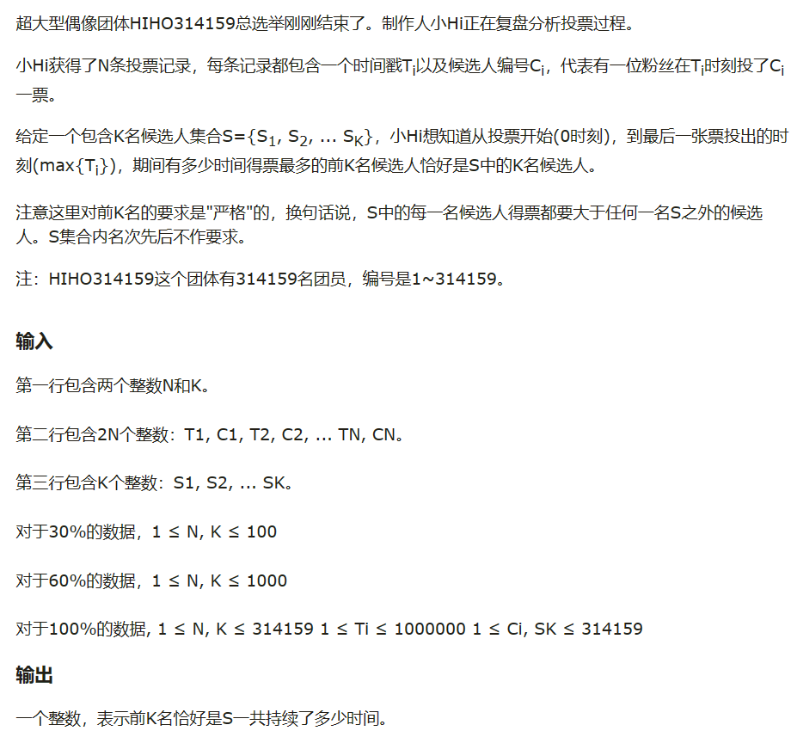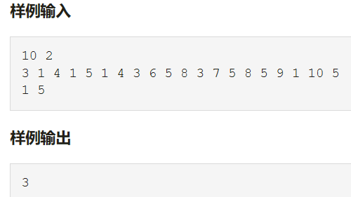
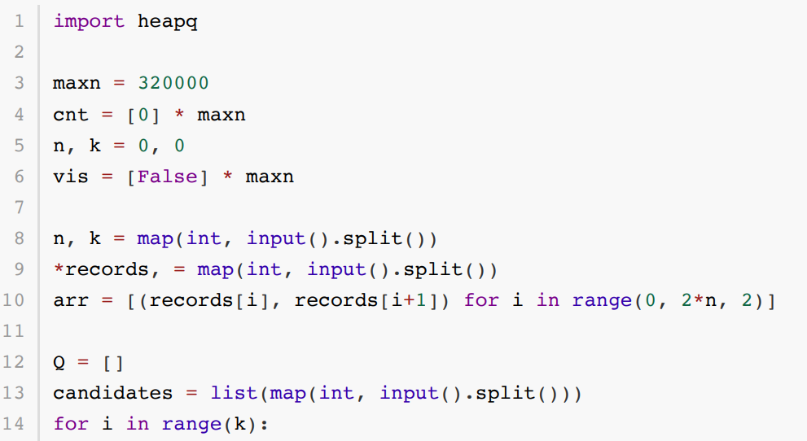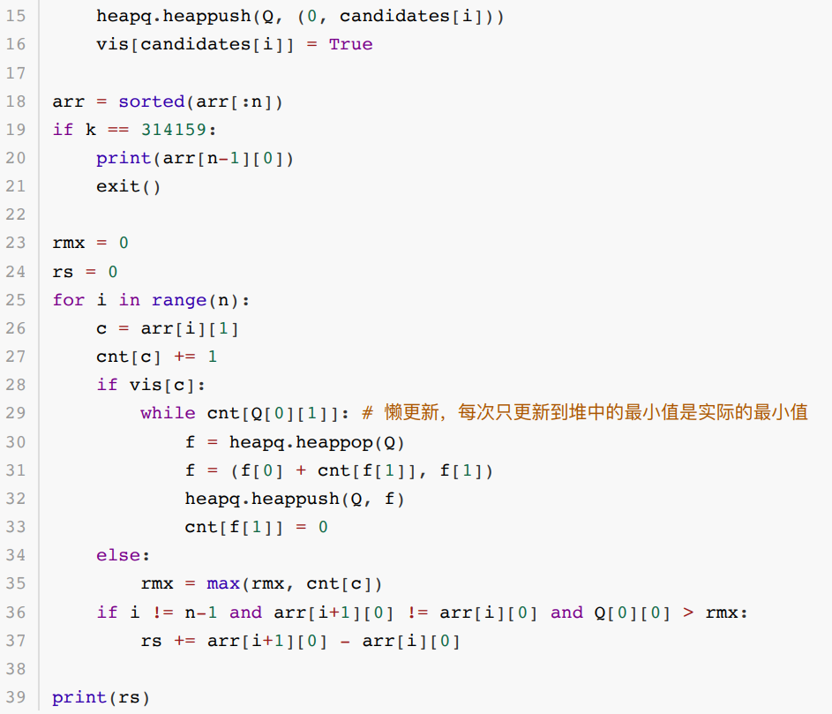
ord("a")=97
ord("A")=65

输出n位小数：
print("%.1f" %number)
print(f"{a:.2f} {b:.2f} {c:.2f} {d:.2f}")

输出格式format：
print(' is the counterfeit coin and it is {}.'.format(weight))

表示无限：
float("inf")

向上取整
math.ceil()

列表排序：
list.sort(key=lambda x:x[0]/x[1],reverse=True)

集合：
.add()
.remove()
+
-

交集：&
并集：|
差集：a-b（a中有b中没有）
对称差集：a^b

字典
d = {key1 : value1, key2 : value2 }
tinydict['Age'] = 8 # 更新、添加
del tinydict['Name'] # 删除键是'Name'的条目
tinydict.clear() # 清空字典所有条目
del tinydict # 删除字典
from collections import defaultdict
sum_indices = defaultdict(list)#初始化为0
student_grades = defaultdict(lambda: 1)#初始化为1

生成质数：
n = 1000000
a = [1] * n
s = set()
#directly add the square of prime into a set, then check if num_input is in set.
for i in range(2,n):
if a[i]:
s.add(i*i)
for j in range(i*i,n,i):
a[j] = 0
print(s)

bfs程序
from collections import deque
distance=[[0]*n for i in range(m)]
visited=[[0]*n for i in range(m)]
q=deque()
for i in range(m):
for j in range(n):
if mat[i][j]==0:
q.append((i,j))
visited[i][j]=1
while q:
x,y=q.popleft()
for dx,dy in [(0,1),(0,-1),(1,0),(-1,0)]:
nx,ny=x+dx,y+dy
if 0<=nx<m and 0<=ny<n and not visited[nx][ny]:
print(nx,ny)
visited[nx][ny]=1
distance[nx][ny]=distance[x][y]+1
q.append((nx,ny))
return distance

前缀和，哈希值
n=int(input())
gift=list(map(int,input().split()))
sumlist=[0]
for i in range(n):
sumlist.append(sumlist[i]+gift[i]-520)
sumset=set()
sumdict={}
maxnumber=0
for i in range(1+n):
if sumlist[i] not in sumset:
sumdict[sumlist[i]]=i
sumset.add(sumlist[i])
else:
maxnumber=max(maxnumber,i-sumdict[sumlist[i]])
print(maxnumber*520)

二维dp
N, M, K = map(int, input().split())
dp = [[float('inf')] * (M + 1) for i in range(K + 1)]
dp[0][0] = 0
for i in range(K):
cost, dmg = map(int, input().split())
for j in range(M, dmg - 1, -1):
for k in range(i + 1, 0, -1):
if dp[k - 1][j - dmg] + cost <= N:
dp[k][j] = min(dp[k][j], dp[k - 1][j - dmg] + cost)
def find():
for i in range(K, -1, -1):
for j in range(M + 1):
if dp[i][j] != float('inf'):
return i, M - j
captured, remaining_life = find()
print(captured, remaining_life)

生成1，n序列
n=int(input())
jiecheng=1
for i in range(1,1+n):
jiecheng*=i
arr = list(range(n))
for j in range(jiecheng):
print(' '.join(map(str, arr)))
for m in range(1, n):
if arr[-m-1] < arr[-m]:
for q in range(1, m+1):
if arr[-q] > arr[-m-1]:
arr[-m-1], arr[-q] = arr[-q], arr[-m-1]
arr = arr[:-m] + sorted(arr[-m:])
break
break

import itertools
def generate_permutations(n):
# 生成从0到n-1的所有全排列
return list(itertools.permutations(range(n)))

