ord("a")=97
ord("A")=65

输出n位小数：
print("%.1f" %number)
print(f"{a:.2f} {b:.2f} {c:.2f} {d:.2f}")
round进⾏四舍六⼊五成双

输出格式format：
print(' is the counterfeit coin and it is {}.'.format(weight))

表示无限：
float("inf")

向上取整
math.ceil()

列表排序：
list.sort(key=lambda x:x[0]/x[1],reverse=True)

集合：
.add()
.remove()
+
-

交集：&
并集：|
差集：a-b（a中有b中没有）
对称差集：a^b

字典
d = {key1 : value1, key2 : value2 }
tinydict['Age'] = 8 # 更新、添加
del tinydict['Name'] # 删除键是'Name'的条目
tinydict.clear() # 清空字典所有条目
del tinydict # 删除字典
from collections import defaultdict
sum_indices = defaultdict(list)#初始化为0
student_grades = defaultdict(lambda: 1)#初始化为1

| __eq__(self, other) | == | 判断相等 |
| __ne__(self, other) | != | 判断不相等 |
| __lt__(self, other) | < | 判断是否⼩于 |
| __le__(self, other) | <= | 判断是否⼩于等于 |
| __gt__(self, other) | > | 判断是否⼤于 |
| __ge__(self, other) | >= | 判断是否⼤于等于 |

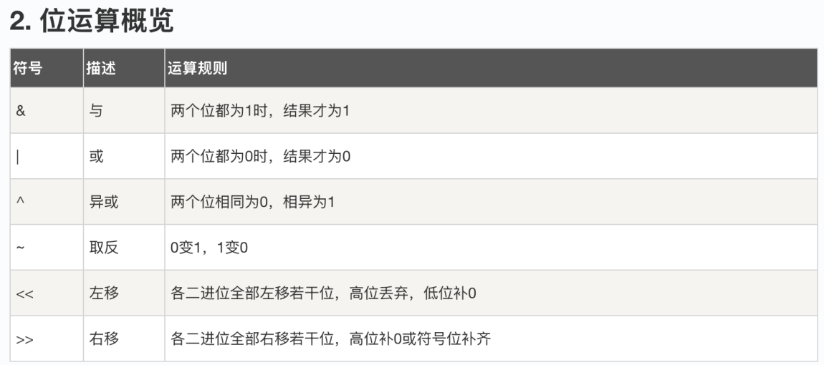

生成质数：
n = 1000000
a = [1] * n
s = set()
#directly add the square of prime into a set, then check if num_input is in set.
for i in range(2,n):
if a[i]:
s.add(i*i)
for j in range(i*i,n,i):
a[j] = 0
print(s)

import itertools
def generate_permutations(n):
# 生成从0到n-1的所有全排列
return list(itertools.permutations(range(n)))

反转链表

def fan(head):
pre,cur=None,head
while cur:
tmp=cur.next
cur.next=pre
pre=cur
cur=tmp
return pre

def fan(head):
pre,nt=None,None
while head!=None:
nt=head.next
head.next=pre
head.last=nt#last表示上一个
pre=head
head=nt
return pre

def detectCycle(head):
if head is None or head.next is None or head.next.next is None:
return None
slow=head.next
fast=head.next.next
while slow!=fast:
if fast.next is None or fast.next.next is None:
return None
slow=slow.next
fast=fast.next.next
fast=head
while slow!=fast:
slow=slow.next
fast=fast.next
return slow

kmp算法
def compute_lps(pattern):
m = len(pattern)
lps = [0] * m # 初始化lps数组
length = 0 # 当前最⻓前后缀⻓度
for i in range(1, m): # 注意i从1开始，lps[0]永远是0
while length > 0 and pattern[i] != pattern[length]:
length = lps[length - 1] # 回退到上⼀个有效前后缀⻓度
if pattern[i] == pattern[length]:
length += 1
lps[i] = length
print(lps)
return lps

def kmp_search(text, pattern):
n = len(text)
m = len(pattern)
if m == 0:
return 0
lps = compute_lps(pattern)
matches = []
# 在 text 中查找 pattern
j = 0 # 模式串指针
for i in range(n): # 主串指针
while j > 0 and text[i] != pattern[j]:
j = lps[j - 1] # 模式串回退
if text[i] == pattern[j]:
j += 1
if j == m:
matches.append(i - j + 1) # 匹配成功
j = lps[j - 1] # 查找下⼀个匹配
return matches

'''text = "ABABABABCABABABABCABABABABC"
pattern = "ABABCABAB"
index = kmp_search(text, pattern)
print("pos matched:", index)
# pos matched: [4, 13]'''
pattern=input()
print(list(range(len(pattern))))
compute_lps(pattern)

rank={'+':0,'-':0,'*':1,'/':1}
def transform(s):
s1=[]
temp=''
for c in s:
if c in '(+*-/)':
if temp!='':
s1.append(temp)
temp=''
s1.append(c)
elif c!=' ':
temp+=c
if temp!='':
s1.append(temp)

stack=[]
dispose=[]
for c in s1:
if c not in '+-*/()':
stack.append(c)
elif c=='(':
dispose.append('(')
elif c in '+-*/':
while True:
if dispose and (dispose[-1]=='(' or rank[dispose[-1]]<rank[c]):
dispose.append(c)
break
elif dispose:
stack.append(dispose.pop())
else:
dispose.append(c)
break
elif c ==')':
while dispose[-1]!='(':
stack.append(dispose.pop())
dispose.pop()
while dispose:
stack.append(dispose.pop())
print(' '.join(stack))

for _ in range(int(input())):
transform(input())

