REMOTE CONTROLLER WITH FIVE FUNCTIONS

Features
- Wide operating voltage range: 2.4V to 5.0V
- Low Standby current
- Auto Power-OFF function for TX2
- Few external components needed

General Description
The TX2/RX2 are a pair of CMOS LSIs designed for remote controlled car applications. TX2 is built with auto Power-OFF function. The TX2/RX2 has five control keys controlling the motions (i.e. Forward, Backward, Rightward, Leftward and Turbo function) of the remote controlled car.

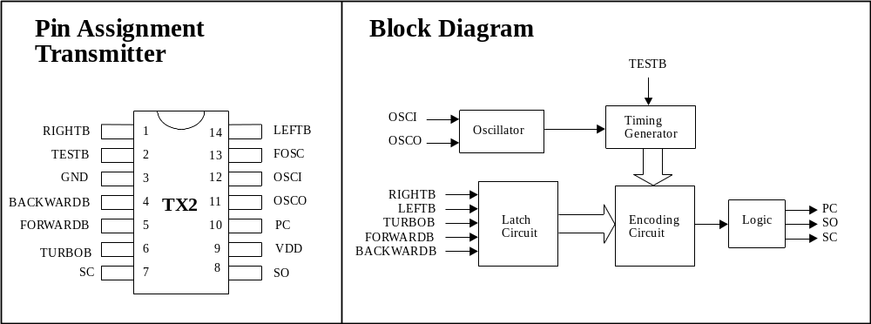
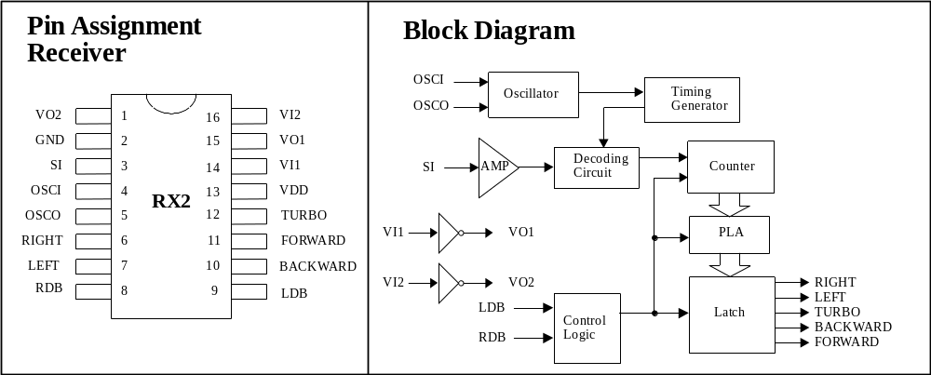

Absolute Maximum Ratings Comments*
DC Supply Voltage.....................................0.3V to 5.0V
Input/Output Voltage...........GND -0.2V to VDD + 0.2V
Operating temperature..............................-10°C to 60°C
Storage Temperature..............................-25°C to 125°C
Never allow a stress to exceed the values listed under "Absolute Maximun Ratings", otherwise the device would suffer from a permanent damage. Nor is a stress at the listed value be allowed to persist over a period, since an extended exposure to the absolute maximum rating condition may also affect the reliability of the device, if not causing a damage thereof.

Electrical Characteristics
TX2

(VDD=4.5V, Fosc = 128KHz, TA=25C, unless otherwise specified.)
Parameter | Symbol | Min. | Typ. | Max.
Operating Voltage | VDD | 2.4V | 4.0V | 5.0V
Operating Current | Idd | - | - | 1mA
Stand-by Current | Istb | - | - | 1μA
DC O/P Driving Current | Idrive | 5mA | - | -
AC O/P Driving Current | Idrive | 5mA | - | -
AC O/P Frequency | Faudio | 500Hz | - | 1KHz

RX2

(VDD=4.0V, Fosc = 128KHz, TA=25C, unless otherwise specified.)
Parameter | Symbol | Min. | Typ. | Max.
Operating Voltage | VDD | 2.4V | 4.0V | 5.0V
Operating Current | Idd | - | - | 1mA
O/P Driving Current | Idrive | 1mA | - | -
O/P Sinking Current | Isink | 1mA | - | -
Effect Decoding  Frequency Variation | Ftolerance | -20% | - | 20%

Pin Description
TX2
Pin No. | Designation | Description
1 | RIGHTB | The rightward function will be selected when this pin is connected to GND.
2 | TESTB | This pin is used for testing purpose only.
3 | GND | Negative power supply
4 | BACKWARDB | The backward function will be selected when this pin is connected to GND.
5 | FORWARDB | The forward function will be selected when this pin is connected to GND.
6 | TURBOB | The turbo function will be selected when this pin is connected to GND.
7 | SC | Output pin of the encoding signal with carrier frequency
8 | SO | Output pin of the encoding signal without carrier frequency
9 | VDD | Positive power supply
10 | PC | Power control output pin
11 | OSCO | Oscillator output pin
12 | OSCI | Oscillator input pin
13 | FOSC | This pin is used for testing mode.
14 | LEFTB | The leftward function will be selected when this pin is connected to GND.

RX2
Pin No. | Designation | Description
1 | VO2 | Inverter 2 output pin for power amplify
2 | GND | Negative power supply
3 | SI | Input pin of the encoding signal
4 | OSCI | Oscillator input pin
5 | OSCO | Oscillator output pin
6 | RIGHT | Rightward output pin
7 | LEFT | Leftward output pin
8 | RDB | Rightward function is disabled when this pin is connected to GND.
9 | LDB | Leftward function is disabled when this pin is connected to GND.
10 | BACKWARD | Backward output pin
11 | FORWARD | Forward output pin
12 | TURBO | TURBO output pin
13 | VDD | Positive power supply
14 | VI1 | Inverter 1 input pin for power amplify
15 | VO1 | Inverter 1 output pin for power amplify
16 | VI2 | Inverter 2 input pin for power amplify

Code Format
Encode Rule

(A) Bit Format
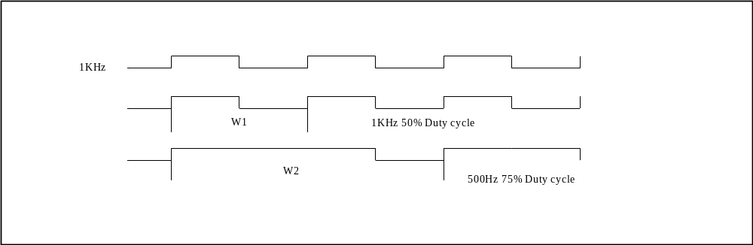

Data Format
W2 W2 W2 W2 (n) x W1 W2 W2 W2 W2 (n) x W1 W2 W2 W2 W2

Number of Function Codes (n) W1 | Function Key | Decode Result
4 |  | End Code
10 | Forward | Forward
16 | Forward & Turbo | Forward
22 | Turbo | Turbo
28 | Turbo & Forward & Left | Forward & Left
34 | Turbo & Forward & Right | Forward & Right
40 | Backward | Backward
46 | Backward & Right | Backward & Right
52 | Backward & Left | Backward & Left
58 | Left | Left
64 | Right | Right

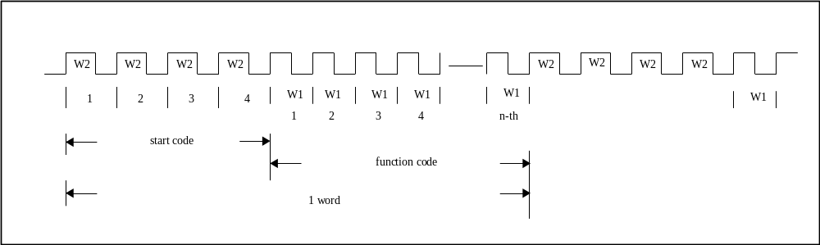

Encode/Decode Timing
(A)
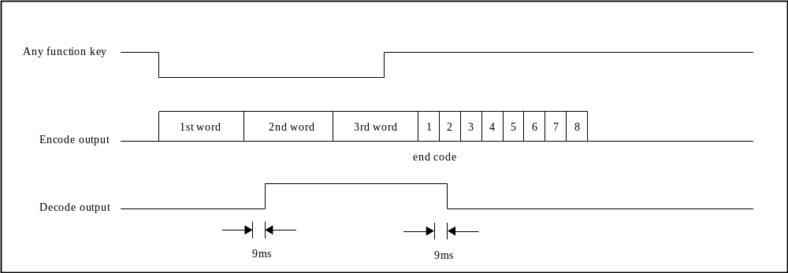

(B)
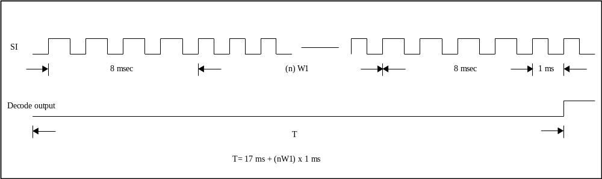

Typical Application Circuit
Transmitter (TX2 Fosc ≅ 128 KHz)
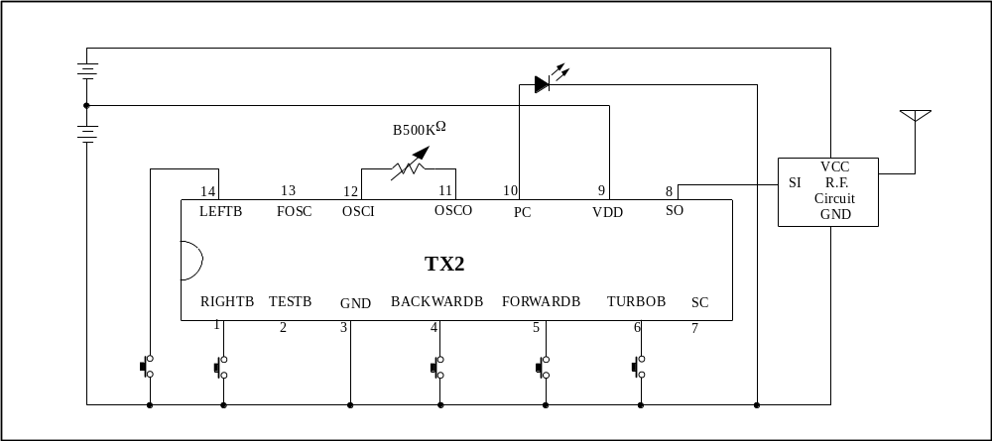

Receiver (RX2 Fosc ≅ 128 KHz)
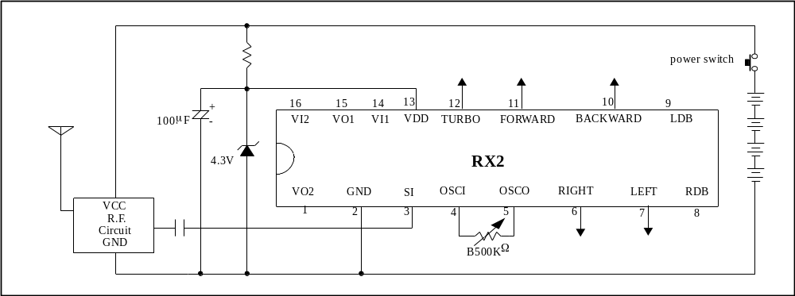

Infrared Application Circuit
Transmitter
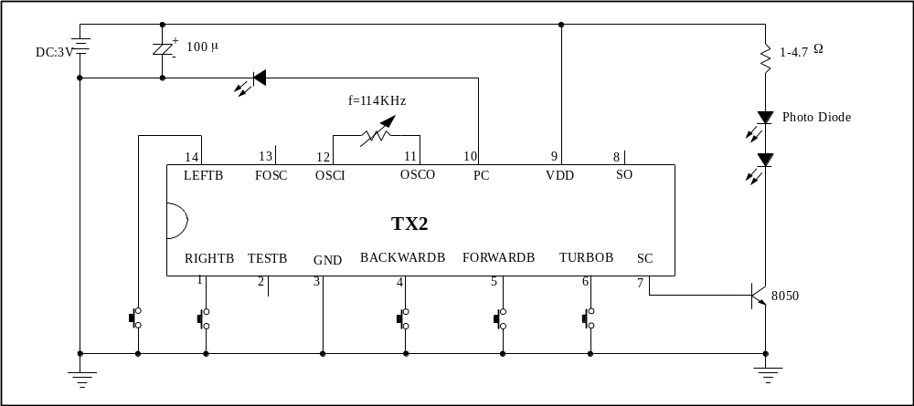

Recevier
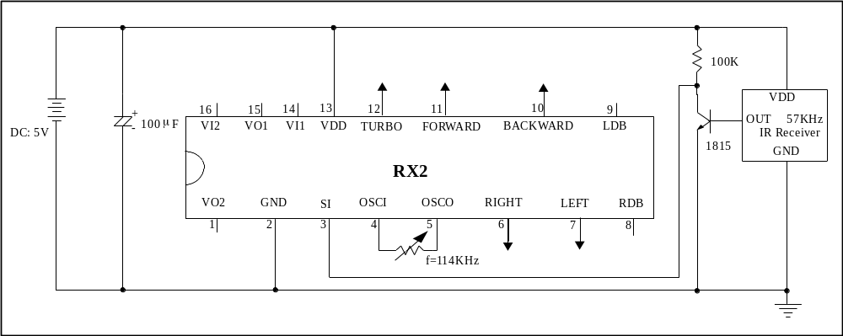

Testing Circuit
Fosc for TX2 ≅ Fosc, RX2 ≅ 128 ΚΗz
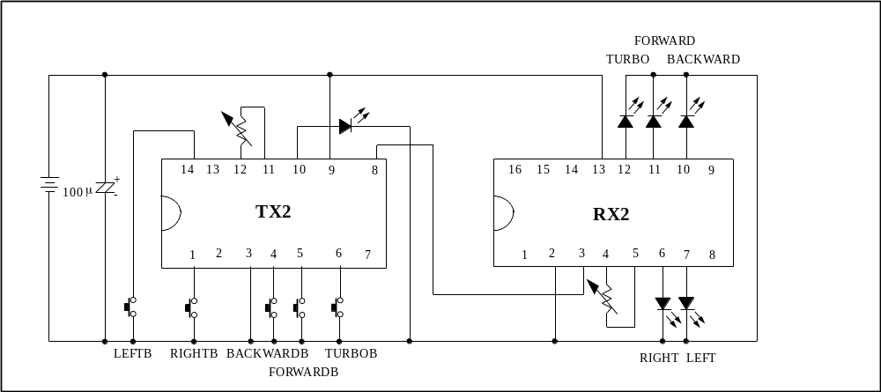

Bonding Diagram
TX2
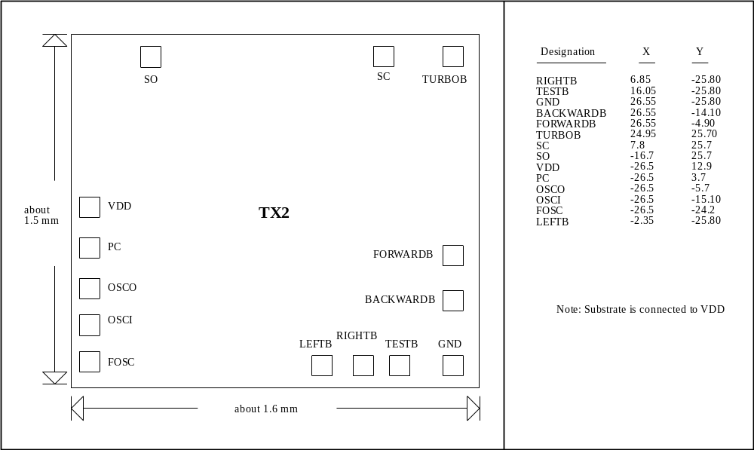

RX2
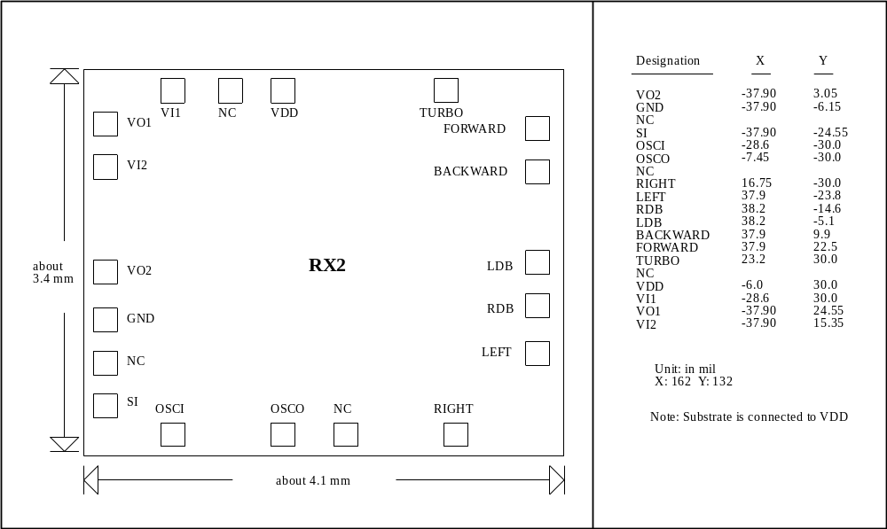

Notice: REALTEK's products are sold by description only, REALTEK reserves the rights to make changes in circuit design and/or specification at any time
without notice. Accordingly, the reader is cautioned to make sure the latest version of data sheets are available before placing orders.
REALTEK Semiconductor Corp.
OFFICE:

3F, NO. 56 WU-KUNG 6 RD.,
WU-KU INDUSTRIAL PARK,
TAIPEI HSIEN, TAIWAN, R.O.C.
TEL:886-2-2980098
FAX:886-2-2980097
HEAD OFFICE:

1F, NO. 11, INDUSTRY E. RD. IX,
SCIENCE-BASED INDUSTRIAL PARK,
HSINCHU, 300 TAIWAN, R.O.C.
TEL:886-3-5780211
FAX:886-3-5776047

